WEEK 3 INTERNSHIP REPORT
Data Cleaning and Preprocessing Pipeline Development
Beauty & Wellness | Data Science with Python Analyst Internship
Prepared by: S. Maithili
Week: 3
Date: 24 October 2026

1. Executive Summary
This report documents a practical data-cleaning and preprocessing pipeline for the skincare dataset used in Weeks 1–2. The raw CSV contains 1,138 rows and 5 original columns: product_name, product_url, product_type, clean_ingreds, price. The pipeline profiles the data, trims text, standardizes product-type labels, parses price amounts while preserving currency symbols, converts ingredient strings into normalized lists, and flags potential price outliers for review. It retains the original fields so every transformation can be traced. The cleaned output is saved as a separate CSV.

2. Dataset and Beauty & Wellness Context
The dataset is Kaggle’s “Skincare Products Clean Dataset” (https://www.kaggle.com/datasets/eward96/skincare-products-clean-dataset), provided locally as skincare_products_clean.csv. Its original fields are product_name, product_url, product_type, clean_ingreds, and price. It is a product-catalogue dataset rather than a customer or sales dataset. Therefore, this pipeline prepares data for descriptive catalogue analysis and does not infer sales, customer satisfaction, or medical efficacy.
Important limitation: the Kaggle page displayed the dataset licence as Unknown. Confirm permitted use before redistributing the original data. The price field contains currency symbols and should not be compared as a single market currency until currency consistency is confirmed.

3. Potential Data Quality Issues
- Missing or blank product names, URLs, product types, ingredient lists, or prices.
- Duplicate rows or repeated product URLs.
- Inconsistent spaces, capitalization, spelling, or category naming.
- Prices stored as text with currency symbols, separators, or non-numeric characters.
- Ingredient lists stored as string representations of lists, with inconsistent separators, casing, or duplicate terms.
- Extreme prices that may be valid premium products or data-entry problems.
- Stale product URLs or listings that have changed since the dataset was collected.
- Different currencies or units, which make direct price comparisons misleading.

4. Data Profiling and Initial Findings
Initial file dimensions: 1,138 rows × 5 original columns.
Missing-value counts in the original CSV: product_name: 0; product_url: 0; product_type: 0; clean_ingreds: 0; price: 0.
Exact duplicate rows detected after trimming text: 0. Repeated product_url values detected: 12.
Price strings that could not be parsed into a numeric amount: 0. Non-positive parsed prices: 0.
Potential price outliers flagged by the 1.5×IQR rule: 59. IQR lower fence: -22.38; upper fence: 63.83. These are flags for investigation, not automatic deletion rules.
Currency symbol counts found in the price field: £: 1138.
The initial missing-value scan is limited to empty/null cells; blank strings and semantically invalid values should also be checked.

5. Cleaning and Preprocessing Pipeline
Step 1 — Preserve the raw file: Keep an untouched copy of the original CSV. Perform all transformations on a working copy so results can be compared and reproduced.
Step 2 — Inspect structure: Use df.shape, df.info(), df.head(), df.isna().sum(), df.duplicated().sum(), and value_counts() to understand types, missingness, duplicates, and category labels.
Step 3 — Normalize text: Trim leading/trailing spaces and collapse repeated spaces. Standardize product_type casing into a separate product_type_clean column, while retaining the original column.
Step 4 — Parse price: Preserve price as price_raw; extract the numeric amount into price_numeric and currency symbol into price_currency_symbol. Do not silently convert currencies or remove suspicious values.
Step 5 — Parse ingredient lists: Convert list-like strings to Python lists using ast.literal_eval when valid; otherwise split only on recognized separators. Trim spaces, lowercase for matching, remove empty tokens and duplicate ingredient names within a product.
Step 6 — Detect duplicates: Identify exact duplicate rows and repeated URLs. Review before removing: repeated URLs may be duplicates, variants, or data collection artifacts.
Step 7 — Detect outliers: Use descriptive statistics and the 1.5×IQR rule to flag extreme price values. Check currency, product type, and source listing before deciding whether to correct, retain, or exclude.
Step 8 — Handle missing values: For missing product names/types, investigate source records; avoid inventing values. Missing ingredient lists can be marked unknown. Missing price values should remain missing unless a reliable source provides them. Imputation is generally not recommended for product prices without a clear rationale.
Step 9 — Validate output: Check row counts, types, valid categories, price parsing, ingredient parsing, and whether original fields remain intact. Record every exclusion or correction.
Step 10 — Export: Save the processed file separately and keep the original file unchanged. Export a data dictionary and a cleaning log.

6. Flowchart of the Pipeline
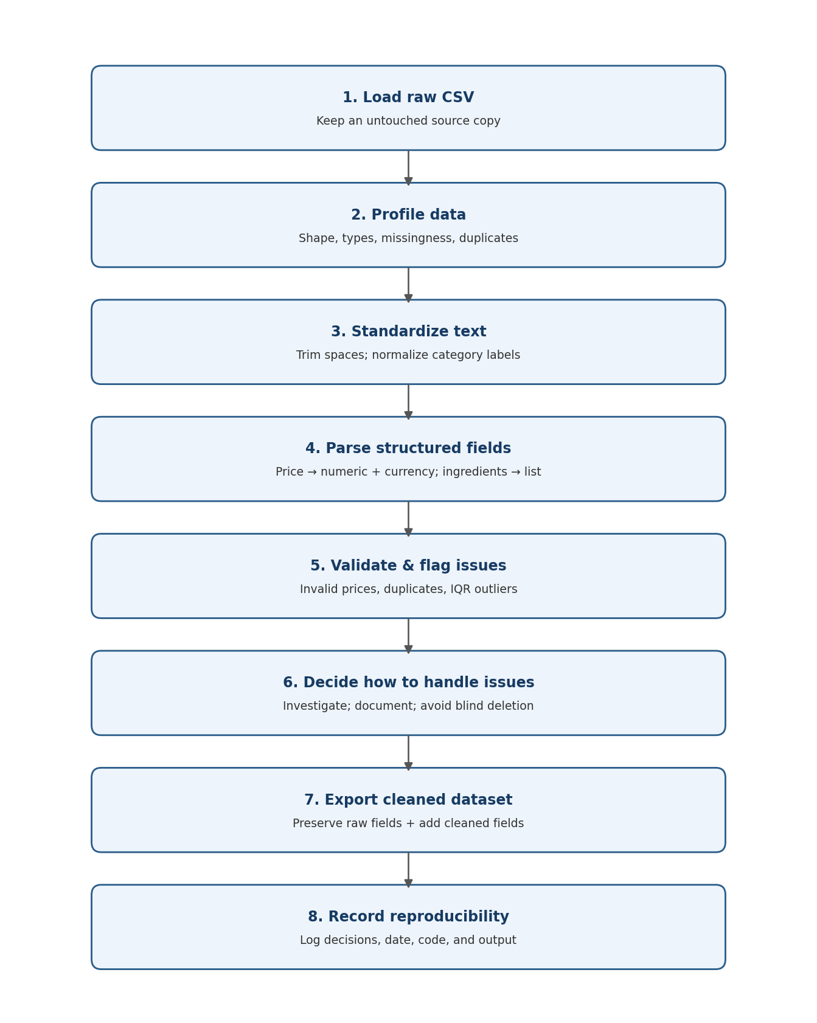
Figure 1. Proposed preprocessing workflow from raw data to a reproducible cleaned dataset.

7. Python Libraries and Why They Fit
Library | Use in pipeline | Reason
pandas | Read CSV, inspect missingness, trim strings, group data, export output | Convenient table operations and data-quality summaries.
NumPy | Represent missing numeric values and perform numeric checks | Efficient numerical handling and NaN support.
re (regular expressions) | Extract numeric prices and normalize whitespace | Flexible text-pattern matching.
ast | Safely parse list-like ingredient strings with literal_eval | Parses Python literals without executing arbitrary code.
Matplotlib / Seaborn | Plot distributions, categories, and outlier checks | Clear, reproducible visual diagnostics.
pathlib / json | Manage file paths and store configuration/log information | Portable file handling and reproducible outputs.

8. Pseudocode / Example Python
import pandas as pd
import numpy as np
import ast
import re
raw = pd.read_csv("skincare_products_clean.csv")
df = raw.copy() # keep raw unchanged
# Standardize whitespace
for col in df.select_dtypes(include="object"):
df[col] = df[col].astype("string").str.strip()
# Normalize category labels in a separate field
df["product_type_clean"] = (
df["product_type"].astype("string")
.str.replace(r"\\s+", " ", regex=True)
.str.title()
)
# Keep raw price; extract numeric amount and currency separately
df["price_raw"] = df["price"]
df["price_numeric"] = pd.to_numeric(
df["price"].astype("string")
.str.replace(",", "", regex=False)
.str.extract(r"(-?\\d+(?:\\.\\d+)?)", expand=False),
errors="coerce"
)
df["price_currency_symbol"] = df["price"].astype("string").str.extract(r"([£$€₹])", expand=False)
# Inspect missing values and duplicate records
missing_summary = df.isna().sum()
duplicate_count = df.duplicated().sum()
# Flag outliers for review; do not automatically delete
q1, q3 = df["price_numeric"].quantile([0.25, 0.75])
iqr = q3 - q1
df["price_outlier_flag"] = (
(df["price_numeric"] < q1 - 1.5 * iqr) |
(df["price_numeric"] > q3 + 1.5 * iqr)
)
# Save as a new file so the source remains unchanged
df.to_csv("skincare_products_preprocessed.csv", index=False)

9. Reproducibility and Documentation
- Store the raw file separately and never overwrite it.
- Record the dataset source URL, access date, file name, and licence status.
- Maintain a cleaning log with columns: date, field, issue, action, reason, rows affected, and validation performed.
- Keep code in a notebook or Python script with clear section headings and fixed input/output paths.
- Record Python and library versions where possible.
- Use deterministic rules and explain any manual corrections or exclusions.
- Save the cleaned CSV, data dictionary, and summary of validation checks alongside the report.

10. How Cleaning Supports Later Analysis
Consistent category labels enable reliable product-type counts and comparisons. Numeric price fields allow summary statistics and charts after currency consistency is checked. Parsed ingredient lists enable ingredient-frequency analysis without counting differences caused only by capitalization or extra spaces. Duplicate and outlier flags reduce the risk of misleading summaries. Preserving original values and documenting transformations makes the results auditable. Because the dataset has no sales or review outcomes, cleaning alone cannot enable sales prediction or customer sentiment modeling; those tasks require additional appropriate data.

11. Domain-Specific Improvements
- Keep both raw and normalized ingredient names to support traceability and avoid losing original label wording.
- Do not combine similar-sounding ingredients unless a trusted ingredient dictionary confirms they are equivalent.
- Check whether a price includes currency symbols and whether all records use the same currency before comparing categories.
- Treat premium prices as possible legitimate products, not errors solely because they are statistical outliers.
- Keep product URLs and source dates so product records can be audited.
- Do not infer that a frequently listed ingredient is more effective, safer, or more popular with consumers.

12. Conclusion
The proposed pipeline uses Python and transparent validation rules to transform a skincare product CSV into a more consistent analysis-ready dataset. The process preserves raw fields, adds normalized categories, numeric price values and currency labels, parses ingredient lists, and flags potential issues for review. Outliers and duplicates are investigated rather than removed blindly. A separate cleaned output and cleaning log improve reproducibility and support reliable exploratory analysis in later weeks.

References
- Kaggle. “Skincare Products Clean Dataset.” https://www.kaggle.com/datasets/eward96/skincare-products-clean-dataset (accessed 24 October 2026; source page displayed licence as Unknown).
- pandas documentation. https://pandas.pydata.org/docs/
- NumPy documentation. https://numpy.org/doc/
- Python documentation: ast.literal_eval. https://docs.python.org/3/library/ast.html
- Matplotlib documentation. https://matplotlib.org/stable/

