WEEK 6 FINAL REPORT

Model Evaluation, Reporting
& Business Impact Communication
Beauty & Wellness | Skincare Product Catalogue Analysis

Student Name | S. Maithili
Dataset | Skincare Products Clean Dataset (Kaggle)
Tools | Python, Pandas, scikit-learn, Matplotlib

A stakeholder-friendly evaluation plan with honest interpretation of the available evidence.

1. Executive Summary
This final report presents an evaluation framework for the predictive modeling strategy developed in Week 5. The project uses a skincare product catalogue containing product types, ingredient information, and listed prices. Because the available data does not include sales, revenue, ratings, customer reviews, or time-based observations, the defensible supervised task is listed-price estimation—not sales forecasting or customer-behavior prediction.
The recommended evaluation compares a simple baseline with Linear Regression and a tuned Decision Tree Regressor. Performance will be assessed using Mean Absolute Error (MAE), Root Mean Squared Error (RMSE), and R-squared (R²), supported by cross-validation, residual checks, and category-level error analysis. A price-distribution chart and evaluation workflow diagram are included to make the process understandable to both technical and non-technical readers. No model performance scores are fabricated: the report separates observed dataset facts from the proposed evaluation plan.

2. Business Problem and Scope
Business question: How accurately can product catalogue attributes estimate a skincare product’s listed price, and can the resulting error analysis help teams review catalogue consistency?
- Possible business users: catalogue managers, merchandising teams, and marketing analysts.
- Potential use: flag listings whose observed prices differ substantially from model estimates for manual review.
- Not supported by this dataset: sales-demand forecasts, customer preference claims, campaign effectiveness, revenue uplift, or product efficacy conclusions.
- Currency: prices are in GBP as supplied by the source dataset. Do not label them INR unless a documented currency conversion is performed.

3. Data Snapshot and Limitations
The processed dataset has 1,138 rows and 11 columns. It includes structured fields created during preprocessing, such as numeric price, normalized product type, and ingredient count.
Price field check: 1,138 rows have a parseable numeric price. The minimum and maximum observed parsed values are 1.95 and 230.00 in the source currency (GBP). These are descriptive dataset values, not model predictions.
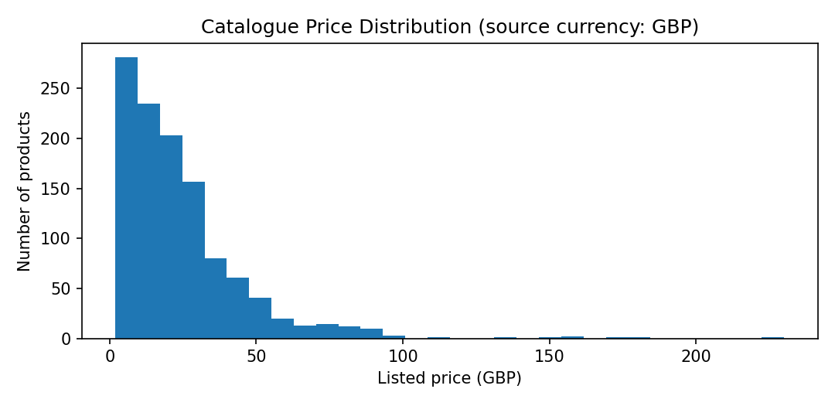
Figure 1. Distribution of listed product prices in the source catalogue; values are in GBP.
The catalogue is a snapshot rather than a time series. There are no target labels for sales, product demand, ratings, or customer satisfaction. Any model conclusion must therefore be limited to the fields actually observed.

4. Evaluation Metrics and Business Meaning
Metric | What it measures | Business-friendly interpretation | Decision rule
MAE | Average absolute gap between predicted and actual price | Typical price-estimation error in GBP | Lower is better; compare with baseline and business tolerance
RMSE | Square-root of average squared error; larger misses count more | Shows whether a few products have especially large errors | Lower is better; investigate if much higher than MAE
R² | Model fit relative to predicting the mean target | How much price variation the model explains relative to a simple mean baseline | Higher is generally better; negative test R² means worse than mean baseline
Residual analysis | Difference between actual and predicted price | Shows whether the model systematically over- or under-estimates certain listings | Look for patterns by price range and product type
Cross-validation variation | Stability across training/validation folds | Whether results depend heavily on which products are sampled | Prefer stable performance, not only one lucky split

Accuracy, F1-score, and AUC-ROC are classification metrics. They are not appropriate for the current continuous-price target unless the business question is deliberately reframed into classes (for example, low/medium/high price bands). Such a classification task would require clear, justified thresholds and metrics such as macro-F1, precision/recall, and confusion matrix.

5. Evaluation Framework and Validation Stages
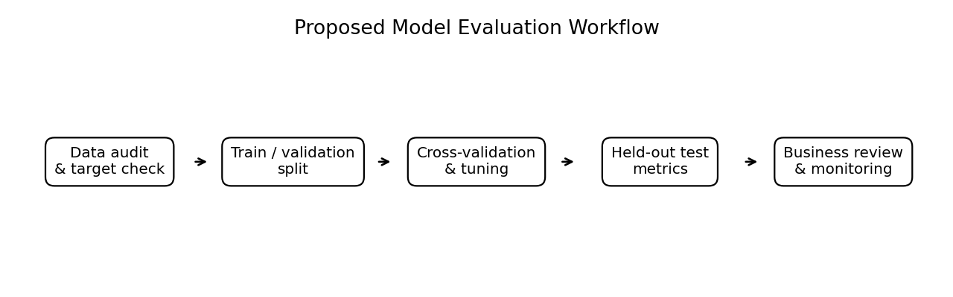
Figure 2. Proposed evaluation workflow from data checks to business review.
- Stage 1 — Data audit: verify numeric prices, currency consistency, duplicates, category labels, and ingredient parsing. Investigate flagged outliers rather than deleting them automatically.
- Stage 2 — Split: create a fixed train/test split (for example, 80/20 with random_state=42). Keep the test set untouched until final evaluation.
- Stage 3 — Baseline: train a DummyRegressor that predicts a simple training-set reference value. Any useful model should outperform this baseline on held-out data.
- Stage 4 — Cross-validation and tuning: use 5-fold cross-validation on the training set to compare Linear Regression and Decision Tree settings. Tune tree depth and minimum leaf size.
- Stage 5 — Test evaluation: report MAE, RMSE, and R² on the test set only after model selection is complete.
- Stage 6 — Diagnostic review: plot predicted vs actual prices and residuals; inspect errors by product type and price range.
- Stage 7 — Business acceptance: agree an acceptable error tolerance with stakeholders and confirm the model is useful for catalogue review before any operational use.
- Stage 8 — Monitoring: if new catalogue snapshots become available, check performance and data drift periodically; retrain only after validation.

6. Performance Reporting Table (Template)
The following table should be filled with actual outputs after the Week 5 pipeline is run. Values are intentionally marked as pending rather than estimated without training.
Model | Test MAE (GBP) | Test RMSE (GBP) | Test R² | Decision
DummyRegressor | Pending run | Pending run | Pending run | Baseline
Linear Regression | Pending run | Pending run | Pending run | Compare interpretability and error
Decision Tree Regressor | Pending run | Pending run | Pending run | Tune depth; check overfitting

Selection guidance: choose a model only if it improves meaningfully on the baseline, has reasonably stable cross-validation results, does not show major category-specific bias, and meets a business-defined error tolerance. If no model passes these checks, report that the current features are insufficient rather than forcing a positive conclusion.

7. Visualizations to Include in Final Evaluation
Visual | What it shows | How stakeholders can use it
Price distribution histogram | Range and concentration of listed prices | Understand the target distribution and whether a few expensive items may dominate errors
Predicted vs actual scatter plot | How close estimates are to actual prices | Points near the diagonal indicate better predictions; systematic deviations indicate bias
Residual plot | Prediction errors against fitted values | Patterns may reveal non-linearity, unequal error spread, or outliers
MAE/RMSE comparison bar chart | Error by candidate model | Makes model comparison accessible; lower bars mean lower error
Error by product type | Typical error for each category | Shows whether one category needs more data or a different approach

8. Communicating Findings to Non-Technical Stakeholders
Use a short narrative rather than technical metrics alone. State what the model predicts, how far off it tends to be, where it performs well or poorly, and what decisions the results can reasonably support. Explain MAE as the typical absolute price miss in GBP. Explain RMSE as a measure that penalizes large mistakes more heavily. Explain R² as a relative fit measure, not as a percentage accuracy score.
- Example wording: “On the held-out test set, the model’s typical price estimate differed from the listed price by £X (MAE). The error was larger for some products, reflected by an RMSE of £Y. We recommend using estimates to prioritize manual listing checks, not to set prices automatically.” Replace X and Y only after running the model.
- Avoid statements such as “the model is 90% accurate” when using regression metrics.
- Show one headline metric, one comparison chart, and one clear limitation on a summary slide or report page.

9. Potential Business Impact and Recommendations
- Use price estimates as a catalogue-quality screening aid. Flag unusually large residuals for a person to verify whether the price, category, or ingredient data is incorrect.
- Compare errors by product type. If one category has consistently high errors, collect more relevant product attributes before relying on estimates for that category.
- Improve product data consistency by standardizing category names, price formatting, and ingredient text.
- Do not automatically change a product’s price based on model output. Pricing depends on factors absent from this dataset, including brand positioning, size, promotions, distribution costs, and market conditions.
- For future marketing or demand predictions, collect suitable time-stamped outcomes such as sales units, conversion rates, campaign exposure, stock availability, and review/ratings data with appropriate permissions.
- Run a small human-reviewed pilot before operational use. Track how many flagged listings are genuinely problematic and whether the review process saves staff time.
Expected impact is conditional, not proven: a well-validated model may help prioritize catalogue checks and improve data quality. The current dataset alone cannot quantify revenue growth, campaign performance, customer engagement, or customer satisfaction.

10. Risks and Mitigation
Risk | Possible effect | Mitigation
Overfitting | Training scores look good but new-product estimates are poor | Cross-validation, shallow trees, minimum leaf sizes, held-out test set
Data leakage | Unrealistically strong test scores | Exclude target-derived features; fit preprocessing only within training folds
Price outliers or parse errors | Metrics distorted by invalid values or genuine premium products | Inspect flagged values; report MAE and RMSE together; document sensitivity checks
Limited features | Model errors remain high | Communicate limitation; collect product size, brand, product claims, and other reliable predictors if available
Snapshot / drift | Current relationships may not hold for future catalogue updates | Validate on later snapshots before deployment

11. Final Summary
The evaluation plan connects technical testing with practical catalogue decisions. A baseline, Linear Regression, and a tuned Decision Tree should be compared using MAE, RMSE, and R², with cross-validation and residual analysis used to check stability and bias. Charts and a plain-language summary will help stakeholders understand both model usefulness and uncertainty. The most defensible immediate business use is to prioritize manual checks of potentially inconsistent product listings. Sales forecasting and claims about customer behavior require additional labeled, time-based data and should remain out of scope until such data is collected.

12. Proposed 30–35 Hour Work Plan
Activity | Hours | Deliverable
Audit data and confirm evaluation target | 3 | Data checks and exclusions
Implement baseline and modeling pipelines | 5 | Reproducible model code
Run cross-validation and tuning | 6 | Candidate model comparison
Calculate held-out metrics and residuals | 5 | Performance table and diagnostics
Create charts and category-level analysis | 4 | Visual evidence
Translate results into stakeholder language | 4 | Business summary and recommendations
Review limitations, reproducibility, and report formatting | 5 | Final report
Total | 32 | Evaluation and business impact report

References
- Skincare Products Clean Dataset, Kaggle: https://www.kaggle.com/datasets/eward96/skincare-products-clean-dataset
- scikit-learn — Model evaluation: https://scikit-learn.org/stable/modules/model_evaluation.html
- scikit-learn — Cross-validation: https://scikit-learn.org/stable/modules/cross_validation.html
- scikit-learn — Dummy estimators: https://scikit-learn.org/stable/modules/model_evaluation.html#dummy-estimators
- scikit-learn — Decision trees: https://scikit-learn.org/stable/modules/tree.html

