WEEK 1
STRATEGIC PLANNING AND
DATA EXPLORATION IN LOGISTICS
A practical logistics analytics report using Python and Google Colab

Prepared by | Maithili Salaavdhi
Role | Logistics Data Analyst Intern
Tools | Python • Pandas • Matplotlib • Google Colab

Assignment focus: define a logistics problem, select measurable KPIs, explore a dataset, identify patterns, and propose data-driven actions.

Executive Summary
This report documents a complete Week 1 logistics analytics workflow: business problem definition, KPI selection, dataset inspection, quality checks, exploratory data analysis (EDA), delay analysis, a demonstration prediction workflow, and operational recommendations. The practical analysis shown in the attached Google Colab screenshots uses a small synthetic practice dataset containing 30 deliveries and 9 fields. The results are therefore useful for demonstrating the method, but they should not be generalized to a real logistics operation without validation on a larger, representative dataset.

Key findings from the practice dataset
- Dataset size: 30 delivery records and 9 columns.
- Data quality: all 30 records have non-null values in the displayed fields; 0 duplicate rows were detected.
- Delivery status: 16 deliveries were labelled Late and 14 On Time, giving a practice-sample on-time rate of 46.7%.
- Delay measure: mean positive delay was 8.3 minutes; the maximum positive delay was 26 minutes.
- Traffic comparison: the displayed group analysis reports average delay of 20.9 minutes for High traffic, 0.6 for Low traffic, and 3.4 for Medium traffic.
- The small sample and the visible differences between traffic groups suggest traffic should be investigated, but 30 records are not enough to establish a stable operational conclusion.

1. Business Scenario and Problem Statement
Logistics teams must deliver orders within promised time windows while controlling delivery cost and maintaining service quality. Delays can reduce customer satisfaction, increase support workload, and create additional operating expense. Dispatch teams need evidence about the conditions associated with late deliveries so they can improve route planning, dispatch timing, and delivery estimates.

Problem statement
How can a logistics operation use delivery records—such as distance, traffic level, weather, order hour, promised delivery time, actual delivery time, delivery status, and delivery cost—to measure service performance, identify factors associated with delays, and plan practical improvements?

Objectives
- Define a measurable logistics problem and identify stakeholders.
- Inspect the dataset structure and verify basic data quality.
- Calculate delivery performance KPIs and compare delivery outcomes.
- Use visualizations to explore delivery-time distribution and traffic-related patterns.
- Demonstrate a baseline prediction workflow while acknowledging sample-size and model limitations.
- Translate findings into realistic, measurable operational recommendations.

2. Business System, Stakeholders and Scope
Stakeholder | Information needed | Decision supported
Operations / dispatch manager | On-time rate, late orders, traffic and route patterns | Reassign resources and adjust dispatch plans
Delivery team | Distance, traffic, weather, promised time | Plan routes and manage delivery expectations
Customer support | Delayed order IDs and delay duration | Prioritize proactive customer updates
Finance / management | Delivery cost and service performance | Balance cost against service level
Data analyst | Data quality, KPIs, distributions, model error | Provide reliable evidence and monitor changes

Scope and assumptions
- Included: descriptive analysis of 30 sample deliveries, basic quality checks, delay calculation, charts, and a baseline model demonstration.
- Not included: live GPS data, route geometry, driver schedules, fuel usage, customer feedback, or production deployment.
- The dataset is synthetic practice data. It is not a sample from a real delivery company.
- For a production study, obtain a larger approved dataset, document its source and date range, and validate all field definitions with the business owner.

3. Dataset Description and Preparation
The practice dataset contains the following fields:
Field | Meaning
Delivery_ID | Unique delivery reference
Distance_km | Delivery distance in kilometres
Traffic_Level | Categorical traffic condition: Low, Medium, or High
Weather | Recorded weather category
Order_Hour | Hour of day when the order was placed
Promised_Delivery_Min | Promised delivery time in minutes
Actual_Delivery_Min | Observed delivery time in minutes
Delivery_Status | Recorded delivery outcome: On Time or Late
Delivery_Cost_INR | Delivery cost in Indian rupees

Data-quality procedure
- Load the CSV into a Pandas DataFrame and inspect the first five records.
- Check row and column counts, column names, data types, and non-null counts.
- Count missing values per field and count duplicated rows.
- Create a cleaned copy by removing exact duplicate rows; preserve the original data for traceability.
- Check ranges and category spelling before any production analysis.
- Calculate derived delay as max(actual delivery time − promised delivery time, 0), so early/on-time deliveries do not become negative delays.
Observed quality checks: 30 rows × 9 columns; zero missing values in the displayed fields; zero duplicate records. Because the sample is small and clean by construction, real operational data may require substantially more cleaning.
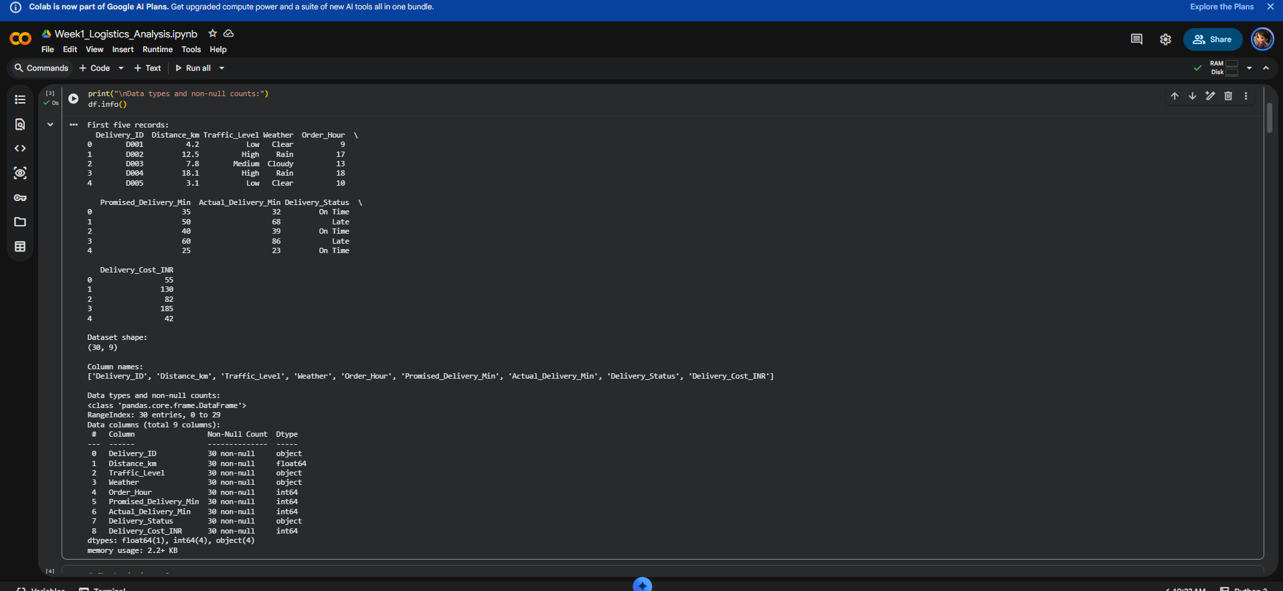
Figure 1. Dataset preview, shape, column names, and data types displayed in Google Colab.
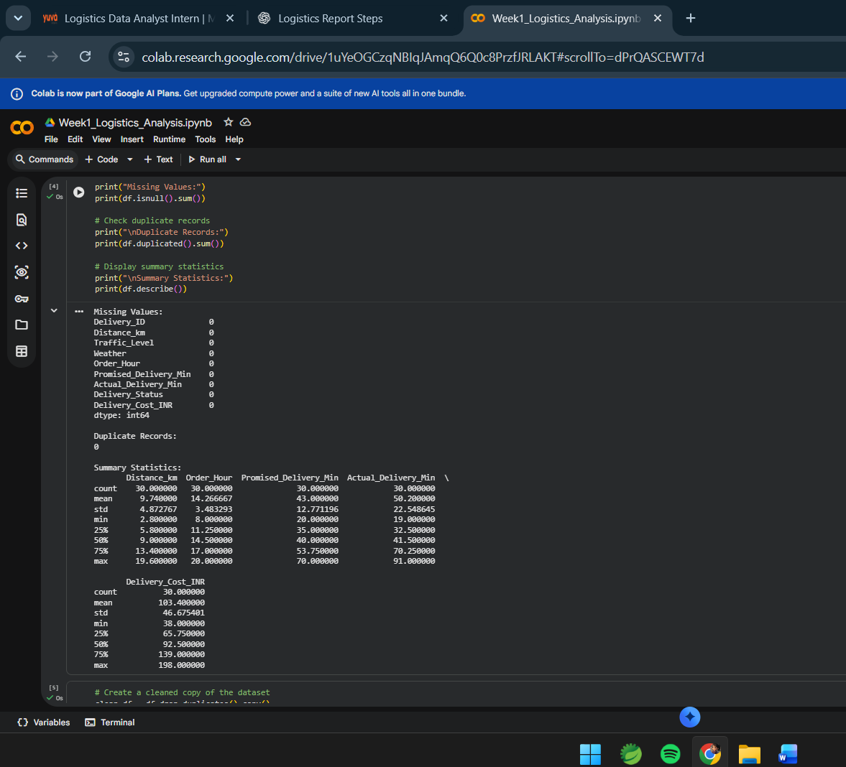
Figure 2. Missing-value counts, duplicate count, and descriptive statistics from the practice dataset.

4. KPI Framework and Definitions
KPI | Definition | Why it matters
On-time delivery rate | On-time deliveries ÷ total deliveries × 100 | Measures reliability against customer promise
Late delivery rate | Late deliveries ÷ total deliveries × 100 | Tracks service failures requiring investigation
Average actual delivery time | Mean of actual delivery minutes | Provides a typical-time baseline
Average positive delay | Mean of max(actual − promised, 0) | Quantifies delay without negative values
Maximum positive delay | Maximum of max(actual − promised, 0) | Highlights worst observed delay in the sample
Average delivery cost | Mean delivery cost in INR | Supports cost and service trade-offs
Delay by traffic level | Average positive delay grouped by traffic | Helps investigate traffic-related operational risks
The practice-sample status counts are 14 On Time and 16 Late. Thus, on-time rate = 14/30 × 100 = 46.7%, while late rate = 16/30 × 100 = 53.3%. These figures describe only the uploaded sample.

5. Exploratory Data Analysis and Results

5.1 Delivery status comparison
The bar chart shows 16 late deliveries and 14 on-time deliveries. In this sample, late deliveries slightly outnumber on-time deliveries. The result is a useful prompt for investigating delay causes, not evidence of the performance of a real company.
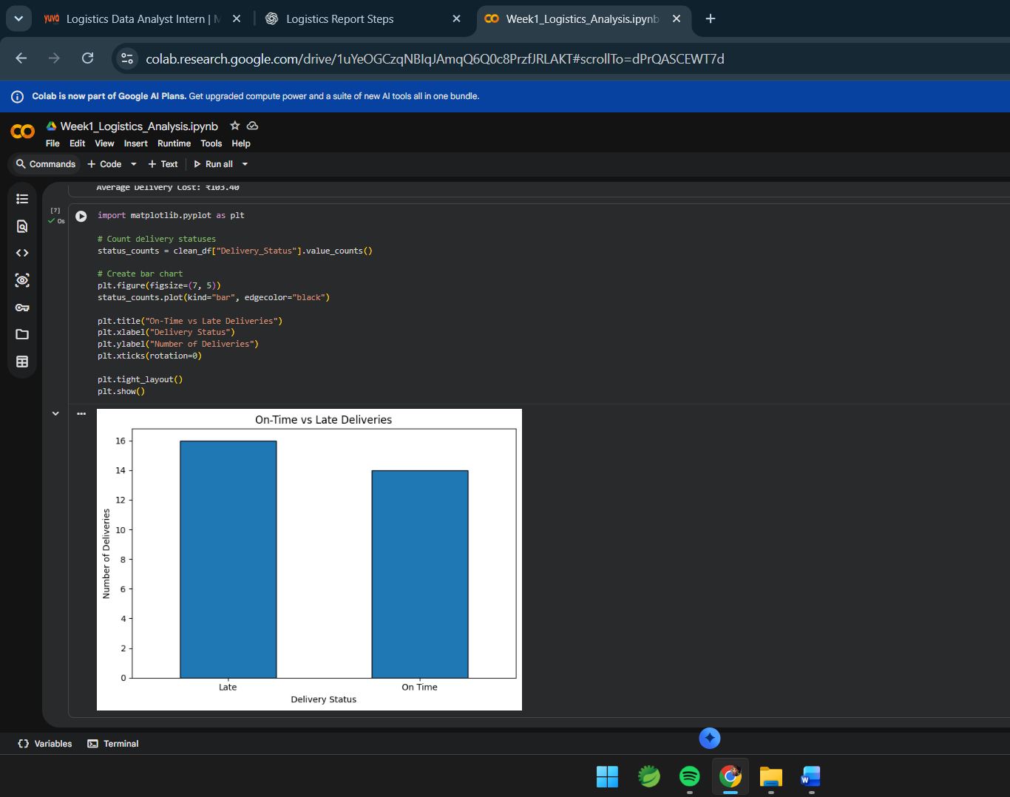
Figure 3. On-Time vs Late Deliveries: 16 late and 14 on-time deliveries.
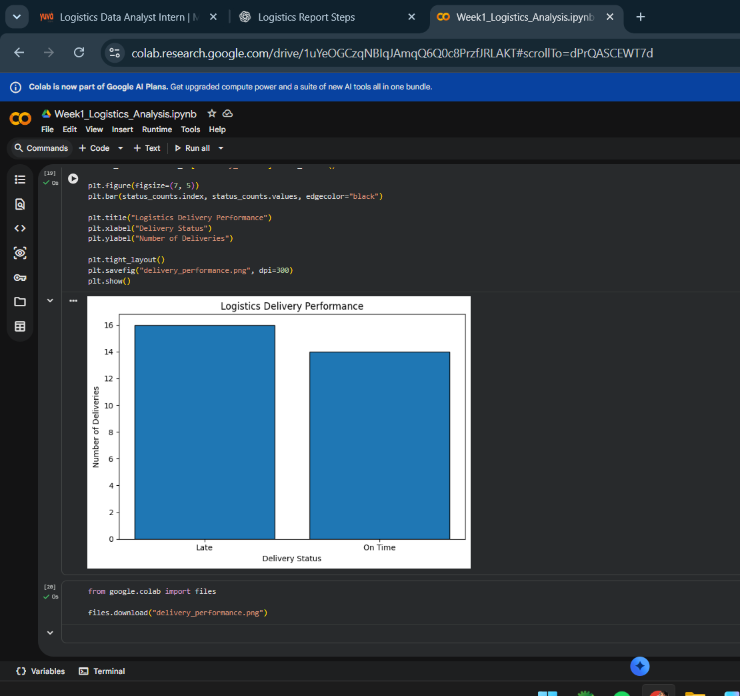
Figure 4. Saved logistics delivery performance chart generated from the same status counts.

5.2 Distribution of actual delivery time
The histogram shows a broad spread in actual delivery times, approximately 19 to 91 minutes. Several deliveries are concentrated around the lower-to-middle range, while a smaller number take considerably longer. A larger sample would be needed to confirm whether the distribution has stable clusters or outliers.
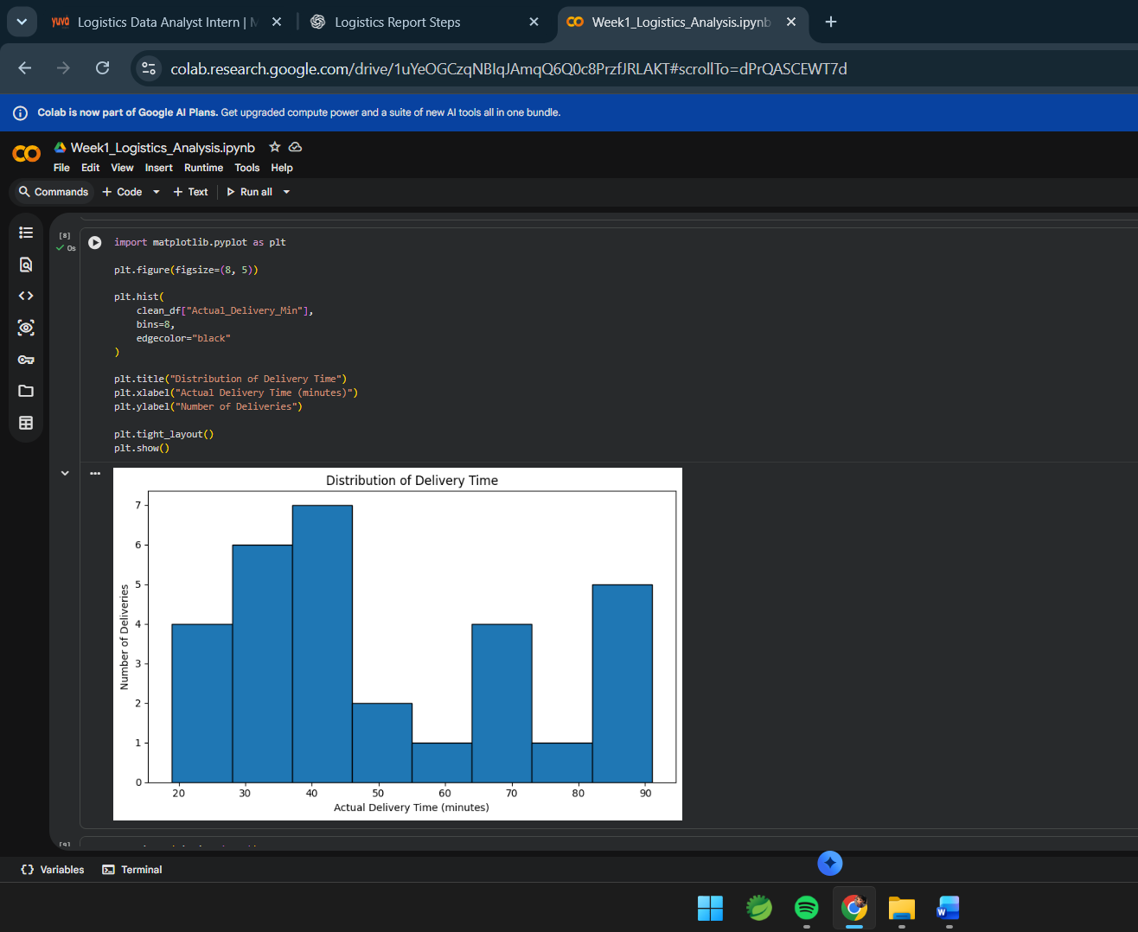
Figure 5. Distribution of actual delivery time in minutes.

5.3 Delivery time by traffic level
The boxplot compares actual delivery-time distributions for High, Low, and Medium traffic. The High-traffic group has the largest observed delivery times in this practice dataset. This supports further investigation of traffic, but group sizes are small and other factors (distance, weather, order hour) may differ between groups.
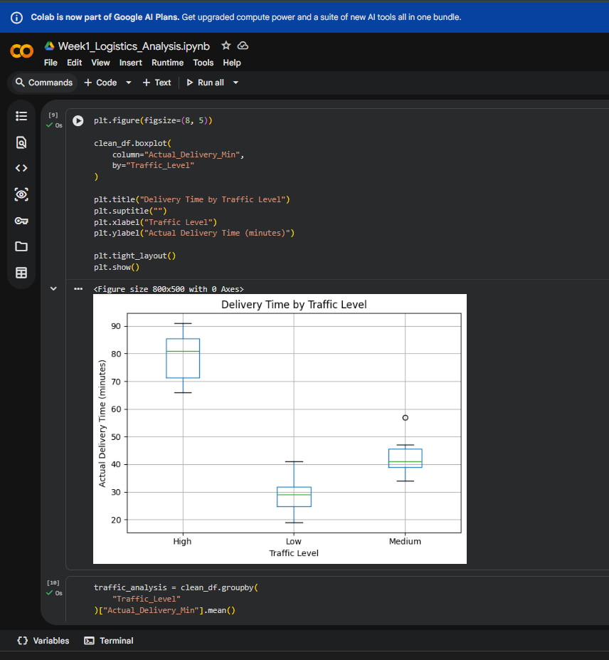
Figure 6. Actual delivery time by traffic level. Boxes show spread and median; individual group sizes are small.

5.4 Delay calculation and traffic-level comparison
Positive delay is calculated as max(Actual_Delivery_Min − Promised_Delivery_Min, 0). The Colab output reports an average positive delay of 8.3 minutes and a maximum of 26 minutes. The traffic-group average delays shown are High: 20.9 minutes, Low: 0.6 minutes, and Medium: 3.4 minutes. High traffic is the strongest pattern in this small sample and is the first area to investigate.
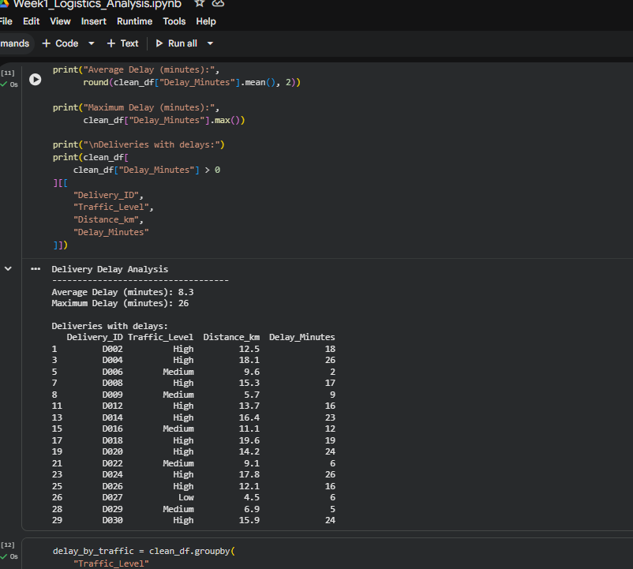
Figure 7. Delay-analysis output listing delayed deliveries and their traffic levels, distances, and delay minutes.
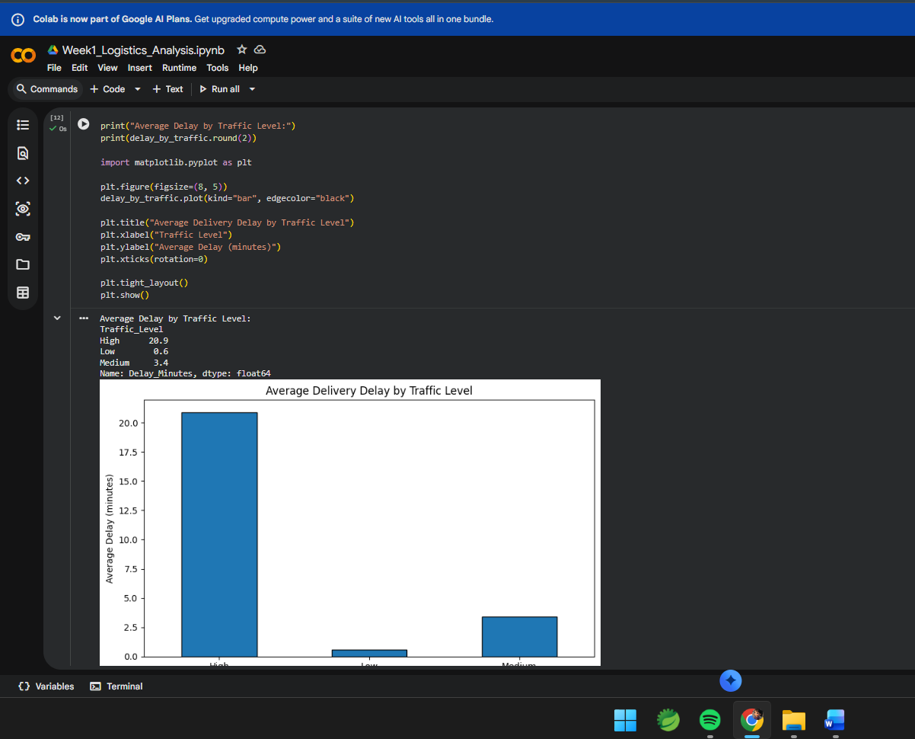
Figure 8. Average positive delay by traffic level: High 20.9, Low 0.6, Medium 3.4 minutes.

6. Baseline Predictive Modelling Demonstration
A baseline regression workflow was run in Colab to demonstrate how delivery-time prediction could be approached. The displayed actual-versus-predicted plot contains a small test set and shows noticeable prediction errors. The plot alone is not sufficient to judge model quality; the report should also record Mean Absolute Error (MAE), Root Mean Squared Error (RMSE), and R² from the executed evaluation cell.
- Target: Actual_Delivery_Min.
- Example input features: Distance_km, Order_Hour, and Promised_Delivery_Min.
- A train/test split is used to estimate performance on held-out records.
- Important limitation: with only 30 records, the test set is very small, and metrics can change substantially with a different split. Treat this as a coding demonstration, not a deployable prediction model.
- Potential leakage check: do not use fields that are only known after delivery, such as final delivery status or actual delivery time, as model inputs when predicting before delivery.
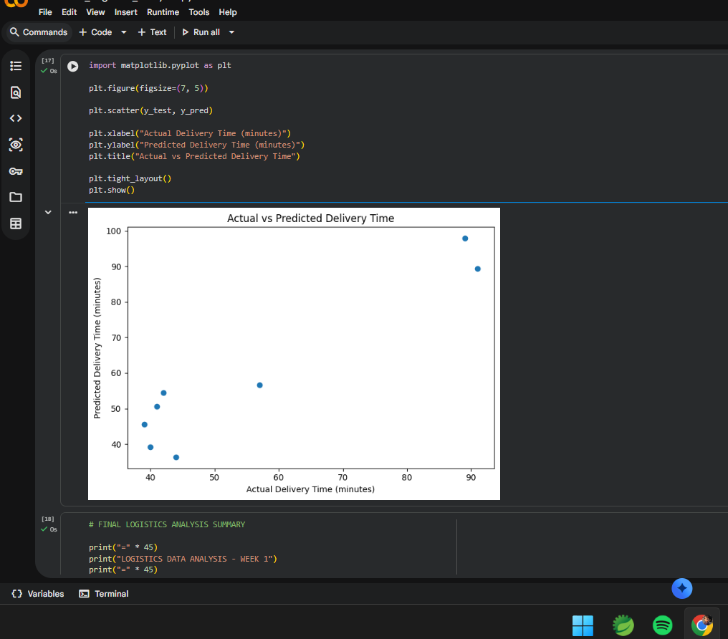
Figure 9. Actual versus predicted delivery time from the baseline regression demonstration. The small test sample limits interpretation.

7. Business Interpretation and Recommendations
- Investigate high-traffic deliveries first: Compare route, distance, order hour, and weather for high-traffic cases. Test dispatch-time adjustments only after validating the pattern on more records.
- Set a daily service dashboard: Track on-time rate, late rate, average positive delay, maximum delay, and delivery cost. Show current period and previous-period comparisons.
- Create a delay exception process: Flag deliveries likely to exceed their promise and notify dispatch/customer support early. Define clear thresholds with operations staff.
- Improve data collection: Capture timestamps, route/area, traffic at dispatch time, weather source, failed delivery attempts, and delay reason. Use consistent definitions.
- Validate before changing operations: Analyse several weeks or months of data and compare similar deliveries before concluding that traffic is the cause.
- Treat prediction as a pilot: Collect more labelled data, use a time-aware split where appropriate, compare against a simple baseline, and monitor MAE/RMSE after deployment.

8. Proposed Implementation Plan
Phase | Action | Deliverable
1. Define | Confirm business question, KPIs, stakeholders, and time window | Approved analysis brief
2. Prepare | Acquire approved data; validate schema, missingness, duplicates, ranges | Documented clean dataset
3. Explore | Compute KPIs; plot status, time distributions, traffic comparisons | EDA notebook and charts
4. Validate | Check segment sizes, confounding factors, and model baseline | Findings with limitations
5. Act | Pilot an intervention and compare results before/after | Action log and KPI review

9. Limitations and Responsible Interpretation
- The data are synthetic practice data and contain only 30 rows.
- A small sample may not represent seasonality, different locations, peak periods, or operational variation.
- Traffic association does not prove causation; distance, weather, order hour, and route characteristics can confound comparisons.
- The model demonstration has a very small test set. No claim of reliable production accuracy is made.
- No customer personal information is included in the displayed dataset. Real datasets should be handled according to company privacy and access policies.

10. Conclusion
This Week 1 exercise establishes an end-to-end foundation for logistics analytics. The practice dataset was loaded and inspected, basic data quality checks were completed, service KPIs were defined and calculated, and charts were used to explore delivery outcomes, delivery-time spread, and traffic-related delay patterns. The strongest descriptive signal in the sample is the higher average delay reported for High traffic. The appropriate next step is not to assume that the same pattern holds everywhere, but to validate it on larger real-world data and test operational changes with measurable KPIs.

11. Reproducibility Checklist
- CSV file uploaded to Google Colab Files panel.
- Dataset loaded and shape, columns, data types displayed.
- Missing values and duplicate records checked.
- Cleaned copy created without overwriting the original data.
- Delivery status chart and delivery-time histogram generated.
- Traffic boxplot and average delay comparison generated.
- Baseline prediction plot generated; evaluation metrics should be recorded from the corresponding output cell.
- Charts and screenshots included as evidence in this report.

Appendix A — Core Python Analysis Pattern
import pandas as pd
import matplotlib.pyplot as plt
df = pd.read_csv("/content/logistics_delivery_dataset.csv")
print("Shape:", df.shape)
print(df.head())
print(df.info())
print("Missing values:\n", df.isnull().sum())
print("Duplicate rows:", df.duplicated().sum())
clean_df = df.drop_duplicates().copy()
clean_df["Delay_Minutes"] = (
clean_df["Actual_Delivery_Min"] -
clean_df["Promised_Delivery_Min"]
).clip(lower=0)
total = len(clean_df)
on_time = (clean_df["Delivery_Status"] == "On Time").sum()
late = (clean_df["Delivery_Status"] == "Late").sum()
print(f"On-time rate: {on_time / total * 100:.1f}%")
print(f"Late rate: {late / total * 100:.1f}%")
print("Average positive delay:",
round(clean_df["Delay_Minutes"].mean(), 2))
print("Maximum positive delay:",
clean_df["Delay_Minutes"].max())
clean_df["Delivery_Status"].value_counts().plot(kind="bar")
plt.title("On-Time vs Late Deliveries")
plt.xlabel("Delivery Status")
plt.ylabel("Number of Deliveries")
plt.tight_layout()
plt.show()
clean_df.groupby("Traffic_Level")["Delay_Minutes"].mean().plot(kind="bar")
plt.title("Average Delivery Delay by Traffic Level")
plt.xlabel("Traffic Level")
plt.ylabel("Average Delay (minutes)")
plt.tight_layout()
plt.show()

Appendix B — Screenshot Evidence Index
- Figure 1: dataset preview and schema
- Figure 2: missing values, duplicate records, and descriptive statistics
- Figures 3–4: delivery status counts and saved performance chart
- Figure 5: actual delivery-time histogram
- Figure 6: delivery-time boxplot by traffic
- Figures 7–8: delay records and mean delay by traffic
- Figure 9: actual-versus-predicted delivery time

References and Tools
- Python Software Foundation. Python documentation: https://docs.python.org/3/
- Pandas documentation: https://pandas.pydata.org/docs/
- Matplotlib documentation: https://matplotlib.org/stable/
- Google Colaboratory: https://colab.research.google.com/
Dataset note: The screenshots in this report show the uploaded file logistics_delivery_dataset.csv, a small synthetic practice dataset. If the internship specifically requires a public or company dataset, repeat the workflow using the approved source and replace the sample-specific results.

