WEEK 4
PREDICTIVE MODELING AND OPTIMIZATION IN LOGISTICS
Logistics Data Analyst Internship Report
Prepared by: Maithili Salavadhi
Role: Logistics Data Analyst Intern
Tools: Python, Pandas, Scikit-learn, Matplotlib, Google Colab

1. Introduction
Logistics operations depend on timely deliveries, efficient route planning, and controlled transportation costs. Predictive modeling uses historical delivery information to estimate delivery duration before a shipment reaches its destination. This report documents a small, simulated logistics exercise using Python to train and compare regression models.

2. Problem Definition
The problem is to predict Actual_Delivery_Min using information available about a shipment, such as distance, order hour, promised delivery time, traffic level, and weather. Better estimates can help logistics teams plan time buffers, identify risky conditions, and communicate realistic delivery expectations.

3. Dataset Description
The dataset used in Google Colab is a simulated CSV named logistics_delivery_dataset.csv. It contains 30 records and 9 columns.
- Delivery_ID: unique shipment identifier.
- Distance_km: delivery distance in kilometres.
- Traffic_Level: Low, Medium, or High traffic category.
- Weather: Clear, Cloudy, or Rain conditions.
- Order_Hour: hour when an order was placed.
- Promised_Delivery_Min: expected delivery duration in minutes.
- Actual_Delivery_Min: observed delivery duration and prediction target.
- Delivery_Status: On Time or Late.
- Delivery_Cost_INR: delivery cost in Indian rupees.
Because the data is simulated and contains only 30 records, it is suitable for learning the workflow but not for making operational claims about a real logistics company.

4. Methodology and Workflow
The workflow followed was: load the CSV → inspect the dataset → convert categorical features into numeric indicators → split into training and testing sets → train two regression models → evaluate errors → compare models → perform cross-validation → review the actual-versus-predicted plot → recommend operational improvements.

5. Data Preparation
Pandas was used to load the CSV and inspect its dimensions, first rows, and data types. Duplicate rows were removed. Categorical columns such as Traffic_Level and Weather were converted using one-hot encoding with pandas.get_dummies(). The target column was Actual_Delivery_Min. The model features were represented by a matrix X, while the target was represented by y.
df = pd.read_csv("/content/logistics_delivery_dataset.csv")
df = df.drop_duplicates().copy()
X = pd.get_dummies(df[["Distance_km", "Traffic_Level", "Weather", "Order_Hour", "Promised_Delivery_Min"]], drop_first=True, dtype=int)
y = df["Actual_Delivery_Min"]

6. Model Selection and Training
Two regression methods were compared. Linear Regression models a linear relationship between the input variables and delivery time. A Decision Tree Regressor can represent non-linear patterns and feature interactions. A fixed random state was used for the train-test split so the experiment can be reproduced.
X_train, X_test, y_train, y_test = train_test_split(X, y, test_size=0.25, random_state=42)
linear_model = LinearRegression().fit(X_train, y_train)
tree_model = DecisionTreeRegressor(max_depth=3, random_state=42).fit(X_train, y_train)

7. Evaluation Metrics
Mean Absolute Error (MAE) is the average absolute difference between actual and predicted delivery times, expressed in minutes. Root Mean Squared Error (RMSE) penalizes larger errors more heavily. R-squared (R²) measures how much variation in the target is explained by the model on the evaluated data; with a very small test set, it can vary substantially.
Observed test-set model comparison from the Colab screenshots:
Model | MAE (min) | RMSE (min) | R²
Linear Regression | 2.71 | 3.00 | 0.979
Decision Tree | 6.34 | 7.41 | 0.872
On this particular test split, Linear Regression had the lower MAE and RMSE and the higher R². Therefore, it was the preferred model for this demonstration. These figures are not proof of general performance because only 8 records were used for testing.
The notebook also reported 5-fold cross-validation MAE values of 3.28, 0.80, 1.17, 2.19, and 2.93 minutes, with an average of 2.08 minutes. The variation across folds shows why performance should be checked on more data.

8. Actual-versus-Predicted Visualization
In the scatter plot, the horizontal axis represents actual delivery time and the vertical axis represents predicted delivery time. The dashed diagonal line indicates perfect predictions. Points close to this line have smaller prediction errors; points farther away represent larger errors. The displayed test predictions are close to the reference line, consistent with the low test MAE, but the test sample is small.

9. Optimization Recommendations
- Traffic-aware planning: review high-traffic routes and consider alternative departure times or routes when traffic is expected to be heavy.
- Weather buffers: allow additional delivery time during rainy conditions, then validate the size of the buffer using more historical data.
- Cost review: compare delivery cost by distance and route to find expensive lanes or inefficient dispatch patterns.
- Prediction monitoring: record predicted and actual delivery times and track MAE regularly as new deliveries arrive.
- Operational validation: test recommendations in a pilot before changing service-level promises or allocating additional resources.

10. Limitations and Responsible Interpretation
This exercise uses only 30 simulated records. The train-test set contains 8 records, so a small number of predictions can strongly affect the scores. The features and patterns may not represent real delivery networks. Cross-validation on such a small dataset is also unstable. The results should be described as an educational demonstration, not a production-ready forecasting system. A larger real dataset, time-based validation, additional features such as route, vehicle type, shipment volume, and actual traffic conditions, and ongoing monitoring would be needed before deployment.

11. Conclusion
The Week 4 exercise demonstrated a complete introductory predictive modeling workflow: preparing logistics features, training Linear Regression and Decision Tree models, evaluating them with MAE, RMSE, and R², and reviewing cross-validation and a prediction plot. Linear Regression performed better on the shown test split. The analysis suggests investigating traffic, weather, and delivery cost as potential areas for operational improvement. Further validation with real and larger datasets is required before applying the model to live logistics decisions.

12. Google Colab Evidence
The following screenshots were supplied from the completed notebook. They document the dataset, feature preparation, model comparison, and reported results.
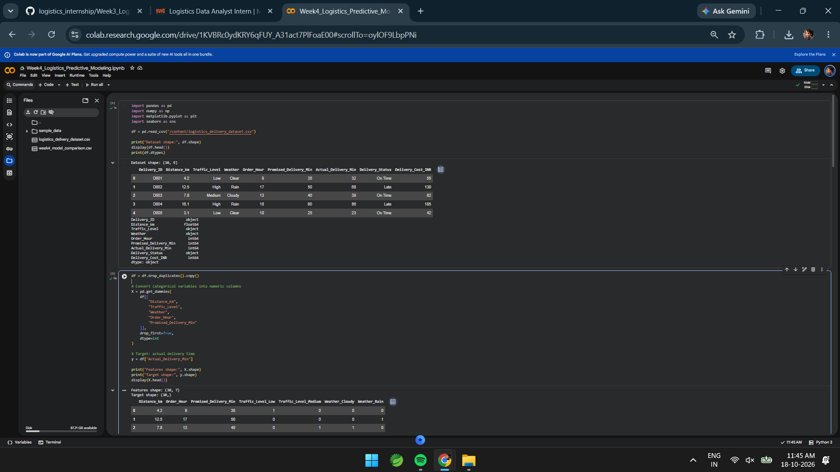
Figure 1. Dataset loaded in Google Colab, including its shape and sample records.
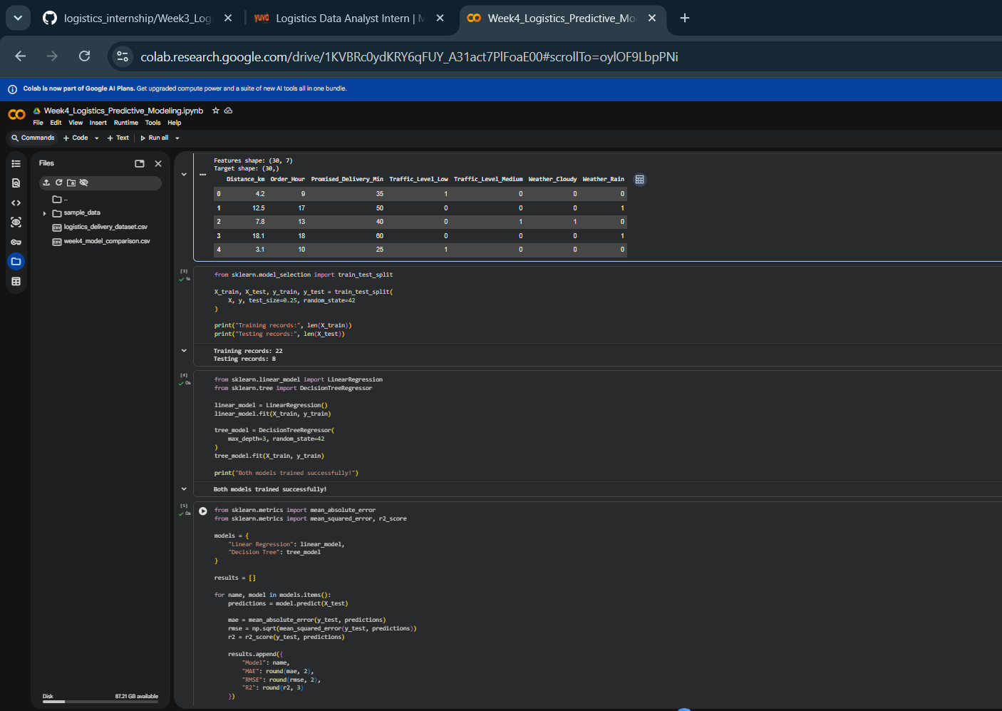
Figure 2. Train-test split, model training, and evaluation code.
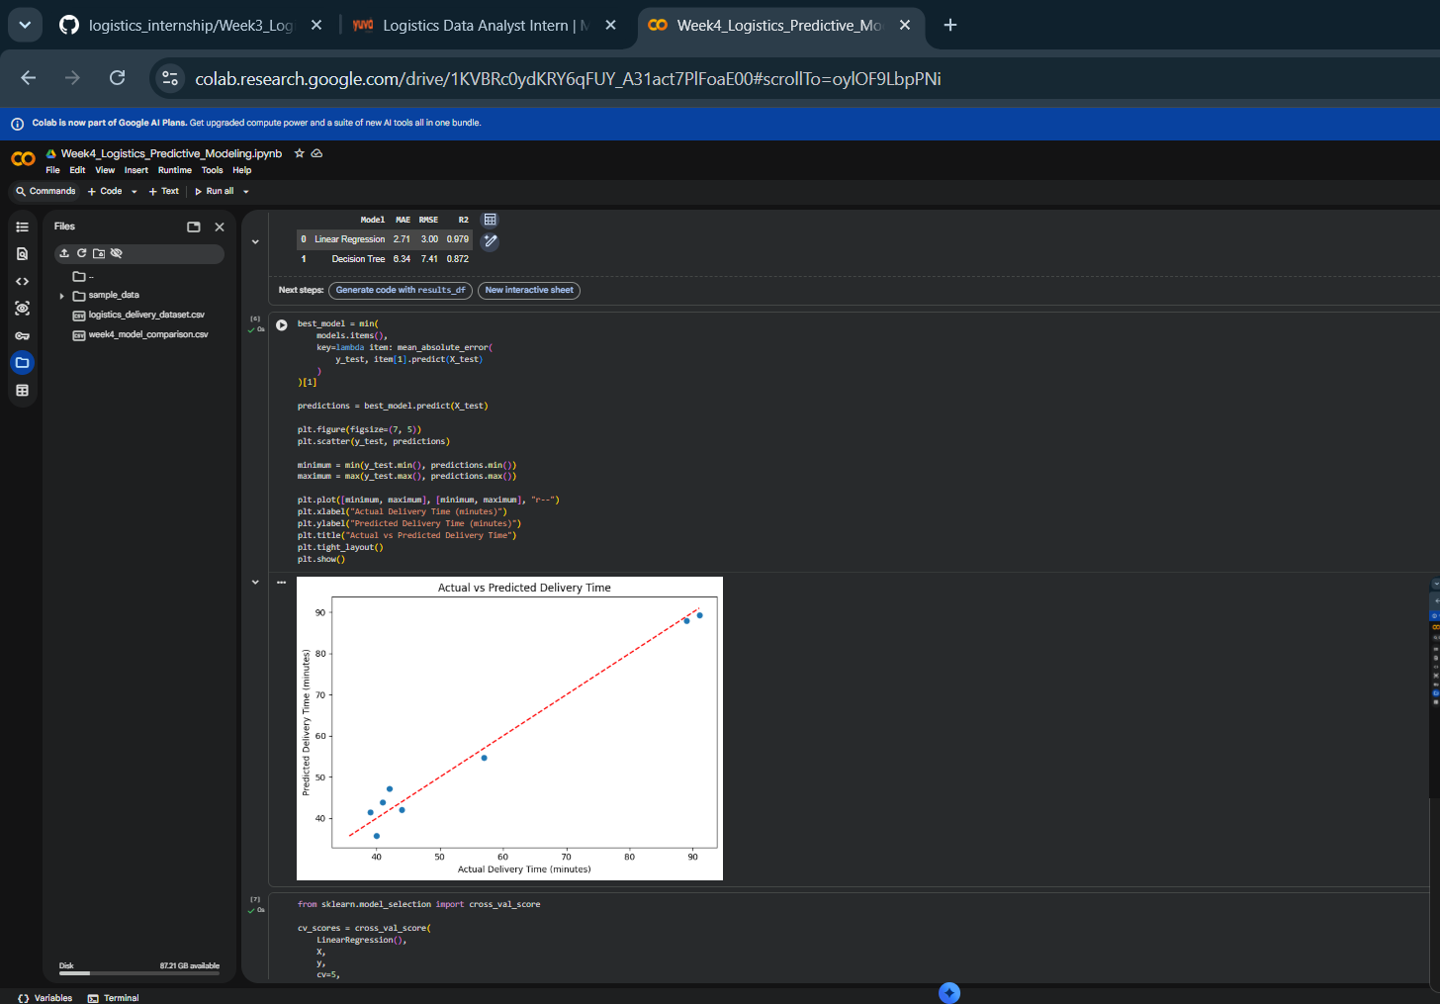
Figure 3. Actual-versus-predicted delivery time plot and cross-validation section.
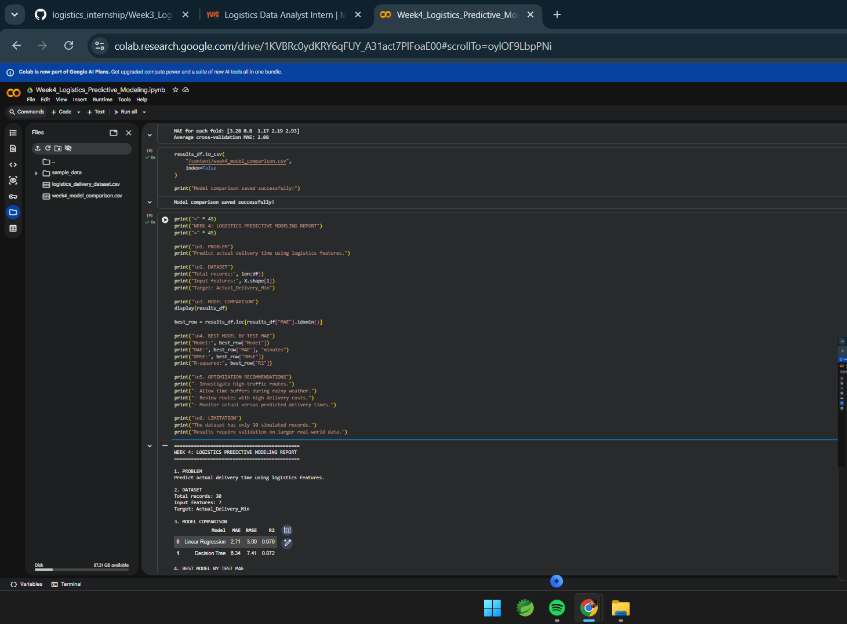
Figure 4. Model comparison table and reported cross-validation MAE.
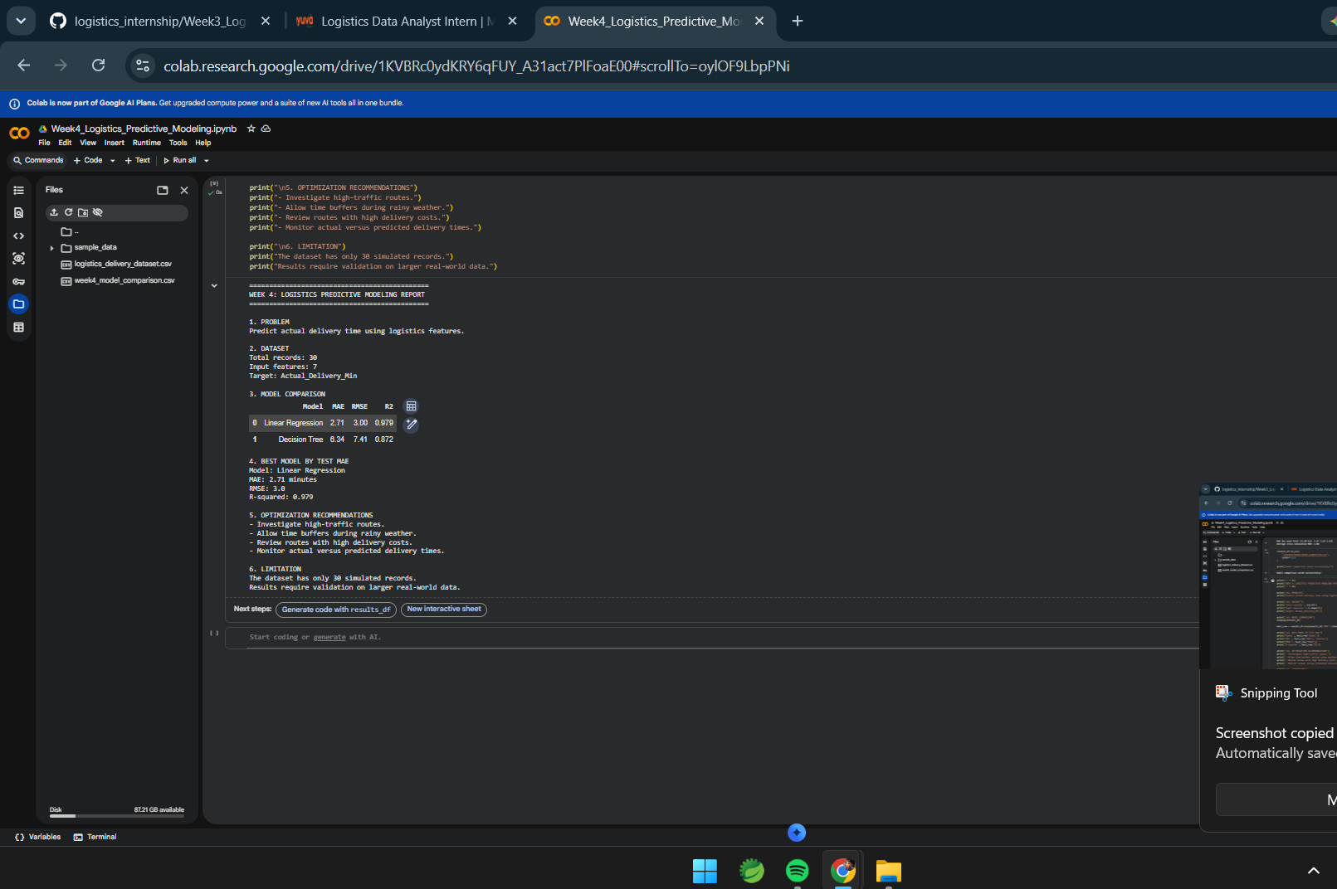
Figure 5. Final summary showing model metrics and optimization recommendations.

Appendix: Reproducibility Notes
The report records the results visible in the supplied screenshots. If the notebook is rerun with changed data, random seeds, feature columns, or library versions, the output may differ. Keep the notebook and CSV alongside the report for reproducibility.

