WEEK 2
DATA COLLECTION, CLEANING,
AND PREPROCESSING FOR LOGISTICS ANALYSIS
A practical Python and Google Colab workflow
Prepared by | Maithili Salaavdhi
Role | Logistics Data Analyst Intern
Tools | Python, Pandas, NumPy, Matplotlib, scikit-learn, Google Colab
Assignment deliverable: a documented preprocessing pipeline with code, observed outputs, screenshots, interpretation, and recommendations.

Executive Summary
This report documents a practical data-preprocessing pipeline for logistics analysis using Python in Google Colab. The workflow loads a delivery dataset, inspects its structure, checks missing values and duplicates, detects potential outliers using the interquartile range (IQR), demonstrates missing-value handling, standardizes text categories, creates Min-Max-normalized and standardized numerical features, validates the result, and exports the prepared CSV files. Screenshots from the executed notebook are included as evidence.
Dataset integrity note: the file used in the screenshots, logistics_delivery_dataset.csv, is a synthetic practice dataset containing 30 rows and 9 columns. It demonstrates the techniques but is not a public company dataset. If the evaluator strictly requires public-source data, repeat this workflow on the actual public dataset and report its real results; do not label these synthetic results as public-data findings.

Key observed results
- Dataset size: 30 records × 9 columns.
- Missing values: 0 across the displayed columns.
- Duplicate rows: 0 before cleaning and 0 after cleaning.
- Shape after duplicate removal: (30, 9).
- Actual delivery-time IQR check: Q1 = 32.5 minutes; Q3 = 70.25 minutes; IQR = 37.75 minutes; lower limit = −24.125; upper limit = 126.875; 0 potential outliers flagged.
- Min-Max scaling produced additional numerical columns between 0 and 1.
- StandardScaler produced additional standardized columns centred approximately around zero.

1. Objective
To simulate a repeatable data preparation workflow for logistics records and explain how quality checks, cleaning choices, and feature scaling improve the reliability of later analysis. The task covers dataset inspection, missing-value handling, duplicate removal, outlier screening, categorical consistency, normalization, standardization, validation, and export.

2. Business Context and Problem Statement
Logistics teams rely on accurate delivery records to assess service levels, cost, route performance, and delay risks. Missing values, duplicate shipments, inconsistent category labels, incorrect data types, and extreme values can distort KPIs and predictive models. Data must be checked and prepared before drawing conclusions.

Problem statement
How can delivery records be assessed and transformed into a consistent, analysis-ready dataset while preserving meaningful operational variation and documenting each preprocessing decision?

3. Dataset Collection Simulation
The dataset was loaded into Google Colab using pandas.read_csv(). The file contains 30 delivery records and 9 columns. It is a simulated dataset used for this practical demonstration.
Column | Description
Delivery_ID | Unique delivery identifier
Distance_km | Delivery distance in kilometres
Traffic_Level | Low, Medium, or High traffic
Weather | Recorded weather category
Order_Hour | Hour of order placement
Promised_Delivery_Min | Promised delivery duration in minutes
Actual_Delivery_Min | Observed delivery duration in minutes
Delivery_Status | On Time or Late
Delivery_Cost_INR | Delivery cost in Indian rupees

Public dataset reference
A possible public reference is the DataCo Smart Supply Chain dataset: https://www.kaggle.com/datasets/shashwatwork/dataco-smart-supply-chain-for-big-data-analysis. If public-source data is mandatory, download that dataset, record its source and access date, inspect its actual schema, and rerun the pipeline using its real column names. This report's numerical results are from the synthetic CSV shown in the screenshots.
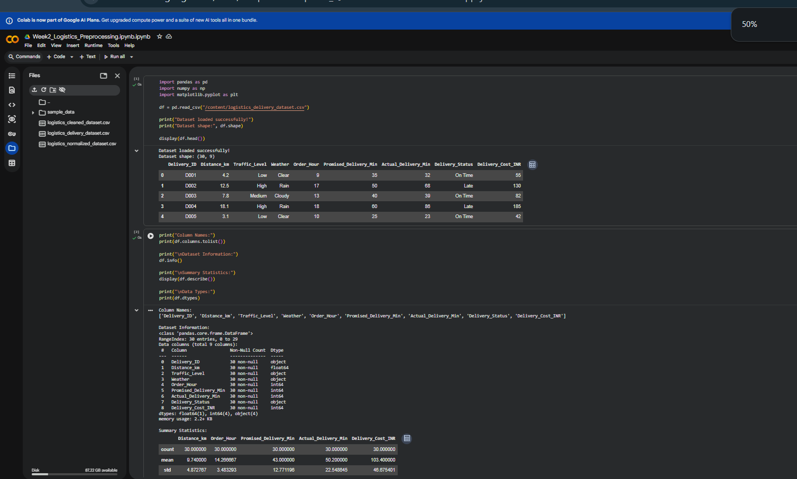
Figure 1. Dataset loaded successfully; the preview shows 30 records and 9 columns.
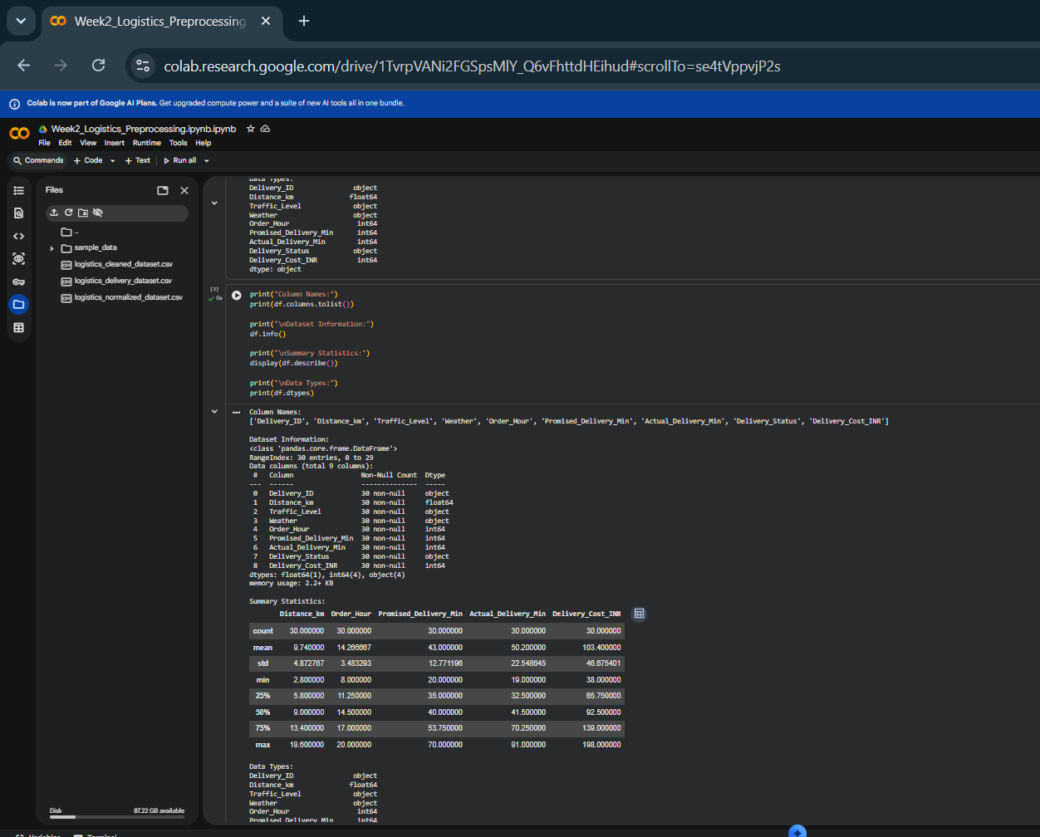
Figure 2. Dataset columns, data types, and descriptive statistics.

4. Methodology and Technical Explanation

4.1 Dataset inspection
The notebook uses head(), shape, columns, info(), dtypes, and describe() to inspect the first records, dimensions, field names, types, completeness, and numeric distributions. Inspection comes first so that cleaning choices are based on evidence rather than assumptions.

4.2 Missing-value detection and treatment
Missingness is measured with df.isnull().sum(). The screenshot shows zero missing values in all columns, so the current dataset did not require imputation. The notebook nevertheless demonstrates median imputation for numeric fields and mode imputation for categorical fields if missing values exist. These are common starting points, not universal rules: the field's meaning and reason for missingness should guide the final choice.
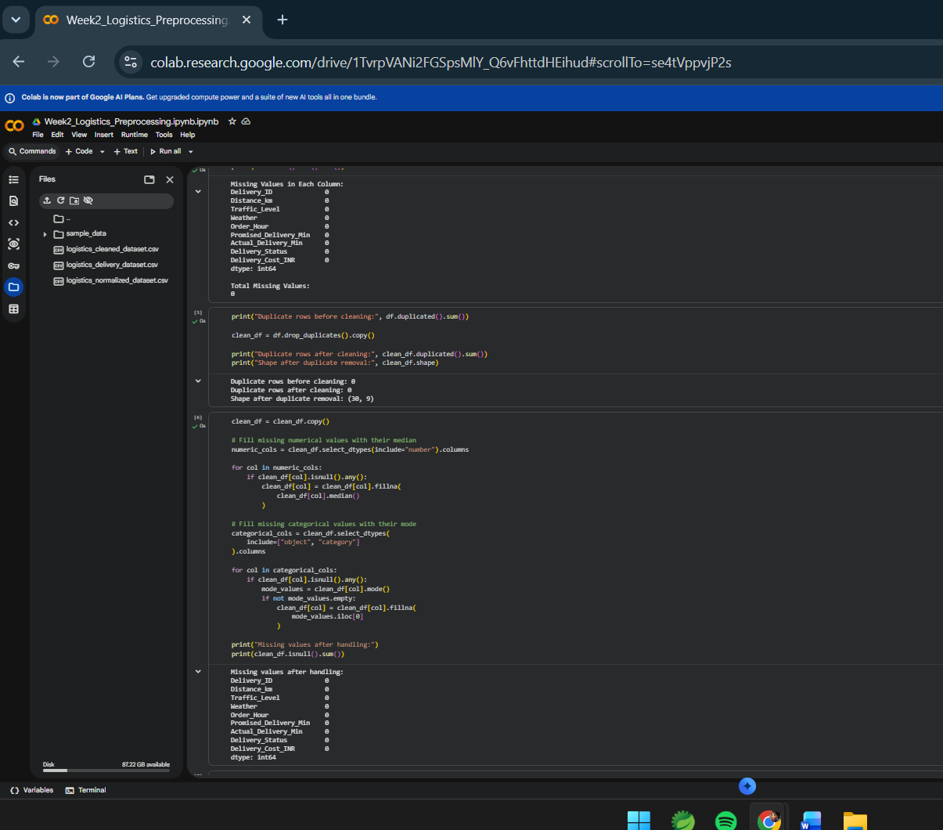
Figure 3. Missing-value checks show zero missing values in each column.

4.3 Duplicate records
The duplicated() method counts exact duplicate rows. drop_duplicates() creates a cleaned copy and helps prevent duplicate deliveries from inflating totals or KPIs. The dataset had zero duplicates, so its shape remained 30 × 9. In real systems, records sharing an ID but containing different values should be investigated rather than automatically deleted.
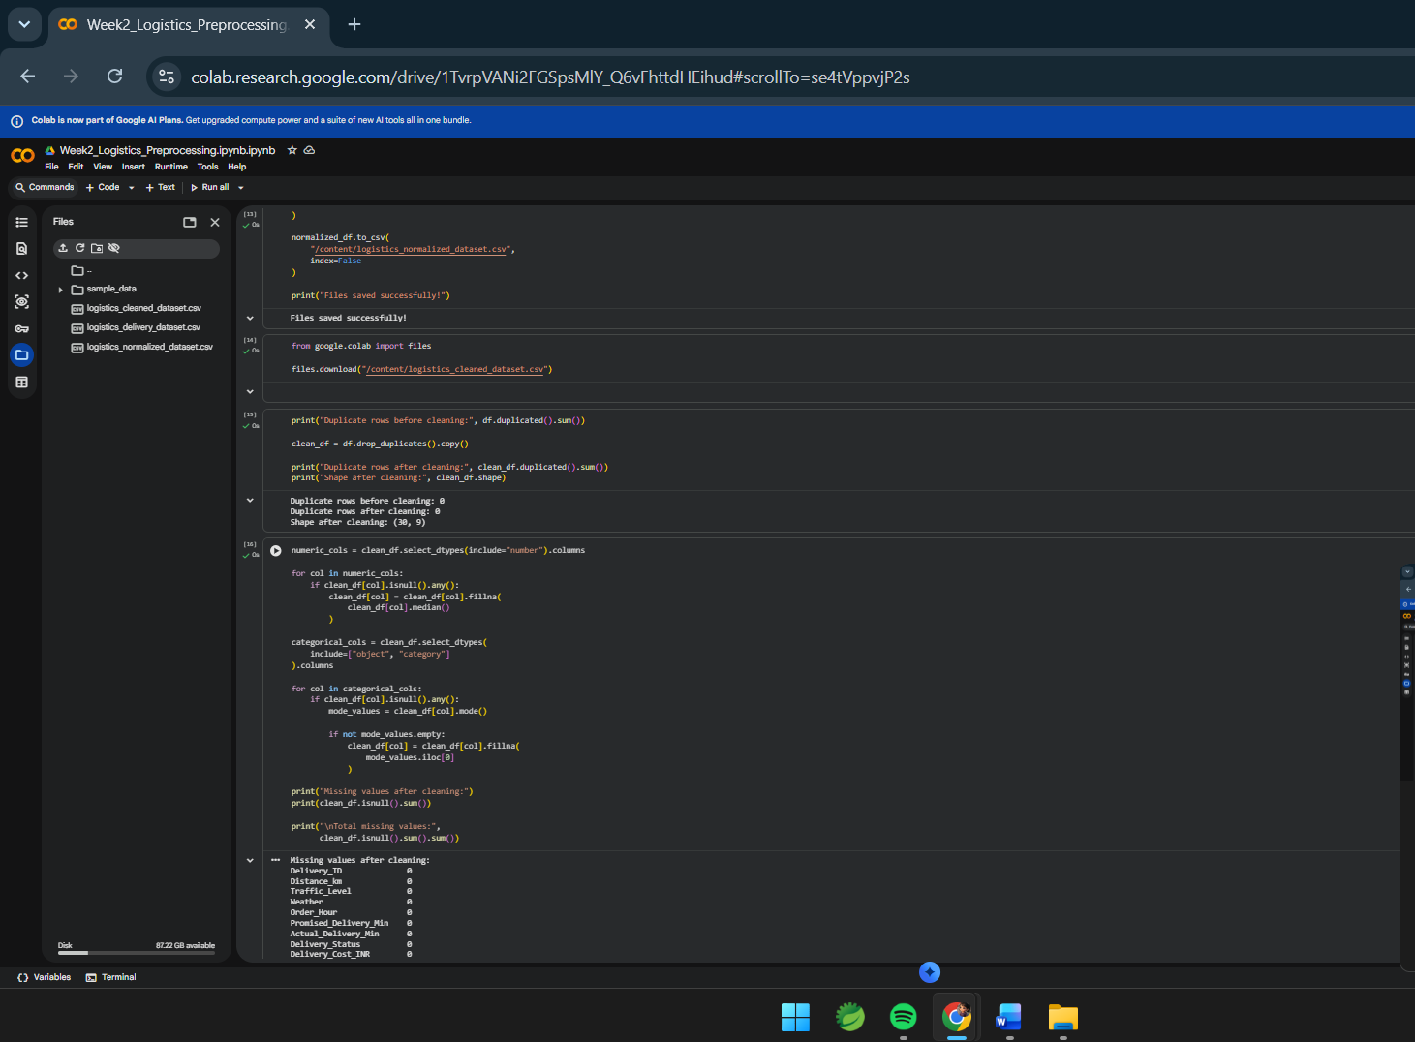
Figure 8. Category values and final data types.

4.4 Outlier detection using IQR
The interquartile range is IQR = Q3 − Q1. Potential outliers are values below Q1 − 1.5 × IQR or above Q3 + 1.5 × IQR. For Actual_Delivery_Min, the notebook reports Q1 = 32.5, Q3 = 70.25, IQR = 37.75, lower limit = −24.125 and upper limit = 126.875. Zero records were flagged. A negative statistical limit is possible even though negative delivery duration is not physically valid; domain rules should be checked separately.
Outliers must not be deleted automatically. An unusually long delivery may be genuine and indicate congestion, bad weather, route complexity, or a failed attempt. Investigate the record and correct or exclude it only when there is a defensible reason.
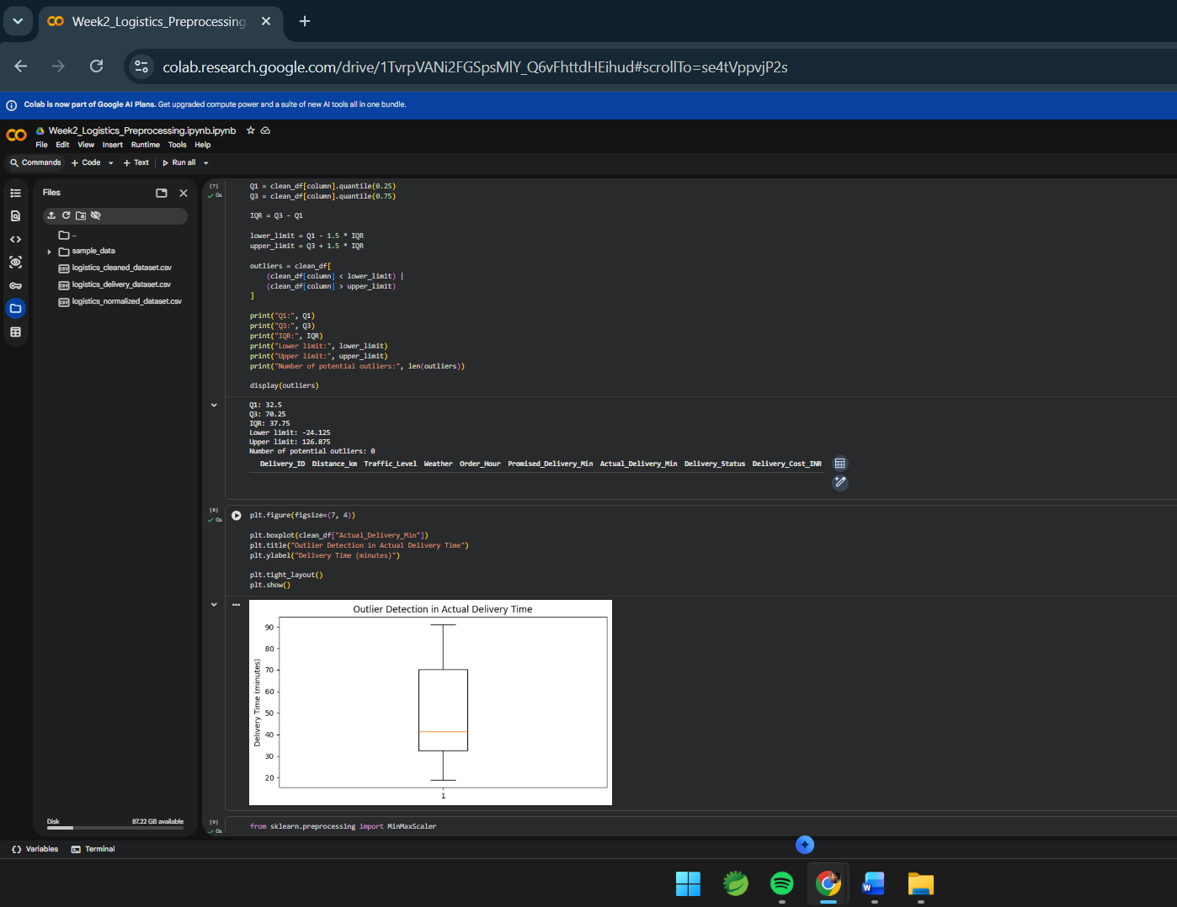
Figure 5. IQR outlier detection and boxplot for actual delivery time.

4.5 Category consistency and data types
Text columns are stripped of accidental leading/trailing spaces. Unique delivery-status and traffic categories and the final data types are printed for review. This reduces label inconsistency. A production pipeline should also validate allowed categories, numeric ranges, unique IDs, and relationships between promised and actual times.
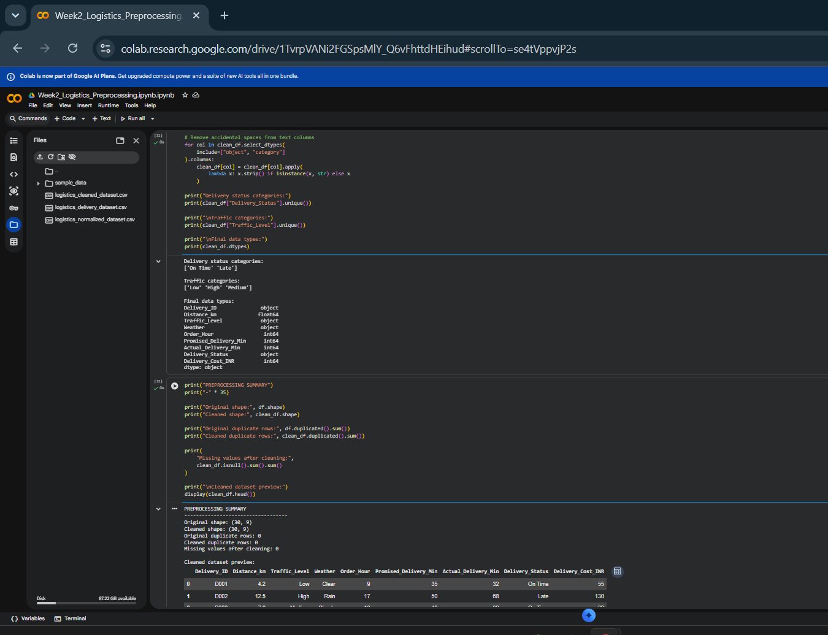
Figure 7. Standardized values alongside original numerical features.

4.6 Min-Max normalization
Min-Max scaling transforms a numeric value using (x − minimum) / (maximum − minimum), producing values between 0 and 1 for the observed training range. The notebook scales distance, promised time, actual time, and cost into new columns while retaining original values. Scaling can help scale-sensitive algorithms compare features with different units, but it is sensitive to extreme values and is not needed for every analysis.
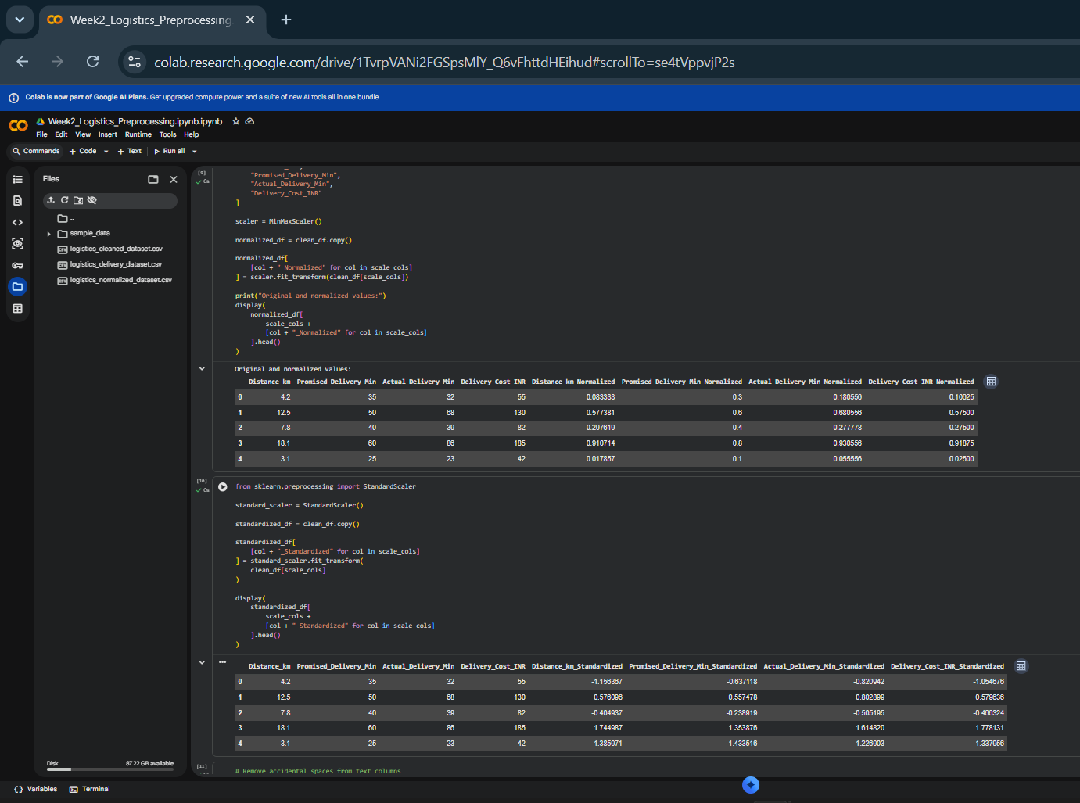
Figure 6. Min-Max-normalized features range from 0 to 1.

4.7 Standardization
StandardScaler transforms a value using (x − mean) / standard deviation. The output is centred approximately around zero and has unit variance on the data used to fit the scaler. The notebook creates separate standardized columns. In a predictive model, fit the scaler only on training data and apply the fitted scaler to validation/test data to avoid data leakage.
Figure 7. Standardized values alongside original numerical features.

5. Core Python Code
import pandas as pd
from sklearn.preprocessing import MinMaxScaler, StandardScaler
df = pd.read_csv("/content/logistics_delivery_dataset.csv")
print("Shape:", df.shape)
print("Missing values:\n", df.isnull().sum())
print("Duplicate rows:", df.duplicated().sum())
clean_df = df.drop_duplicates().copy()
for col in clean_df.select_dtypes(include="number").columns:
if clean_df[col].isnull().any():
clean_df[col] = clean_df[col].fillna(clean_df[col].median())
for col in clean_df.select_dtypes(include=["object", "category"]).columns:
if clean_df[col].isnull().any():
modes = clean_df[col].mode()
if not modes.empty:
clean_df[col] = clean_df[col].fillna(modes.iloc[0])
col = "Actual_Delivery_Min"
q1, q3 = clean_df[col].quantile([0.25, 0.75])
iqr = q3 - q1
lower, upper = q1 - 1.5 * iqr, q3 + 1.5 * iqr
outliers = clean_df[(clean_df[col] < lower) | (clean_df[col] > upper)]
scale_cols = ["Distance_km", "Promised_Delivery_Min",
"Actual_Delivery_Min", "Delivery_Cost_INR"]
normalized_df = clean_df.copy()
normalized_df[[c + "_Normalized" for c in scale_cols]] = (
MinMaxScaler().fit_transform(clean_df[scale_cols])
)
standardized_df = clean_df.copy()
standardized_df[[c + "_Standardized" for c in scale_cols]] = (
StandardScaler().fit_transform(clean_df[scale_cols])
)
clean_df.to_csv("/content/logistics_cleaned_dataset.csv", index=False)
normalized_df.to_csv("/content/logistics_normalized_dataset.csv", index=False)

6. Final Validation and Export
The final notebook cell checks the original and cleaned shapes, duplicate counts, missing-value total, and cleaned preview. The cleaned and normalized datasets are then saved as CSV files and downloaded from Colab.
- Original shape: 30 × 9.
- Cleaned shape: 30 × 9.
- Duplicate rows: 0 before and after cleaning.
- Missing values after cleaning: 0.
- Cleaned and normalized CSV files saved successfully.
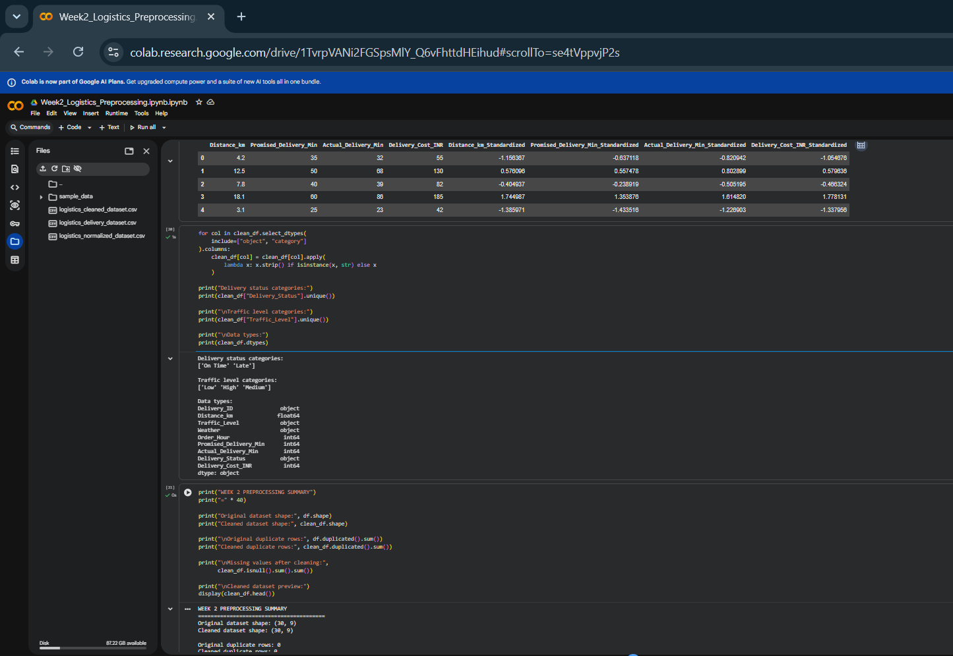
Figure 9. Final preprocessing summary confirms unchanged shape and zero missing values/duplicates.
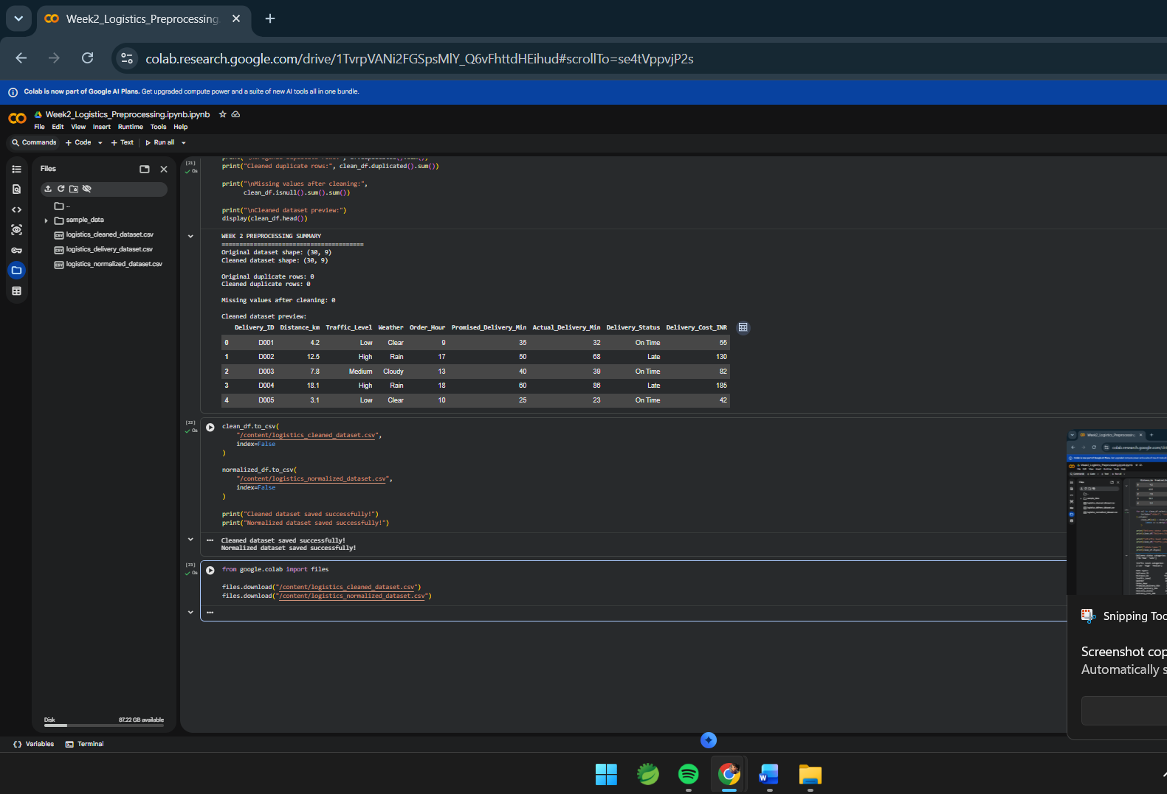
Figure 10. Cleaned and normalized CSV files saved in Google Colab.

7. Impact on Logistics Analysis
- Accurate counts: removing true duplicates prevents shipments being counted more than once.
- Reliable metrics: missing-value checks reveal incomplete records that may bias KPIs.
- Comparable features: scaling can help algorithms use distance, time, and cost features fairly.
- Operational context: reviewing outliers preserves genuine delay events that may require action.
- Reproducibility: separate original, cleaned, and scaled outputs make transformations traceable.

8. Limitations and Improvements
- The dataset is synthetic and small; findings should not be generalized to a real logistics network.
- There were no missing values, duplicates, or IQR-flagged delivery-time outliers, so the methods were demonstrated without changing those records.
- Median/mode imputation should be justified field by field in real data.
- For machine learning, fit preprocessing transformations on the training set only.
- If public data is required, include the actual source, access date, schema, and results obtained by rerunning the pipeline on that dataset.

9. Reflection
Preprocessing is not merely a technical step; it influences whether logistics insights can be trusted. In this practice file, checks found zero missing values and duplicates, and the IQR rule did not flag delivery-time outliers. Separate normalized and standardized versions were produced without overwriting original measurements. In a real operation, statistical checks should be combined with business rules, and each change should be recorded and justified.

10. Conclusion
The Week 2 workflow demonstrates dataset inspection, missing-value checks and handling logic, duplicate checks, IQR outlier screening, category cleanup, Min-Max normalization, standardization, final validation, and CSV export in Google Colab. Screenshots provide evidence of execution. The main next step, if required by the evaluator, is to run the same workflow on an actual public logistics dataset and document its genuine results.

References
- Pandas documentation: https://pandas.pydata.org/docs/
- scikit-learn preprocessing: https://scikit-learn.org/stable/modules/preprocessing.html
- Matplotlib documentation: https://matplotlib.org/stable/
- Google Colaboratory: https://colab.research.google.com/
- DataCo Smart Supply Chain dataset reference: https://www.kaggle.com/datasets/shashwatwork/dataco-smart-supply-chain-for-big-data-analysis

