WEEK 3 REPORT
ADVANCED DATA ANALYSIS AND VISUALIZATION IN LOGISTICS

Prepared by: Maithili Salavadhi
Role: Logistics Data Analyst Intern
Tools: Python, Pandas, NumPy, Matplotlib, Seaborn, Google Colab

1. Introduction
Logistics analytics uses delivery, distance, traffic, weather, and cost information to understand operational performance. This Week 3 task explores a hypothetical logistics dataset with Python, calculates summary statistics, creates visualizations, and converts the results into practical recommendations.
Important note: The analysis uses a small, simulated practice dataset containing 30 deliveries. The findings demonstrate the analysis process and should not be treated as conclusions about a real logistics company.

2. Objectives
- Explore the structure and quality of a logistics dataset.
- Calculate central tendency, variability, and correlations.
- Visualize delivery status, delivery times, traffic, weather, distance, and cost.
- Interpret the charts to identify possible operational bottlenecks.
- Provide Python code and recommendations in a professional report.

3. Dataset Description
The dataset contains 30 delivery records and 9 columns:
Column | Meaning | Data type / role
Delivery_ID | Unique identifier for each delivery | Categorical identifier
Distance_km | Delivery distance in kilometres | Numeric
Traffic_Level | Traffic level (Low, Medium, High) | Categorical
Weather | Weather condition (Clear, Cloudy, Rain) | Categorical
Order_Hour | Hour at which the order was placed | Numeric
Promised_Delivery_Min | Expected delivery time in minutes | Numeric
Actual_Delivery_Min | Observed delivery time in minutes | Numeric
Delivery_Status | On Time or Late | Categorical outcome
Delivery_Cost_INR | Delivery cost in Indian rupees | Numeric

4. Methodology
- Data loading: Read the CSV file into a Pandas DataFrame and inspect the first rows, shape, columns, and data types.
- Descriptive statistics: Use mean, median, standard deviation, minimum, maximum, and quartiles to understand numeric variables.
- Correlation analysis: Calculate Pearson correlations among numeric columns. Correlation shows association, not causation.
- Delivery status analysis: Count on-time and late deliveries and compare their proportions.
- Weather analysis: Group deliveries by weather and calculate average delivery time.
- Traffic and delay analysis: Calculate delay as the positive difference between actual and promised time, then compare by traffic level.
- Visualization: Use bar charts for categories, histograms for distributions, boxplots for spread/outliers, scatter plots for relationships, and a heatmap for correlations.
- Recommendations: Use the results to suggest areas for further investigation, while acknowledging the small simulated sample.

5. Key Findings
- Delivery performance: 14 of 30 deliveries were on time and 16 were late. The on-time rate was 46.67%, while the late rate was 53.33%.
- Delivery duration: Average actual delivery time was 50.20 minutes, compared with an average promised time of 43.00 minutes.
- Average delay: The notebook reports an average delay of 8.30 minutes. This value depends on the notebook's delay calculation; if delay is clipped at zero, early deliveries count as zero delay.
- Delivery cost: Average delivery cost was ₹103.40, and average delivery distance was 9.74 km.
- Weather pattern: Average delivery time was 35.67 minutes in clear weather, 50.00 minutes in cloudy weather, and 69.78 minutes in rainy weather. Rainy deliveries took longer on average in this sample.
- Traffic pattern: The notebook's delay-by-traffic summary reports the highest average delay for High traffic (20.90 minutes), compared with Low (0.60 minutes) and Medium (3.40 minutes).
- Correlation: The screenshot shows strong positive associations among distance, promised delivery time, actual delivery time, and cost. In a 30-row simulated dataset, these relationships should be treated as exploratory rather than definitive.

6. Visualizations and Interpretation
The screenshots below document the executed Colab analysis. Some screenshots show multiple outputs in a single capture; captions explain the relevant evidence.
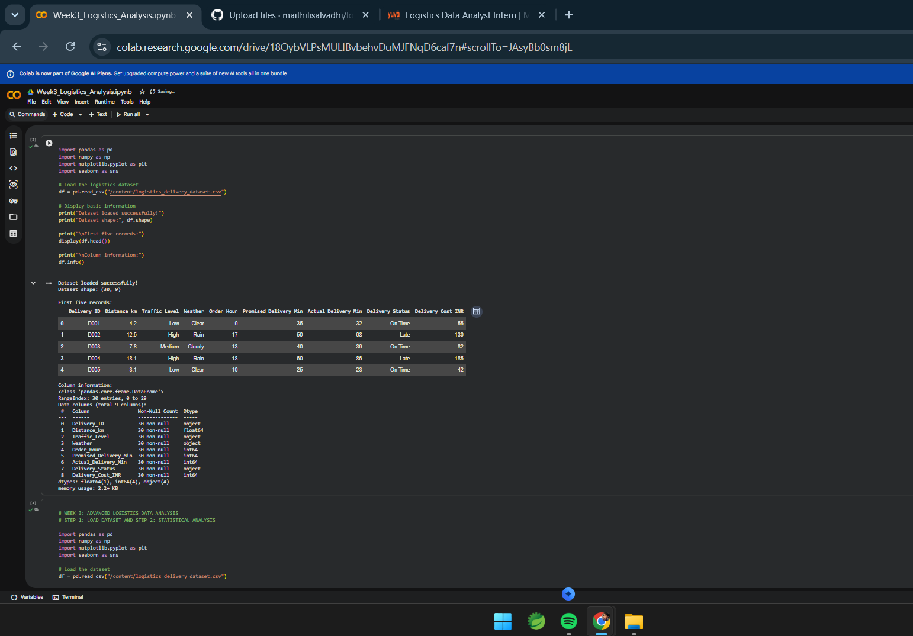
Figure 1. Dataset preview and schema: 30 rows, 9 columns, with numeric and categorical variables.

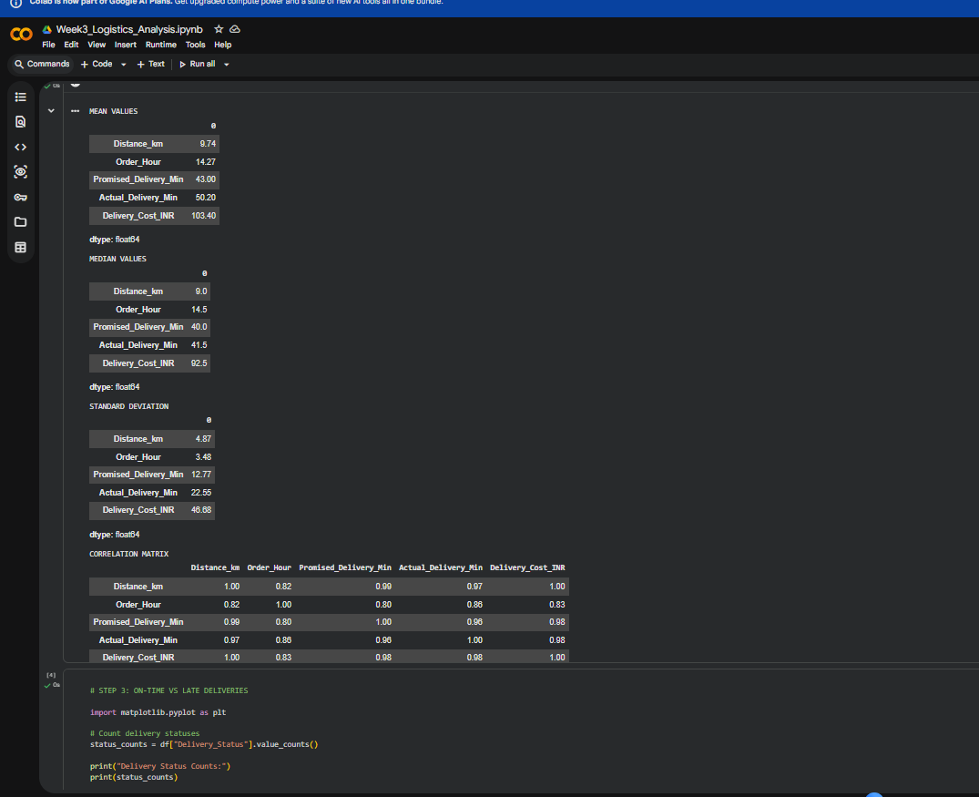
Figure 2. Descriptive statistics and correlation matrix: means, medians, standard deviations, and positive correlations among several numeric variables.

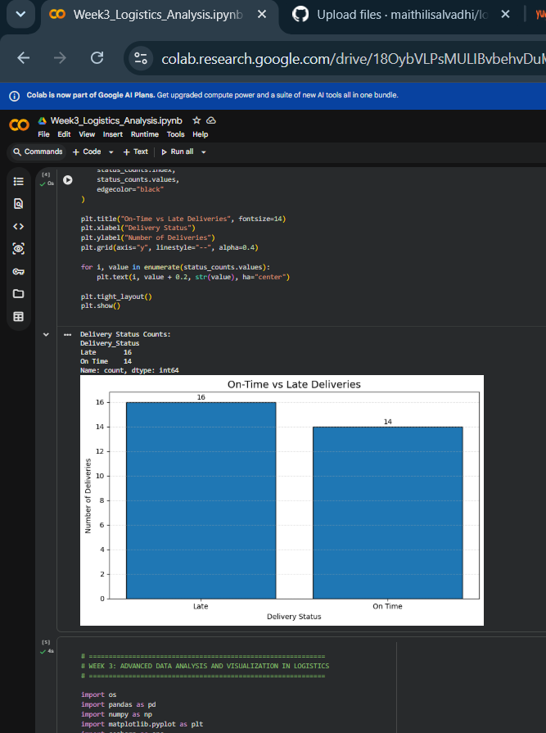
Figure 3. Delivery-status bar chart: 16 late deliveries versus 14 on-time deliveries.

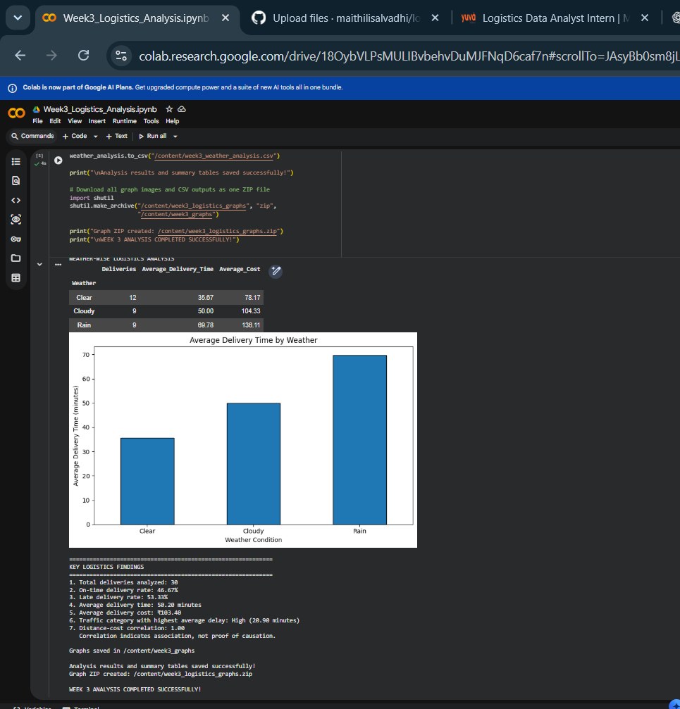
Figure 4. Weather analysis: average delivery time rises from clear to cloudy to rainy conditions in the simulated sample.

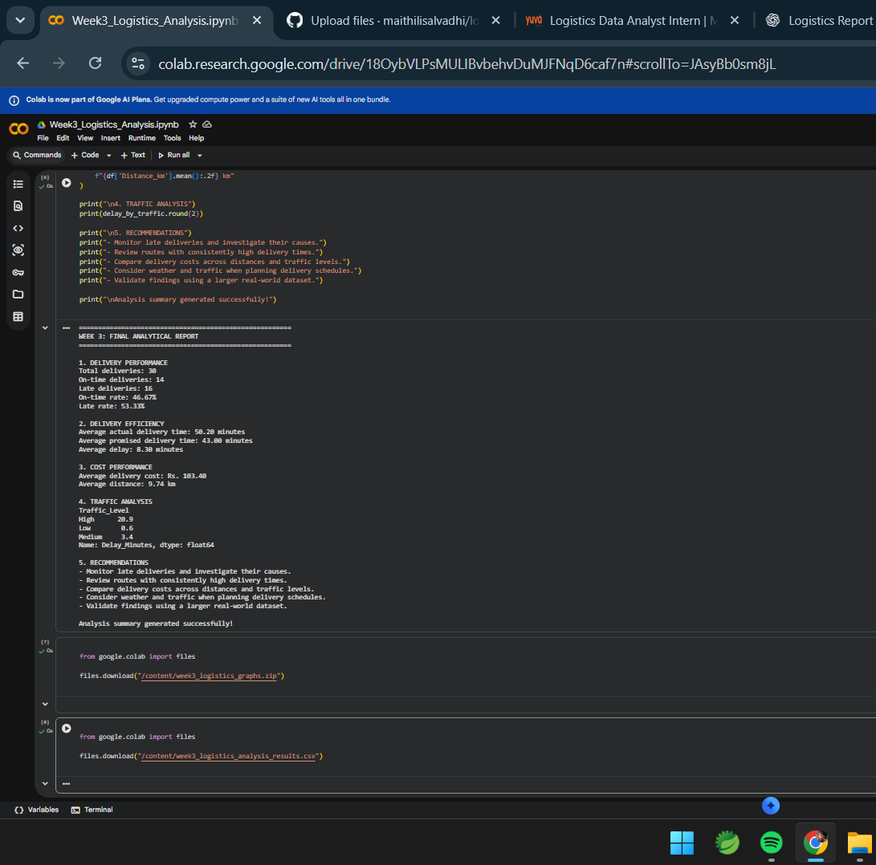
Figure 5. Final analytical summary and recommendations generated in Colab.

7. Python Code Excerpts

Load and inspect the dataset
import pandas as pd
import numpy as np
import matplotlib.pyplot as plt
import seaborn as sns
df = pd.read_csv("/content/logistics_delivery_dataset.csv")
print("Dataset shape:", df.shape)
display(df.head())
df.info()

Descriptive statistics and correlations
numeric_df = df.select_dtypes(include="number")
print("Mean values")
print(numeric_df.mean())
print("Median values")
print(numeric_df.median())
print("Standard deviation")
print(numeric_df.std())
print("Correlation matrix")
display(numeric_df.corr())

Compare delivery status
status_counts = df["Delivery_Status"].value_counts()
status_counts.plot(kind="bar", edgecolor="black")
plt.title("On-Time vs Late Deliveries")
plt.xlabel("Delivery Status")
plt.ylabel("Number of Deliveries")
plt.tight_layout()
plt.show()

Analyze weather and delivery time
weather_summary = df.groupby("Weather").agg(
Deliveries=("Delivery_ID", "count"),
Average_Delivery_Time=("Actual_Delivery_Min", "mean"),
Average_Cost=("Delivery_Cost_INR", "mean")
)
print(weather_summary)
weather_summary["Average_Delivery_Time"].plot(kind="bar")
plt.title("Average Delivery Time by Weather")
plt.ylabel("Minutes")
plt.tight_layout()
plt.show()

Calculate delay by traffic
df["Delay_Minutes"] = (
df["Actual_Delivery_Min"] - df["Promised_Delivery_Min"]
).clip(lower=0)
delay_by_traffic = df.groupby("Traffic_Level")["Delay_Minutes"].mean()
print(delay_by_traffic)

Correlation heatmap
plt.figure(figsize=(8, 5))
sns.heatmap(numeric_df.corr(), annot=True, cmap="coolwarm", fmt=".2f")
plt.title("Correlation Heatmap")
plt.tight_layout()
plt.show()

8. Recommendations
- Investigate the 16 late deliveries to identify recurring causes rather than assuming one factor explains every delay.
- Plan additional time buffers for rainy conditions, based on the observed pattern in this simulated sample.
- Review routes and dispatch schedules during high-traffic periods.
- Compare cost per kilometre as well as total delivery cost to make distance-based comparisons fairer.
- Repeat the analysis on a larger, real operational dataset before making business or staffing decisions.
- Track additional variables where available, such as vehicle type, route, package volume, driver shift, and warehouse processing time.

9. Limitations
The dataset is small and hypothetical, with only 30 records. Patterns can be affected by how the sample was constructed. Correlation does not prove causation, and the analysis does not control for all possible factors. The findings are suitable for demonstrating Python EDA techniques, not for forecasting actual company performance.

10. Conclusion
This task demonstrated a complete exploratory analysis workflow for logistics data: loading and inspecting the dataset, calculating summary statistics, examining correlations, visualizing delivery status and weather patterns, and preparing recommendations. The sample showed a higher number of late deliveries than on-time deliveries, longer average delivery times in rainy weather, and higher reported delay during high traffic. A larger real-world dataset is required to validate these findings and support operational decisions.

Appendix: Files Generated in Colab
The notebook indicates that graph images and CSV summary outputs were saved under /content/week3_logistics_graphs and that a ZIP archive was created at /content/week3_logistics_graphs.zip. Download these files from Colab if you need to submit them separately.

