WEEK 6 FINAL INTEGRATION, EVALUATION AND REPORTING
Supermarket Sales Analysis Using Tableau
Virtual Internship – Final Report
Student: S. Maithili
Roll No.: 2400032693
Dataset: Supermarket Sales Dataset
Tool: Tableau
Project Duration: Weeks 1–6

Final Integration of Exploratory Analysis, Dashboard Design, Interactive Storytelling,
Advanced Visualization, Performance Optimization, and Evaluation.

Table of Contents
The headings below provide the structure of the final integrated report. In Word, the table can be refreshed if a dynamic Table of Contents is required.
1. Executive Summary
2. Project Introduction
3. Dataset Overview and Data Preparation
4. Week 1 – Exploratory Data Analysis and Insight Generation
5. Week 2 – Dashboard Planning and Design Strategy
6. Week 3 – Interactive Data Storytelling
7. Week 4 – Advanced Chart Techniques and Calculation Insights
8. Week 5 – Performance Optimization and Interactive Feature Enhancement
9. Final Integration and Evaluation
10. Overall Learning Journey
11. Lessons Learned
12. Challenges Faced and How They Were Addressed
13. Recommendations for Future Enhancements
14. Future Scope
15. Professional Reflection
16. Final Conclusion
Appendix A – Evidence and Screenshots
Appendix B – Final Deliverables

1. Executive Summary
This six-week Tableau project developed a complete analytical workflow using the Supermarket Sales Dataset. The work progressed from exploratory data analysis in Week 1 to dashboard planning in Week 2, interactive data storytelling in Week 3, advanced visualizations and calculations in Week 4, and performance optimization plus interactive feature enhancement in Week 5. Week 6 integrates these outcomes into a single evaluation of the overall process.
The project used transaction-level sales information to investigate sales trends, country performance, product performance, quantity patterns, geographic distribution, price relationships, and sales–quantity relationships. A calculated Total Sales measure was created from Price × Quantity. The final work also introduced Sales Category, Sales per Unit, Percent of Total, a Select Metric parameter, and a simplified Country dropdown. The resulting workflow demonstrates not only chart creation but also planning, storytelling, interaction design, performance awareness, testing, and reflection.

Executive Outcome
- Built a structured EDA foundation from the Supermarket Sales Dataset.
- Planned a business-oriented dashboard with target users, KPIs, questions, layout, interaction, and accessibility considerations.
- Converted individual analyses into an eight-point Tableau data story.
- Added advanced dual-axis and heat-map analysis with calculated fields and table calculations.
- Added a parameter for switching between Total Sales and Quantity.
- Simplified the Country filter into a Single Value dropdown and validated it using Germany.
- Documented the complete learning progression and identified practical future enhancements.

2. Project Introduction
The purpose of the project was to develop practical Tableau visualization skills through a continuous Supermarket Sales analysis. Each week built on the previous week rather than creating an unrelated output. This made the project a progression from understanding data to communicating insights and finally improving the usability and performance of the analytical product.
Stage | Focus | Main Outcome
Week 1 | Exploration | EDA worksheets and initial business insights
Week 2 | Planning | Dashboard blueprint, KPIs, audience, layout and interaction strategy
Week 3 | Storytelling | Interactive eight-point Tableau data story
Week 4 | Advanced analysis | Calculated fields, dual-axis chart, heat map, Percent of Total and dashboard
Week 5 | Optimization | Metric parameter, Country dropdown and performance/usability improvements
Week 6 | Integration | Final evaluation, reflection, recommendations and professional report

3. Dataset Overview and Data Preparation
The project used the Supermarket Sales Dataset, containing approximately 541,910 transaction records and eight original fields. The dataset represents sales transactions and includes product, date, quantity, price, customer and country information.
Field | Type | Purpose
Invoice | Numerical | Transaction/invoice identification
Stock Code | Categorical | Product identification
Description | Categorical | Product name
Quantity | Numerical | Number of items sold
Invoice Date | Date | Transaction date
Price | Numerical | Product price
Customer ID | Numerical | Customer identification
Country | Categorical | Customer/location country
Total Sales | Calculated Measure | Sales value, Price × Quantity

Core Calculation
Total Sales = [Price] * [Quantity]

4. Week 1 – Exploratory Data Analysis and Insight Generation
Week 1 established the analytical foundation. The objective was to understand the dataset, identify sales trends, compare countries and products, study relationships between variables, and generate business insights through Tableau visualizations.

4.1 Visualizations Created
- Sales by Country
- Monthly Sales Trend
- Top 10 Products by Sales
- Quantity Sold by Country
- Sales by Country Map
- Price Distribution
- Price vs Quantity
- Sales vs Quantity

4.2 Key Findings
- Sales vary considerably across countries.
- The United Kingdom is the dominant market in terms of transaction quantity.
- Sales show noticeable monthly fluctuations.
- A small group of products contributes significantly to sales.
- Product prices are concentrated in lower ranges, with unusually high values appearing as potential outliers.
- Quantity and sales show a relationship that can help understand product demand.
- Geographic analysis can help identify important markets for business expansion.

4.3 EDA Evidence
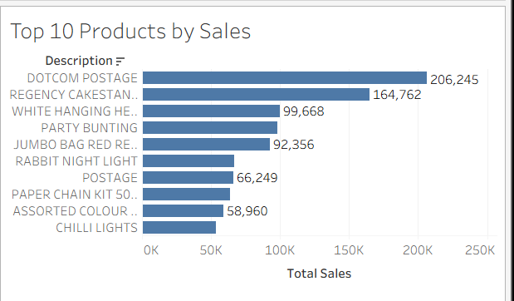
Week 1 evidence – Tableau visualization 1.
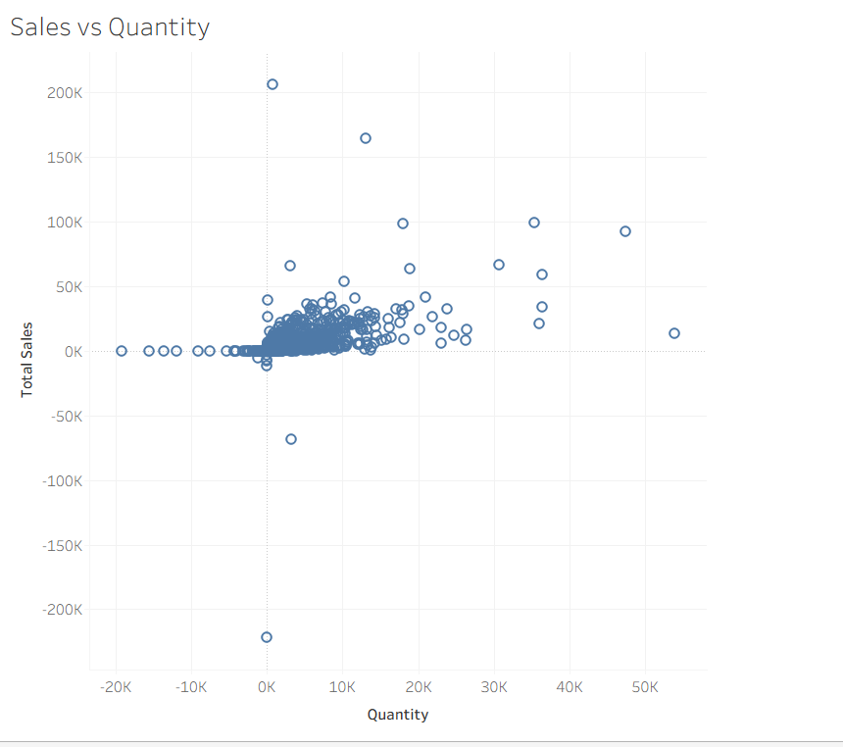
Week 1 evidence – Tableau visualization 2.
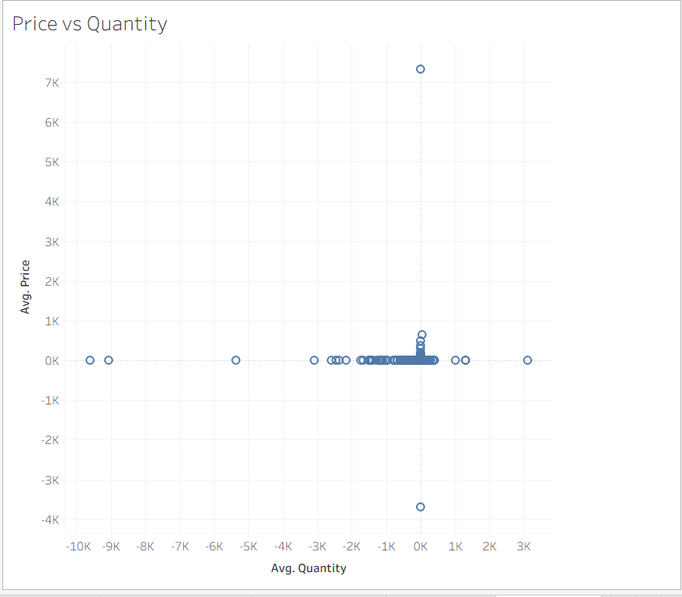
Week 1 evidence – Tableau visualization 3.
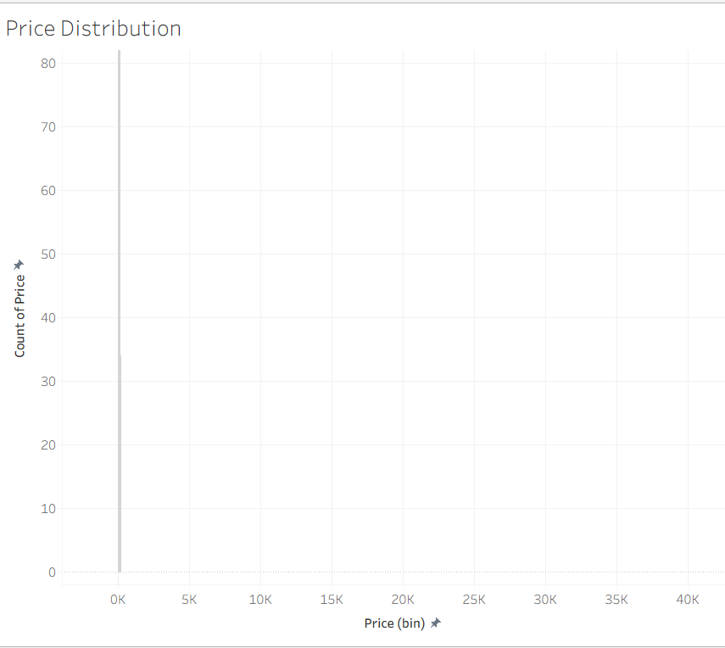
Week 1 evidence – Tableau visualization 4.
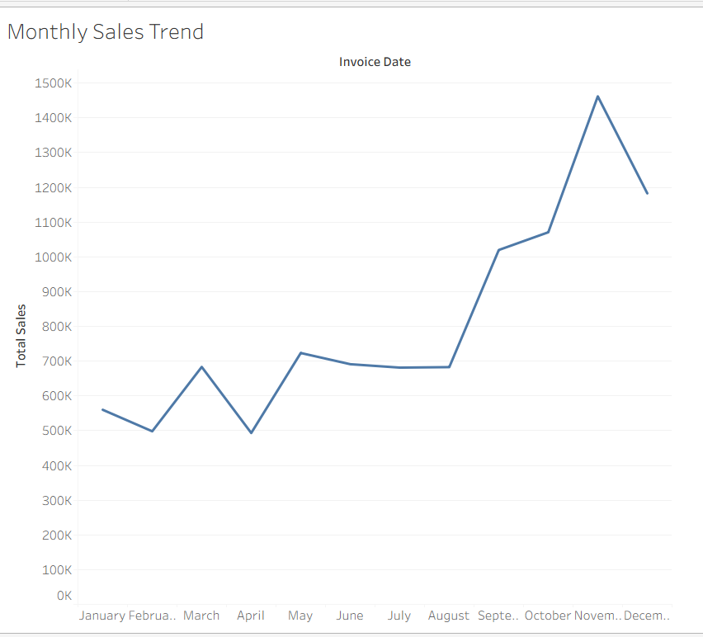
Week 1 evidence – Tableau visualization 5.
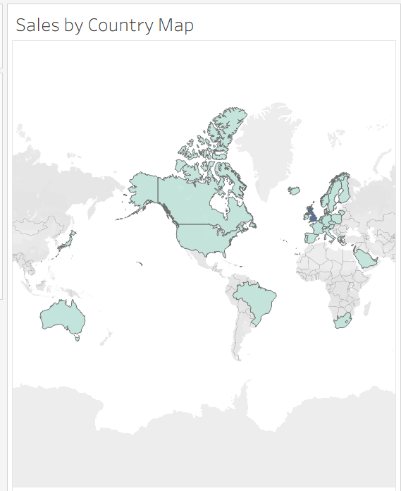
Week 1 evidence – Tableau visualization 6.

5. Week 2 – Dashboard Planning and Design Strategy
Week 2 translated the EDA findings into a dashboard blueprint. The planning covered target audience, business questions, KPIs, selected visualizations, layout hierarchy, color strategy, interactions, user flow, user experience, accessibility, and future implementation.

5.1 Target Audience
Audience | Purpose
Sales Manager | Monitor sales performance and identify high-performing countries and products.
Business Manager | Understand overall business trends and support decision-making.
Marketing Team | Identify popular products and markets for promotional strategies.
Business Analyst | Explore trends, relationships, outliers and detailed patterns.
Management | Get a high-level overview through KPIs and visuals.

5.2 Business Questions
- Which countries generate the highest sales?
- How do sales change from month to month?
- Which products generate the highest sales?
- Which countries have the highest quantity sold?
- How are sales geographically distributed?
- What is the distribution of product prices?
- Is there a relationship between price and quantity?
- Is there a relationship between quantity sold and total sales?

5.3 KPIs and Visual Design
KPI / Visual | Purpose
Total Sales | Overall sales value
Total Quantity | Total units sold
Number of Countries | Geographic coverage
Top-Selling Product | Highest sales product
Monthly Sales | Time-based performance
Country Chart / Map | Geographic comparison
Top 10 Products | Product contribution
Scatter Plots | Relationship analysis

5.4 Interaction and UX Strategy
- Country filter for market-focused analysis.
- Invoice Date filter for time-based analysis.
- Product selection where applicable.
- Map selections and linked views.
- Tooltips for additional details.
- Clean layout, clear titles, consistent spacing and readable labels.
- Accessibility through contrast, readable fonts and reduced dependence on color alone.

6. Week 3 – Interactive Data Storytelling
Week 3 transformed the analytical work into a logical Tableau Story. The story moved from an overall performance view to monthly trends, country performance, products, geography, relationships, and final insights. This sequence helped users progress from overview to detailed investigation.

6.1 Story Flow
Overall Sales Performance → Monthly Sales Trends → Country-wise Sales Performance → Top-Selling Products → Geographic Sales Distribution → Price and Quantity Relationship → Sales and Quantity Relationship → Key Business Insights

6.2 Eight Story Points
Story Point | Role
1. Overall Sales Performance | Introduces the overall supermarket sales situation.
2. Monthly Sales Trends | Shows how sales change across months.
3. Country-wise Sales Performance | Compares sales between countries.
4. Top-Selling Products | Identifies products with the highest sales.
5. Geographic Sales Distribution | Shows where sales are concentrated geographically.
6. Price and Quantity Relationship | Explores the relationship between price and quantity.
7. Sales and Quantity Relationship | Explores the association between quantity and total sales.
8. Key Business Insights | Summarizes the main observations.

6.3 Storytelling Evaluation
The story format was effective because each visualization had a specific narrative role. The first point established context, the middle points progressively deepened the analysis, and the final point summarized the insights. Visible filters, selections and tooltips supported user exploration.
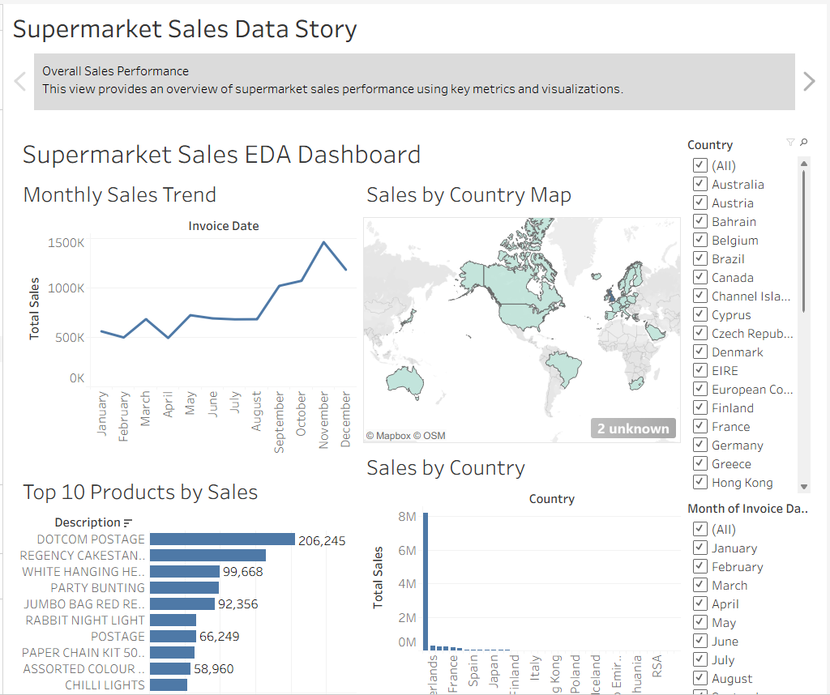
Week 3 evidence – interactive story visual 1.
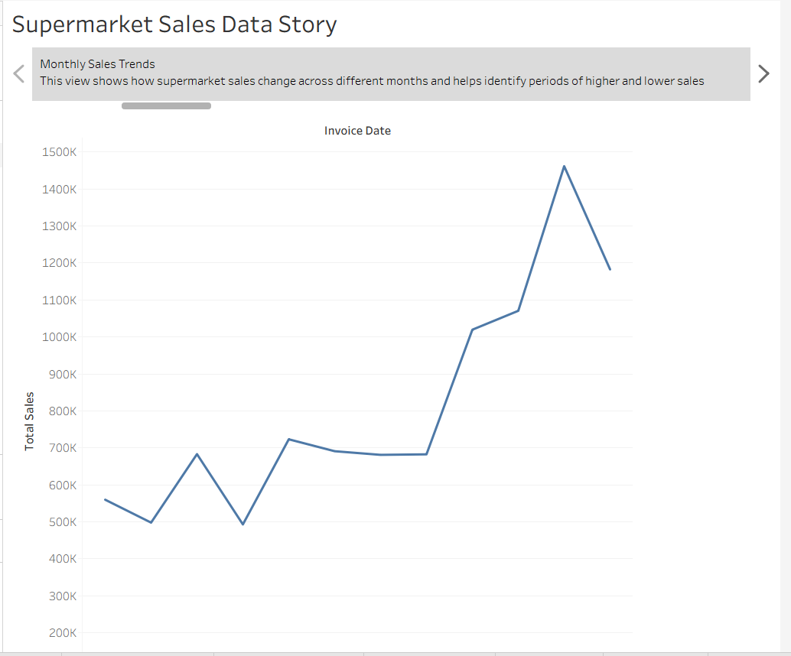
Week 3 evidence – interactive story visual 2.
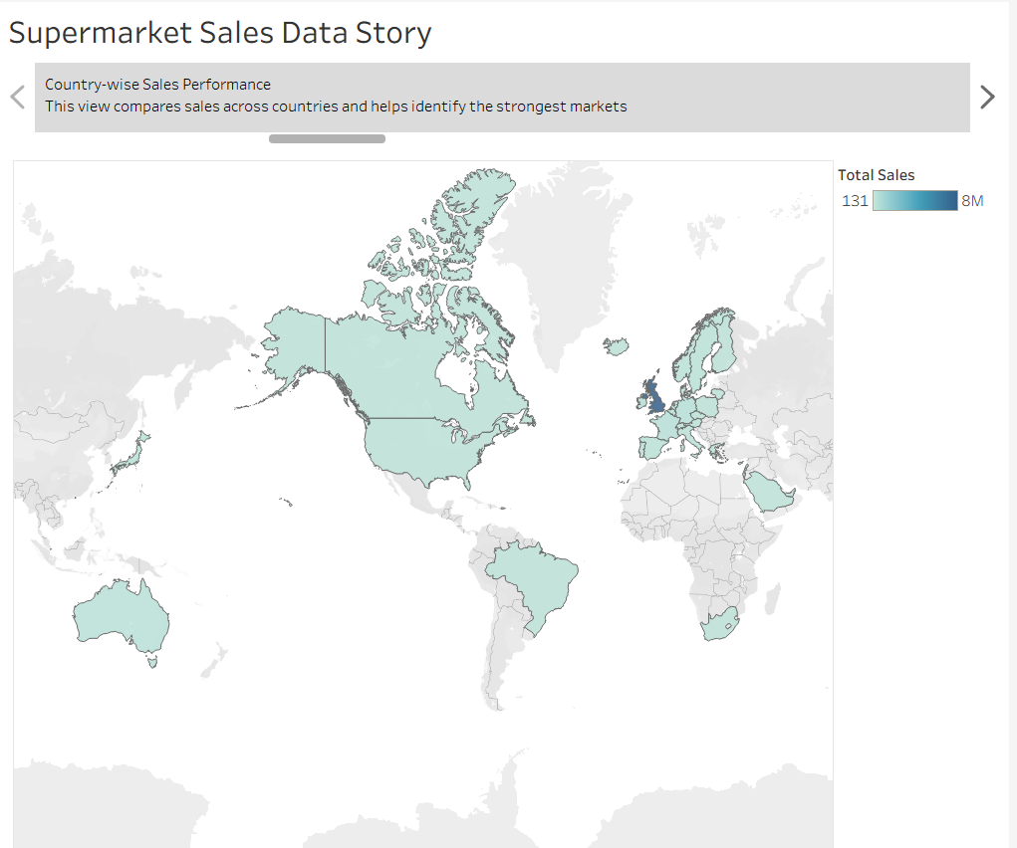
Week 3 evidence – interactive story visual 3.
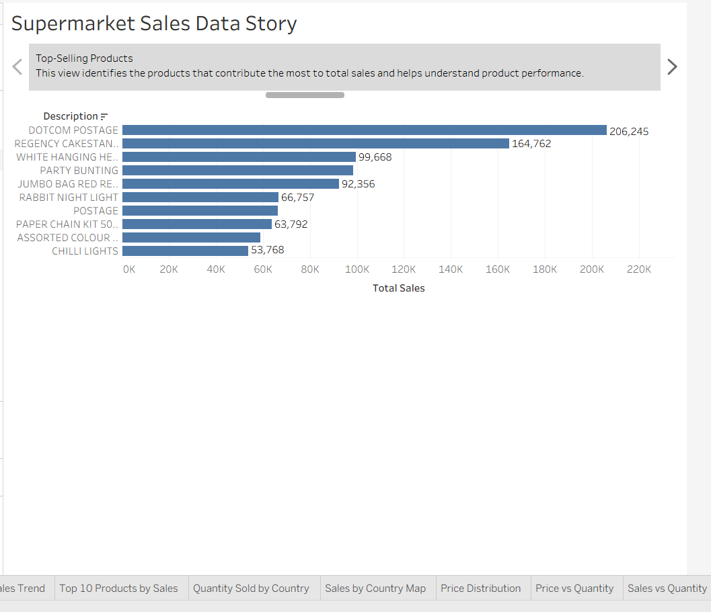
Week 3 evidence – interactive story visual 4.
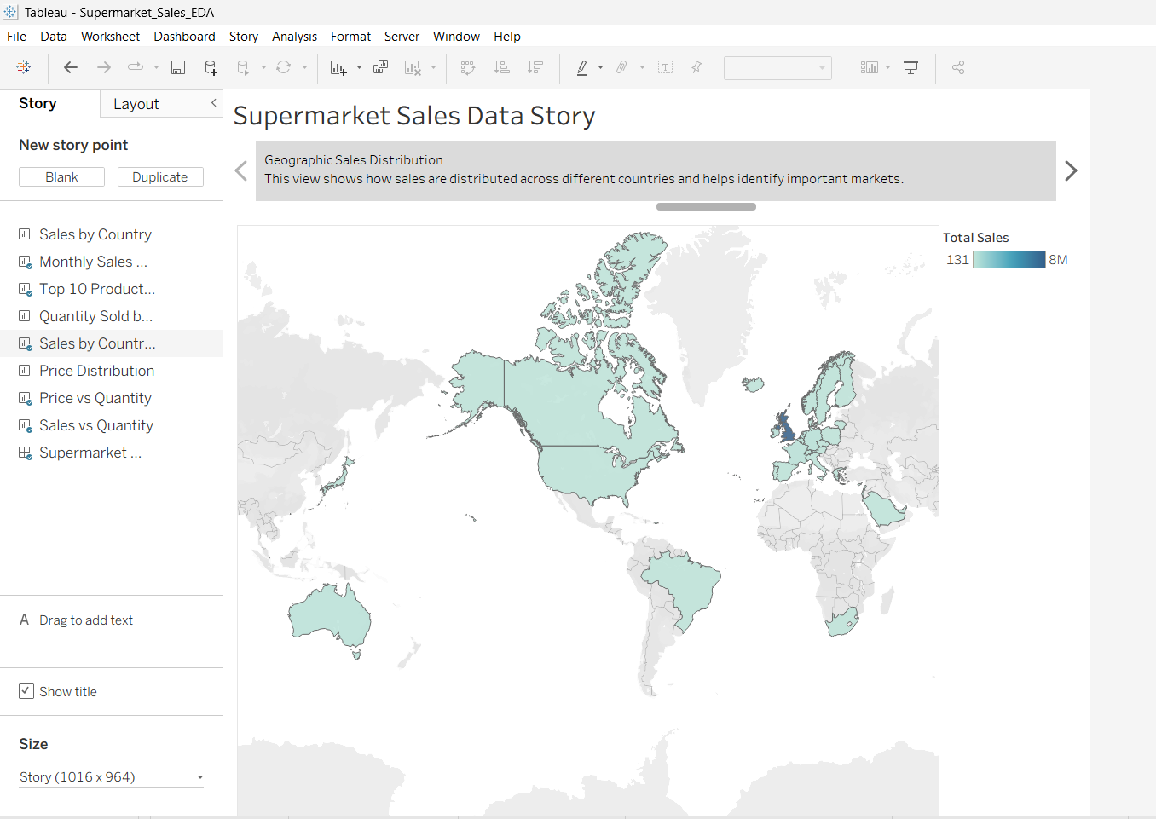
Week 3 evidence – interactive story visual 5.
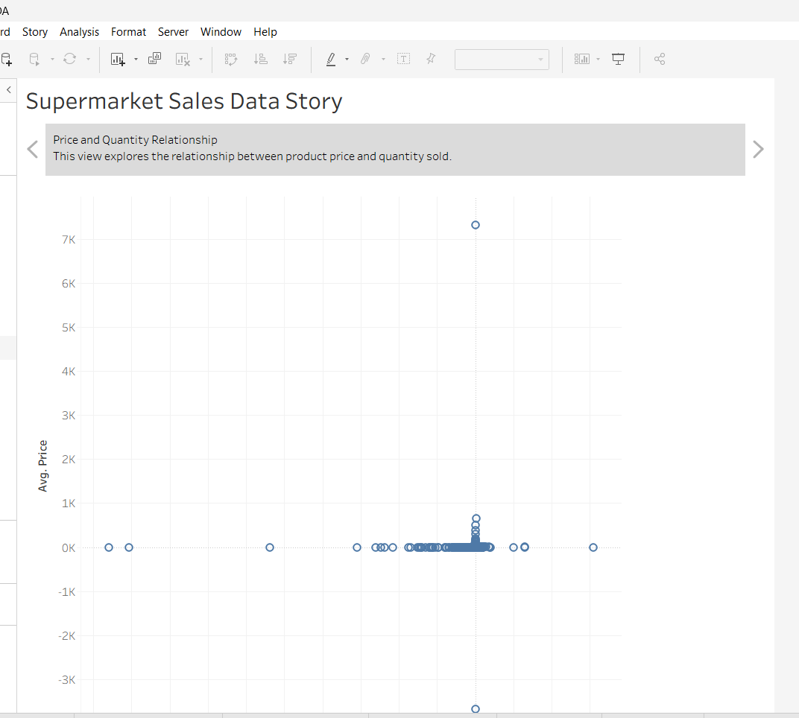
Week 3 evidence – interactive story visual 6.
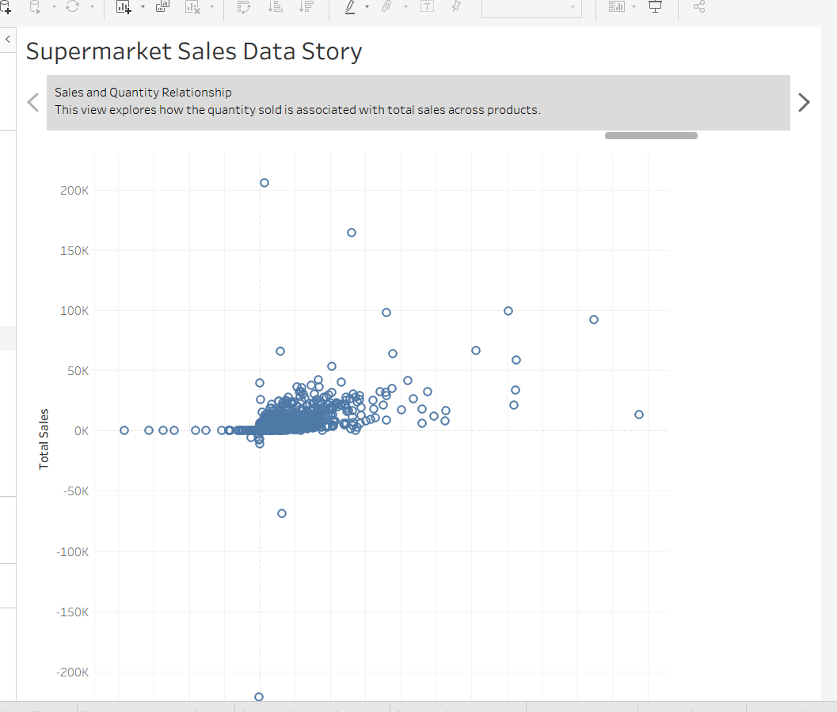
Week 3 evidence – interactive story visual 7.
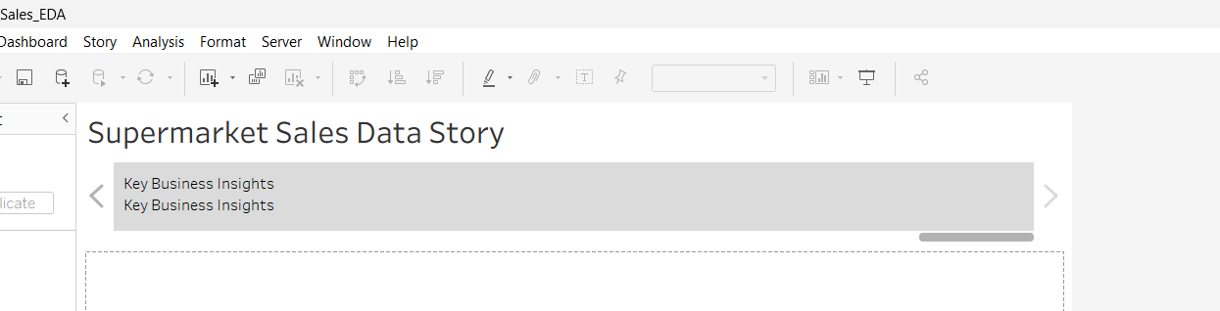
Week 3 evidence – interactive story visual 8.

7. Week 4 – Advanced Chart Techniques and Calculation Insights
Week 4 increased the technical depth of the project through calculated fields, table calculations and advanced visualizations.

7.1 Calculated Fields
Calculated Field | Formula / Method | Purpose
Total Sales | [Price] * [Quantity] | Calculates sales value for each transaction.
Sales Category | IF [Total Sales] >= 1000 THEN "High Sales" ELSEIF [Total Sales] >= 500 THEN "Medium Sales" ELSE "Low Sales" END | Classifies transactions into High, Medium and Low sales groups.
Sales per Unit | IF [Quantity] <> 0 THEN [Total Sales] / [Quantity] ELSE 0 END | Measures sales value associated with each unit.
Percent of Total | Quick Table Calculation → Percent of Total | Shows relative contribution.

7.2 Advanced Visualizations
- Dual-axis chart comparing monthly Total Sales and Quantity.
- Country-by-month Sales Heat Map using color intensity.
- Percent of Total applied to the heat map.
- Advanced Sales Analysis dashboard combining the dual-axis chart, heat map and Top 10 Products.

7.3 Interactive Country Filter
A Country filter was added so users could focus the analysis on a selected market. The filter reduced the need to inspect every country manually and connected user selection with the dashboard analysis.
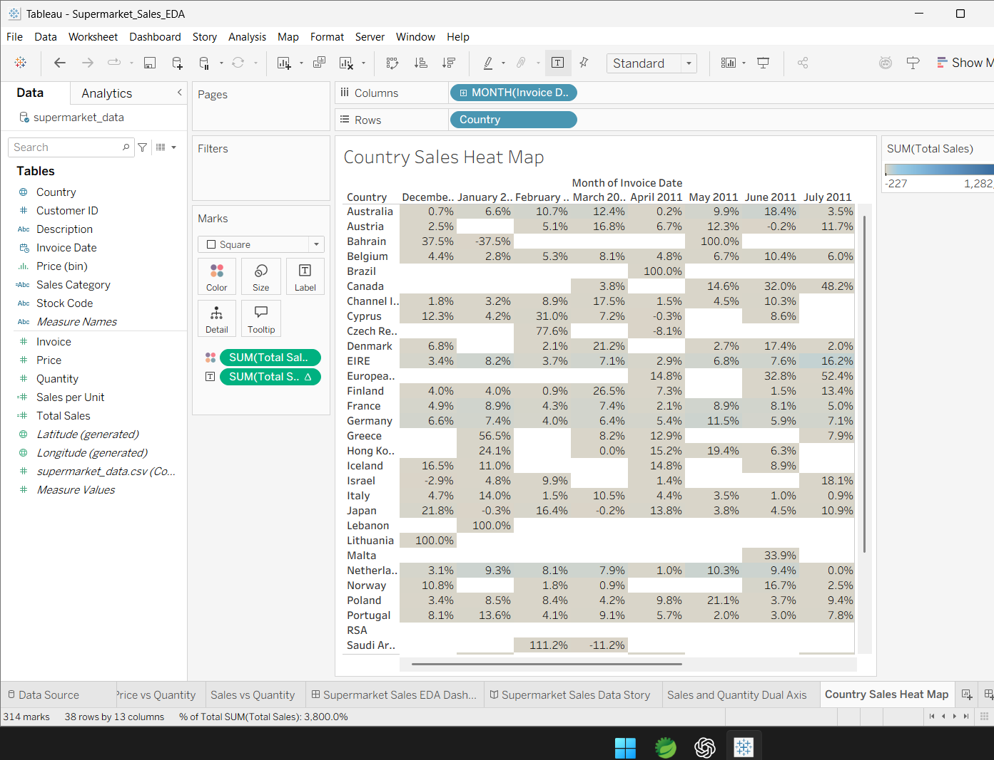
Week 4 evidence – advanced analysis visual 1.
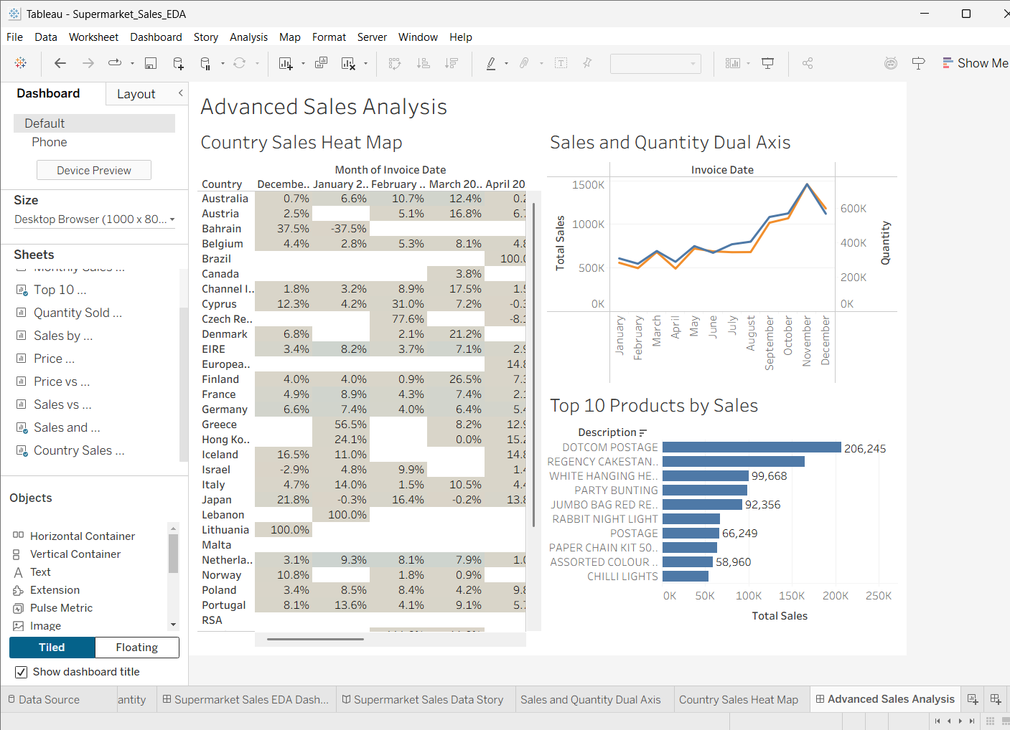
Week 4 evidence – advanced analysis visual 2.
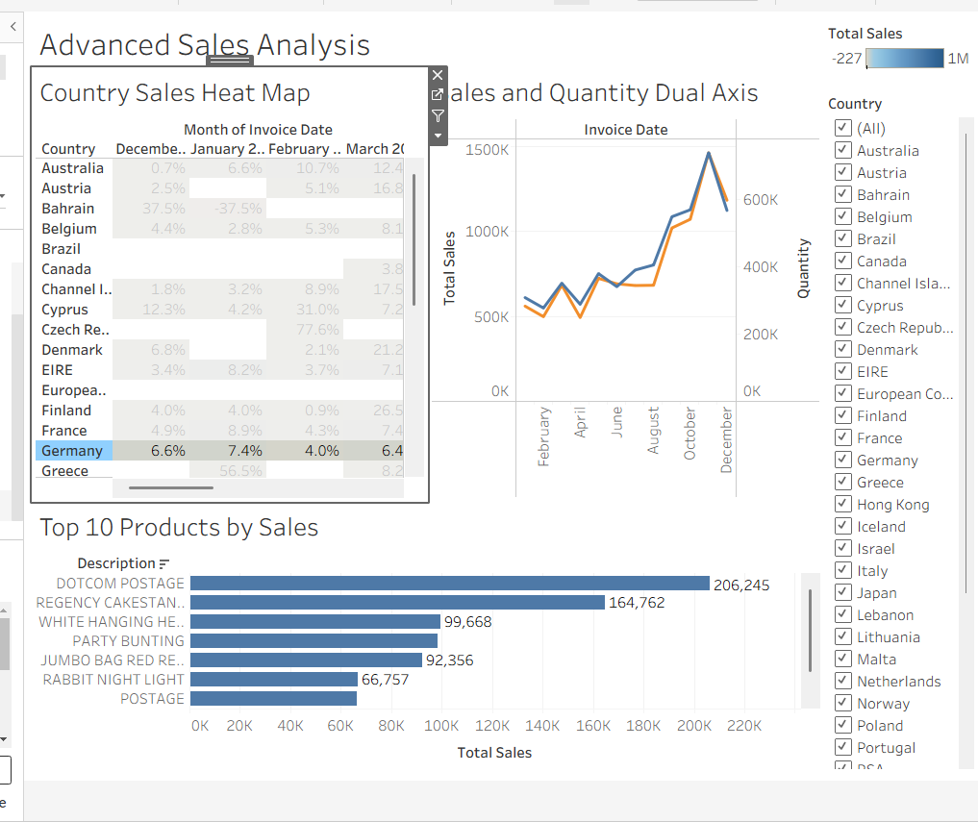
Week 4 evidence – advanced analysis visual 3.

8. Week 5 – Performance Optimization and Interactive Feature Enhancement
Week 5 focused on practical dashboard optimization and enhanced interaction. The work considered the impact of approximately 541,910 transaction records, multiple visualizations, calculations and filters.

8.1 Bottlenecks Considered
- Large transaction-level row count.
- Multiple dashboard worksheets increasing rendering/query work.
- Calculations applied across many records.
- Long Country filter list consuming space.
- Detailed visualizations producing many marks.

8.2 Optimization Strategies
- Use Tableau extracts where appropriate.
- Keep only necessary worksheets on a dashboard.
- Avoid unnecessary high-cardinality filters.
- Reduce unnecessary marks and labels.
- Keep calculations simple and purposeful.
- Use concise tooltips.
- Test dashboard interactions after changes.

8.3 Select Metric Parameter
A String parameter named Select Metric was created with two values: Total Sales and Quantity.
CASE [Select Metric]
WHEN "Total Sales" THEN [Total Sales]
WHEN "Quantity" THEN [Quantity]
END
The Selected Metric field was placed on Rows. Changing the parameter dynamically changes the measure shown in the visualization.

8.4 Country Filter Enhancement
The original long checkbox list was changed to a Single Value dropdown. The dashboard was tested by selecting Germany, and the Country Sales Heat Map updated successfully.
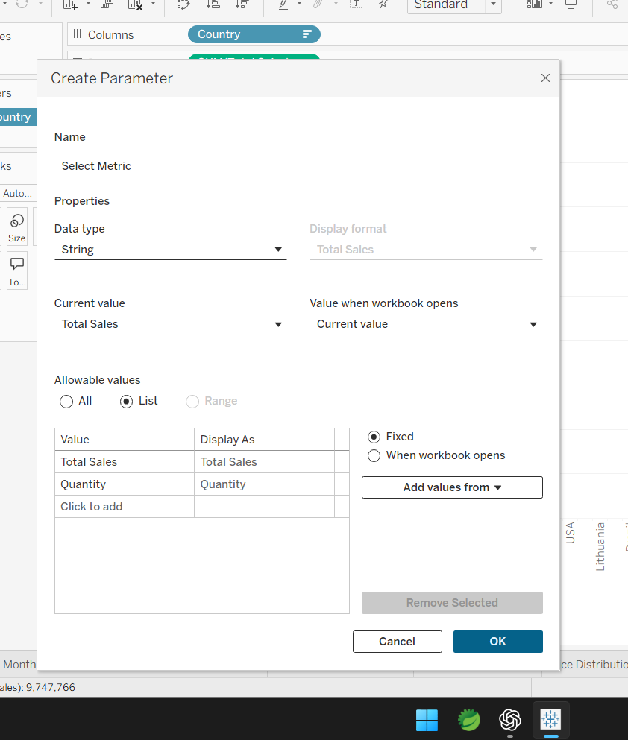
Week 5 evidence – implementation screenshot 1.
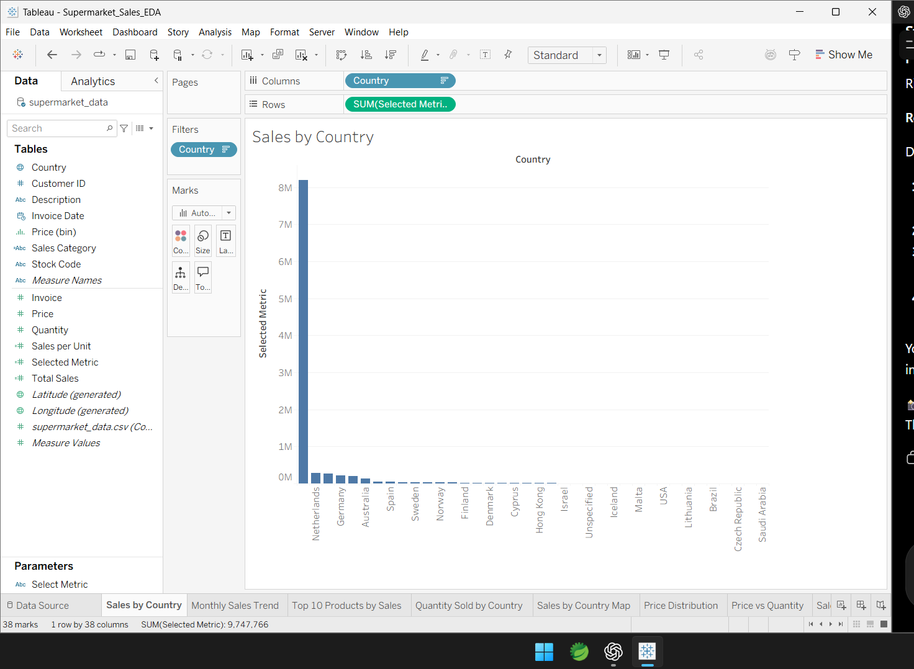
Week 5 evidence – implementation screenshot 2.
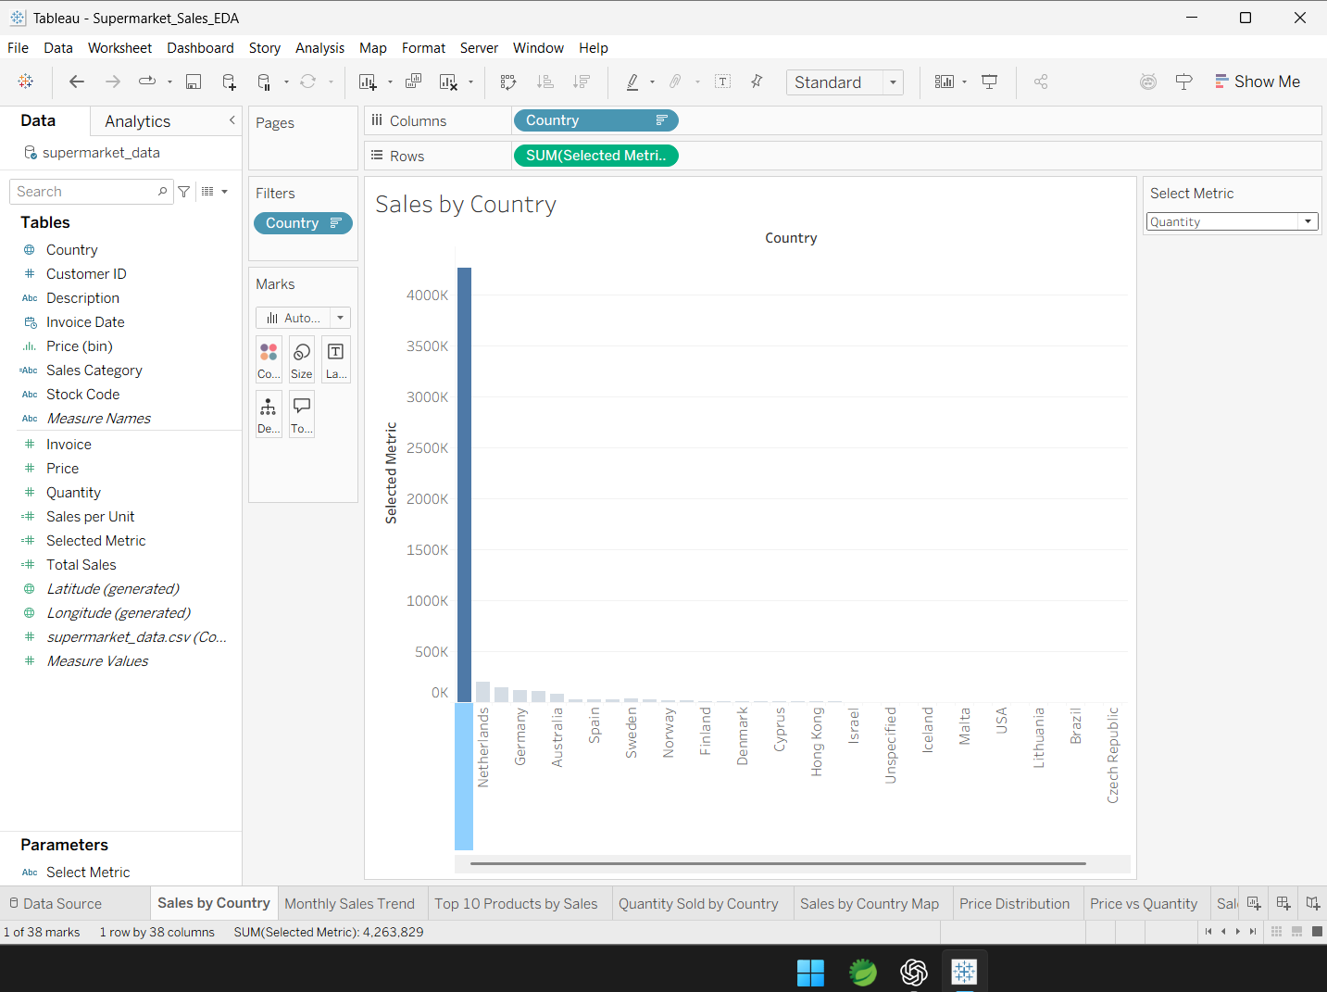
Week 5 evidence – implementation screenshot 3.
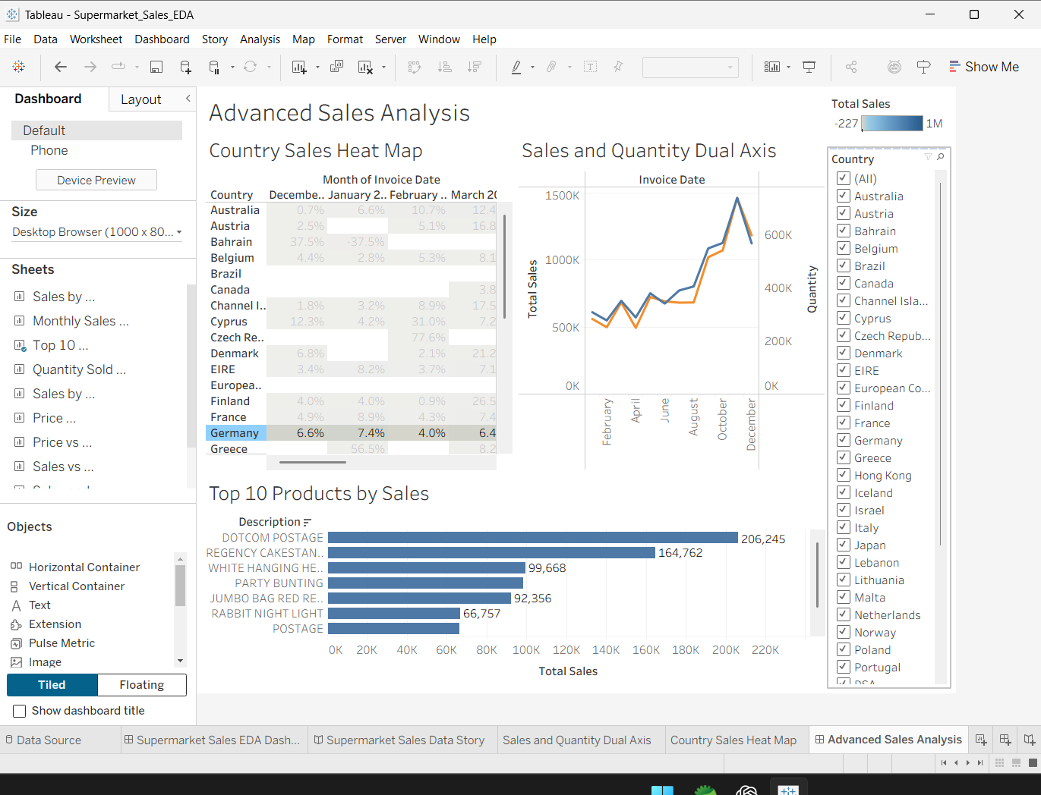
Week 5 evidence – implementation screenshot 4.
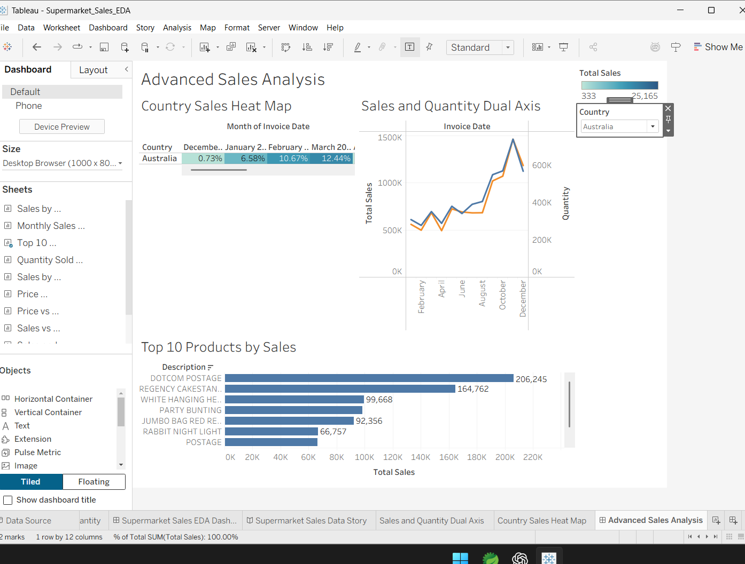
Week 5 evidence – implementation screenshot 5.
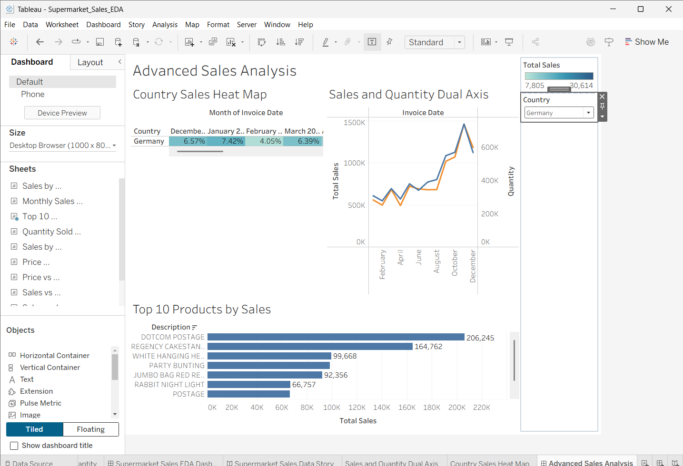
Week 5 evidence – implementation screenshot 6.

9. Final Integration and Evaluation
The project demonstrates a clear progression from data understanding to professional dashboard development. Each week contributed a distinct layer: Week 1 established evidence, Week 2 established design intent, Week 3 established narrative, Week 4 established technical depth, and Week 5 established optimization and flexible interaction.
Evaluation Area | Progression | Final Assessment
Data exploration | EDA worksheets and initial insights | Strong foundation for later dashboard decisions
Dashboard design | Audience, KPIs, layout, interaction and accessibility planning | Business-oriented and structured
Data storytelling | Eight-point story flow | Clear movement from overview to detail
Advanced visualization | Dual axis, heat map, calculations, table calculation | Greater analytical depth
Interactivity | Country filter, parameter and dropdown | User-driven exploration improved
Performance awareness | Bottleneck identification and complexity reduction | Practical optimization approach
Documentation | Weekly reports and evidence | Integrated into a professional final report

9.1 Effectiveness of Design Decisions
- The top-to-bottom dashboard planning supported a logical reading order.
- The story sequence reduced the risk of presenting unrelated charts without context.
- The dual-axis chart allowed two time-based measures to be compared in one view.
- The heat map compactly represented country-month patterns.
- The parameter reduced the need for separate charts for Total Sales and Quantity.
- The Country dropdown improved screen-space efficiency and filter usability.

9.2 Performance Evaluation
No exact before/after response-time benchmark was recorded in the weekly work, so the project does not claim a numerical speed improvement. Instead, Week 5 applied practical strategies expected to reduce visual overhead and improve usability: focused dashboard content, compact filtering, simpler interaction, and purposeful calculations.

10. Overall Learning Journey
Week | Skill Developed | Evidence of Learning
1 | EDA and insight generation | Multiple analytical worksheets and business insights
2 | Dashboard planning | Audience, questions, KPIs, layout and UX strategy
3 | Data storytelling | Eight-point interactive Tableau Story
4 | Advanced Tableau | Calculated fields, dual axis, heat map, table calculation
5 | Optimization and interaction | Parameter, dropdown filter, testing and performance strategy
6 | Integration and evaluation | Professional final report and reflective assessment
The most important progression was learning that effective visualization is not only about making charts. It involves choosing the right question, selecting an appropriate visual form, creating a logical narrative, designing intuitive interaction, considering performance, testing the result, and communicating findings clearly.

11. Lessons Learned
- EDA should come before dashboard design because it reveals patterns and questions that the dashboard must answer.
- Dashboard planning helps prevent overcrowding and keeps the visual hierarchy focused.
- Different chart types serve different analytical purposes; no single visualization is sufficient for the full dataset.
- Calculated fields can add meaningful analytical dimensions beyond the original columns.
- Table calculations are useful for understanding relative contribution.
- Interactive parameters can make one visualization support multiple analytical questions.
- Filters should be useful without occupying excessive dashboard space.
- Performance should be considered while designing, not only after a dashboard becomes slow.
- Storytelling is more effective when visualizations are arranged in a logical sequence.
- Testing each interaction is essential before final submission.

12. Challenges Faced and How They Were Addressed
Challenge | How It Was Addressed
Understanding Tableau menus and workflow | Features were implemented progressively and tested worksheet by worksheet.
Creating calculated fields | Formulas were developed for Total Sales, Sales Category, Sales per Unit and Selected Metric.
Combining multiple visualizations | Dashboard planning and a structured layout were used to organize the views.
Building a coherent story | Eight story points were arranged from overall performance to detailed relationships and insights.
Managing interactive controls | Country filtering and a Select Metric parameter were tested directly in the dashboard.
Large filter list | Country filter was changed to a Single Value dropdown.
Large transaction volume | Performance bottlenecks were identified and dashboard complexity was kept focused.
Validating interaction | The parameter was tested with Quantity and the Country filter was tested with Germany.

13. Recommendations for Future Enhancements
- Use Tableau extracts or an optimized database connection where appropriate.
- Introduce scheduled refreshes for regularly updated sales data.
- Add KPI cards for Total Sales, Total Quantity, Number of Countries and other approved business measures.
- Add profit and profit-margin measures if the required cost/profit data becomes available.
- Introduce additional parameters for time period, country or product analysis.
- Develop richer drill-down interactions from country to product or transaction level.
- Add forecasting for future sales trends when suitable historical data is available.
- Explore customer segmentation using purchasing behavior.
- Create a mobile-optimized dashboard layout.
- Establish measurable performance benchmarks so future versions can be compared using actual response times.

14. Future Scope
Future development could extend the project from descriptive and exploratory analytics toward predictive and operational analytics. Potential additions include sales forecasting, customer segmentation, automated data refresh, real-time or near-real-time database connections, advanced KPI monitoring, anomaly detection, and mobile reporting. These enhancements would require additional data, validation, and business requirements.

15. Professional Reflection
This project changed the approach to data visualization from simply producing charts to building a complete analytical communication product. The weekly progression encouraged repeated practice with Tableau and made it possible to see how exploration, design, storytelling, advanced analysis and optimization depend on each other. The final result demonstrates practical skills that can be transferred to business dashboards, analytics projects and portfolio work.
An important professional lesson is that a strong dashboard should be useful to its audience, not merely technically complex. Clear questions, appropriate visualizations, simple interaction, readable design, responsible interpretation of patterns, and performance awareness are all part of effective visualization practice.

16. Final Conclusion
The six-week Supermarket Sales Tableau project successfully integrated exploratory analysis, dashboard planning, interactive storytelling, advanced visualization, calculated insights, performance optimization, and evaluation. The project began with approximately 541,910 transaction records and progressively transformed the data into a structured analytical experience. Week 1 established the evidence base; Week 2 converted that evidence into a dashboard strategy; Week 3 created a connected story; Week 4 added advanced analytical techniques; and Week 5 improved interaction and dashboard efficiency. Week 6 brings these outputs together into a professional report that reflects both technical development and analytical learning.
The final work provides a strong foundation for future Tableau projects because it demonstrates the complete cycle from data exploration to communication, testing and improvement.

Appendix A – Evidence and Screenshots
The following pages contain representative evidence from the five completed weekly tasks. The images are taken from the submitted weekly documents, including the Week 5 implementation screenshots.

Week 1 Evidence
Week 1 – Evidence 1.
Week 1 – Evidence 2.
Week 1 – Evidence 3.
Week 1 – Evidence 4.
Week 1 – Evidence 5.

Week 2 Evidence

Week 3 Evidence
Week 3 – Evidence 1.
Week 3 – Evidence 2.
Week 3 – Evidence 3.
Week 3 – Evidence 4.
Week 3 – Evidence 5.
Week 3 – Evidence 6.

Week 4 Evidence
Week 4 – Evidence 1.
Week 4 – Evidence 2.
Week 4 – Evidence 3.

Week 5 Evidence
Week 5 – Evidence 1.
Week 5 – Evidence 2.
Week 5 – Evidence 3.
Week 5 – Evidence 4.
Week 5 – Evidence 5.
Week 5 – Evidence 6.

Appendix B – Final Deliverables
Deliverable | Status
Week 1 EDA report | Completed
Week 2 dashboard planning report | Completed
Week 3 interactive data story report | Completed
Week 4 advanced chart and calculation report | Completed
Week 5 performance optimization report with screenshots | Completed
Week 5 Tableau workbook: Supermarket_Sales_Week5_Performance_Optimization.twbx | Completed
Week 6 integrated final report | Completed

Appendix C – Final Technical Summary
Technical Component | Implemented
Tableau data exploration | Yes
Calculated Total Sales | Yes
Calculated Sales Category | Yes
Calculated Sales per Unit | Yes
Percent of Total table calculation | Yes
Monthly sales analysis | Yes
Country analysis and map | Yes
Top 10 product analysis | Yes
Price/quantity relationship analysis | Yes
Sales/quantity relationship analysis | Yes
Dual-axis chart | Yes
Country Sales Heat Map | Yes
Interactive Country filter | Yes
Select Metric parameter | Yes
Single Value Country dropdown | Yes
Interactive testing | Yes

