WEEK 3 TASK
CRAFTING INTERACTIVE DATA STORIES
Tableau – Supermarket Sales Analysis

Student Details | Information
Name | S. Maithili
Roll Number | 2400032693
Dataset | Supermarket Sales Dataset
Tool | Tableau
Project | Supermarket Sales Data Story

Week 3: Interactive Data Storytelling

1. Introduction
Week 3 focuses on transforming the exploratory analysis from Week 1 and the dashboard planning from Week 2 into an interactive data story using Tableau. The story presents supermarket sales information in a logical sequence so that users can move from an overall view to detailed analysis of time, countries, products, geography, price, quantity, and sales relationships.

2. Data Story Concept
The data story is titled “Understanding Supermarket Sales Performance”. The narrative begins with overall sales performance, then examines monthly trends, country-wise performance, top-selling products, geographic distribution, and relationships between price, quantity, and sales. The story ends with a concise summary of the main business insights.

3. Objective
The objective is to create a clear and engaging visual narrative that communicates important sales patterns and allows users to explore the data through Tableau filters, selections, and tooltips.

4. Target Audience
- Sales Managers – monitor sales performance and important markets.
- Business Managers – understand sales patterns for decision-making.
- Marketing Teams – identify important products and markets.
- Business Analysts – investigate trends, relationships, and unusual observations.

5. Key Message
Supermarket sales performance varies across countries, products, and time periods. Interactive visualizations make these patterns easier to understand and allow users to investigate specific parts of the dataset.

6. Data Story Flow
START → Overall Sales Performance → Monthly Sales Trends → Country-wise Sales Performance → Top-Selling Products → Geographic Sales Distribution → Price and Quantity Relationship → Sales and Quantity Relationship → Key Business Insights → END

7. Visualization Sequence
Story Point | Visualization | Role in the Story
1 | Overall Sales Performance | Introduces the overall supermarket sales situation.
2 | Monthly Sales Trends | Shows how sales change across months.
3 | Country-wise Sales Performance | Compares sales between countries.
4 | Top-Selling Products | Identifies products with the highest sales.
5 | Geographic Sales Distribution | Shows where sales are concentrated geographically.
6 | Price and Quantity Relationship | Explores the relationship between product price and quantity.
7 | Sales and Quantity Relationship | Explores the association between quantity sold and total sales.
8 | Key Business Insights | Summarizes the main observations from the story.

8. Story Point 1 – Overall Sales Performance
The first story point provides an overview of the supermarket sales analysis. It brings together the monthly sales trend, country map, sales by country, and top products so that the audience can understand the overall context before moving to detailed analysis.
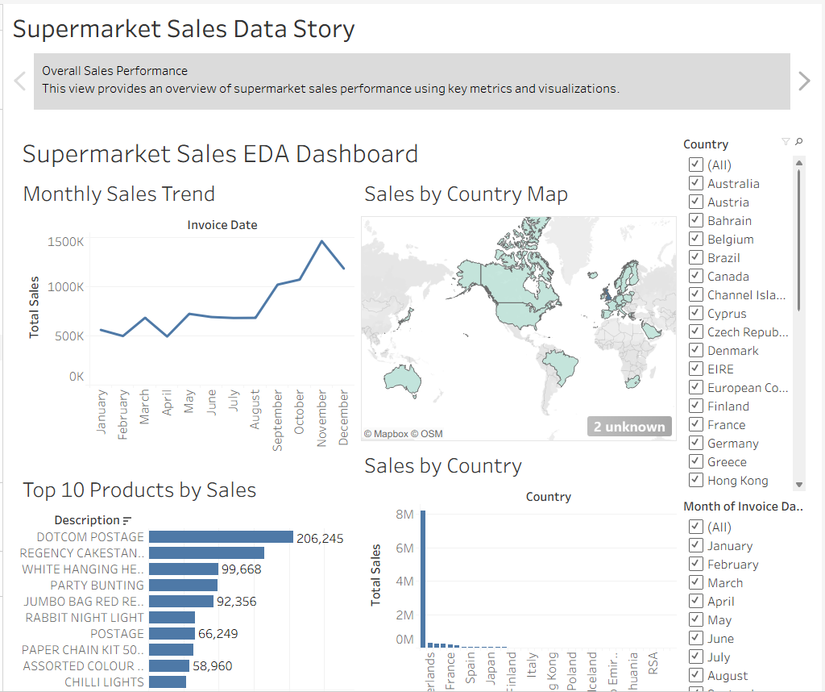
Figure 1. Overall Sales Performance story point
The dashboard also demonstrates interactivity through the visible Country and Month of Invoice Date filters.

9. Story Point 2 – Monthly Sales Trends
The second story point focuses on sales performance across months. The line chart shows fluctuations during the year and makes it easier to identify periods of relatively higher and lower sales.
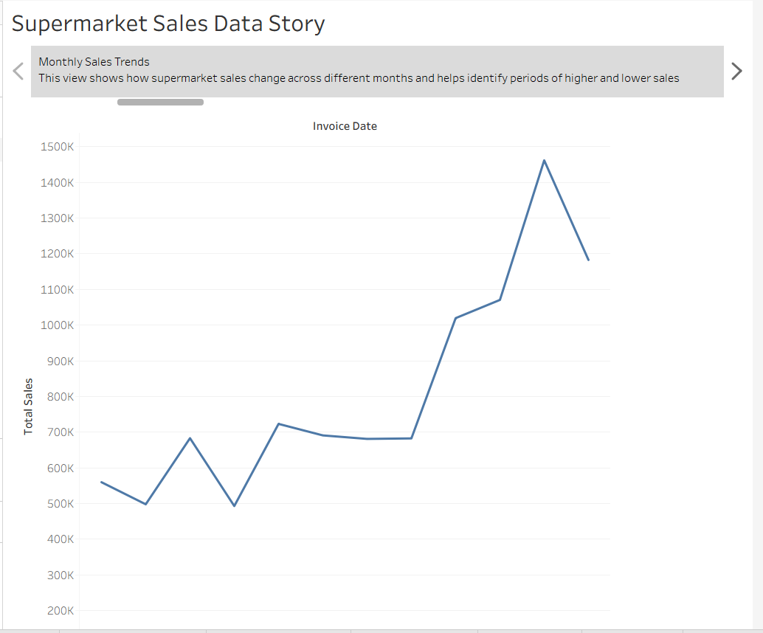
Figure 2. Monthly Sales Trends story point
The trend shows relatively lower values in some early months, followed by stronger sales later in the year, with a noticeable peak around November and a decline in December.

10. Story Point 3 – Country-wise Sales Performance
The third story point compares sales across countries. This helps the audience identify the strongest markets and understand that sales are not evenly distributed across all countries.
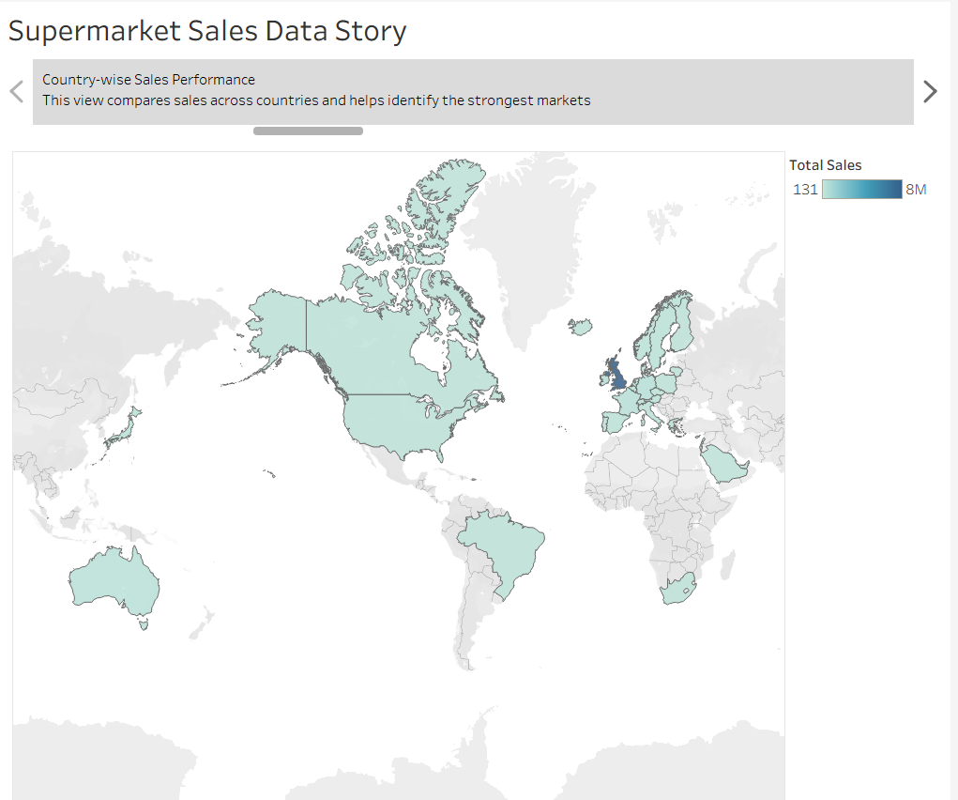
Figure 3. Country-wise Sales Performance story point

11. Story Point 4 – Top-Selling Products
The fourth story point identifies the products contributing the most to total sales. The chart highlights DOTCOM POSTAGE as the highest among the displayed top products, followed by REGENCY CAKESTAND and WHITE HANGING HEART.
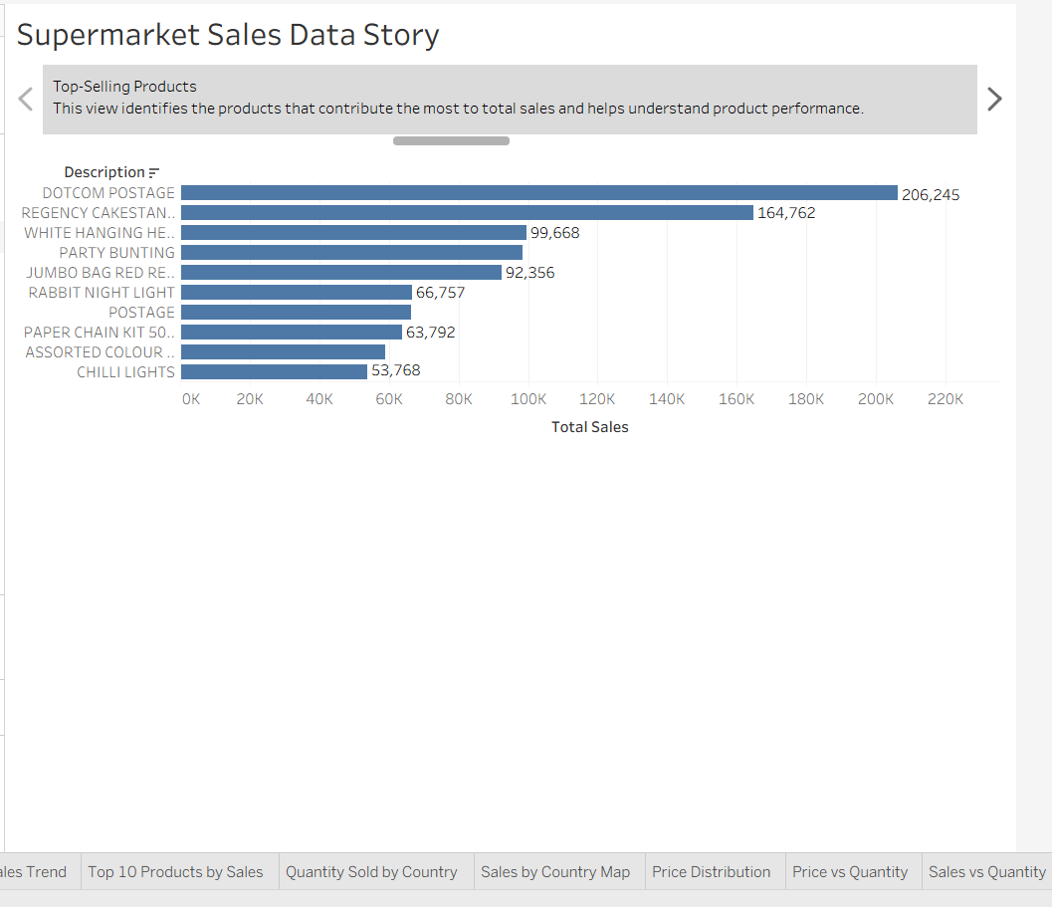
Figure 4. Top-Selling Products story point

12. Story Point 5 – Geographic Sales Distribution
The fifth story point uses a map to communicate the geographic distribution of sales. It provides a visual way to identify countries represented in the dataset and compare their relative sales intensity.
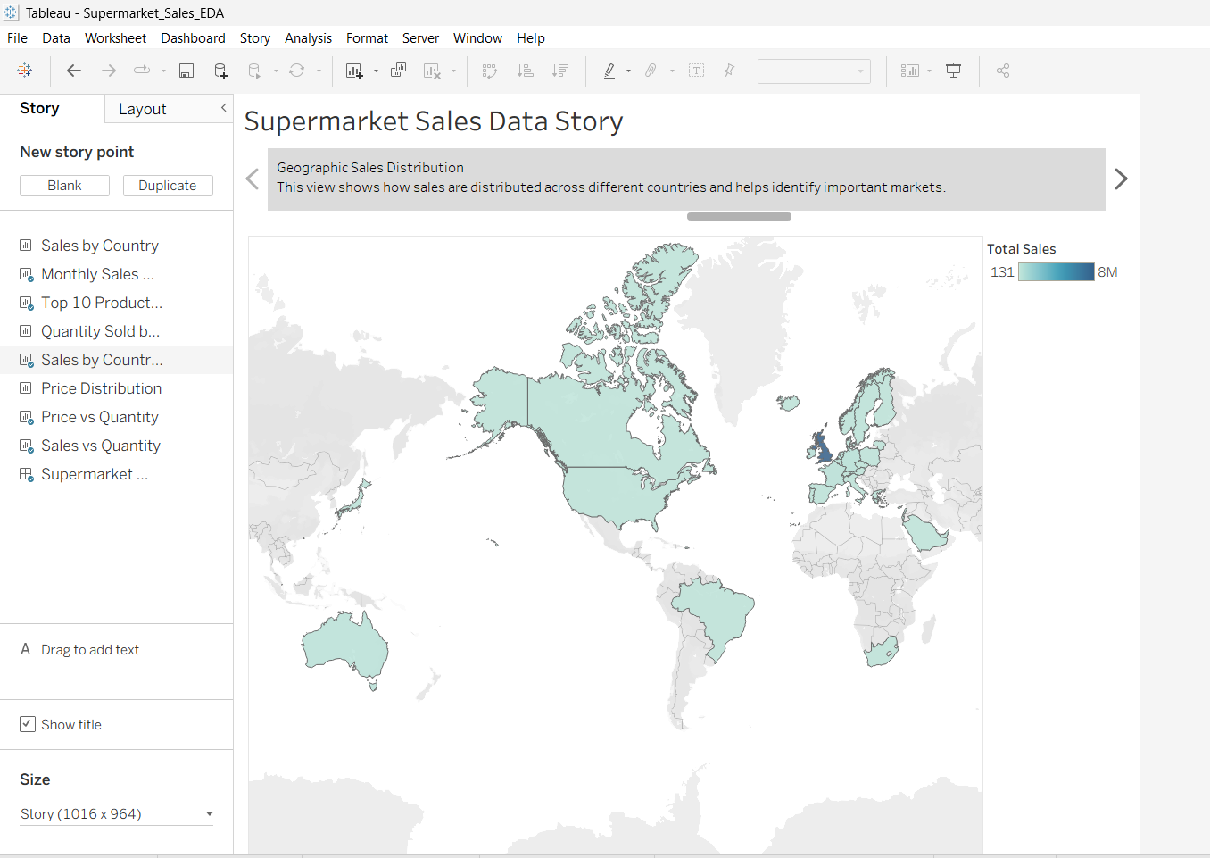
Figure 5. Geographic Sales Distribution story point

13. Story Point 6 – Price and Quantity Relationship
The sixth story point uses a scatter plot to explore the relationship between product price and quantity sold. The visualization also makes unusual observations visible. These patterns are treated as associations rather than proof of causation.
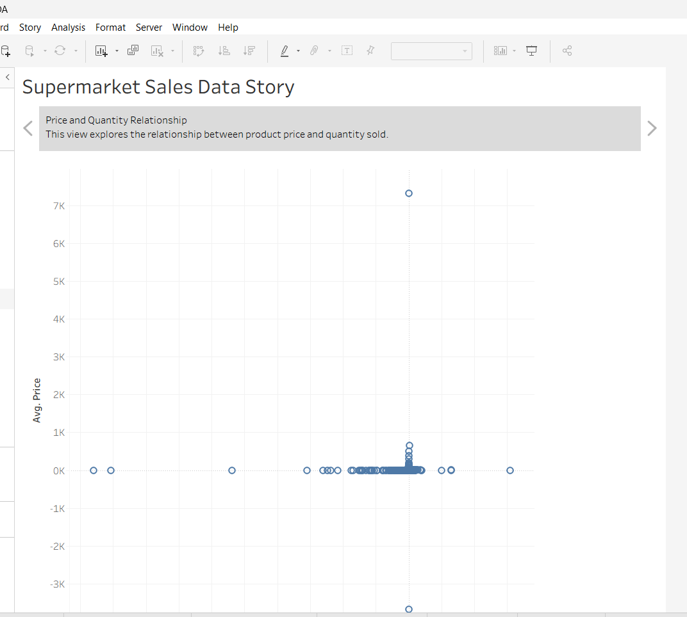
Figure 6. Price and Quantity Relationship story point

14. Story Point 7 – Sales and Quantity Relationship
The seventh story point examines the association between quantity sold and total sales across products. Most observations are concentrated in a lower range, while several points are separated from the main cluster and may require further investigation.
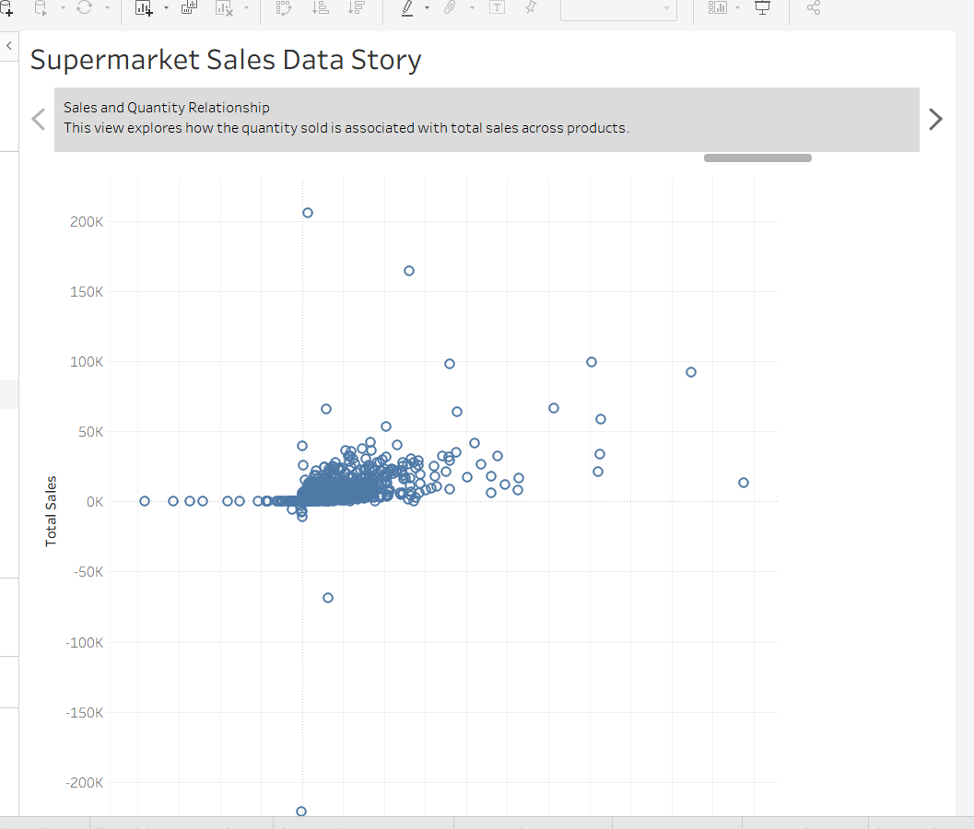
Figure 7. Sales and Quantity Relationship story point

15. Story Point 8 – Key Business Insights
The final story point summarizes the main observations from the complete narrative. It provides closure and connects the individual visualizations to business-oriented interpretation.
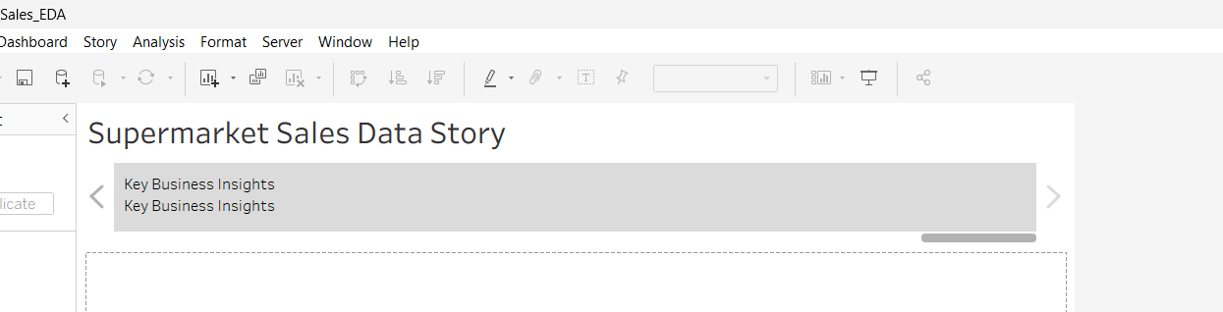
Figure 8. Key Business Insights story point

16. Interactive Elements
Interactive Element | How It Supports the Story
Country Filter | Allows users to focus the analysis on a selected country.
Month/Date Filter | Allows users to investigate a selected time period.
Map Selection | Helps users explore geographic sales patterns.
Product Exploration | Allows investigation of individual product performance where applicable.
Tooltips | Provide additional information when users hover over visual marks.
Story Navigation | Allows users to move sequentially through the narrative.

17. Interactive Narrative Strategy
The interactive elements allow the audience to explore the story instead of only viewing a fixed set of charts. For example, the Country filter can be used to focus on a particular market, while the date/month filter can be used to investigate a selected period. Tooltips provide additional details without adding visual clutter. These interactions support deeper investigation while preserving the main narrative flow.

18. Key Business Insights
- Sales performance changes noticeably across different months.
- Sales are concentrated in particular countries rather than being evenly distributed.
- A small group of products contributes strongly to the displayed top-sales ranking.
- The geographic map provides a quick view of important sales markets.
- The price-versus-quantity visualization contains a dense main cluster along with unusual observations.
- The sales-versus-quantity chart shows a main concentration of observations and several outlying points.
- Interactive filtering allows users to investigate individual markets and periods.

19. Accessibility and User Experience
- Use clear titles and readable labels.
- Maintain a simple left-to-right or top-to-bottom narrative flow.
- Use consistent visual formatting across story points.
- Keep filters visible and understandable.
- Use tooltips for supporting details.
- Avoid excessive colors and unnecessary visual elements.
- Do not rely only on color to communicate important information.

20. Evaluation Against Week 3 Requirements
Requirement | How It Is Addressed
Clear data story concept | The story focuses on understanding supermarket sales performance.
Key message and audience | Defined in Sections 3–5.
Sequential visual narrative | Eight story points provide a logical sequence.
Interactive elements | Country/date filters, map selection, tooltips, and navigation are included/planned.
Depth of analysis | Time, country, product, geographic, price, quantity, and sales relationships are covered.
Complete and engaging story | The narrative moves from overview to detailed analysis and final insights.

21. Conclusion
Week 3 successfully converts the supermarket sales EDA and dashboard plan into an interactive Tableau data story. The eight story points provide a coherent sequence from overall performance to detailed analysis and final insights. Filters, selections, tooltips, and story navigation improve user engagement and allow users to explore the data according to their interests. The resulting story provides a clear and accessible way to communicate data-driven supermarket sales insights.

