WEEK 4 TASK
ADVANCED CHART TECHNIQUES AND CALCULATION INSIGHTS
Tableau – Supermarket Sales Analysis
Student Details | Information
Name | S. Maithili
Roll Number | 2400032693
Dataset | Supermarket Sales Dataset
Tool | Tableau
Workbook | Supermarket_Sales_EDA

1. Introduction
Week 4 focuses on advanced Tableau visualization techniques, calculated fields, and table calculations. The same Supermarket Sales dataset used in previous weeks was extended with additional calculations and advanced charts to provide deeper analysis.

2. Objective
- Apply advanced visualization techniques in Tableau.
- Create calculated fields that add analytical value.
- Use a table calculation to show percentage contribution.
- Build an interactive dashboard combining the advanced visualizations.
- Improve the clarity of the visual narrative through filters and comparisons.

3. Dataset
The project uses the publicly available Supermarket Sales dataset. The dataset contains transaction-level information such as Country, Description, Invoice Date, Price, Quantity, and Customer ID. Total Sales was calculated as Price multiplied by Quantity.

4. Calculated Fields
Calculated Field | Formula / Method | Purpose
Total Sales | [Price] * [Quantity] | Calculates the sales value for each transaction.
Sales Category | IF [Total Sales] >= 1000 THEN "High Sales" ELSEIF [Total Sales] >= 500 THEN "Medium Sales" ELSE "Low Sales" END | Classifies transactions into High, Medium, and Low sales groups.
Sales per Unit | IF [Quantity] <> 0 THEN [Total Sales] / [Quantity] ELSE 0 END | Measures sales value associated with each unit sold.
Percent of Total | Quick Table Calculation → Percent of Total | Shows the contribution of each displayed value as a percentage.

5. Calculated Field – Sales Category
Sales Category groups transactions into High Sales, Medium Sales, and Low Sales based on Total Sales. This classification makes it easier to distinguish stronger and weaker sales transactions during analysis.
Formula:
IF [Total Sales] >= 1000 THEN "High Sales"
ELSEIF [Total Sales] >= 500 THEN "Medium Sales"
ELSE "Low Sales"
END

6. Calculated Field – Sales per Unit
Sales per Unit is calculated by dividing Total Sales by Quantity when Quantity is not zero. It provides a simple measure for comparing the sales value associated with individual units.
Formula:
IF [Quantity] <> 0 THEN
[Total Sales] / [Quantity]
ELSE
0
END

7. Advanced Visualization 1 – Dual-Axis Chart
A dual-axis chart was created to compare monthly Total Sales and Quantity. Invoice Date was placed on Columns at the month level, while Total Sales and Quantity were placed on Rows. The two measures were combined using Dual Axis and synchronized so their trends could be compared.
- X-axis: Month of Invoice Date
- Left axis: Total Sales
- Right axis: Quantity
- Visualization type: Dual-axis line chart
- Purpose: compare monthly sales and quantity trends.

8. Advanced Visualization 2 – Country Sales Heat Map
A country-by-month heat map was created using Country on Rows, Month of Invoice Date on Columns, and Total Sales as the measure. The color intensity helps users compare sales patterns across countries and months.
- Rows: Country
- Columns: Month of Invoice Date
- Measure: Total Sales
- Mark type: Square / Highlight Table
- Purpose: identify variations in sales across countries and months.
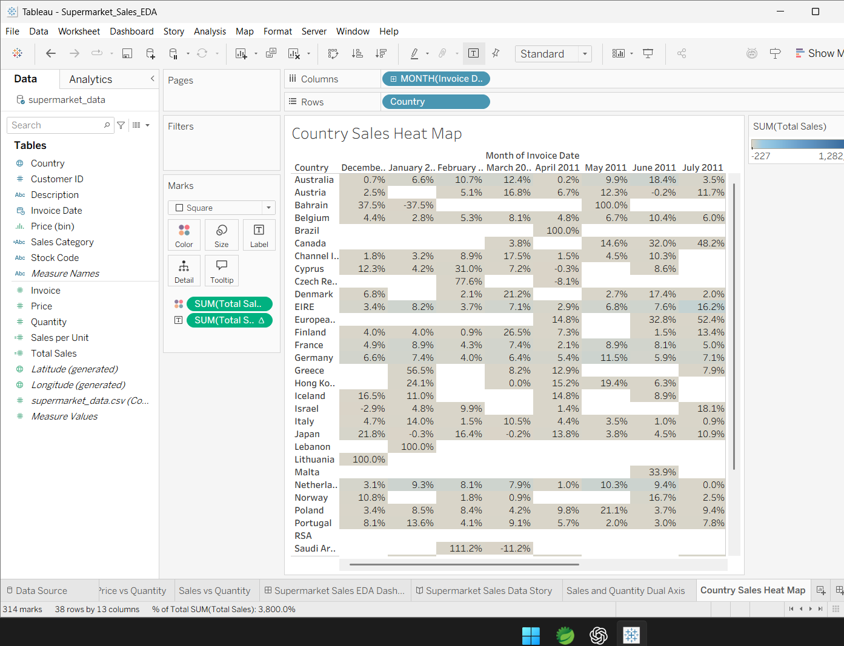
Figure 1. Country Sales Heat Map with percentage table calculation

9. Table Calculation – Percent of Total
The Quick Table Calculation option Percent of Total was applied to Total Sales in the heat map. This converts the displayed sales values into percentage contributions within the selected table calculation direction. It helps the user understand relative contribution rather than only absolute sales.

10. Advanced Sales Analysis Dashboard
The advanced dashboard combines the dual-axis chart, country sales heat map, and Top 10 Products by Sales. This arrangement provides a compact analytical view containing time-based comparison, country-month analysis, and product performance.
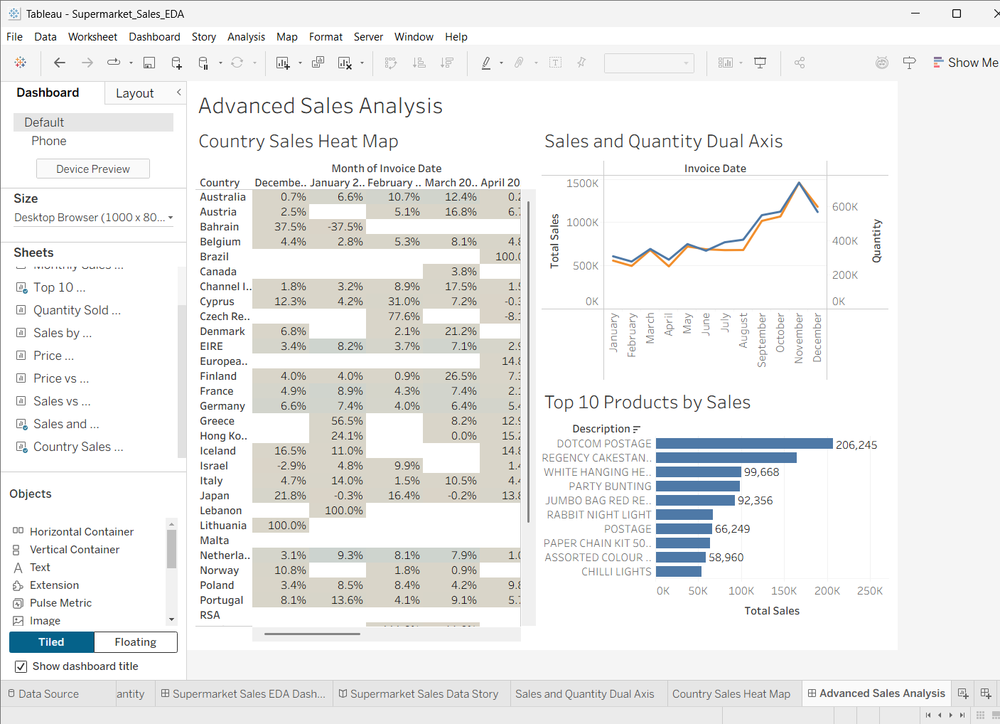
Figure 2. Advanced Sales Analysis dashboard

11. Interactive Feature – Country Filter
A Country filter was added to the dashboard so users can focus the analysis on a selected country. The filter makes the dashboard interactive and supports country-level investigation without creating separate dashboards for each market.
- Users can select a country from the filter.
- The dashboard responds to the selected country.
- The filter supports focused analysis of market performance.
- This reduces the need to manually inspect every country.
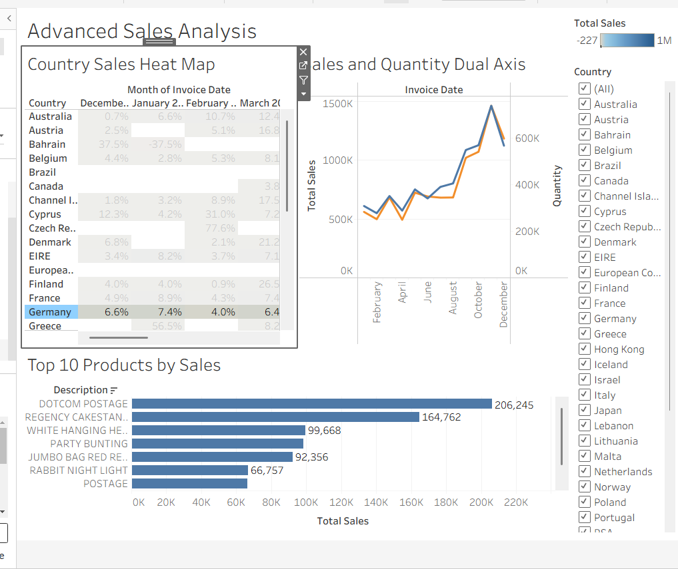
Figure 3. Advanced dashboard with Country filter

12. Design Rationale
- The dual-axis chart was selected because it compares two related measures over the same time period.
- The heat map was selected because it efficiently displays many country-month combinations.
- The Top 10 Products chart provides a focused product-level comparison.
- The Country filter supports user-driven exploration.
- The dashboard uses a simple layout so users can move from trends to geographic details and then to products.

13. Key Insights
- Monthly sales and quantity show changing patterns across the year.
- Some countries contribute much more sales than others.
- The heat map reveals differences in sales contribution across countries and months.
- A small group of products dominates the Top 10 sales ranking.
- The percentage table calculation provides relative contribution information.
- Interactive country filtering allows users to investigate individual markets.

14. User-Centered Design
- Important visualizations are visible together on one dashboard.
- Chart titles clearly communicate the purpose of each visualization.
- The Country filter provides direct user control.
- Tooltips and labels can provide additional details without overcrowding the dashboard.
- The dashboard supports both overview analysis and focused investigation.

15. Technical Work Completed
Component | Status
Sales Category calculated field | Completed
Sales per Unit calculated field | Completed
Dual-Axis visualization | Completed
Country Sales Heat Map | Completed
Percent of Total table calculation | Completed
Advanced Sales Analysis dashboard | Completed
Country interactive filter | Completed

16. Conclusion
Week 4 enhanced the Supermarket Sales project by applying advanced Tableau techniques and calculated metrics. The dual-axis chart compares sales and quantity trends, while the heat map shows country-wise monthly sales patterns. Calculated fields add new analytical dimensions, and the Percent of Total table calculation provides relative contribution. The final dashboard combines these techniques with an interactive Country filter, improving both technical depth and user experience.

