Week 1 Task: Exploratory Data Analysis and Insight Generation

Dataset: Supermarket Sales Dataset
Tool: Tableau
Name: S. Maithili
Roll No: 2400032693

2. Introduction
Explain what the project is about.
Example:
This project focuses on performing Exploratory Data Analysis (EDA) on a publicly available supermarket sales dataset using Tableau. The objective is to understand the dataset, identify sales trends, compare countries and products, analyze relationships between variables, and generate useful business insights through visualization

3. Dataset Description
Mention:
- Dataset name: Supermarket Sales Dataset
- Number of records: approximately 541,910
- Number of fields: 8
- Data contains sales transactions.
- Main dimensions include Country, Description, Invoice Date and Customer ID.
- Main measures include Quantity, Price and Total Sales.
From your Tableau data, we already saw approximately:
541,910 rows
4. Variables Used
Create a table

Variable | Type | Purpose
Invoice | Numerical | Transaction/invoice identification
Stock Code | Categorical | Product identification
Description | Categorical | Product name
Quantity | Numerical | Number of items sold
Invoice Date | Date | Transaction date
Price | Numerical | Product price
Customer ID | Numerical | Customer identification
Country | Categorical | Customer/location country
Total Sales | Calculated Measure | Sales value

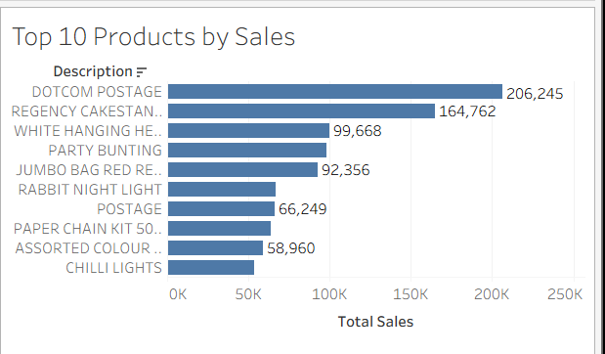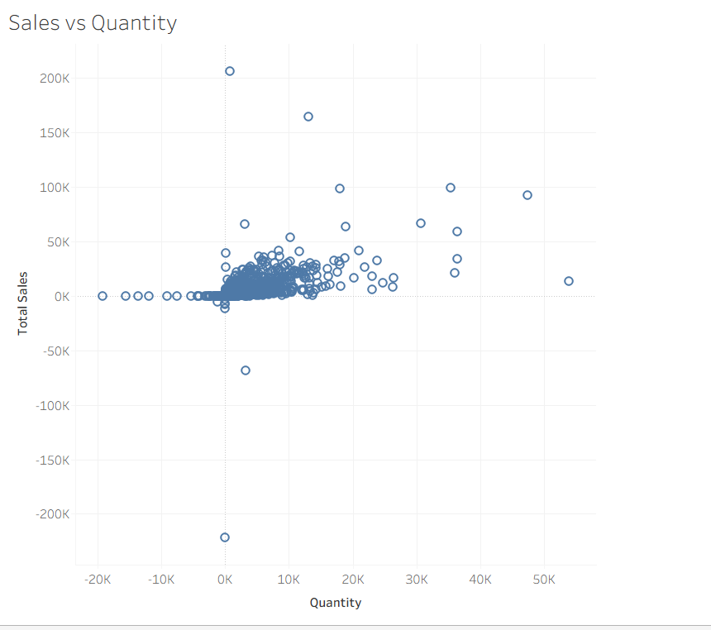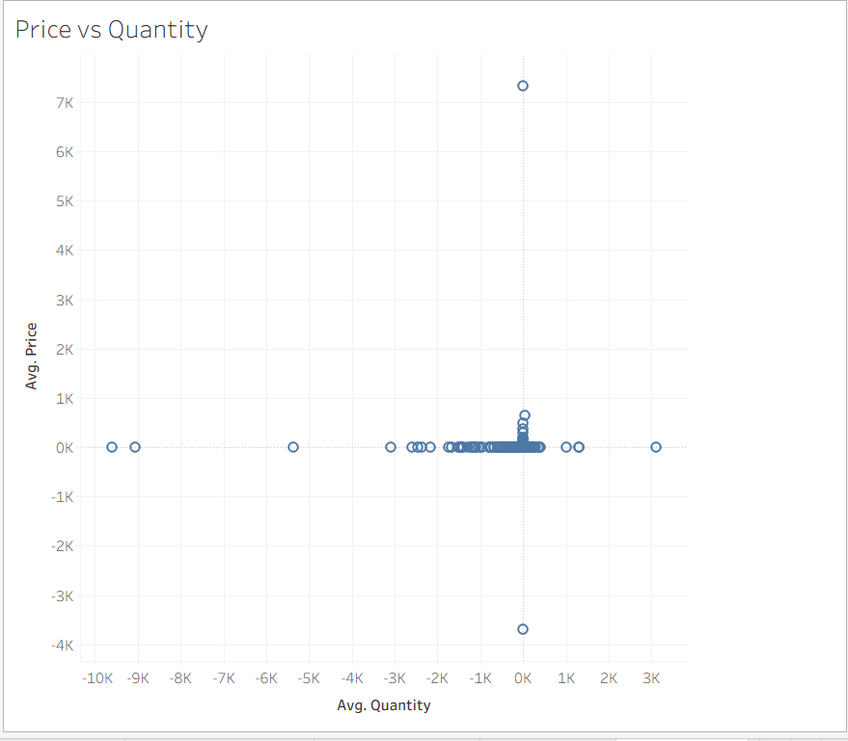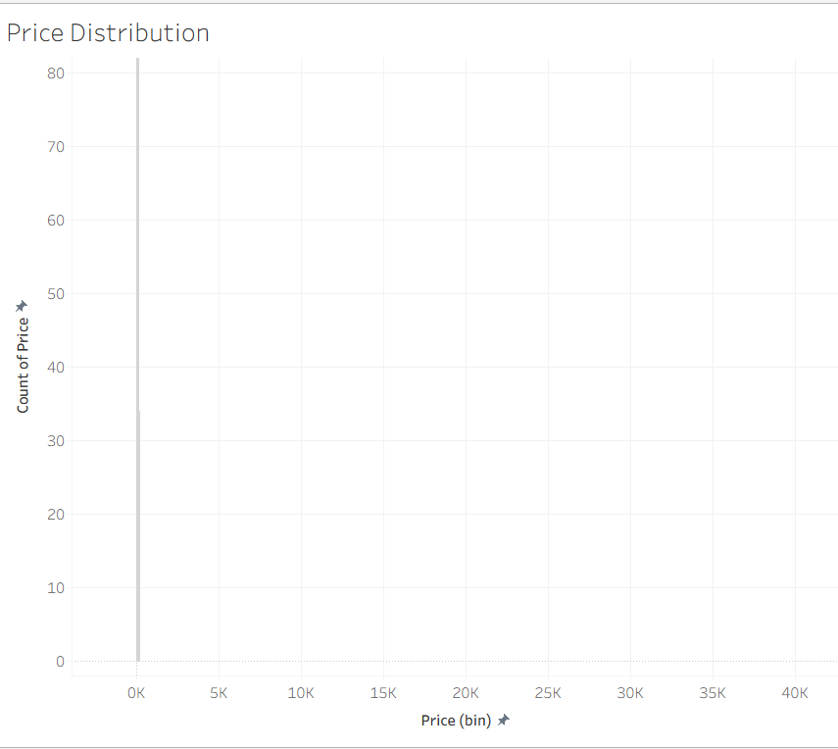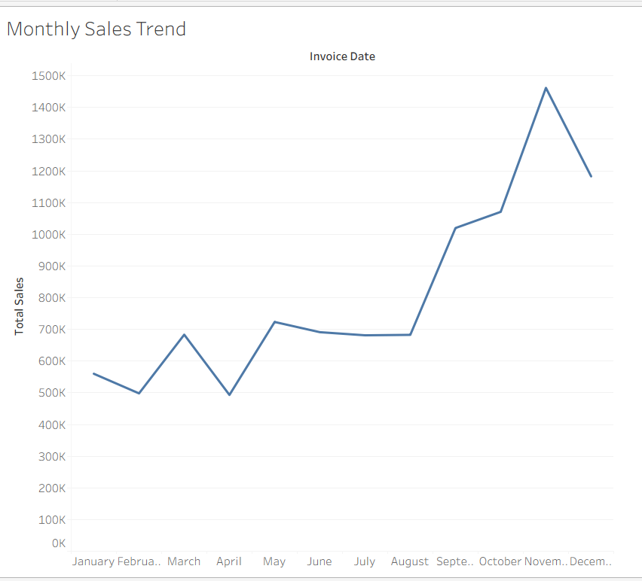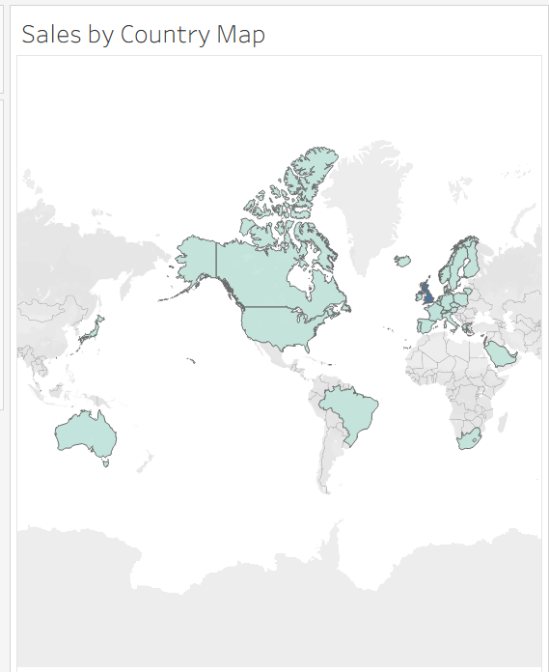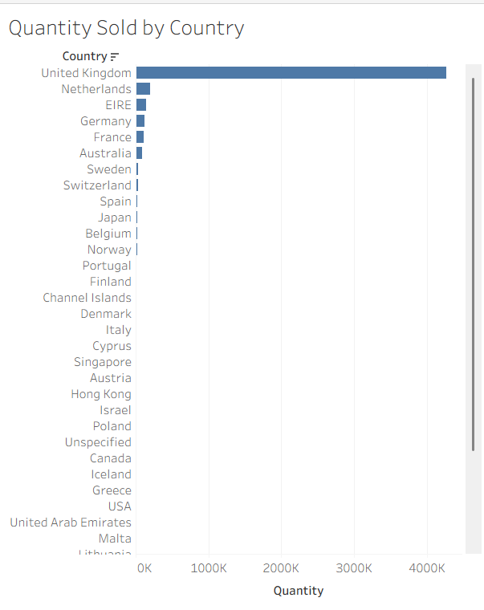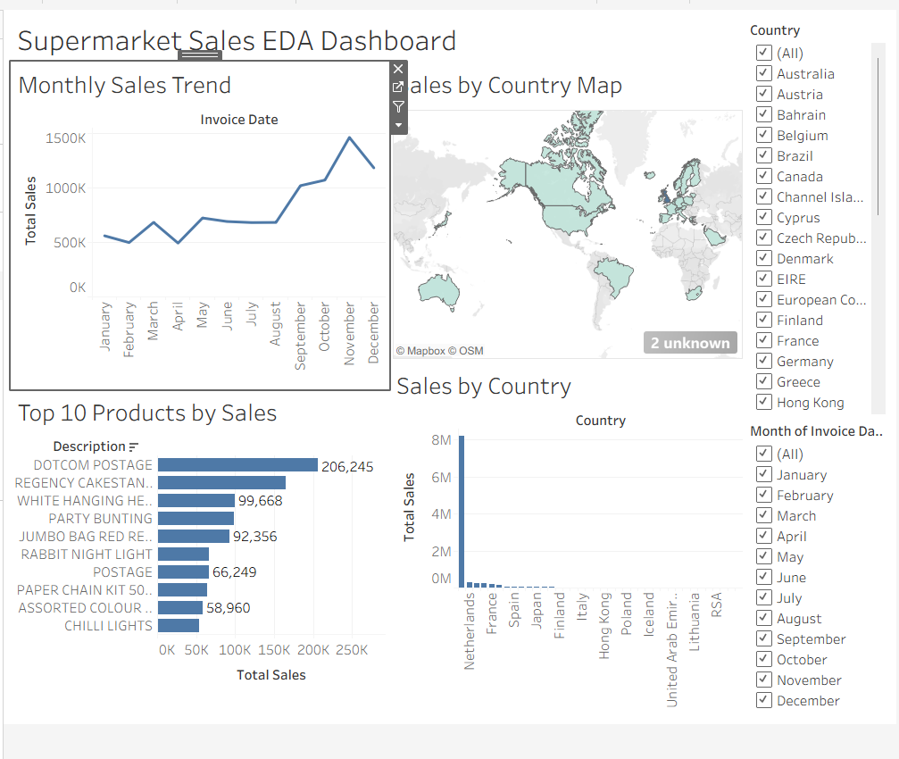
Key Business Insights
Include approximately 5–7 insights.
For example:
- Sales vary considerably across countries.
- The United Kingdom is the dominant market in terms of transaction quantity.
- Sales show noticeable monthly fluctuations.
- A small group of products contributes significantly to sales.
- Product prices are concentrated in lower ranges, while some unusually high values appear as potential outliers.
- Quantity and sales show a relationship that can help understand product demand.
- Geographic analysis can help identify important markets for business expansion
- Outlier Analysis
The price distribution shows that most observations are concentrated within a relatively low price range, while a small number of observations have unusually high values. These extreme values should be investigated further to determine
Conclusion

The exploratory analysis provided an initial understanding of the supermarket sales dataset using Tableau. Multiple visualizations were created to examine geographic performance, monthly trends, product sales, quantity distribution, price distribution, and relationships between variables. The analysis identified important sales patterns, high-performing products, geographic differences, and potential price outliers. These findings can be used as a foundation for deeper business analysis and dashboard development.

