WEEK 5 TASK
Performance Optimization and Interactive Feature Enhancement
Supermarket Sales Analysis using Tableau
Student: S. Maithili
Roll No.: 2400032693

1. Introduction
This report documents the Week 5 improvements made to the Supermarket Sales Tableau workbook. The work focuses on practical performance optimization, simpler dashboard controls, and enhanced interactivity while preserving the analytical views developed in earlier weeks.

2. Objectives
- Identify possible bottlenecks related to data volume, filters, calculations, and dashboard complexity.
- Apply practical Tableau performance best practices.
- Improve dashboard usability through simpler interactive controls.
- Create a parameter that switches between Total Sales and Quantity.
- Convert the Country filter from a long checklist into a compact single-value dropdown.
- Test and document the resulting interactions.

3. Current Dashboard Assessment
The Advanced Sales Analysis dashboard contains a Country Sales Heat Map, Sales and Quantity Dual Axis chart, Top 10 Products by Sales chart, and a Country filter. The underlying supermarket dataset contains approximately 541,910 transaction records. Transaction-level data combined with several visualizations, calculations, and filters can increase processing and rendering work.
Area | Potential Bottleneck | Optimization Response
Data volume | Large transaction-level dataset | Avoid unnecessary dashboard complexity and use extracts where appropriate
Country filter | Long list of checkbox values | Changed to Single Value dropdown
Dashboard views | Several charts on one dashboard | Retained key analytical views
Calculated fields | Calculations across many records | Used a focused parameter-driven calculation
User interaction | Metric was fixed in the chart | Added Select Metric parameter

4. Performance Bottlenecks Considered
- Large row count can increase work when filters or calculations change.
- Multiple dashboard worksheets can increase rendering/query work.
- Complex calculations applied across many rows can affect responsiveness.
- Large filter lists consume dashboard space and can make selection slower.
- Highly detailed visualizations can create many marks and increase rendering work.

5. Performance Optimization Strategies
- Use Tableau extracts where appropriate for faster local analytical access.
- Keep only necessary worksheets on a dashboard.
- Avoid unnecessary high-cardinality filters and prefer focused controls.
- Reduce unnecessary marks and labels.
- Keep calculated fields simple and purposeful.
- Use concise tooltips and avoid excessive decoration.
- Test interactions after each major dashboard change.

6. Interactive Enhancement — Select Metric Parameter
A String parameter named Select Metric was created with two allowable values:
- Total Sales
- Quantity
This parameter lets one visualization support two related analytical measures.

7. Selected Metric Calculated Field
The following calculated field was created:
CASE [Select Metric]
WHEN "Total Sales" THEN [Total Sales]
WHEN "Quantity" THEN [Quantity]
END
The Selected Metric field was placed on the Rows shelf. Changing the parameter causes Tableau to recalculate the selected measure and update the chart.

8. Interactive Enhancement — Country Filter
The original Country filter displayed a long checklist. It was changed to Single Value (dropdown), producing a compact control that allows one country to be selected at a time. The dashboard was tested by selecting Germany, and the Country Sales Heat Map updated accordingly.

9. Usability Improvements
- Users can switch between Total Sales and Quantity without needing separate charts.
- The Country dropdown uses less dashboard space than a long checklist.
- Interactive controls support quick exploration and comparison.
- The dashboard keeps the main analytical views visible while controls remain compact.

10. Before and After Comparison
Component | Before | After
Country filter | Long checkbox list | Single Value dropdown
Metric analysis | Fixed measure | Total Sales / Quantity parameter
Dashboard interaction | Basic filtering | Metric + country selection
Screen space | Large filter area | Compact control
User experience | More scrolling | Simpler exploration

11. Expected Performance Improvements
The changes are intended to improve practical responsiveness and usability rather than claim a specific measured speed increase. The compact filter reduces visual overhead, while the parameter allows one visualization to support multiple metrics. Keeping the dashboard focused also avoids unnecessary rendering work.

12. Expected User Engagement Improvements
- Users can actively change the metric shown.
- Users can focus the dashboard on one country.
- The dashboard supports exploration without creating additional worksheets.
- The controls are simple and intuitive for non-technical users.

13. Testing and Validation
- Select Metric was tested with Total Sales.
- Select Metric was changed to Quantity and the chart values changed.
- The Country filter was changed to a dropdown.
- Germany was selected from the Country dropdown.
- The dashboard updated to Germany, confirming the filter interaction.
- The final workbook was saved as Supermarket_Sales_Week5_Performance_Optimization.twbx.

14. Screenshot Evidence
- Create Parameter window showing Select Metric with Total Sales and Quantity.
- Worksheet showing SUM(Selected Metric).
- Parameter control showing Quantity and the updated chart.
- Advanced Sales Analysis dashboard with the Country filter.
- Country filter changed to Single Value dropdown.
- Dashboard after selecting Germany.

15. Conclusion
Week 5 successfully enhanced the Supermarket Sales Tableau dashboard through practical performance and interactivity improvements. The Select Metric parameter provides flexible metric switching, while the Country dropdown simplifies filtering. Testing with Germany confirmed that the dashboard responds correctly to user selection. Overall, the dashboard is more compact, intuitive, and flexible while retaining the analytical work from previous weeks.

16. Final Deliverables
Tableau workbook: Supermarket_Sales_Week5_Performance_Optimization.twbx
Report: Week_5_Performance_Optimization_and_Interactive_Feature_Enhancement.docx

17. Actual Screenshot Evidence
The following screenshots are the actual Tableau screenshots captured during the Week 5 implementation. They provide visual evidence for the parameter creation, metric switching, dashboard optimization, Country dropdown enhancement, and final Germany filter test.
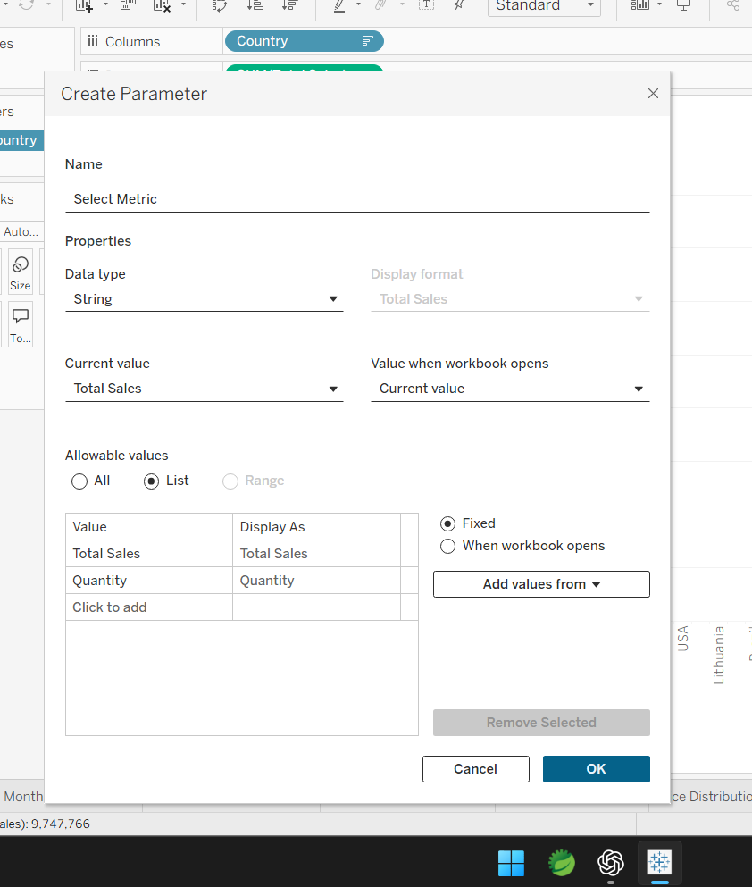
Figure 1. Select Metric parameter created with String data type and Total Sales / Quantity values.
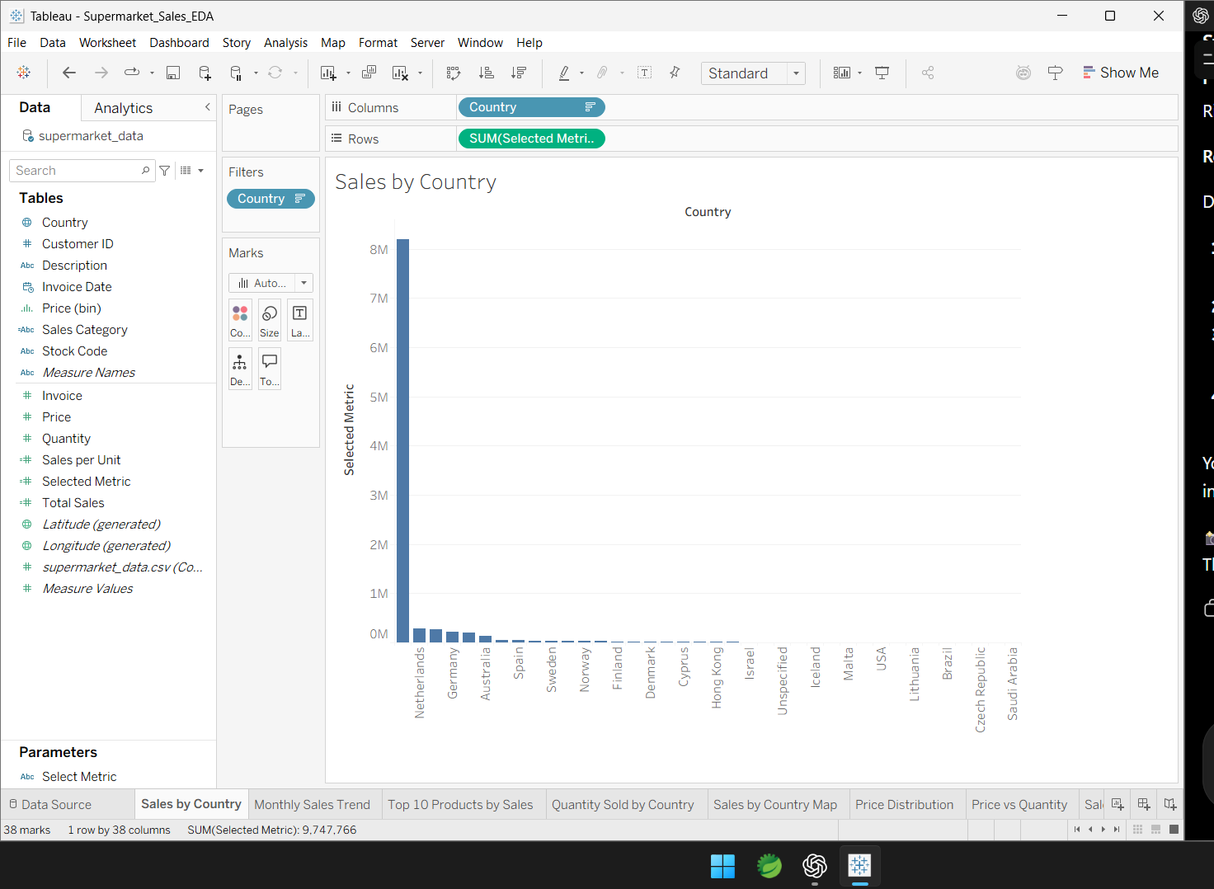
Figure 2. Selected Metric added to the Sales by Country worksheet.
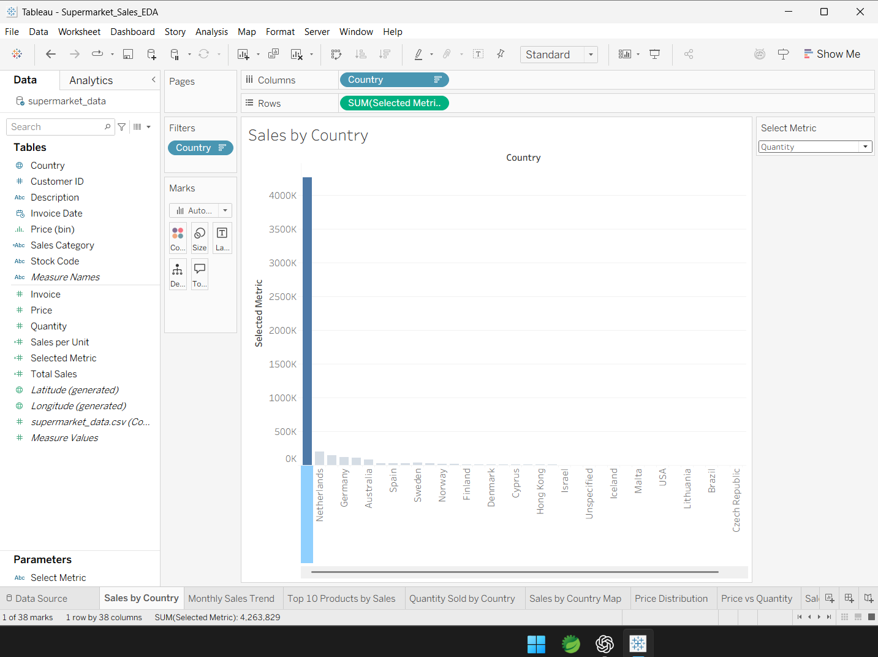
Figure 3. Parameter changed to Quantity and the chart updated interactively.
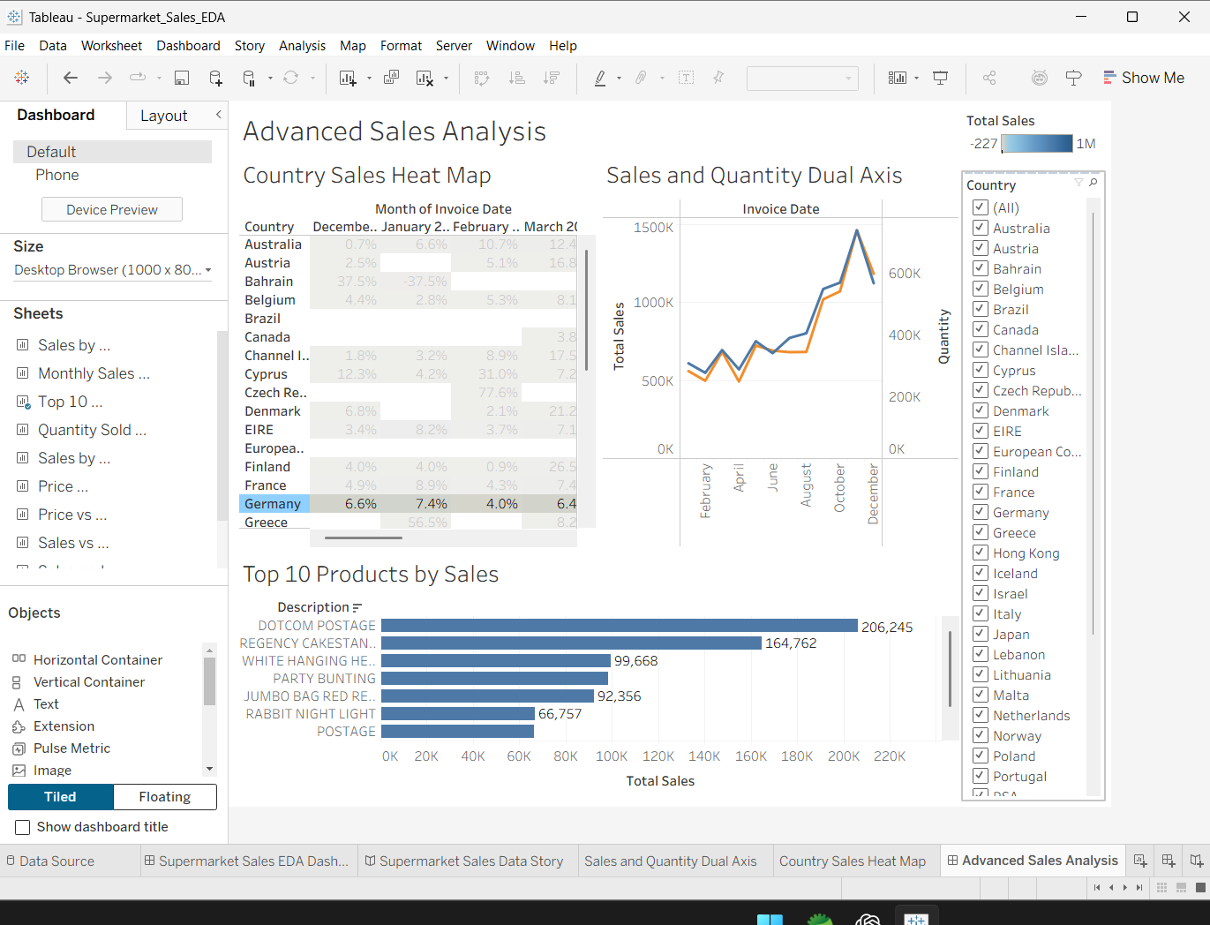
Figure 4. Advanced Sales Analysis dashboard before Country filter simplification.
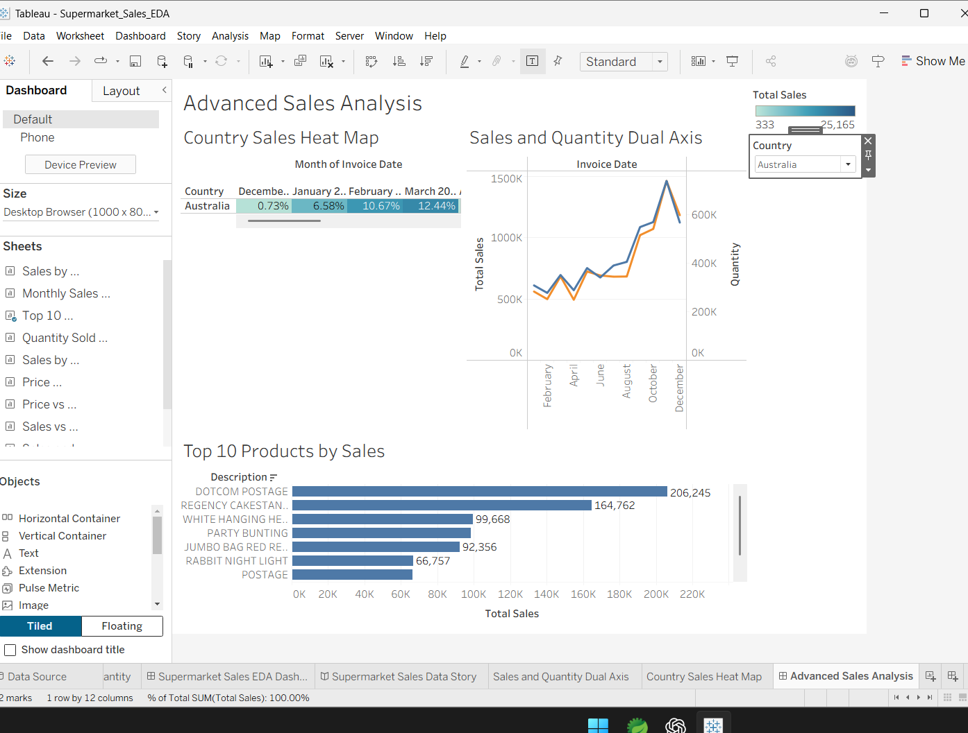
Figure 5. Country filter changed to a compact Single Value dropdown.
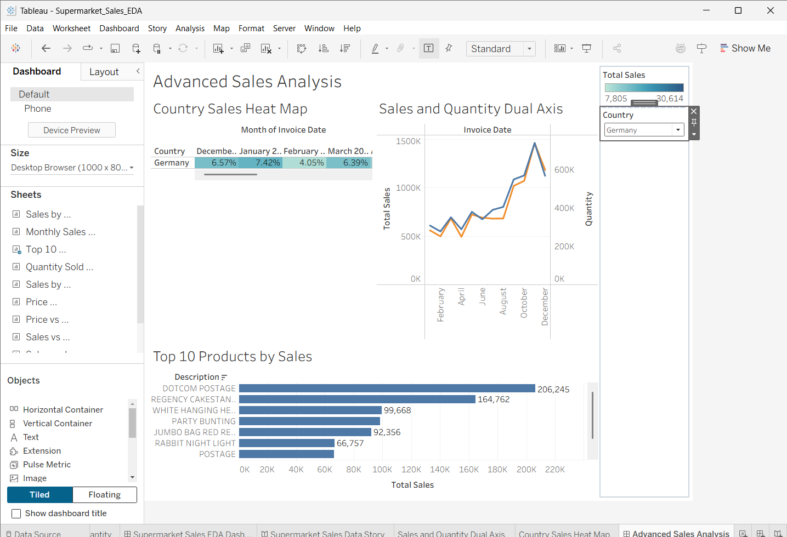
Figure 6. Final dashboard test with Germany selected; the dashboard updates successfully.

18. Evidence Summary
Evidence | What it demonstrates
Figure 1 | Select Metric parameter configuration.
Figure 2 | Selected Metric calculation used in the worksheet.
Figure 3 | Interactive switch from Total Sales to Quantity.
Figure 4 | Advanced Sales Analysis dashboard and existing Country filter.
Figure 5 | Country filter optimized to a single-value dropdown.
Figure 6 | Germany selected and dashboard interaction validated.

