Online Blood Bank Management System

Database Management Systems (UCS310)
B.Tech ( 2nd Year )


Computer Engineering

Aryan Sharma ( 1024030679 )
Maithli Arora ( 1024030687 )
Submitted to: Dr. Ananya Pandey

Session-Year ( Jan-May,2026 )

INTRODUCTION:

The Blood Bank Management System belongs to the healthcare information system domain, where accurate and timely management of medical resources is essential. Blood banks are responsible for collecting, storing, and distributing blood to hospitals and patients in emergency and routine medical situations. Efficient management of donor records, blood inventory, and hospital requests is crucial to ensure uninterrupted healthcare services.

The motivation for selecting this problem is its strong social relevance and real-world importance. In emergency situations such as accidents, surgeries, and critical illnesses, the availability of suitable blood can save lives. However, many blood banks still rely on manual registers or partially computerized systems, which are prone to errors and delays. Developing a digital database-driven system helps improve operational efficiency and reliability.

Using a Database Management System instead of a file-based system provides several advantages such as centralized data storage, data security, consistency, and efficient retrieval of information. A DBMS supports multi-user access, enforces data integrity through constraints, and provides mechanisms for backup and recovery. These features are essential for handling sensitive healthcare data and ensuring uninterrupted availability of critical information.

PROBLEM STATEMENT:

The existing blood bank management process in many organizations is largely manual or based on isolated record-keeping systems. Donor details, blood stock information, and hospital requests are often maintained in physical registers or separate files. This leads to problems such as data redundancy, inconsistency, delayed updates, and difficulty in accessing real-time information during emergencies.

Due to the absence of a centralized system, tracking blood availability, donor eligibility, and expiry dates becomes inefficient and error-prone. Manual systems also lack proper security and audit mechanisms, increasing the risk of data loss, unauthorized access, and incorrect record modification. As a result, timely decision-making and effective resource utilization are often compromised.

The scope of database usage in this project includes designing a centralized and normalized relational database to store and manage all blood bank-related information. The system will automate donor registration, blood stock updates, and request processing using SQL and PL/SQL mechanisms. It will ensure data accuracy, consistency, and reliability through constraints, triggers, and transactions, thereby addressing the limitations of the existing system and improving overall efficiency.

OBJECTIVES OF THE PROJECT:

The main objectives of the Digital Blood Bank and Donor Management System are as follows:

- To design a structured and efficient database using E–R data modeling techniques in order to accurately represent real-world entities such as donors, blood units, hospitals, and transactions.
- To convert the conceptual ER model into well-defined relational tables by identifying appropriate primary keys, foreign keys, and relationships among entities.
- To apply database normalization techniques up to Third Normal Form (3NF) / Boyce-Codd Normal Form (BCNF) to eliminate data redundancy and maintain data consistency.
- To implement the database system using SQL for data definition, manipulation, and retrieval, including the use of joins, subqueries, aggregate functions, and views.
- To utilize PL/SQL programming constructs such as stored procedures, functions, triggers, cursors, and exception handling for implementing business logic and automating system operations.
- To ensure data integrity, reliability, and consistency through the use of constraints, transactions, and concurrency control mechanisms, thereby maintaining accuracy and security of sensitive healthcare data.

SCOPE OF THE PROJECT:

The scope of the Digital Blood Bank and Donor Management System is limited to the design and implementation of a robust backend database system for managing blood bank operations efficiently. The project primarily focuses on database modeling, data management, and automation of core functionalities using SQL and PL/SQL.
Functional Boundaries of the System
- The system is designed to manage donor records, blood unit inventory, hospital details, and blood request processing.
- It supports registration of donors, storage and tracking of blood units, and issuing of blood to hospitals.
- The system maintains records of blood donations, blood distribution, and administrative activities.
- The project is restricted to backend database operations and does not include advanced user interface or real-time communication features.
- External integrations such as online payment systems, mobile applications, or GPS tracking are outside the scope of this project.

Types of Users Involved
- Administrator: Responsible for managing system users, maintaining database integrity, and overseeing all operations.
- Staff: Handles donor registration, blood collection, request processing, and blood issuing operations
- Hospital Users: Represent hospitals that place blood requests and receive blood units (access managed through administrative records).
All user activities are controlled through database procedures and privileges to ensure security and accountability.

Modules Covered ( Backend Focus )
- Donor Management Module
Manages donor registration, personal details, and donation history.
- Blood Inventory Management Module
Handles storage, availability status, and expiry management of blood units.
- Hospital and Request Management Module
Maintains hospital records and processes blood requests.
- Blood Issue and Distribution Module
Controls blood issuing operations using stored procedures and transaction management.
- Audit and Monitoring Module
Records administrative activities and system changes using triggers and audit logs.
- Reporting and Query Module
Generates analytical reports and summaries using SQL queries, views, and cursors.

PROPOSED SYSTEM DESCRIPTION:

The proposed Digital Blood Bank and Donor Management System is a centralized, database-driven application designed to efficiently manage blood donation, storage, and distribution processes. The system integrates various components such as donor management, blood inventory control, hospital request processing, and administrative monitoring within a single relational database framework.
All data related to donors, blood units, hospitals, requests, and transactions is stored in a structured and normalized format. The system uses SQL for data definition and manipulation, and PL/SQL for implementing business logic and automation. Core operations such as donor registration, blood issuing, and request approval are executed through stored procedures to ensure reliability and consistency.
The database system continuously enforces business rules and operational constraints using triggers, functions, and exception handling mechanisms. Automated processes such as expiry checking and audit logging help maintain data accuracy and accountability. Transactions are used to ensure that critical operations are completed fully or rolled back in case of failure.
Key Features and Functionalities
- Centralized storage and management of donor, blood unit, hospital, and request information
- Automated donor registration and validation using stored procedures.
- Real-time tracking of blood availability and expiry status.
- Secure processing of blood requests and distribution through transactional procedures.
- Automatic logging of critical operations for monitoring and auditing purposes.
- Efficient data retrieval using optimized SQL queries, views, and aggregate functions.
- Role-based access control implemented through administrative privileges.

Improvement in Efficiency, Consistency, and Data Integrity
The proposed system significantly enhances operational efficiency by automating routine database operations and reducing manual intervention. Stored procedures and triggers minimize processing time and prevent repetitive tasks, thereby improving overall system performance.
Data consistency is ensured through normalization, referential integrity constraints, and controlled access mechanisms. Foreign keys, unique constraints, and check constraints prevent invalid and duplicate data entries.
Data integrity and reliability are further strengthened through transaction management and exception handling. The use of COMMIT and ROLLBACK ensures that incomplete or erroneous operations do not affect the database state. Audit logging and automated validation mechanisms provide additional layers of security and accountability, making the system robust and dependable for healthcare data management.
DATABASE DESIGN:

Entity–Relationship (ER) Diagram
The Entity–Relationship (ER) model is used to represent the conceptual structure of the proposed database system. It identifies the major entities involved in blood bank operations, their attributes, and the relationships among them. The ER diagram provides a clear visualization of how data is organized and interconnected within the system.
Identification of Entities
- Donor
Represents individuals who donate blood. It stores personal and medical information of donors.
- Blood Unit
Represents individual blood packets collected from donors. It maintains information related to blood group, collection date, expiry date, and status.
- Blood Bank
Represents blood bank centers where blood units are stored and managed.
- Hospital
Represents hospitals that request and receive blood units.
- Blood Request
Represents requests placed by hospitals for specific blood groups and quantities.
- Donation Record
Represents the donation history linking donors with blood units.
- Issue Record
Represents records of blood units issued to hospitals.
- User Admin
Represents administrative staff responsible for managing system operations.
- Audit Log
Represents system logs used to track administrative activities.

Identification of Attributes
- Donor: donor_id, name, age, gender, blood_group, phone, email, address, last_donation_date

- Blood_Unit: unit_id, blood_group, collection_date, expiry_date, status, bank_id

- Blood_Bank: bank_id, bank_name, location, contact_no, email

- Hospital: hospital_id, hospital_name, address, contact_no, email

- Blood_Request: request_id, hospital_id, blood_group, quantity, request_date, status

- Donation_Record: record_id, donor_id, unit_id, donation_date, remark

- Issue_Record: issue_id, unit_id, hospital_id, issue_date, handled_by

- User_Admin: admin_id, username, password, role, created_at

- Audit_Log: log_id, admin_id, action, table_name, record_id, log_time

Identification of Relationships
- Donor – Donation_Record ( 1:N )
One donor can make multiple donations, but each donation record belongs to only one donor.

- Blood_Unit – Donation_Record ( 1:1 )
Each blood unit is associated with exactly one donation record.

- Blood_Bank – Blood_Unit ( 1:N )
One blood bank can store multiple blood units.

- Hospital – Blood_Request ( 1:N )
One hospital can place multiple blood requests.

- Hospital – Issue_Record ( 1:N )
One hospital can receive multiple blood units.

- Blood_Unit – Issue_Record ( 1:1 )
Each blood unit can be issued only once.

- User_Admin – Issue_Record ( 1:N )
One administrative user can handle multiple issue transactions.

- User_Admin – Audit_Log ( 1:N )
One administrative user can generate multiple audit records.

Cardinality and Constraints
- A donor may donate blood multiple times, but each donation is linked to a single donor.
- Each blood unit must belong to exactly one blood bank.
- A blood unit cannot be issued more than once.
- A hospital must exist before placing a blood request.
- Donor age is restricted between 18 and 65 years.
- Each issue record must be associated with a valid hospital and administrative user.
- Blood unit status is restricted to predefined values such as Available, Issued, and Expired.
- Duplicate donor phone numbers and administrative usernames are not allowed.

ER DIAGRAM REPRESENTATION

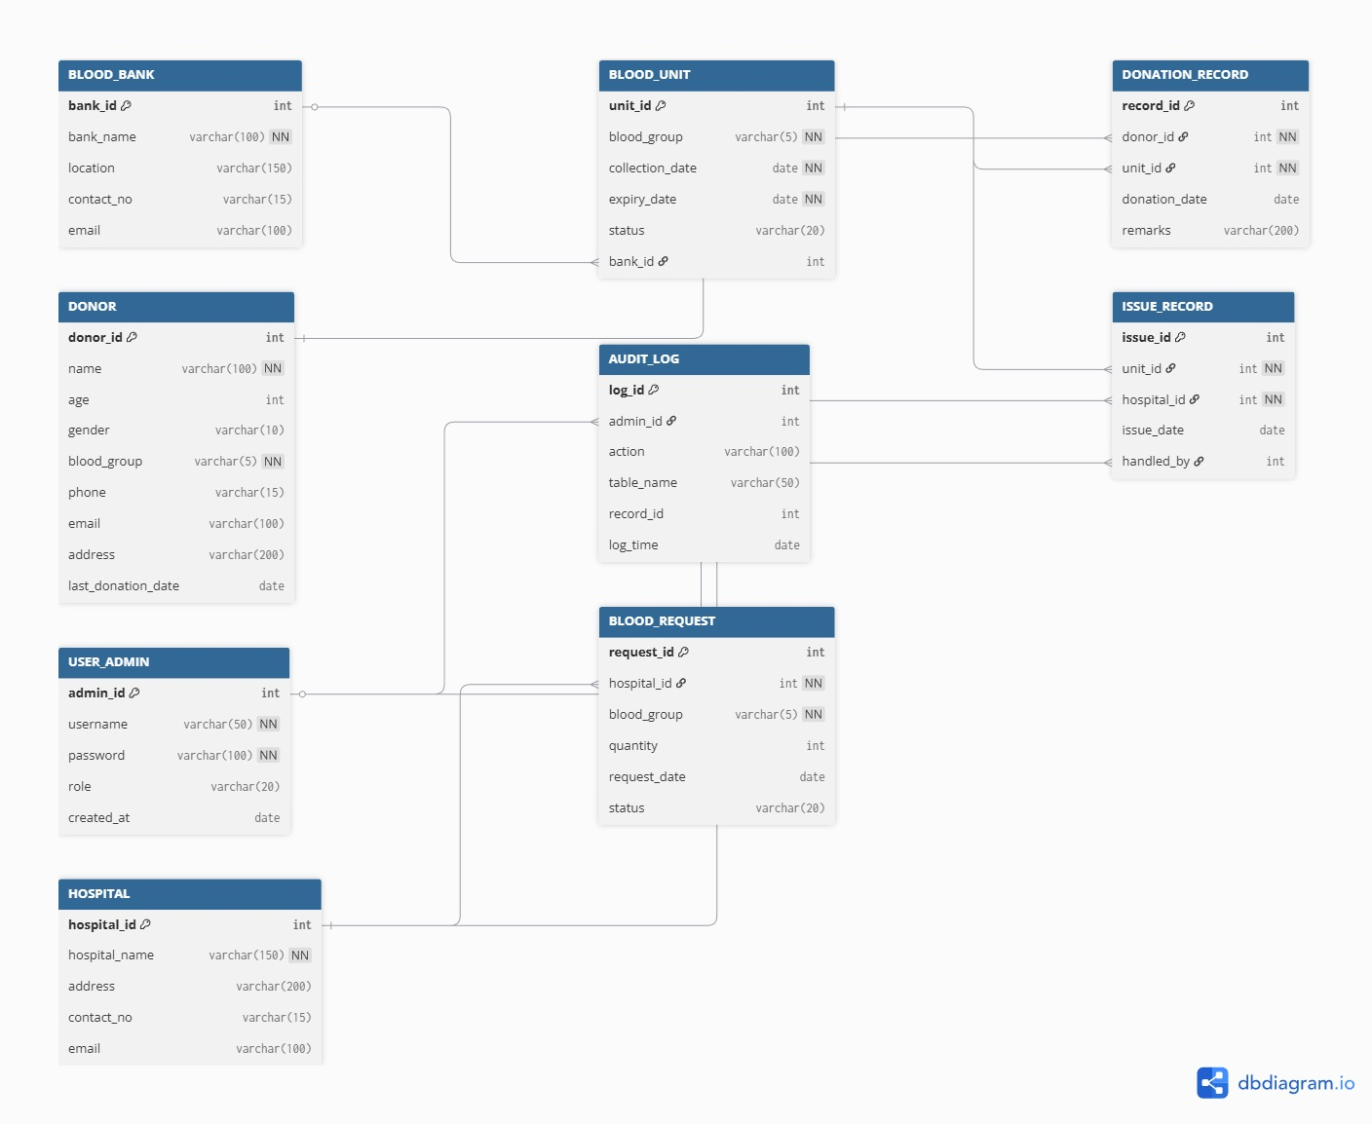

The ER diagram graphically represents the entities, attributes, and relationships described above, along with their cardinalities and constraints. It serves as the conceptual foundation for converting the system into relational tables.

RELATIONAL SCHEMA

The relational schema of the proposed Digital Blood Bank and Donor Management System is derived by converting the Entity–Relationship (ER) model into a set of normalized relational tables. Each relation is defined with appropriate primary keys and foreign keys to maintain data integrity and represent relationships among entities.
The schema ensures elimination of redundancy, supports efficient data retrieval, and enforces referential integrity constraints.
Primary And Foreign Keys
- BLOOD_BANK:
Primary Key: bank_id

- DONOR:
Primary Key: donor_id

- USER_ADMIN:
Primary Key: admin_id

- HOSPITAL:
Primary Key: hospital_id

- BLOOD_UNIT:
Primary Key: unit_id
Foreign Key: bank_id → BLOOD_BANK(bank_id)
- DONATION_RECORD:
Primary Key: record_id
Foreign Keys:
donor_id → DONOR(donor_id)
unit_id → BLOOD_UNIT(unit_id)

- BLOOD_REQUEST:
Primary Key: request_id
Foreign Key: hospital_id → HOSPITAL(hospital_id)

- ISSUE_RECORD:
Primary Key: issue_id
Foreign Keys:
unit_id → BLOOD_UNIT(unit_id)
hospital_id → HOSPITAL(hospital_id)
handled_by → USER_ADMIN(admin_id)

- AUDIT_LOG
Primary Key: log_id
Foreign Key: admin_id → USER_ADMIN(admin_id)

Table Relationships
- Each Blood Unit is associated with one Blood Bank.
- Each Donation Record links one Donor with one Blood Unit.
- Each Blood Request is placed by a specific Hospital.
- Each Issue Record links a Blood Unit, Hospital, and Administrative User.
- Each Audit Log entry is associated with an administrative user.
NORMALIZATION

Normalization is the systematic process of organizing data in a database to minimize redundancy and eliminate undesirable characteristics such as insertion, update, and deletion anomalies. In the proposed Blood Bank Management System, normalization techniques have been applied up to Third Normal Form (3NF) and Boyce-Codd Normal Form (BCNF) to ensure data consistency, integrity, and efficient data management.

Identification of Functional Dependencies
Functional dependencies represent the relationships between attributes in a relation. In the proposed system, the following major functional dependencies have been identified:
- DONOR
donor_id → name, age, gender, blood_group, phone, email, address, last_donation_date
phone → donor_id

- BLOOD BANK
bank_id → bank_name, location, contact_no, email
contact_no → bank_id

- HOSPITAL
hospital_id → hospital_name, address, contact_no, email

- BLOOD UNIT
unit_id → blood_group, collection_date, expiry_date, status, bank_id

- DONATION RECORD
record_id → donor_id, unit_id, donation_date, remarks
unit_id → record_id

- REQUEST RECORD
request_id → hospital_id, blood_group, quantity, request_date, status

- ISSUE RECORD
issue_id → unit_id, hospital_id, handled_by, issue_date
unit_id → issue_id

- USER ADMIN
admin_id → username, password, role, created_at
username → admin_id

- AUDIT LOG
log_id → admin_id, action, table_name, record_id, log_time

These dependencies indicate that all non-key attributes are functionally dependent on the primary key of their respective relations.

NORMALIZATION PROCESS

First Normal Form (1NF)
A relation is in First Normal Form if all attributes contain atomic and indivisible values, and no repeating groups exist.
In the proposed system:
- Each field contains single-valued data.
- Multi-valued and composite attributes are eliminated.
- Separate tables are created for distinct entities.
Example: Each donor has a single phone number per record, and blood group values are stored in individual fields.
Therefore, all relations satisfy 1NF.

Second Normal Form (2NF)
A relation is in Second Normal Form if it is in 1NF and all non-key attributes are fully functionally dependent on the entire primary key
In the proposed system:
- All tables use single-attribute primary keys.
- There are no partial dependencies.
- Each non-key attribute depends completely on its primary key.
Example: Donor details depend only on donor_id and not on any part of a composite key.
Therefore, all relations satisfy 2NF.
Third Normal Form (3NF)
A relation is in Third Normal Form if it is in 2NF and contains no transitive dependencies.
In the proposed system:
- Non-key attributes do not depend on other non-key attributes.
- Related information is stored in separate tables.
Example:
Hospital contact information is stored only in the HOSPITAL table and not repeated in other relations.
Therefore, all relations satisfy 3NF.

Boyce-Codd Normal Form (BCNF)
A relation is in BCNF if for every functional dependency X → Y, X is a candidate key
In the proposed system:
- Each functional dependency has a determinant that is a candidate key.
- Unique constraints are applied to key attributes such as phone numbers and usernames.
Hence, the major relations conform to BCNF.

FINAL NORMALISED TABLE STRUCTURE

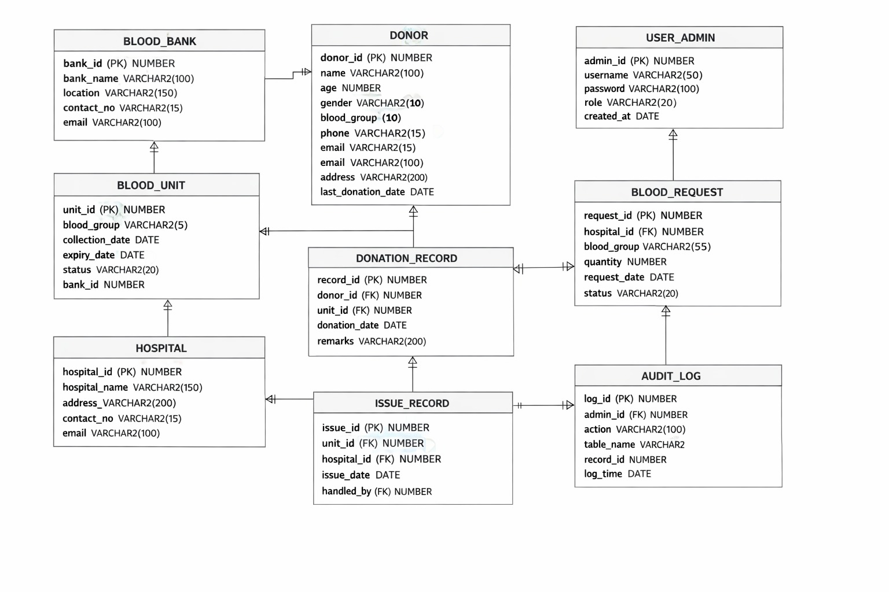

The application of normalization techniques up to 3NF/BCNF ensures that the database design is free from update, insertion, and deletion anomalies. It enhances maintainability, scalability, and reliability of the Blood Bank Management System.

DATABASE IMPLEMENTATION

The database implementation phase involves converting the logical database design into a physical database using SQL and PL/SQL. This phase focuses on creating tables, inserting data, defining relationships, and implementing business logic to support automated and secure operations.

- SQL IMPLEMENTATION
- Data Definition Language (DDL)
DDL commands are used to define the structure of the database objects. In this project, DDL statements are used to create and manage tables, constraints, and views.
Examples:
- Creation of tables using CREATE TABLE
- Definition of primary keys and foreign keys
- Application of CHECK, UNIQUE, and NOT NULL constraints
- Use of ALTER and DROP commands for schema modification
- Creation of database views

- Data Manipulation Language (DML)
DML commands are used to insert, update, delete, and retrieve records from database tables.

In this project, DML operations are performed to:
- Register donors
- Store blood units
- Record donations
- Process hospital requests
- Maintain audit logs

- SELECT Queries
- JOIN queries
used to retrieve data from multiple tables.

Example:
SELECT d.name, b.blood_group
FROM DONOR d
JOIN DONATION_RECORD dr ON d.donor_id = dr.donor_id;

- SUB queries
Used to retrieve conditional data

Example:
SELECT hospital_name
FROM HOSPITAL
WHERE hospital_id IN
(SELECT hospital_id FROM BLOOD_REQUEST WHERE status='Pending');

- Aggregate Functions
Used for statistical analysis
Example:
SELECT COUNT(*) FROM BLOOD_UNIT WHERE status='Available';

- GROUP BY and HAVING Clauses
Used to group data

Example:
SELECT blood_group, COUNT(*)
FROM BLOOD_UNIT
GROUP BY blood_group
HAVING COUNT(*) > 1;

- VIEWS
Views are created to provide simplified and secure access to frequently used data.

Example:
CREATE VIEW available_blood_view AS
SELECT unit_id, blood_group
FROM BLOOD_UNIT
WHERE status='Available';
Views help in hiding complex joins and improving query readability.

- PL/SQL COMPONENTS
- Stored Procedures
Stored procedures are used to perform frequently executed operations and enforce business rules.
The following major procedures are implemented:
- register_donor – Registers new donors with validation.
- issue_blood – Issues blood units after availability verification.
- approve_request – Approves hospital blood requests.
- show_available_blood – Displays available stock count.
- These procedures improve performance and reduce code redundancy.

- Functions
User-defined functions are implemented to return calculated values.
Example:
check_stock – Returns the number of available blood units for a given blood group.
Functions support modular and reusable database logic.

- Triggers
Triggers are used to automatically execute predefined actions in response to database events.
The following triggers are implemented:
- trg_log_issue – Automatically records blood issuing activities.
- trg_check_expiry – Automatically updates expired blood unit status.
Triggers enhance automation and prevent manual errors.
- Cursors
Cursors are used to process multiple rows sequentially.

Example:
donor_report – Generates donor reports using cursor-based iteration.
Cursors enable row-by-row processing for reporting purposes.

- Exception Handling
Exception handling is implemented to manage runtime errors and ensure system stability.
Examples of handled exceptions include:
- NO_DATA_FOUN
- DUP_VAL_ON_INDE
- OTHERS
These mechanisms prevent abrupt termination and maintain transaction safety.

TRANSACTION MANAGEMENT AND CONCURRENCY

Transaction management is an essential component of a reliable database system. It ensures that database operations are executed in a consistent and secure manner. In the proposed Blood Bank Management System, transaction management and concurrency control mechanisms are implemented to maintain data accuracy, reliability, and system stability.

Use of Transactions:
In this project, transactions are used in critical operations such as donor registration, blood issuing, and request approval.

The following transaction control statements are utilized:
- COMMIT: Used to permanently save all changes made during a transaction. After successful execution of operations such as inserting donor records or issuing blood units, the COMMIT statement ensures that the data is stored permanently in the database.
- ROLLBACK: Used to undo changes when an error occurs during a transaction. In case of invalid input or system failure, ROLLBACK restores the database to its previous consistent state.
- SAVEPOINT: Used to create intermediate checkpoints within a transaction. Although SAVEPOINT is not extensively used in this project, it can be applied to partially undo operations without rolling back the entire transaction.

Ensuring ACID Properties:
The system ensures the four fundamental ACID properties of database transactions as follows:

- Atomicity :
All operations within a transaction are treated as a single unit. Either all changes are committed successfully, or none are applied. This is achieved using COMMIT and ROLLBACK statements in stored procedures.

- Consistency:
The database always transitions from one valid state to another. Integrity constraints, triggers, and validation procedures ensure that only valid data is stored in the database.

- Isolation:
Multiple users can perform transactions simultaneously without interfering with each other. Oracle’s isolation mechanisms ensure that uncommitted changes made by one transaction are not visible to others.

- Durability:
Once a transaction is committed, the changes remain permanent even in case of system failure. Oracle’s recovery mechanisms and logging features guarantee durability.

Concurrency Control and Data Consistency :

Concurrency control manages simultaneous access to the database by multiple users. In the proposed system, Oracle’s built-in concurrency control mechanisms are used to ensure data consistency and prevent conflicts.
The following techniques are applied:
- Locking Mechanism:
Oracle automatically applies row-level locks during update and insert operations. This prevents multiple users from modifying the same data simultaneously.

- Read Consistency:
Oracle provides consistent read operations, ensuring that users view stable data even when other transactions are in progress.

- Transaction Isolation:
The system uses Oracle’s default isolation level, which prevents dirty reads and ensures reliable transaction processing.

- Deadlock Prevention:
Oracle detects and resolves deadlocks automatically, ensuring uninterrupted system operations.

These mechanisms enable safe multi-user access and maintain the integrity of sensitive healthcare data.
TOOLS AND TECHNOLOGIES USED

DBMS Software:
Oracle Database is used as the primary Database Management System for this project. It provides strong support for relational data modeling, transaction management, security, and PL/SQL programming. Its robustness and scalability make it suitable for handling sensitive healthcare data efficiently.

SQL/PL SQL:
SQL is used for defining database structures, inserting and manipulating data, and retrieving information using queries, views, and constraints.
PL/SQL is used for implementing business logic, stored procedures, functions, triggers, cursors, and exception handling. It enhances the functionality of SQL by supporting procedural programming features.

DEVELOPMENT AND INTERFACE TOOLS:
Oracle SQL Developer is used as the primary development environment for writing, executing, and testing SQL and PL/SQL programs. It provides a user-friendly interface for database administration and query execution.
Online tools such as dbdiagram.io and diagrams.net are used for designing and visualizing ER diagrams and relational schemas.
EXPECTED OUTCOMES

The successful implementation of the Digital Blood Bank and Donor Management System is expected to result in a reliable, efficient, and well-structured database system that supports automated and secure management of blood bank operations.

The major expected outcomes of the project are as follows:
- Successful Creation of a Normalized Database
The system will be developed using normalization techniques up to Third Normal Form (3NF) and Boyce-Codd Normal Form (BCNF). This ensures minimal data redundancy, reduced storage requirements, and improved maintainability of the database.

- Efficient Data Retrieval Using SQL Queries
The implementation of optimized SQL queries, joins, views, and aggregate functions will enable fast and accurate retrieval of information such as blood availability, donor records, and hospital requests. This supports effective decision-making and operational planning.

- Automation Using Procedures, Functions, and Triggers
The use of PL/SQL stored procedures, functions, and triggers will automate critical operations such as donor registration, blood issuing, request approval, audit logging, and expiry management. This reduces manual intervention and minimizes human errors.
- Improved Data Consistency and Integrity
Data consistency and integrity will be ensured through primary keys, foreign keys, constraints, and transaction control mechanisms. These features prevent invalid, duplicate, and inconsistent data entries, thereby maintaining the reliability of the system.

- Enhanced System Reliability and Security
The application of access controls, audit logs, and exception handling mechanisms will improve system security and accountability. Sensitive healthcare information will be protected against unauthorized access and misuse.

- Scalable and Maintainable Database Architecture
The modular and well-documented design of the database will allow easy future enhancements, such as integration with web or mobile applications, without major structural changes.

Conclusion
The proposed system will provide a strong foundation for managing blood bank operations in a structured and automated manner. By combining normalization, automation, and transaction management, the project will deliver a dependable and practical solution for healthcare data management.

Signature of Faculty

