This is a project I did for my bootcamp at brainstation.I will start with the issues that I faced and how I resolved it

1.I downloaded the CVS file and the json data in the file. I could not clear it using the various excel techniques. So my husband helped me with a python script(have to learn python he he he) and with that I was able to clean the excel.

2.The next thing I face is the issue with special characters. I tried various methods including creating multiple columns in excel and changing one special character and even find and replace method but since there are multiple characters it is hard. So my instructor said he will help me

3.The next was using what I learned in class. I used the table import wizard in mysql to import the csv,but all the records were not getting pulled. So I decided to do it manually.

4.So manually I created a table using the create table movie_dataset and then used this code

LOAD DATA local INFILE 'C:/Users/Maithreyee/Downloads/movies_dataset.csv'

INTO TABLE movies_data

FIELDS TERMINATED BY ','

ENCLOSED BY '"'

LINES TERMINATED BY '\n'

IGNORE 1 ROWS;

5. When I used this I got an error 1290 saying –sercure-file-prive in mysql.Due to this I could not import.

a.So using the internet I searched and found where I go to **C drive** in that I click on view on the top bar and click on hidden item box.

b. When I click on that I got ProgramData which was one of the file path mentioned then C:/ProgramData/MySQL/MySQL Server 8.0.

c.Once I reach here I click on a file named **my** and in that search for this variable sercure-file-prive and change its path to null.So originally it was sercure-file-prive=’C:/ProgramData/MySQL/MySQL Server 8.0./Uploads now it is

sercure-file-prive=” “.

d. After changing it I tried to run code in point four again,the same error was coming 2064 was still popping so what I was suppose to do was

Using service on your desktop stop MYSQL 80 service then restart the service again then restart the workbench again ,then the variable sercure-file-prive=” “ was set to null.

e.I got error 30 which is permission denied for this I had to include the command local in the code LOAD DATA INFILE will now become LOAD DATA LOCAL INFILE

f. After this happened we experienced an other error which is error 3948 which is local data disabled so for this in mysql workbench

Show global variables like 'local_infile';

It is not true then

Set global local_infile =true.

G. I get the error 2068 which is restriction on access to root user hence file request rejected.

So for this I have go to my mysql connection page 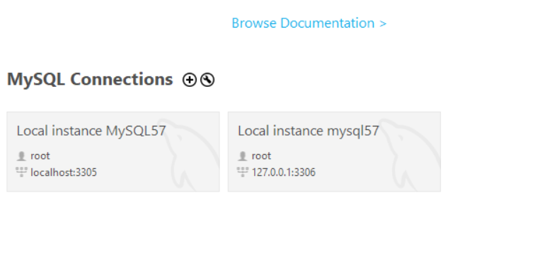

Then left click and click on edit connection 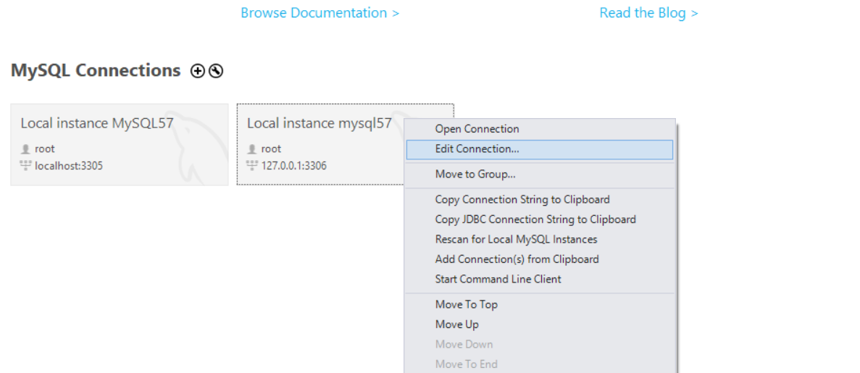

Then click on advanced option and in others typeopt_local_infile=1

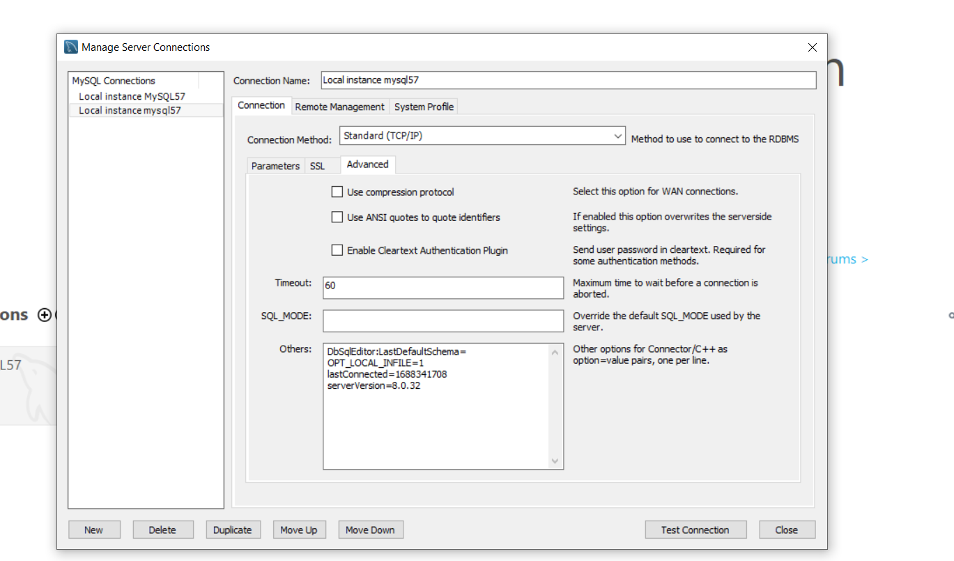

After doing this I ran the command in point 4 and it worked but not all rows came so will check the schema of the database.

After you import kindly look into the command ,don't just copy paste understand and make changes accordingly

1. **LOAD DATA INFILE –** It specifies the location of the input CSV file.
2. **INTO TABLE –** It specifies the table into which data is to be populated.
3. **FIELDS TERMINATED BY –** It specifies the delimiter through which the individual values in the file are separated.
4. **ENCLOSED BY –** It specifies the symbol which specifies the values in the CSV file.
5. **LINES TERMINATED BY –** It specifies the code for a line break.
6. **IGNORE 1 ROWS –** It specifies the number of lines to be ignored from an input CSV file which might contain column labels, etc.

LOAD DATA local INFILE 'C:/Users/Maithreyee/Downloads/movies_dataset.csv'

INTO TABLE movies_data

FIELDS TERMINATED BY ','

ENCLOSED BY '"'

LINES TERMINATED BY '\n'

IGNORE 1 ROWS;

While loading the database into the mysql workbench I got into a lot of problems

1.One is a special character. If you want import with it it will lead to an error saying encoding is not possible. So you have to run a script to change the special characters with a null space

2.Even mentioning date make sure you check the format as mysql is the format of yyyy-mm-dd so make the change accordingly.

3. Be very careful while adding the date type in the import wizard as even a space can cause error while importing values.

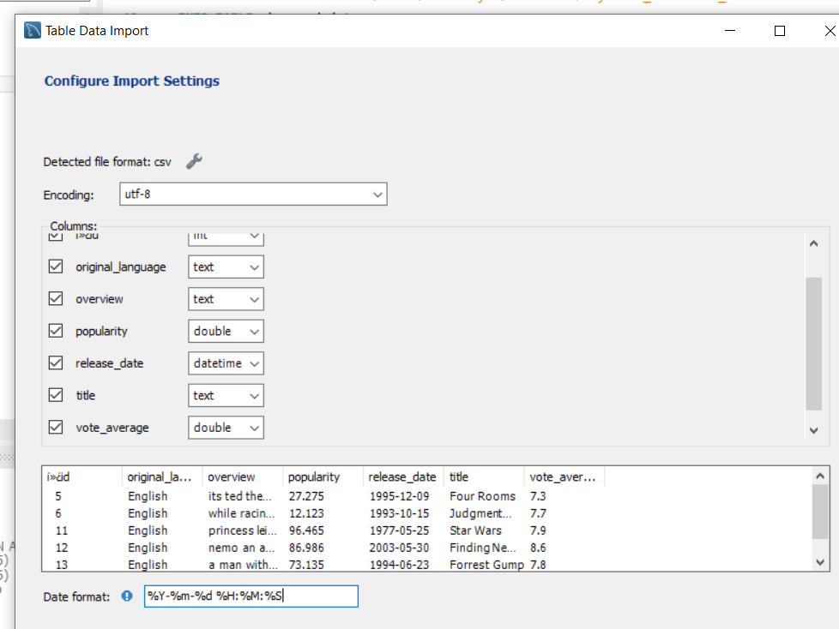

Now in the above there is %H %M%S remove that as you do t have the timestamp and make sure there is no space after %d as sql thinks there is space after you release date so be very careful

Below is the image as how it should be done.

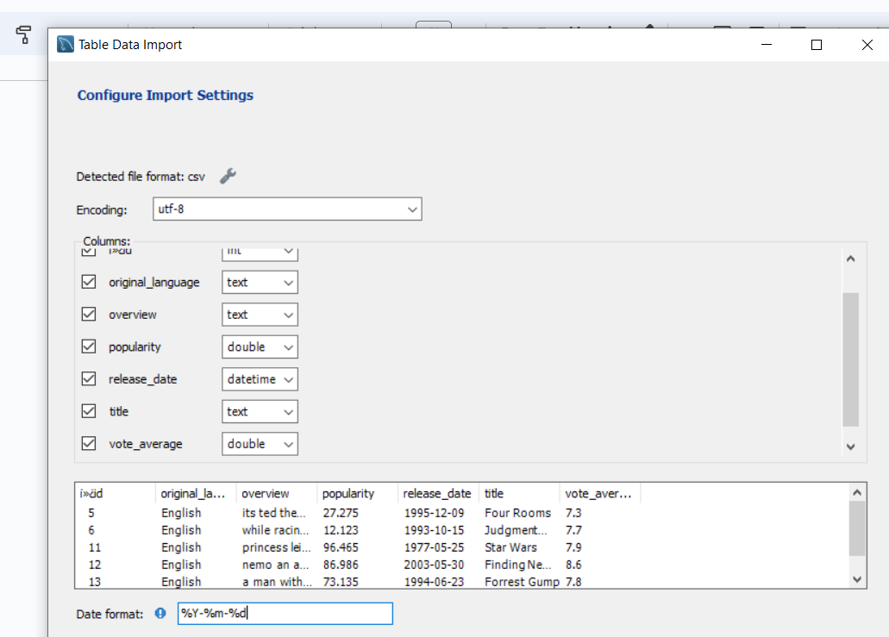

4.There won't be a proper unique value for you to put it as primary key ,so you combine two keys and form a super key to import values.

5. Sometime when data is separated by comma replace it with semicolon because of this line of code **‘FIELDS TERMINATED BY ','’** will cause it to terminate

6.Empty cells in the excel because of which data won’t get imported so in such a case add values like 0 in case of numbers and in case of string add N/A and in case of date add 9999-09-09

7. When names are given in the excel sometime the names would be in the form of +@Yuki this leads to the error #NAME?.So to remove this use CTRL +F and in that dialogue box where **look in**  is present change from Formulas and Values and then you can change the values manually.

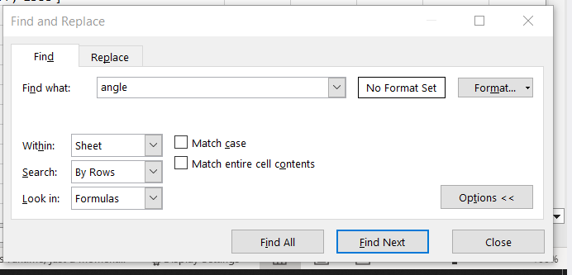

So I started my analysis so I am doing a profile of the database

1.So I have two databases on anime so I am combining two databases to find the common records,before I do this I will do individual analysis

Anime_new database

No of rows in the anime_table -**16217**

select distinct *

from anime_new an;

No of rows in review-**192117**

select *

from review;

No of rows in profile-**81727**

select *

from profile

Now I am exploring each table individually.

Profile table

**Q.Trying to find no of male and female users in the table**

Query

select gender,count(profile) as no

from profile

group by gender;

Note-Change the where clause to male

No of female records is -16018

No of male records- 37096

No of non binary-28631.

Note- When the results came out I saw four column as non binary has been specified in two different ways

|  |  |  |
| --- | --- | --- |
| Male |  | 21196 |
| Female |  | 9269 |
| Non Binary |  | 17011 |
| Non-Binary |  | 426 |

**Q.Who has the most no of favorite animes of each user give the top ten**

So for this question I had to split the array [9253;5514;1535] into multiple rows so that I could count the numbers of anime each user has watched and the top favorite anime watched.

To do this I used the power query tool in excel where there is an option called split columns and in that I got another option called split rows. So I split it into rows and uploaded my data set and after that. With this I am able to answer my above question.

So this is power query

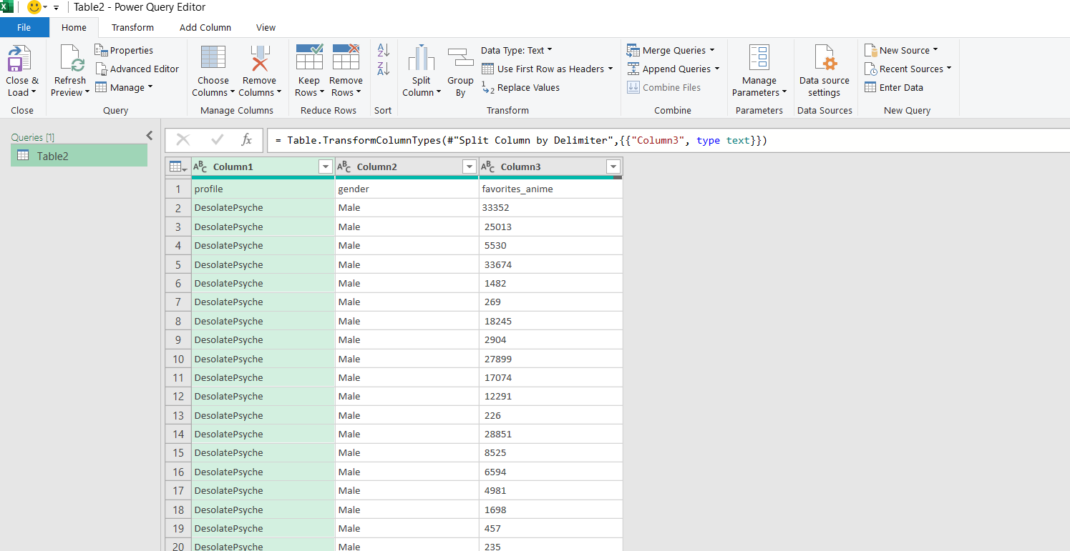

And below is the dialogue box for which you can split the array values into rows.

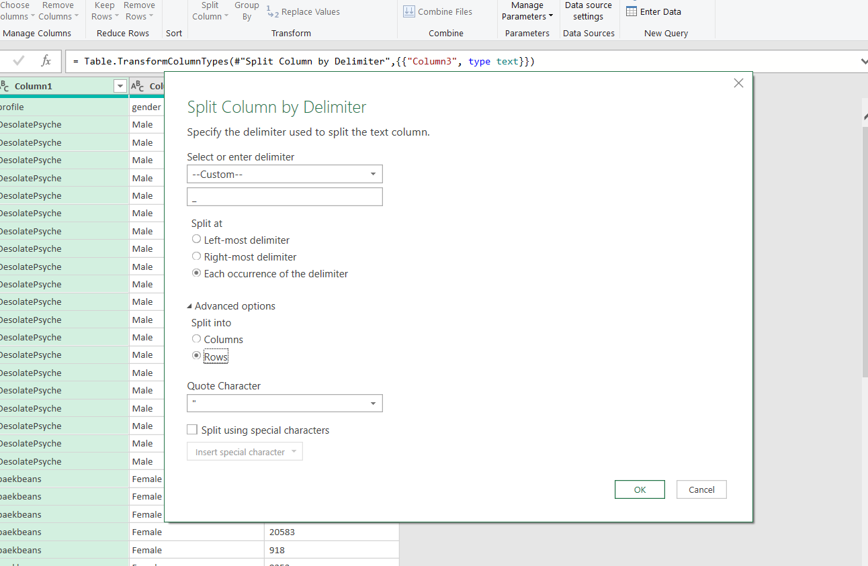

Now will answer the question with the query .The top user with most watched anime

select distinct profile,count(favorites_anime)as total_anime

from profile

group by profile

order by total_anime DESC

limit 10;

| AnimeFlyz | 20 |
| --- | --- |
| AnimeMarathon | 20 |
| aliyn89 | 20 |
| -asphyxia- | 20 |
| 71 | 20 |
| animejas | 20 |
| animesthabomb | 20 |
| 10q | 20 |
| anime-prime | 20 |
| anime_feels | 20 |

**Q .What are the top watched anime among users?**

select favorites_anime,count(favorites_anime) as top_watched_anime

from profile

group by favorites_anime

order by top_watched_anime DESC

limit 11;

**Id count**

|  | 5114 | 4919 |
| --- | --- | --- |
|  | 9253 | 4627 |
|  | 1535 | 3363 |
|  | 11061 | 3152 |
|  | 4181 | 2796 |
|  | 1575 | 2782 |
|  | 2001 | 2641 |
|  | 1 | 2401 |
|  | 30 | 2318 |
|  | 21 | 2131 |

**Q. Now a follow up question,what are the titles of these anime ids ?**

select favorites_anime, count(*) as total_no,a.title

from profile p

left join anime_new a on a.anime_id= p.favorites_anime

group by favorites_anime,a.title

order by total_no DESC;

|  | 5114 | 4919 | Fullmetal Alchemist: Brotherhood |
| --- | --- | --- | --- |
|  | 9253 | 4627 | Steins;Gate |
|  | 1535 | 3363 | Death Note |
|  | 11061 | 3152 | Hunter x Hunter (2011) |
|  | 4181 | 2796 | Clannad: After Story |
|  | 1575 | 2782 | Code Geass: Hangyaku no Lelouch |
|  | 2001 | 2641 | Tengen Toppa Gurren Lagann |
|  | 1 | 2401 | Cowboy Bebop |
|  | 30 | 2318 | Neon Genesis Evangelion |
|  | 21 | 2131 | One Piece |

Now analysis on Review

Q. **Which user has rated the most number of anime**

Profile id

|  | Sidewinder51 | 762 |
| --- | --- | --- |
|  | Stark700 | 743 |
|  | ktulu007 | 648 |
|  | LegendAqua | 566 |
|  | ggultra2764 | 491 |
|  | literaturenerd | 464 |
|  | BanjoTheBear | 390 |
|  | PyraXadon | 388 |
|  | BabyGirl06301 | 328 |
|  | angelsreview | 321 |

I wanted to give the userid as well along with their profiles but I realized that they have rated using different user id due to which I cannot give the user id along with their profile.

How I found this was checked the uid of the second profile

select uid from review

where profile='Stark700';

And with this got multiple user id so I realized I will not get the correct answer.

Q.**Now in the review table I want to find the anime with the top score and most votes.**

select r.anime_id,r.score,a.title,count(r.profile) as no_of_votes

from review r

left join anime_new a on r.anime_id=a.anime_id

group by r.anime_id,r.score,a.title

order by r.score DESC, no_of_votes DESC

limit 10;

|  | **anime_id** | **score** | **title** | **nono_of_votes** |
| --- | --- | --- | --- | --- |
|  | 413 | 11 | Hametsu no Mars | 1 |
|  | 9253 | 10 | Steins;Gate | 858 |
|  | 5114 | 10 | Fullmetal Alchemist: Brotherhood | 840 |
|  | 4181 | 10 | Clannad: After Story | 818 |
|  | 32281 | 10 | Kimi no Na wa. | 710 |
|  | 1535 | 10 | Death Note | 708 |
|  | 2001 | 10 | Tengen Toppa Gurren Lagann | 460 |
|  | 9756 | 10 | Mahou Shoujo Madokaâ˜…Magica | 448 |
|  | 4224 | 10 | Toradora! | 438 |
|  | 1575 | 10 | Code Geass: Hangyaku no Lelouch | 420 |

21 10 One Piece 416

Q. **What is the anime with the least score and votes.**

select r.anime_id,r.score,a.title,count(r.profile) as no_of_votes

from review r

left join anime_new a on r.anime_id=a.anime_id

group by r.anime_id,r.score,a.title

order by r.score , no_of_votes ;

Anime_id score title no_of_votes

219 1 Kidou Senkan Nadesico: The Prince of Darkness 1

29906 1 Kakari 1

146 1 Kono Minikuku mo Utsukushii Sekai 1

5622 1 The Chocolate Panic Picture Show 1

35971 1 Onyankopon 1

8925 1 Kobe to Watashi 1

2232 1 Funny Pets 1

31267 1 Akuma no Kairozu 1

16692 1 Jigoku Youchien 1

1102 1 Urda 1

Q. Which anime have the least overall score and the most overall score?

With this I realized that score and overall score are the same.

|  | 413 | 11 | Hametsu no Mars | 1 |
| --- | --- | --- | --- | --- |
|  | 9253 | 10 | Steins;Gate | 858 |
|  | 5114 | 10 | Fullmetal Alchemist: Brotherhood | 840 |
|  | 4181 | 10 | Clannad: After Story | 818 |
|  | 32281 | 10 | Kimi no Na wa. | 710 |
|  | 1535 | 10 | Death Note | 708 |
|  | 2001 | 10 | Tengen Toppa Gurren Lagann | 460 |
|  | 9756 | 10 | Mahou Shoujo Madokaâ˜…Magica | 448 |
|  | 4224 | 10 | Toradora! | 438 |
|  | 1575 | 10 | Code Geass: Hangyaku no Lelouch | 420 |
|  | 21 | 10 | One Piece | 416 |

Now the least score

|  | 219 | 1 | Kidou Senkan Nadesico: The Prince of Darkness | 1 |
| --- | --- | --- | --- | --- |
|  | 29906 | 1 | Kakari | 1 |
|  | 146 | 1 | Kono Minikuku mo Utsukushii Sekai | 1 |
|  | 5622 | 1 | The Chocolate Panic Picture Show | 1 |
|  | 35971 | 1 | Onyankopon | 1 |
|  | 8925 | 1 | Kobe to Watashi | 1 |
|  | 2232 | 1 | Funny Pets | 1 |
|  | 31267 | 1 | Akuma no Kairozu | 1 |
|  | 16692 | 1 | Jigoku Youchien | 1 |
|  | 1102 | 1 | Urda | 1 |

Q. Let us find the anime with the best stories and the worst stories

select r.anime_id,r.story,a.title,count(r.profile) as no_of_votes

from review r

left join anime_new a on r.anime_id=a.anime_id

group by r.anime_id,r.story,a.title

order by r.story , no_of_votes ;

Best

|  | 413 | 11 | Hametsu no Mars | 1 |
| --- | --- | --- | --- | --- |
|  | 9253 | 10 | Steins;Gate | 906 |
|  | 1535 | 10 | Death Note | 820 |
|  | 5114 | 10 | Fullmetal Alchemist: Brotherhood | 810 |
|  | 4181 | 10 | Clannad: After Story | 762 |
|  | 9756 | 10 | Mahou Shoujo Madokaâ˜…Magica | 490 |
|  | 21 | 10 | One Piece | 450 |
|  | 1575 | 10 | Code Geass: Hangyaku no Lelouch | 440 |
|  | 32281 | 10 | Kimi no Na wa. | 430 |
|  | 2001 | 10 | Tengen Toppa Gurren Lagann | 364 |
|  | 9989 | 10 | Ano Hi Mita Hana no Namae wo Bokutachi wa Mada Shiranai. | 342 |

Worst

|  | 29317 | 1 | Saenai Heroine no Sodatekata: Ai to Seishun no Service-kai | 1 |
| --- | --- | --- | --- | --- |
|  | 29597 | 1 | Hana | 1 |
|  | 29617 | 1 | Good-by Elvis and USA | 1 |
|  | 29771 | 1 | Recorder | 1 |
|  | 29854 | 1 | Ushio to Tora (TV) | 1 |
|  | 29906 | 1 | Kakari | 1 |
|  | 29908 | 1 | Kodomo no Kaitei no Koto | 1 |
|  | 29979 | 1 | Petting a Dog | 1 |
|  | 30100 | 1 | Black Bullet: Tenchuuï¼ŠGirls | 1 |
|  | 30328 | 1 | Head Spoon | 1 |

**Q. The anime with the best animation and the worst animation**

**select r.anime_id,r.animation,a.title,count(r.profile) as no_of_votes**

**from review r**

**left join anime_new a on r.anime_id=a.anime_id**

**group by r.anime_id,r.animation,a.title**

**order by r.animation , no_of_votes ; just add DESC to get the best in the order by clause**

Best

|  | 32281 | 10 | Kimi no Na wa. | 1010 |
| --- | --- | --- | --- | --- |
|  | 33352 | 10 | Violet Evergarden | 626 |
|  | 1535 | 10 | Death Note | 564 |
|  | 5114 | 10 | Fullmetal Alchemist: Brotherhood | 548 |
|  | 4181 | 10 | Clannad: After Story | 512 |
|  | 9253 | 10 | Steins;Gate | 400 |
|  | 9756 | 10 | Mahou Shoujo Madokaâ˜…Magica | 388 |
|  | 2001 | 10 | Tengen Toppa Gurren Lagann | 350 |
|  | 30276 | 10 | One Punch Man | 350 |
|  | 38000 | 10 | Kimetsu no Yaiba | 298 |

Worst

|  | 34631 | 1 | Aitata Bocchi | 1 |
| --- | --- | --- | --- | --- |
|  | 38851 | 1 | Virtual-san wa Miteiru | 1 |
|  | 35739 | 1 | Pikotarou no Lullaby Lullaby (TV) | 1 |
|  | 30328 | 1 | Head Spoon | 1 |
|  | 28637 | 1 | Dreams | 1 |
|  | 33948 | 1 | Hinako Note | 1 |
|  | 22157 | 1 | Yasashii Kinyoubi | 1 |
|  | 6950 | 1 | Aos | 1 |
|  | 3533 | 1 | Gakuentoshi Varanoir Joukan | 1 |
|  | 7024 | 1 | Heya | 1 |

**Q. The anime with the best sound and the worst sound effects.**

select r.anime_id,r.sound,a.title,count(r.profile) as no_of_votes

from review r

left join anime_new a on r.anime_id=a.anime_id

group by r.anime_id,r.sound,a.title

order by r.sound DESC, no_of_votes DESC ;

Remove DESC to get the worst in order by clause.

**Best anime with sound effects**

|  | 32281 | 10 | Kimi no Na wa. | 648 |
| --- | --- | --- | --- | --- |
|  | 1535 | 10 | Death Note | 632 |
|  | 4181 | 10 | Clannad: After Story | 618 |
|  | 5114 | 10 | Fullmetal Alchemist: Brotherhood | 606 |
|  | 9253 | 10 | Steins;Gate | 522 |
|  | 9756 | 10 | Mahou Shoujo Madokaâ˜…Magica | 476 |
|  | 1 | 10 | Cowboy Bebop | 474 |
|  | 2001 | 10 | Tengen Toppa Gurren Lagann | 406 |
|  | 33352 | 10 | Violet Evergarden | 338 |
|  | 9989 | 10 | Ano Hi Mita Hana no Namae wo Bokutachi wa Mada Shiranai. | 322 |

**Worst**

|  | 2524 | 1 | Jungle de Ikou! | 1 |
| --- | --- | --- | --- | --- |
|  | 10838 | 1 | Double-J | 1 |
|  | 1611 | 1 | Galerians: Rion | 1 |
|  | 5624 | 1 | Biohazard 4D-Executer | 1 |
|  | 33274 | 1 | Onara Gorou | 1 |
|  | 38162 | 1 | Rinshi!! Ekoda-chan | 1 |
|  | 9330 | 1 | Dragon Crisis! | 1 |
|  | 34631 | 1 | Aitata Bocchi | 1 |
|  | 37952 | 1 | Shoumetsu Toshi | 1 |
|  | 38851 | 1 | Virtual-san wa Miteiru | 1 |

Q. The anime with the best and the worst characters.

select r.anime_id,r.characters,a.title,count(r.profile) as no_of_votes

from review r

left join anime_new a on r.anime_id=a.anime_id

group by r.anime_id,r.characters,a.title

order by r.characters DESC , no_of_votes DESC ;

Best characters

|  | 9253 | 10 | Steins;Gate | 862 |
| --- | --- | --- | --- | --- |
|  | 5114 | 10 | Fullmetal Alchemist: Brotherhood | 810 |
|  | 1535 | 10 | Death Note | 780 |
|  | 4181 | 10 | Clannad: After Story | 772 |
|  | 4224 | 10 | Toradora! | 556 |
|  | 21 | 10 | One Piece | 484 |
|  | 2001 | 10 | Tengen Toppa Gurren Lagann | 476 |
|  | 1575 | 10 | Code Geass: Hangyaku no Lelouch | 424 |
|  | 32281 | 10 | Kimi no Na wa. | 378 |
|  | 9756 | 10 | Mahou Shoujo Madokaâ˜…Magica | 368 |

Worst characters

|  | 340 | 1 | Mutsu Enmei Ryuu Gaiden: Shura no Toki | 1 |
| --- | --- | --- | --- | --- |
|  | 630 | 1 | Mahoutsukai Tai! | 1 |
|  | 285 | 1 | Argento Soma | 1 |
|  | 1192 | 1 | Kakurenbo | 1 |
|  | 4066 | 1 | Tytania | 1 |
|  | 1654 | 1 | Kashimashi: Girl Meets Girl - Shoujo wa Shoujo ni Koi wo Shita | 1 |
|  | 30806 | 1 | Schwarzesmarken | 1 |
|  | 29854 | 1 | Ushio to Tora (TV) | 1 |
|  | 67 | 1 | Basilisk: Kouga Ninpou Chou | 1 |
|  | 34866 | 1 | Yuâ˜†Giâ˜†Oh! VRAINS | 1 |

Q. Anime which people enjoyed

select r.anime_id,r.enjoyment,a.title,count(r.profile) as no_of_votes

from review r

left join anime_new a on r.anime_id=a.anime_id

group by r.anime_id,r.enjoyment,a.title

order by r.enjoyment DESC , no_of_votes DESC ;

Best

|  | 9253 | 10 | Steins;Gate | 946 |
| --- | --- | --- | --- | --- |
|  | 5114 | 10 | Fullmetal Alchemist: Brotherhood | 884 |
|  | 4181 | 10 | Clannad: After Story | 828 |
|  | 1535 | 10 | Death Note | 798 |
|  | 32281 | 10 | Kimi no Na wa. | 776 |
|  | 2001 | 10 | Tengen Toppa Gurren Lagann | 620 |
|  | 4224 | 10 | Toradora! | 582 |
|  | 9756 | 10 | Mahou Shoujo Madokaâ˜…Magica | 520 |
|  | 1575 | 10 | Code Geass: Hangyaku no Lelouch | 516 |
|  | 21 | 10 | One Piece | 484 |

Worst

|  | 2263 | 1 | Sonicâ˜…theâ˜…Hedgehog | 1 |
| --- | --- | --- | --- | --- |
|  | 7580 | 1 | Ikkitousen: Xtreme Xecutor | 1 |
|  | 4066 | 1 | Tytania | 1 |
|  | 1654 | 1 | Kashimashi: Girl Meets Girl - Shoujo wa Shoujo ni Koi wo Shita | 1 |
|  | 11319 | 1 | Zero no Tsukaima F | 1 |
|  | 29854 | 1 | Ushio to Tora (TV) | 1 |
|  | 430 | 1 | Fullmetal Alchemist: The Conqueror of Shamballa | 1 |
|  | 34321 | 1 | Fate/Grand Order: First Order | 1 |
|  | 4548 | 1 | Yozakura Quartet | 1 |
|  | 32108 | 1 | Digimon Adventure tri. 2: Ketsui | 1 |

Now let me do a distribution analysis on each of characteristic used to rate an anime

**Count**   ***score overall story animation sound characters enjoyment***

0 91 91 8663 8799 9212 8878 9324

1 3554 3554 5929 1777 1864 6306 5508

2 3814 3814 4618 1425 1386 4824 4153

3 7196 7196 9018 2932 2858 7769 6360

4 7533 7533 7195 3892 4192 6459 5991

5 11150 11150 12251 7578 9113 10442 9015

6 16495 16495 19491 15187 17129 15396 12656

7 25821 25821 27126 29592 30473 22639 19647

8 34805 34805 31804 40759 39066 29537 27526

9 39685 39685 29163 37662 34069 39138 32641

10 41972 41972 36858 42513 42754 47728 59295

11 1 1 1 1 1 1 1

**So here 0 signifies that these anime have not been rated.**

The code which I used is

select count(*)

from review

where enjoyment =11;

Here i changed the where condition with score,overall,story,animation,sound,characters,enjoyment

Now let me do the average for the above set of parameters.

**Average**   ***score overall story animation sound characters enjoyment***

7.56 7.56 6.89 7.58 7.49 7.14 7.4

select avg(sound)

from review;

**Sum**  ***score overall story animation sound characters enjoyment***

**1453705 1453705 1324572 1455318 1438328 1370985 1422336**

|  |
| --- |

select sum(enjoyment)

from review;

|  |
| --- |

Now let us do an analysis on **anime_new table**

**Q. Sort the anime_new table according to most popular series**

select * from

anime_new

order by popularity DESC;

|  | 1535 | Death Note | ['Mystery'; 'Police'; 'Psychological'; 'Supernatural'; 'Thriller'; 'Shounen'] | Oct 4 2006 to Jun 27 2007 | 37 | 1871043 | 1 | 52 | 8.65 |
| --- | --- | --- | --- | --- | --- | --- | --- | --- | --- |
|  | 16498 | Shingeki no Kyojin | ['Action'; 'Military'; 'Mystery'; 'Super Power'; 'Drama'; 'Fantasy'; 'Shounen'] | Apr 7 2013 to Sep 29 2013 | 25 | 1754979 | 2 | 111 | 8.47 |
|  | 11757 | Sword Art Online | ['Action'; 'Adventure'; 'Fantasy'; 'Game'; 'Romance'] | Jul 8 2012 to Dec 23 2012 | 25 | 1657823 | 3 | 1771 | 7.49 |
|  | 5114 | Fullmetal Alchemist: Brotherhood | ['Action'; 'Military'; 'Adventure'; 'Comedy'; 'Drama'; 'Magic'; 'Fantasy'; 'Shounen'] | Apr 5 2009 to Jul 4 2010 | 64 | 1615084 | 4 | 1 | 9.23 |
|  | 30276 | One Punch Man | ['Action'; 'Sci-Fi'; 'Comedy'; 'Parody'; 'Super Power'; 'Supernatural'; 'Seinen'] | Oct 5 2015 to Dec 21 2015 | 12 | 1475219 | 5 | 50 | 8.68 |
|  | 22319 | Tokyo Ghoul | ['Action'; 'Mystery'; 'Horror'; 'Psychological'; 'Supernatural'; 'Drama'; 'Seinen'] | Jul 4 2014 to Sep 19 2014 | 12 | 1346036 | 6 | 674 | 7.93 |
|  | 9253 | Steins;Gate | ['Thriller'; 'Sci-Fi'] | Apr 6 2011 to Sep 14 2011 | 24 | 1331710 | 7 | 2 | 9.11 |
|  | 19815 | No Game No Life | ['Game'; 'Adventure'; 'Comedy'; 'Supernatural'; 'Ecchi'; 'Fantasy'] | Apr 9 2014 to Jun 25 2014 | 12 | 1291615 | 8 | 201 | 8.34 |
|  | 20 | Naruto | ['Action'; 'Adventure'; 'Comedy'; 'Super Power'; 'Martial Arts'; 'Shounen'] | Oct 3 2002 to Feb 8 2007 | 220 | 1280914 | 9 | 670 | 7.93 |
|  | 6547 | Angel Beats! | ['Action'; 'Comedy'; 'Drama'; 'School'; 'Supernatural'] | Apr 3 2010 to Jun 26 2010 | 13 | 1247282 | 10 | 284 | 8.25 |

Q. List the top ranked anime

select *

from anime_new

order by ranked ;

|  | 5114 | Fullmetal Alchemist: Brotherhood | ['Action'; 'Military'; 'Adventure'; 'Comedy'; 'Drama'; 'Magic'; 'Fantasy'; 'Shounen'] | Apr 5 2009 to Jul 4 2010 | 64 | 1615084 | 4 | 1 | 9.23 |
| --- | --- | --- | --- | --- | --- | --- | --- | --- | --- |
|  | 9253 | Steins;Gate | ['Thriller'; 'Sci-Fi'] | Apr 6 2011 to Sep 14 2011 | 24 | 1331710 | 7 | 2 | 9.11 |
|  | 11061 | Hunter x Hunter (2011) | ['Action'; 'Adventure'; 'Fantasy'; 'Shounen'; 'Super Power'] | Oct 2 2011 to Sep 24 2014 | 148 | 1052761 | 20 | 3 | 9.11 |
|  | 32281 | Kimi no Na wa. | ['Romance'; 'Supernatural'; 'School'; 'Drama'] | Aug 26 2016 | 1 | 1139878 | 15 | 4 | 9.09 |
|  | 38524 | Shingeki no Kyojin Season 3 Part 2 | ['Action'; 'Drama'; 'Fantasy'; 'Military'; 'Mystery'; 'Shounen'; 'Super Power'] | Apr 29 2019 to Jul 1 2019 | 10 | 446370 | 175 | 5 | 9.07 |
|  | 28977 | GintamaÂ° | ['Action'; 'Comedy'; 'Historical'; 'Parody'; 'Samurai'; 'Sci-Fi'; 'Shounen'] | Apr 8 2015 to Mar 30 2016 | 51 | 281594 | 351 | 6 | 9.05 |
|  | 9969 | Gintama' | ['Action'; 'Sci-Fi'; 'Comedy'; 'Historical'; 'Parody'; 'Samurai'; 'Shounen'] | Apr 4 2011 to Mar 26 2012 | 51 | 278110 | 353 | 7 | 9.04 |
|  | 820 | Ginga Eiyuu Densetsu | ['Military'; 'Sci-Fi'; 'Space'; 'Drama'] | Jan 8 1988 to Mar 17 1997 | 110 | 175423 | 620 | 8 | 9.03 |
|  | 35180 | 3-gatsu no Lion 2nd Season | ['Drama'; 'Game'; 'Seinen'; 'Slice of Life'] | Oct 14 2017 to Mar 31 2018 | 22 | 169544 | 657 | 9 | 9.02 |
|  | 28851 | Koe no Katachi | ['Drama'; 'School'; 'Shounen'] | Sep 17 2016 | 1 | 842277 | 53 | 10 | 9.01 |

Q. Which are the anime which has the most members

select anime_id,title,members

from anime_new

order by members DESC

limit 10;

1535 Death Note 1871043

16498 Shingeki no Kyojin 1754979

11757 Sword Art Online 1657823

5114 Fullmetal Alchemist: Brotherhood 1615084

30276 One Punch Man 1475219

22319 Tokyo Ghoul 1346036

9253 Steins;Gate 1331710

19815 No Game No Life 1291615

20 Naruto 1280914

6547 Angel Beats! 1247282

Q. Anime with the top score

select anime_id,title,score

from anime_new

order by score DESC

limit 10;

5114 Fullmetal Alchemist: Brotherhood 9.23

11061 Hunter x Hunter (2011) 9.11

9253 Steins;Gate 9.11

32281 Kimi no Na wa. 9.09

35151 Quiz de Manabu Pinocchio no Koutsuu Ansen 9.08

38524 Shingeki no Kyojin Season 3 Part 2 9.07

28977 GintamaÂ° 9.05

9969 Gintama' 9.04

820 Ginga Eiyuu Densetsu 9.03

35180 3-gatsu no Lion 2nd Season 9.02

Q. Group the anime based on their episodes and score. Take the top 10.

select episodes,count(anime_id) as total

from anime_new

group by episodes

having total >7

order by episodes DESC ;

So if you want to release an anime, keep it up to 25 episodes or less. If the anime has gained a lot of popularity then you can continue with the number of episodes.

Q. Compare the popularity and score. Top 10

select episodes,count(anime_id) as total_anime,score,title,popularity

from anime_new

group by episodes,score,title,popularity

order by popularity;

For the above query the popular anime all have scores 7.5.

select episodes,count(anime_id) as total

from anime_new

group by episodes

having total >7

order by episodes DESC ;

37 1 8.65 Death Note 1

25 1 8.47 Shingeki no Kyojin 2

25 1 7.49 Sword Art Online 3

64 1 9.23 Fullmetal Alchemist: Brotherhood 4

12 1 8.68 One Punch Man 5

12 1 7.93 Tokyo Ghoul 6

24 1 9.11 Steins;Gate 7

12 1 8.34 No Game No Life 8

220 1 7.93 Naruto 9

13 1 8.25 Angel Beats! 10

Q. Now finding out the number of anime with various genre

Even for this question I had to flatten the array and because of which a lot of duplicates will be there so use distinct to find out information under other columns.

select genre, count(distinct anime_id) as total_anime

from anime_new

group by genre

order by total_anime DESC;

So there are 44 genres and the top 10 genre are

genre total_anime

Comedy 5640

Action 3572

Fantasy 2971

Adventure 2753

Sci-Fi 2462

Kids 2458

Drama 2457

Shounen 1915

Music 1863

Romance 1762

Now let me write the queries needed for my presentation and visualizations,so to give recommendations

#### Queries I need for showing my visualizations

#Q. Top animes watched by females ,males and non binary.Based on gender

select distinct a.title,

count(distinct r.uid) as no_of_users,

round(avg(r.score),2) as avg_score

from anime_new a

left join review r on a.anime_id=r.anime_id

left join profile p on r.profile=p.profile

where gender ='Female'

group by a.title

having no_of_users >100

order by avg_score DESC

limit 10;

# Top animes watched by males

select distinct a.title,count(distinct r.uid) as no_of_users,round(avg(r.score),2) as avg_score

from anime_new a

left join review r on a.anime_id=r.anime_id

left join profile p on r.profile=p.profile

where gender ='Male'

group by a.title

having no_of_users >100

order by avg_score DESC;

# Gender not specified

select distinct a.title,

count(distinct r.uid) as no_of_users,

round(avg(r.score),2) as avg_score

from anime_new a

left join review r on a.anime_id=r.anime_id

left join profile p on r.profile=p.profile

where gender not in ('Female','Male')

group by a.title

having no_of_users >100

order by avg_score DESC;

####### Top animes based on score,story,animation,sound,characters and enjoyment

#############Score

select distinct a.title,count(distinct r.uid) as no_of_users,round(avg(r.overall),1) as avg_overall

from anime_new a

left join review r on a.anime_id=r.anime_id

group by title

having avg_overall> 7 and no_of_users >100

order by avg_overall DESC;

##Story

select distinct a.title,

count(distinct r.uid) as no_of_users,

round(avg(r.story),1) as avg_story

from anime_new a

left join review r on a.anime_id=r.anime_id

group by title

having avg_story > 7 and no_of_users >100

order by avg_story DESC;

####Animation

select distinct a.title,

count(distinct r.uid) as no_of_users,

round(avg(r.animation),1) as avg_animation

from anime_new a

left join review r on a.anime_id=r.anime_id

group by title

having avg_animation > 7 and no_of_users >100

order by avg_animation DESC;

### Sound

select distinct a.title,

count(distinct r.uid) as no_of_users,

round(avg(r.sound),1) as avg_sound

from anime_new a

left join review r on a.anime_id=r.anime_id

group by title

having avg_sound> 7 and no_of_users >100

order by avg_sound DESC;

#########Characters

select distinct a.title,count(distinct r.uid) as no_of_users,round(avg(r.characters),1) as avg_characters

from anime_new a

left join review r on a.anime_id=r.anime_id

group by title

having avg_characters> 7 and no_of_users >300

order by avg_characters DESC;

########Enjoyment

select distinct a.title,count(distinct r.uid) as no_of_users,round(avg(r.enjoyment),1) as avg_enjoyment

from anime_new a

left join review r on a.anime_id=r.anime_id

group by title

having avg_enjoyment> 7 and no_of_users >100

order by avg_enjoyment DESC;

#########Popularity

select distinct a.title,

count(distinct r.uid)as no_of_users ,

round(avg(r.score),2) as avg_score,

a.popularity

from anime_new a

left join review r on a.anime_id=r.anime_id

group by title,a.popularity

having no_of_users >100

order by a.popularity ;

########Genre

select distinct a.title,

count(distinct r.uid)as no_of_users,

round(avg(r.score),2) as avg_score

from anime_new a

left join review r on a.anime_id=r.anime_id

where genre='Comedy'

group by title

having no_of_users >100

order by avg_score DESC;

select genre, count(distinct anime_id) as total_anime

from anime_new

group by genre;

select distinct title,members,popularity

from anime_new

order by popularity