**PROGRAM CODING:**

**bank1.java**

import java.rmi.*;

import java.util.Vector;

public interface bank1 extends Remote

{

public Vector<account> getbankaccounts() throws RemoteException;

}

**Bankimpl.java**

import java.rmi.*;

import java.rmi.server.*;

import java.util.Vector;

public class bankimpl extends UnicastRemoteObject implements bank1

{

private Vector<account> accinfo;

public bankimpl(Vector<account> accvals) throws RemoteException

{accinfo=accvals;

}

public Vector<account> getbankaccounts() throws RemoteException

{return accinfo;

}}

**account.java**

public class account implements java.io.Serializable

{

private int accnum;

private String surname;

private String finame;

private double bal;

public account(int accno,String sname, String fname,double balan)

{

accnum=accno;

surname=sname;

finame=fname;

bal=balan;

}

public int getacctnum()

{

return accnum;

}

public String getname()

{

return (finame+""+surname);

}

public double getbalance()

{

return bal;

}

public double withdraw(double amt)

{

if((amt>0)&&(amt<=bal))

return amt;

else

return 0;

}

public void deposit(double amt)

{

if(amt>0)

bal+=amt;

}}

**client.java**

import java.rmi.*;

import java.util.Vector;

public class client

{

private static final String host="localhost";

public static void main(String[] args)

{

try

{

bank1 temp=(bank1)Naming.lookup("rmi://"+host+"/accounts");

Vector<account> accdetails=temp.getbankaccounts();

for(int i=0;i<accdetails.size();i++)

{

account acc=accdetails.elementAt(i);

System.out.println("\n account no:"+acc.getacctnum());

System.out.println("name:"+acc.getname());

System.out.println("balance:"+acc.getbalance());

}}

catch(ConnectException ce)

{

System.out.println("unable to connect to server!");

System.exit(1);

}catch(Exception e)

{e.printStackTrace();

System.exit(1);

}}}

**server.java**

import java.rmi.*;

import java.util.Vector;

public class server

{

private static final String host="localhost";

public static void main(String[] args) throws Exception

{

account[] account={new account(11,"swathi","sri",112.58),

new account(22,"lashmi","priya",507.85),

new account(33,"sp","rm",2435.00),

new account(44,"ps","mr",666.00)

};

Vector<account> accdetails= new Vector<account>();

for(int i=0;i<account.length;i++)

accdetails.add(account[i]);

bankimpl temp=new bankimpl(accdetails);

String rmioname="rmi://"+host+"/accounts";

Naming.rebind(rmioname,temp);

System.out.println("binding complete..\n");

}}

**OUTPUT:**

/* rmiregistry */

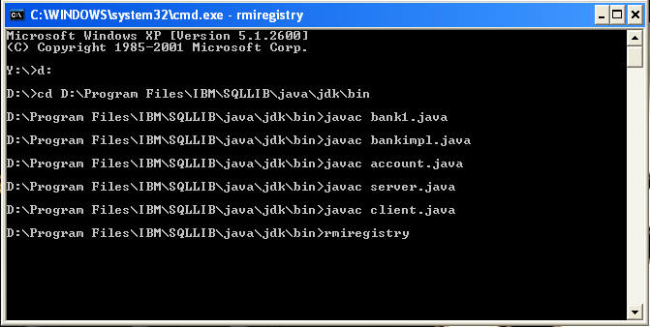

/* server */

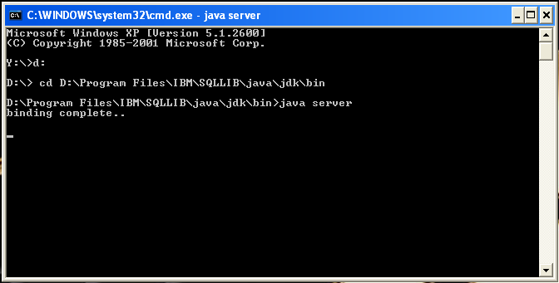

/* client */

