**PROGRAM CODING:**

**Bean Code (colors.java)**package colours;

import java.awt.*;

import java.awt.event.*;

public final class colors extends Canvas{

transient private Color color;

private boolean rectangular;

public colors()

{

addMouseListener(new MouseAdapter()

{

public void mousePressed(MouseEvent me)

{

change();

} });

rectangular=false;

setSize(200,100);

change();

}

public boolean getRectangular(boolean flag)

{

this.rectangular=flag;

repaint();

return rectangular; }

public void change()

{

color=randomColor();

repaint();

}

public Color randomColor()

{

int r=(int)(255*Math.random());

int g=(int)(255*Math.random());

int b=(int)(255*Math.random());

return new Color(r,g,b);

}

public void paint(Graphics g)

{

Dimension d= getSize();

int h=d.height;

int w=d.width;

g.setColor(color);

if(rectangular)

{

g.fillRect(0, 0, w-1, h-1); }

else

{

g.fillOval(0,0,w-1,h-1);

} } }

**Application code**

package samp;

public class sample extends javax.swing.JFrame {

public sample() {

initComponents();

}

@SuppressWarnings("unchecked")

private void initComponents() {

colors1 = new colours.colors();

setDefaultCloseOperation(javax.swing.WindowConstants.EXIT_ON_CLOSE);

javax.swing.GroupLayout layout = new javax.swing.GroupLayout(getContentPane());

getContentPane().setLayout(layout);

layout.setHorizontalGroup(

layout.createParallelGroup(javax.swing.GroupLayout.Alignment.LEADING)

.addGroup(javax.swing.GroupLayout.Alignment.TRAILING, layout.createSequentialGroup()

.addContainerGap(113, Short.MAX_VALUE)

.addComponent(colors1, javax.swing.GroupLayout.PREFERRED_SIZE, javax.swing.GroupLayout.DEFAULT_SIZE, javax.swing.GroupLayout.PREFERRED_SIZE)

.addGap(87, 87, 87))

);

layout.setVerticalGroup(

layout.createParallelGroup(javax.swing.GroupLayout.Alignment.LEADING)

.addGroup(javax.swing.GroupLayout.Alignment.TRAILING, layout.createSequentialGroup()

.addContainerGap(105, Short.MAX_VALUE)

.addComponent(colors1, javax.swing.GroupLayout.PREFERRED_SIZE, javax.swing.GroupLayout.DEFAULT_SIZE, javax.swing.GroupLayout.PREFERRED_SIZE)

.addGap(95, 95, 95))

);

pack();

}

public static void main(String args[]) {

java.awt.EventQueue.invokeLater(new Runnable() {

public void run() {

new sample().setVisible(true);

}

});

}

private colours.colors colors1;

}

**OUTPUT:**

/* palette */

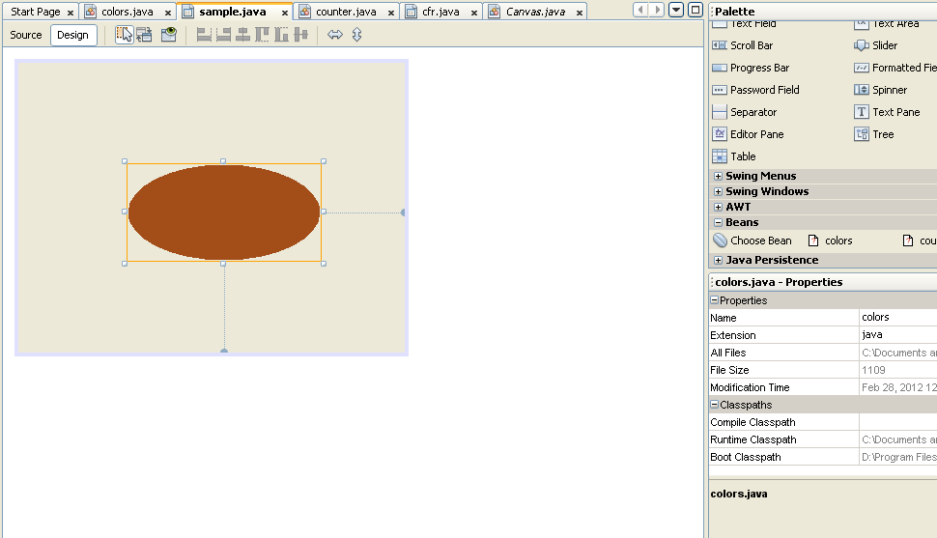

/* bean */

