PROGRAM CODING:
getname.html
<html>
<head>
<title>Enter Your Name</title>
</head>
<body>
<p>&nbsp;</p>
<form method="POST" action="showname.jsp">
<p><font color="blue" size="5">Enter Your Name:</font>
<input type="text" name="username" size="20"></p>
<p><input type="submit" value="Submit" name="B1"></p>
</form>
</body>
</html>
showname.jsp
<%@page contentType="text/html"%>
<html>
<body>
<p><font size="5">Welcome:
<%=request.getParameter("username")%></font></p>
<p><font color="blue" size="5">Have a Nice Day!!!</font></p>
</body>
</html>

OUTPUT:
/* getname.html */
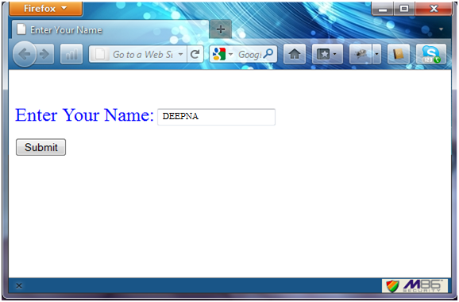

/* showname.jsp */

