**PROGRAM CODING:**

import java.sql.*;

import java.io.*;

public class sample

{

public static void main(String args[])

{

String connectionurl="jdbc:odbc:stud";

try

{

Class.forName("sun.jdbc.odbc.JdbcOdbcDriver");

Connection con=DriverManager.getConnection(connectionurl);

Statement st=con.createStatement();

ResultSet rs;

DataInputStream din=new DataInputStream(System.in);

System.out.println("1.select");

System.out.println("2.insert");

System.out.println("3.delete");

System.out.println("4.update");

String line=din.readLine();

int choice=Integer.parseInt(line);

switch(choice)

{

case 1:

{

System.out.println("output will be.....");

rs=st.executeQuery("select * from stud");

while(rs.next())

{

String s=rs.getString("name");

int n=rs.getInt("id1");

System.out.println(s+" "+n);

}}

break;

case 2:

{

String s="insert into stud values (1,'swathi')";

System.out.println(s);

st.executeUpdate(s);

System.out.println("inserted");

rs=st.executeQuery("select * from stud");

}

break;

case 3:

{

int c = st.executeUpdate("delete from stud where name = 'swathi'");

System.out.println(c);

if(c==1)

System.out.println("deleted");

}

break;

case 4:

{

st.executeUpdate("update stud set name= 'swathika' where id1= 1");

System.out.println("updated");

}}}

catch(SQLException e)

{

System.out.println(e);

}

catch(Exception e)

{

System.out.println(e);

}}}

**OUTPUT:**

/* select statement */

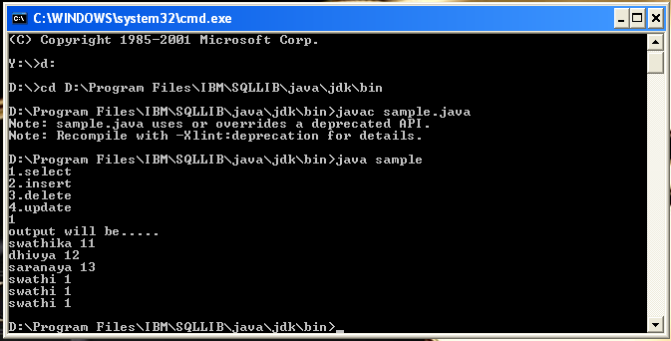

/* insert statement */

