PROGRAM CODING:
index.jsp
<%@ page language="java" import="java.sql.*"%>
<%
Connection con = null;
Statement st = null;
ResultSet rs = null;
PreparedStatement pst = null;
int no = Integer.parseInt(request.getParameter("NO"));
String name = request.getParameter("NAME");
String address = request.getParameter("ADDRESS");
String btn = request.getParameter("btn");
Class.forName("sun.jdbc.odbc.JdbcOdbcDriver");
con = DriverManager.getConnection("jdbc:odbc:student");
st = con.createStatement();
rs = st.executeQuery("select * from student");
if (btn != null) {
if (btn.equals("Insert")) {
int k = 0;
while (rs.next()) {
if (rs.getInt(1) == no) {
k = 1;
}
}

if (k == 0) {
pst = con.prepareStatement("insert into student values (?,?,?)");
pst.setInt(1, no);
pst.setString(2, name);
pst.setString(3, address);
int i = pst.executeUpdate();
%>
<%
if (i > 0) {
out.println("record inserted succesfully");
} else {
out.println("record not inserted");
}%>
<%
} else {
out.println("record alredy exist");
}
}

else
{
out.println("not valid action");
}
}

else
{
out.println("Specify the action");
}
%>
<table border="0" bgcolor="lightgreen" cellspacing="5" cellpadding="2">
<tr><th>No</th><th>Name</th><th>Address</th></tr>
<%
st = con.createStatement();
rs = st.executeQuery("select * from student");
while (rs.next()) {
%>
<tr>
<td><%=rs.getInt(1)%></td>
<td><%=rs.getString(2)%></td>
<td><%=rs.getString(3)%></td>
</tr>
<% }
%>
</table>
student.html
<html>
<head>
<title></title>

<meta http-equiv="Content-Type" content="text/html; charset=UTF-8">
</head>
<body>

<form action="index.jsp" method="post"><table><tr>
<td> No: </td><td><input type="text" size="15" name="NO"></br></tr></td><tr>
<td> Name:</td><td><input type="text" size="15" name="NAME"></br></tr></td><tr>
<td> Address:</td><td><input type="text" size="15" name="ADDRESS"></br></tr></td><tr>

<td> <input name="btn" type="submit" value="Insert"></td></tr>
</table>
</form>
</body>
</html>

OUTPUT:
/* student.html */
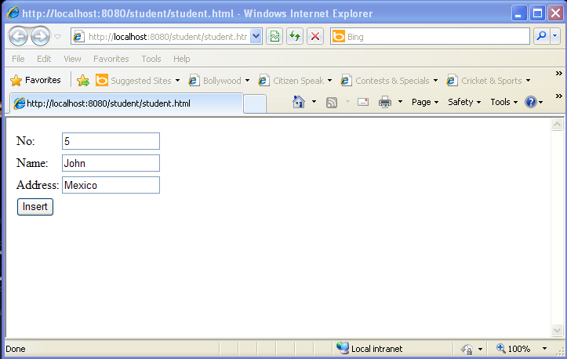

/* inserted record */
