PROGRAM CODING:
first.html
<html>
<head>
<title>Name Input Form</title>
</head>
<body>
<form method="post" action="http://localhost:8080/session/savename.jsp">
<p><b>Enter Your Name:</b>
<input type="text" name="username"><br>
<input type="submit" value="Submit">
</form>
</body>
</html>
savename.jsp
<%@ page language="java" %>
<%
String username=request.getParameter("username");
if(username==null)
username="";
session.setAttribut("username",username);
%>
<html>
<head>

<title>Name Saved</title>
</head>
<body>
<p><a href="http://localohost:8080/session/displaysessionvalue.jsp">Next Page to view the Session value</a></p>
</body>
</html>
displaysessionvalue.jsp
<%@page language="java" %>
<%
String username=(String)session.getAttribute("username");
if(username==null)
username="";
%>
<html>
<head>
<title>Show Saved Name</title>
</head>
<body>
<p>Welcome: <%=username%></p>
</body></html>

OUTPUT:
/* first.html */
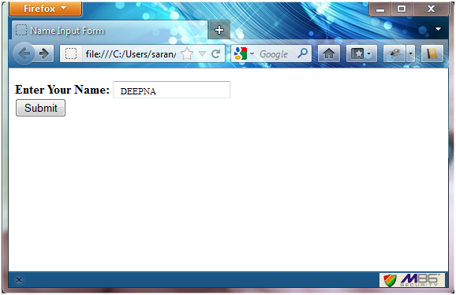
/* savename.jsp */
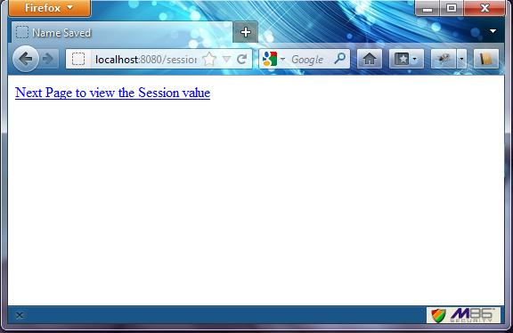

/* displaysessionvalue.jsp */
