**ToDo Application**

**By Maithri SG Krishnan**

**HTML5, CSS3, Bootstrap, ASP.NET, C#, SQL Server, ADO.Net**

**SCREENSHOTS:**

By launching the application in a browser, the following web page is displayed. The grid view in the right corner of the page displays the existing tasks in the database with its respective status. Note that, the completed tasks are displayed differently from the active tasks. The panel in the center of the page displays a list of radio buttons and a link button along with the current count of active tasks in the database.

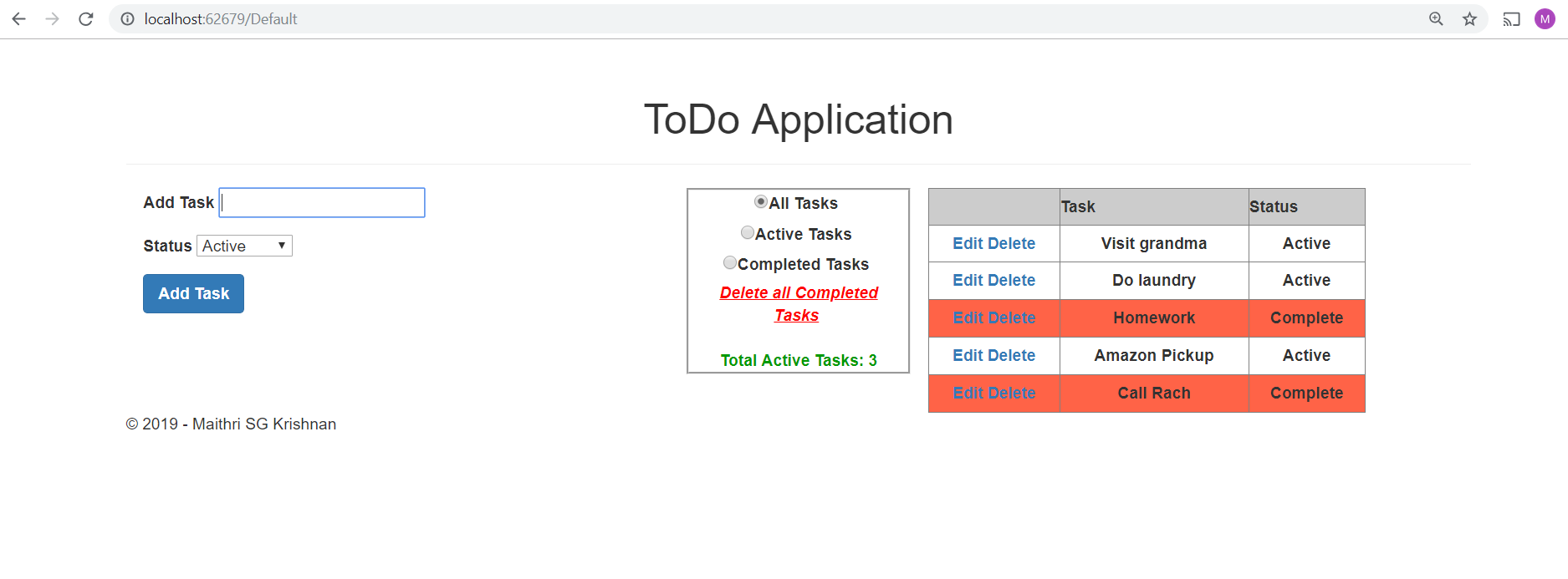

The cursor will point (focus) to the text box and will be ready for the user to type in. A required field validator is set for the Add task text box and when the user clicks the Add Task button without entering the task, “Task can’t be blank” error message will be displayed.

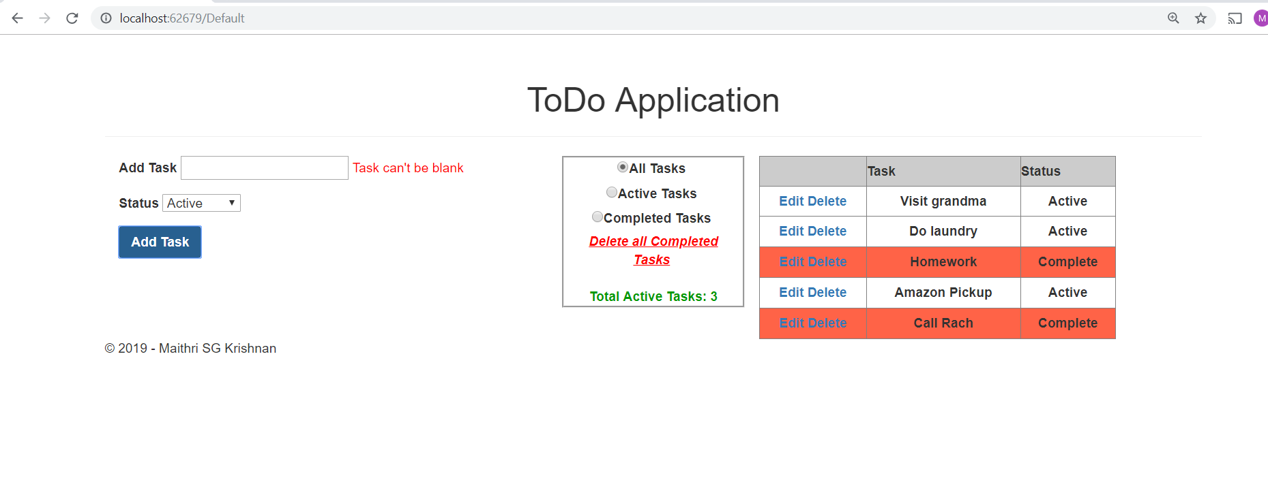

The user can select the status of the task from the drop down list box.

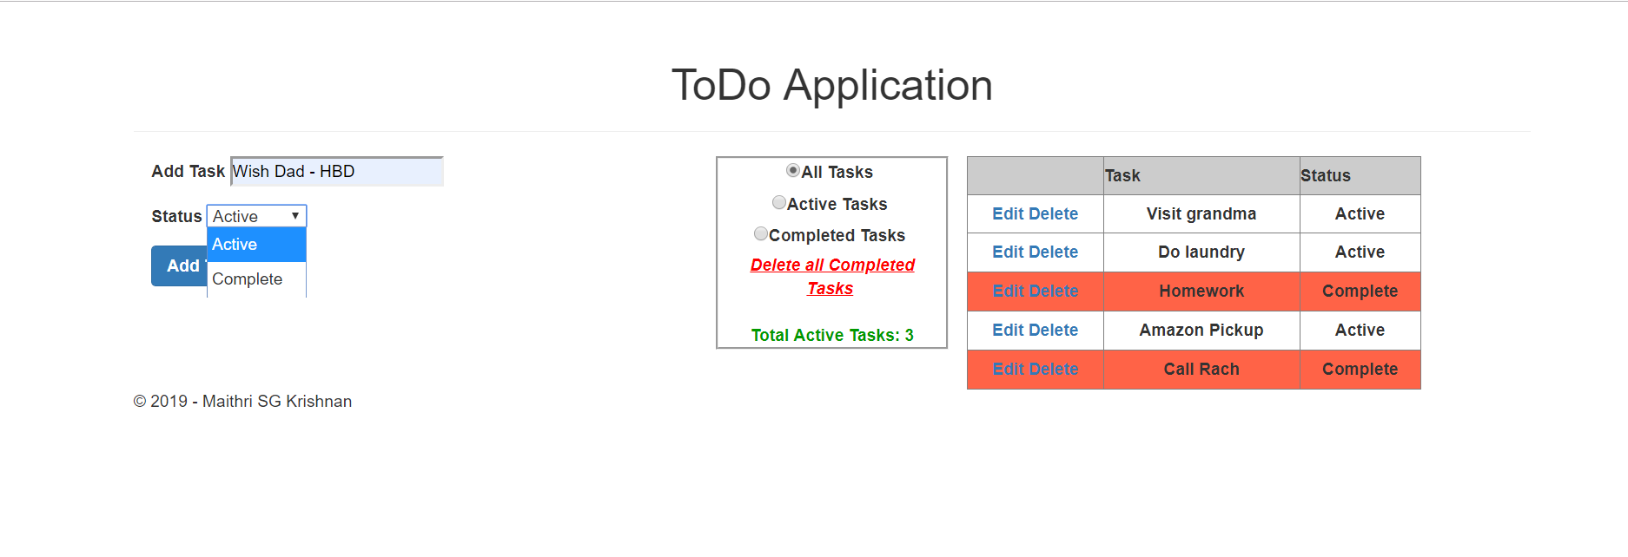

A new task – “Wish Dad – HBD” is inserted with the status – “Active”. The grid view automatically updates the database table and displays the inserted record. Note that, the Total Active Tasks count is also incremented by 1.

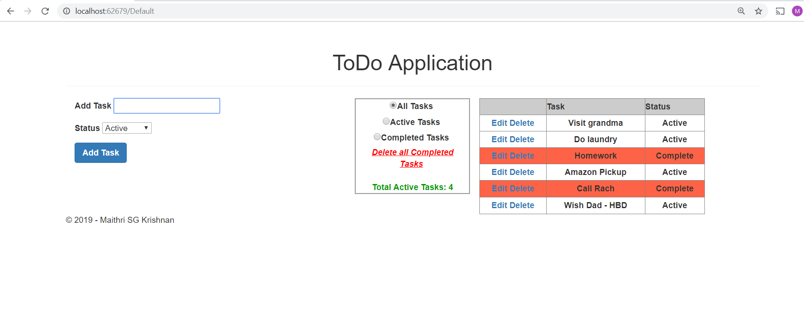

By default, the “All Tasks” radio button is checked. When the user selects the “Active Tasks” radio button, only those tasks with status ‘Active’ is displayed in the gridview.

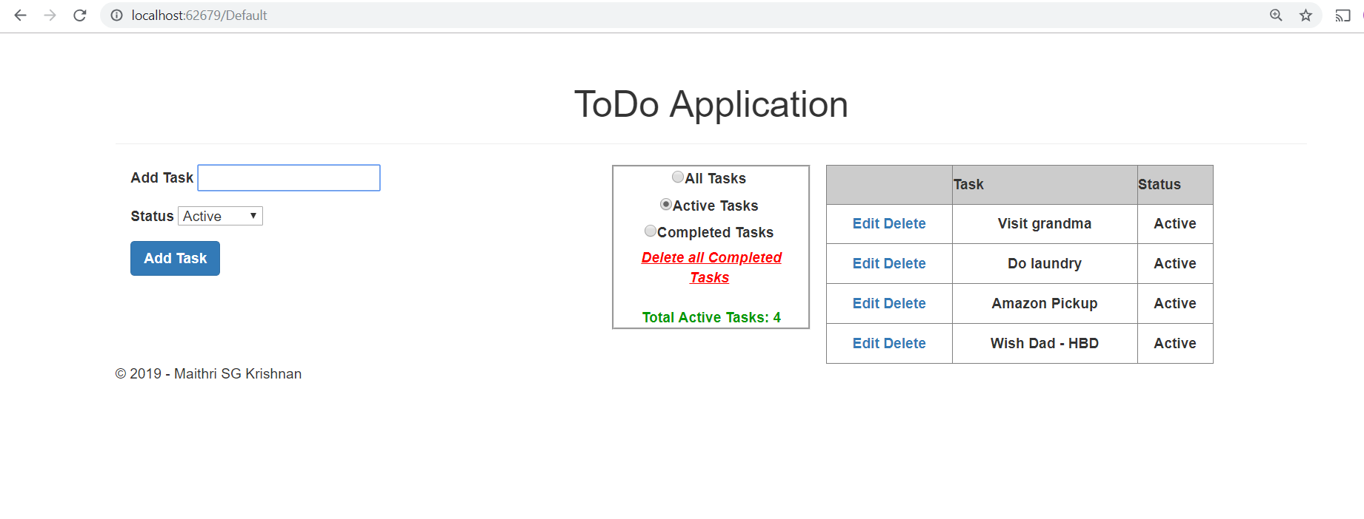

Likewise, when the user selects the “Completed Tasks” radio button, only those tasks with status ‘Complete’ is displayed in the gridview.

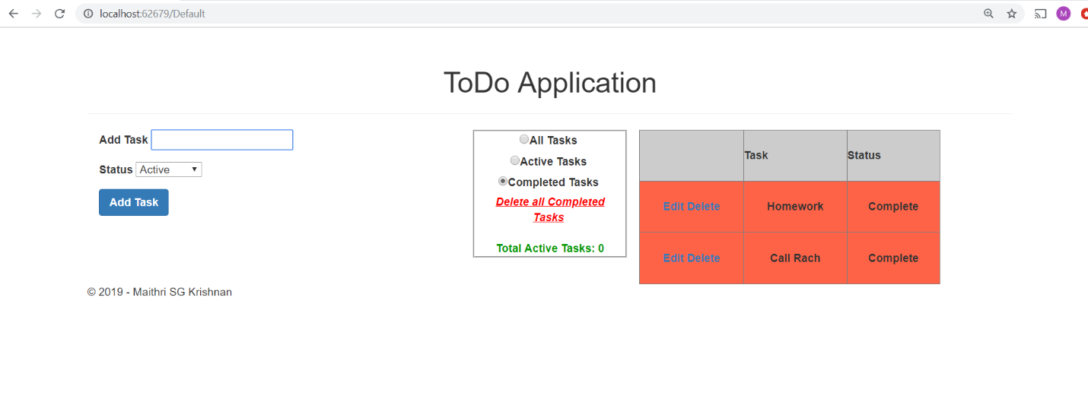

When the user clicks on the “Delete all Completed Tasks” link button, all of the completed tasks are deleted from the database and the gridview is rendered accordingly.

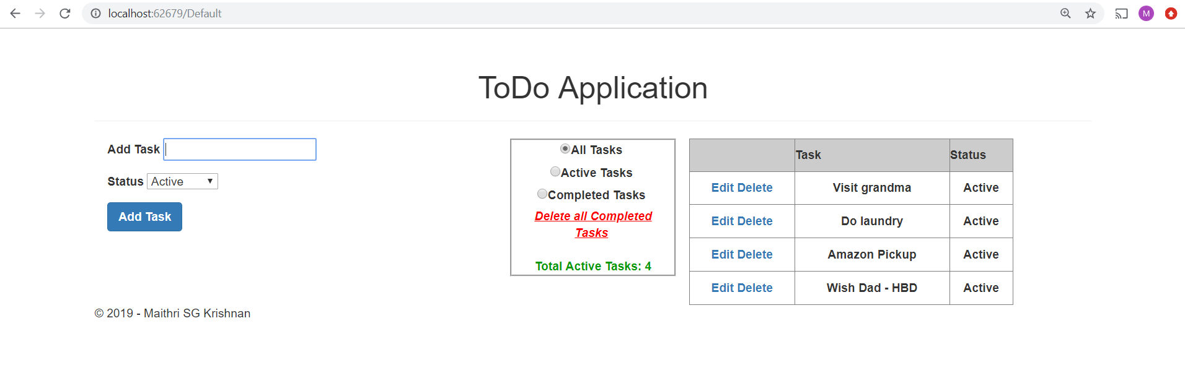

When the user tries to insert a new task with status “Complete”,

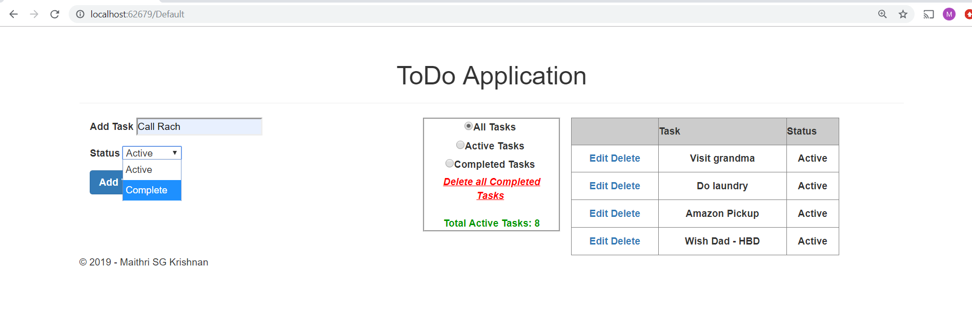

The grid view automatically renders the task with a different backColor.

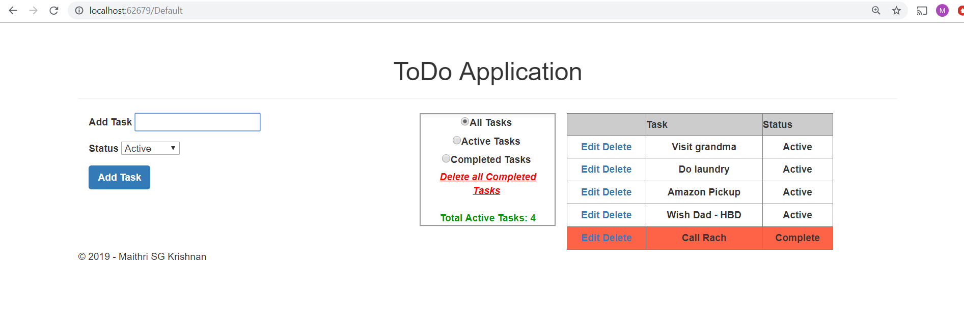

The user can edit the “Do Laundry” task by clicking the edit button.

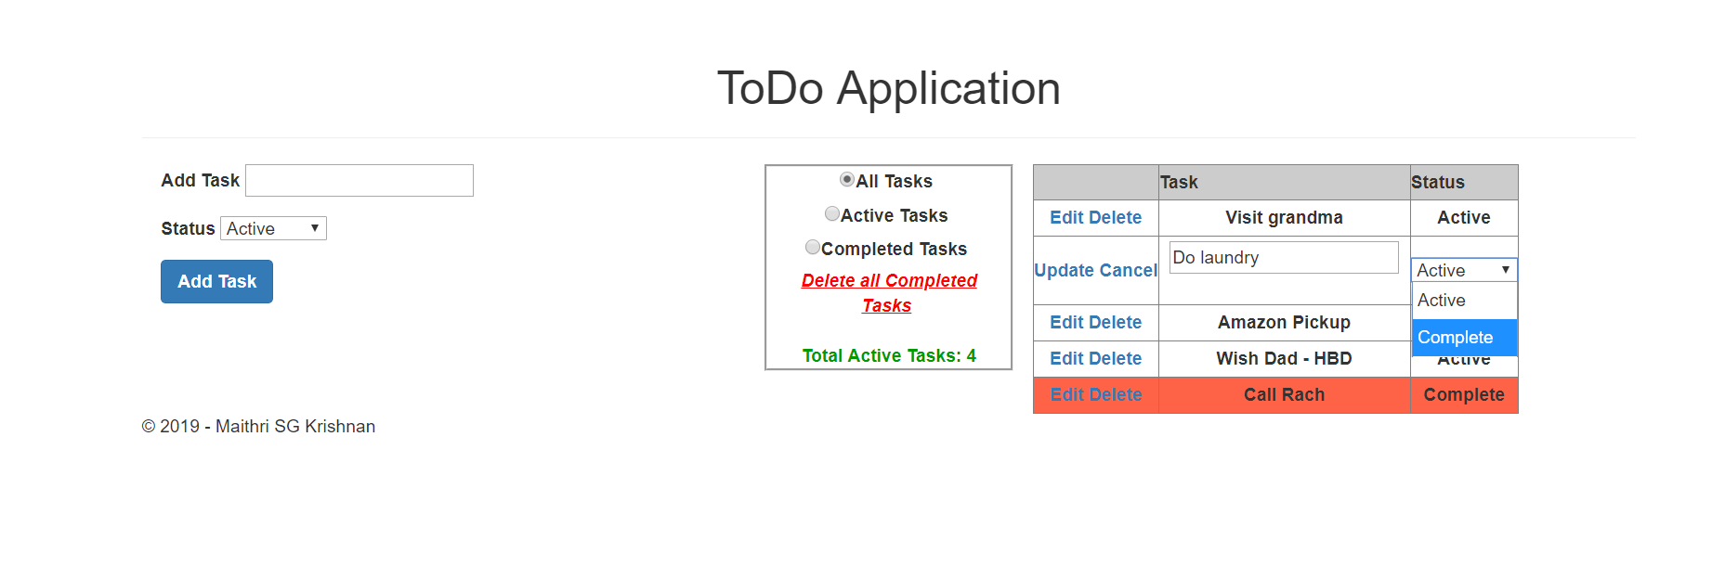

The user can change the status of that particular task from Active to Complete or vice versa and also can edit the task name. Here the status of the “Do Laundry” is changed from active to complete, and the update button is clicked.

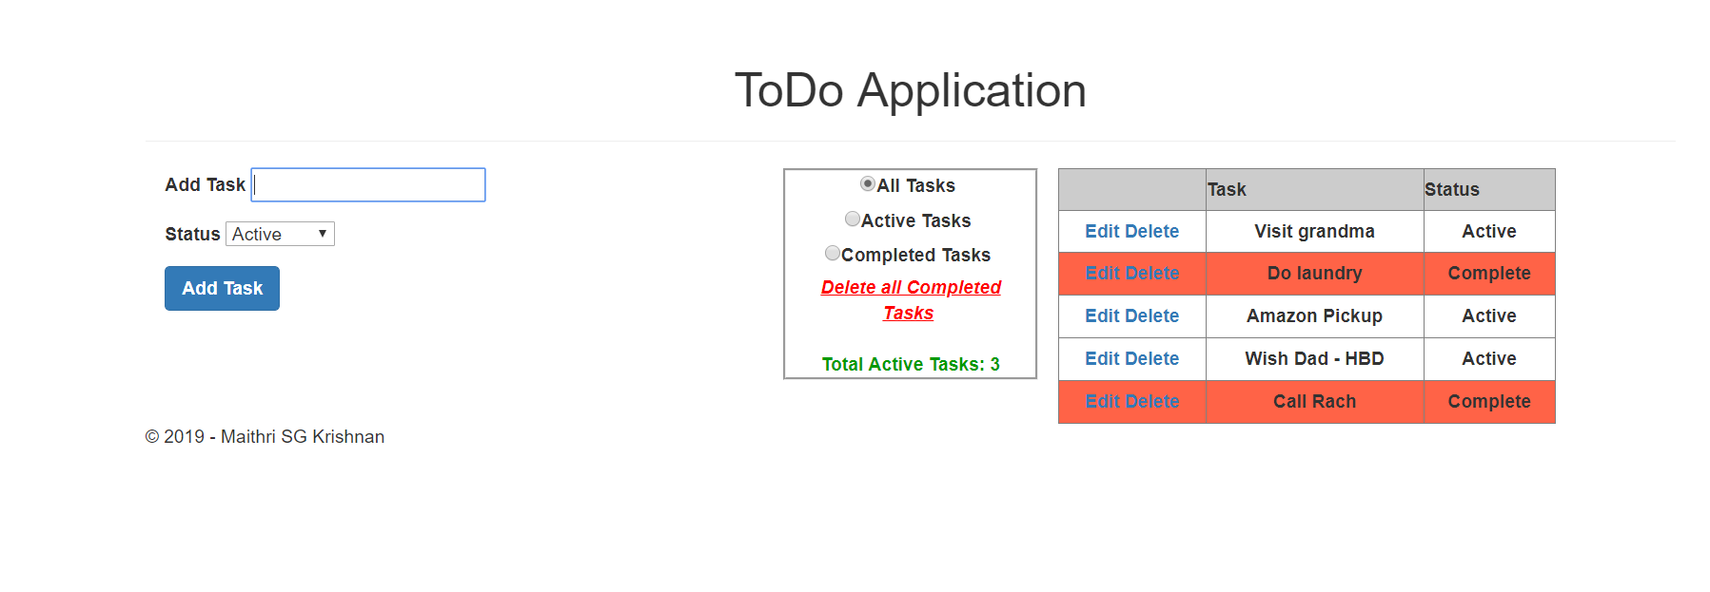

The user can delete particular tasks by clicking on the delete button next to the displayed tasks in the gridview. Here the user tries to delete the “Visit grandma” task.

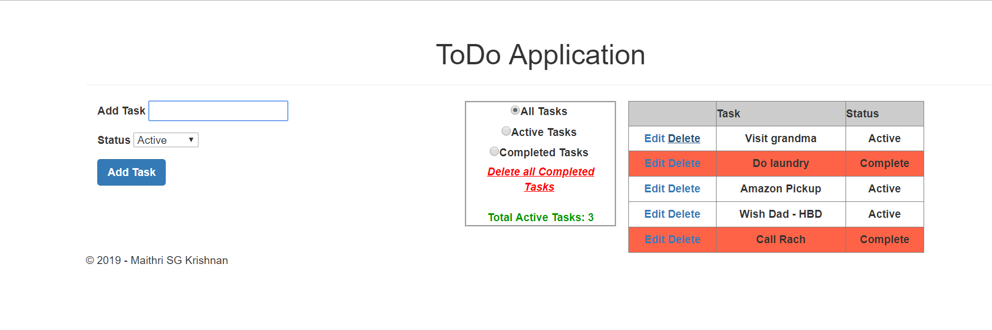

The total active tasks count is updated to 2 from 3 and the “Visit grandma” task is now deleted.

