PROGRAM CODING:
Cookieform.jsp
<html>
<head>
<title>Cookie Input Form</title>
</head>
<body>
<form method="post" action="http://localhost:8080/cookie/setcookie.jsp">
<p><b>Enter Your Name:</b><input type="text" name="username"><br>
<input type="submit" value="Submit">
</form>
</body>
</html>
setcookie.jsp
<% @page languae="java" import="java.util.*" %>
<%
String username=request.getParameter("username");
if(username==null)
username="";
Date now=new Date();
String timestamp=now.toString();
Cookie cookie=new Cookie("username",username);
cookie.setMaxAge(365*24*60*60);
response.addCookie(cookie);
%>
<html>
<head>
<title>Cookie Saved</title>
</head>
<body>
<p><a href="http://localhost:8080/cookie/showcookievalue.jsp">Next Page to view the cookie value</a></p>
</body>
</html>
showcookievalue.jsp
<% @page language="java" import="java.util.*"
%>
<%
String cookieName="username";
Cookie cookies[]=request.getCookies();
Cookie myCookie=null;
if(cookies!=null)
{
for(int i=0;i<cookies.length;i++)
{
if(cookies[i].getName().equals(cookieName))
{
myCookie=cookies[i];

break;
}}}
%>
<html>
<head>
<title>Show Saved Cookie</title>
</head>
<body>
<%
if(myCookie==null){
%>
No Cookie found with the name<%=cookieName%>
<%
} else {
%>
<p>Welcome: <%=myCookie.getValue()%>
<%
}
%>
</body>
</html>

OUTPUT:
/* cookieform.html */
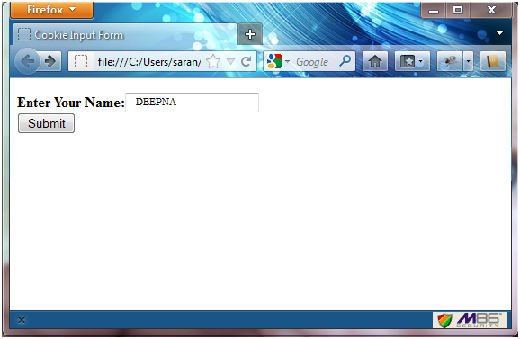

/* setcookie.jsp */
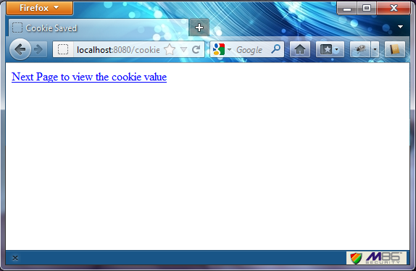
/* showcookievalue.jsp */
