**HW3**

**CS 522 – Human Computer Interaction**

**Fitts’ Law Experiment**

**Fitts’ Law:**

**Fitts's law** (often cited as **Fitts' law**) is a predictive model of human movement primarily used in [human–computer interaction](https://en.wikipedia.org/wiki/Human%E2%80%93computer_interaction) and [ergonomics](https://en.wikipedia.org/wiki/Human_factors_and_ergonomics). This [scientific law](https://en.wikipedia.org/wiki/Scientific_law) predicts that the time required to rapidly move to a target area is a function of the ratio between the distance to the target and the width of the target.[[1]](https://en.wikipedia.org/wiki/Fitts%27s_law#cite_note-Fitts1954-1) Fitts's law is used to [model](https://en.wikipedia.org/wiki/Conceptual_model) the act of *pointing*, either by physically touching an object with a hand or finger, or virtually, by pointing to an object on a [computer monitor](https://en.wikipedia.org/wiki/Computer_monitor) using a [pointing device](https://en.wikipedia.org/wiki/Pointing_device).

The original 1954 paper by [Paul Fitts](https://en.wikipedia.org/wiki/Paul_Fitts)[[1]](https://en.wikipedia.org/wiki/Fitts%27s_law#cite_note-Fitts1954-1) proposed a metric to quantify the difficulty of a target selection task. The metric was based on an information analogy, where the distance to the target (*D*) is like a signal and the tolerance or width of the target (*W*) is like noise. The metric is Fitts's *index of difficulty* (*ID*, in bits):

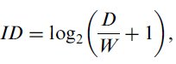

{\displaystyle {\text{ID}}=\log _{2}{\Bigg (}{\frac {2D}{W}}{\Bigg )}}Fitts also proposed an *index of performance* (*IP*, in bits per second) as a measure of human performance. The metric combines a task's index of difficulty (*ID*) with the movement time (*MT*, in seconds) in selecting the target. In Fitts's words, "The average rate of information generated by a series of movements is the average information per movement divided by the time per movement" (1954, p. 390). Thus,



{\displaystyle {\text{IP}}={\Bigg (}{\frac {\text{ID}}{\text{MT}}}{\Bigg )}}Today, *IP* is more commonly called *throughput* (*TP*). It is also common to include an adjustment for accuracy in the calculation.

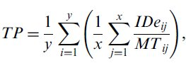

Researchers after Fitts began the practice of building linear regression equations and examining the correlation (*r*) for goodness of fit. The equation expresses the relationship between *MT* and the *D* and *W* task parameters:

{\displaystyle {\text{MT}}=a+b\cdot {\text{ID}}=a+b\cdot \log _{2}{\Bigg (}{\frac {2D}{W}}{\Bigg )}}where:

* *MT* is the average time to complete the movement.
* *a* and *b* are constants that depend on the choice of input device and are usually determined empirically by [regression analysis](https://en.wikipedia.org/wiki/Regression_analysis).
* *ID* is the index of difficulty.
* *D* is the distance from the starting point to the center of the target.
* *W* is the width of the target measured along the axis of motion. *W* can also be thought of as the allowed error tolerance in the final position, since the final point of the motion must fall within ± *W*⁄2 of the target's center.

**Experimental method:**

To replicate Fitts’ Law, I developed a graphical user interface to test the relationship between moving time and index of difficulty as well as throughput and index of difficulty.

The Experimental apparatus was developed using Python GUI toolkit – Tkinter and data analysis as carried out using scipy library to plot the linear regression graph

Screen shots for GUI are as follows:



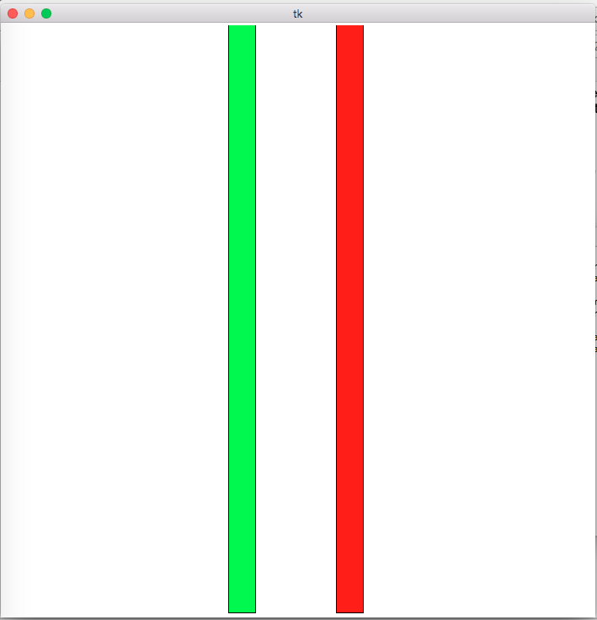

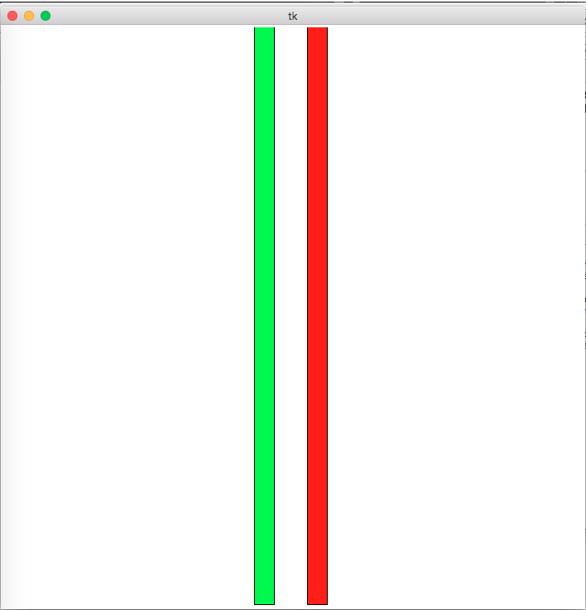

Screenshots for Graphs generated are as follows:

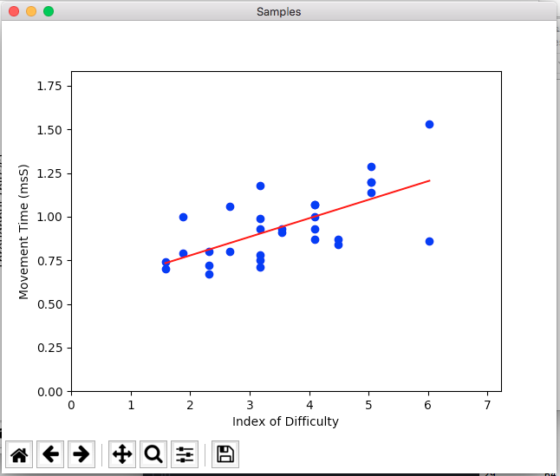

Regression coefficients: A=7.016171654322353e-05, B=0.0007727541899720645

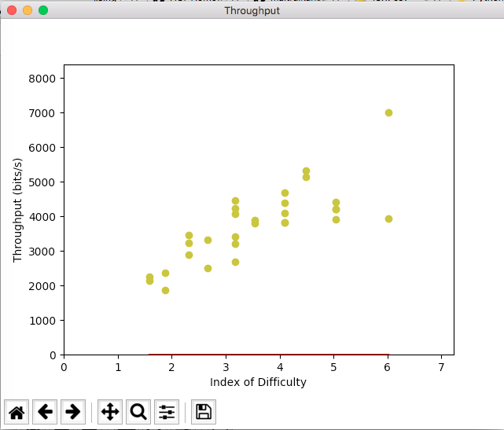

Regression coefficients: A=0.016171654322353e-05, B=0.0007727541899720645

**Data Dump:**

distance width ID current_count time

0 64 16 2.321928 2 1.61

1 64 32 1.584963 1 0.63

2 64 32 1.584963 2 0.60

3 128 32 2.321928 1 0.72

4 128 32 2.321928 2 0.67

5 128 16 3.169925 1 0.71

6 128 16 3.169925 2 0.92

7 64 8 3.169925 1 0.75

8 64 8 3.169925 2 0.91

9 512 8 6.022368 1 0.91

10 512 8 6.022368 2 1.19

11 256 16 4.087463 1 1.16

12 256 16 4.087463 2 0.96

13 512 24 4.481127 1 1.04

14 512 24 4.481127 2 0.87

15 256 8 5.044394 1 1.16

16 256 8 5.044394 2 2.15

17 128 24 2.662965 1 1.10

18 128 24 2.662965 2 0.85

19 512 32 4.087463 1 0.87

20 512 32 4.087463 2 0.98

21 256 24 3.544321 1 0.97

22 256 24 3.544321 2 1.02

23 512 16 5.044394 1 1.00

24 512 16 5.044394 2 1.00

25 256 32 3.169925 1 1.27

26 256 32 3.169925 2 0.95

27 128 8 4.087463 1 0.87

28 128 8 4.087463 2 0.90

29 64 24 1.874469 1 1.02