Best Space Ed-Books For People of all Age groups

~Maitree Rawat

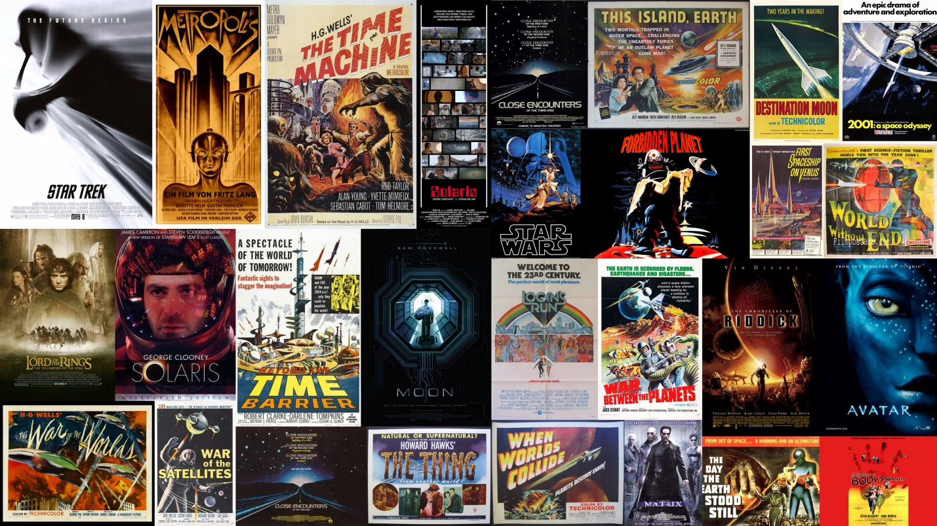

**SPACE-ED BOOKS**

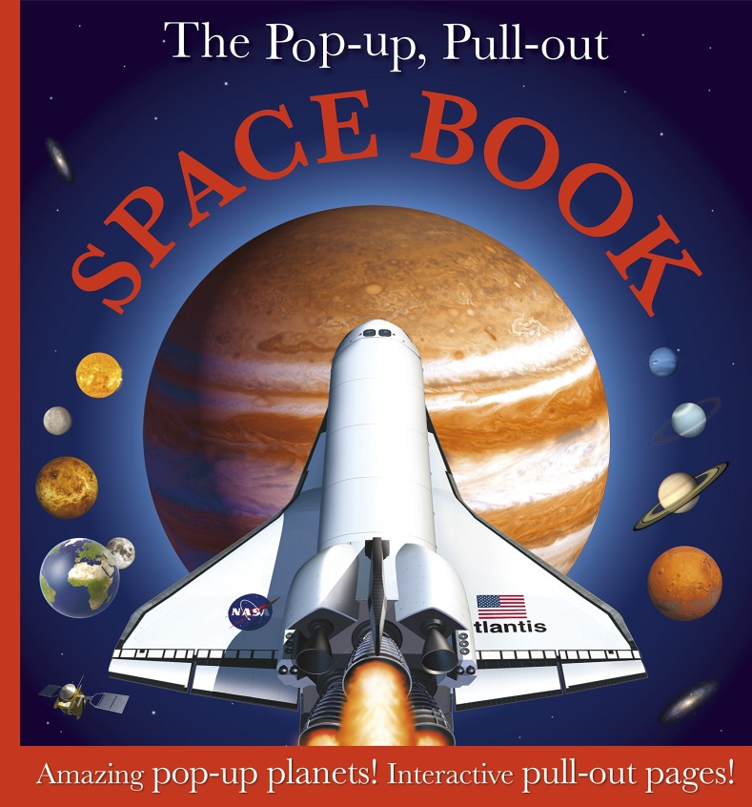Books have always played a significant role in developing the knowledge about a topic or to inculcate moral values among progenies. The growth of our intellects begins right from the age of toddlers and start grasping the very little things they see among themselves. Book reading benefits the minds to enhance the intellectual skills, creativity and gives them a different perspective of the same context.

For instance the Book India’s Struggle for independence by Mr. Bipin Chandra embarks not only an unbiased account of the movement but also covers its progress throughout India. It is that one book which gives you a complete and detailed account of the independence movement, sans any bias or taint while Anandmath by Bankim Chandra Chattopadhyay was among those earliest pieces of literature that fueled the fire of imagination of the nationalists and became a sacred treatise of freedom struggle. While both the books showcased the struggle by the freedom fighters but had a different perspective.

With rise in the Space Education books it’s gets a little difficult for the parents to pick the right ones for their kids. This article will take us through a set of 5 books starting from “Here we are “to the “Black Hole”. Each and Every book listed is written beautifully and perfectly for the readers in the age group (which is mentioned).

By cultivating the habit to read in the young minds we will develop their ability to learn and explore new facts in any field of education.

Below is a list of Top-5 Books with the corresponding Age group and the reviews. The reviews are taken from [www.amazon.com](http://www.amazon.com), [www.goodreads.com](http://www.goodreads.com), [www.space.com](http://www.space.com) & [www.timesofindia.com](http://www.timesofindia.com).

**Here We Are: Notes for Living On Planet Earth**

**by Oliver Jeffers**

(Age Group: 2+ Years)

**There’s enough for everyone ~ Jeffers**

**#1 New York Times Bestseller and #1 TIME Best Book of the Year for 2017!**

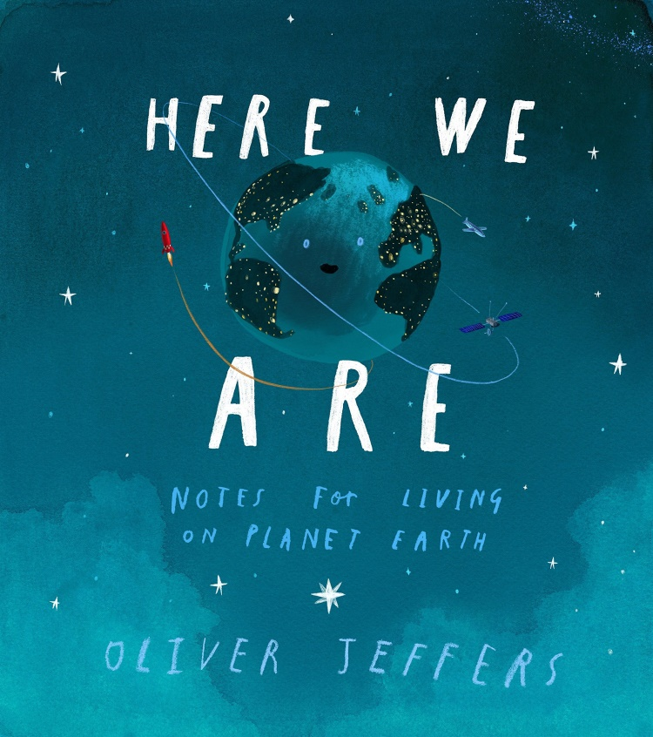It's a toddler-friendly guide to the big, blue marble we call home. Or, as Jeffers' editor joked, it's a book for "new babies, new parents and misplaced humans." But most of all, it's a manual for how to be a standup human being, one who is tolerant, respectful and unfailingly kind.

Kids will enjoy his distinctive illustrations and sense of humor very much. The pictures will not disappoint.

The pages are filled with striking contrast and color and did a great job at conveying the scale of Earth for little kids. The story is somewhat lacking, but it is more about the illustrations and showcasing the different parts of our world. The narrator is ambiguous in race and gender, but it could be for anyone. Touching upon the basics of what our planet Earth literally is and has, is the vehicle author Oliver Jeffers uses to offer up for exploration some universal truths that are vital for living on our planet, to his firstborn, and readers. One of the most necessary is the truth that no matter how different we may seem from one another, we are all "people". Another brilliant truth is that we all have a part to play in order to understand and make our world a better place. There is a gentle reminder of using time wisely, for it is finite for every one of us. Jeffers affirms that he will be there to answer his son's questions but doesn't pretend this will be so forever, but offers the comforting truth that we are never alone, for our Earth is full of people and we will always find someone to step up and support us. The illustrations are full of details that will have readers finding new things to point at, laugh, and be awed by.

**There’s No Place Like Space**

**by Tish Rabe**

(Age Group: 4-8 Years)

**“But there’s a lot to discover, and it might be you who looks up in the sky and finds something that’s new!” -Dr, Seuss**

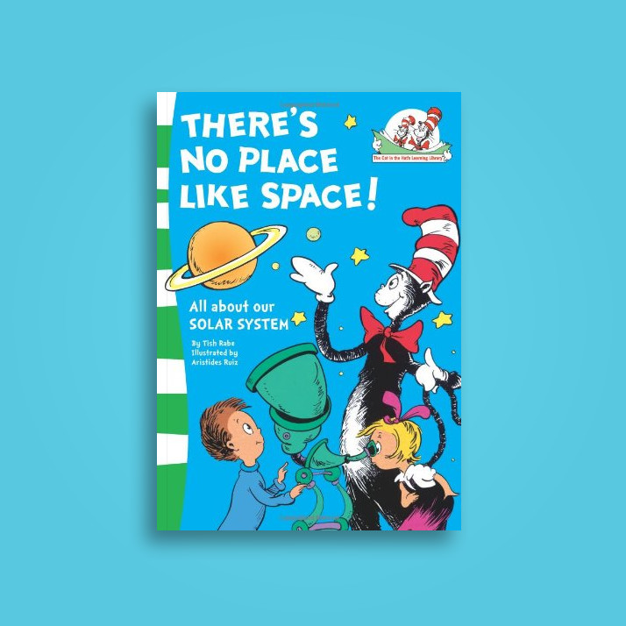This book introduces young minds with the basic concepts of the universe our solar system, constellations and the moons. Mr. Cat in the Hat takes us on a space voyage to explore new planets and the outer world.

It is one of the best books for young minds to introduce them with the concepts of outer space.

It has a beautiful Illustration and [Picturisation](https://www.collinsdictionary.com/dictionary/english/picturisation) by Aristides Ruiz.

With an average of 3/5 in India and 4.5/5 in the world at amazon.com this book is one of the best sellers.

Consisting of a fine glossary, simple terms and amazing story The Cat in The Hat has always amazed us with its publications.

“The Cat in the Hat comes as when it demonstrates all its knowledge about solar planets in its rhyming fashion. Loved this informative and humorous book” said one of the Readers.

This book does not simply talk about the sun, the moon and the stars, but this book goes into constellations, space exploration vehicle, the names of planets, the size of planets compared to other planets and so many more cool facts. The wonderful illustrations will leave you wanting to just flip to the next page to see what picture resides there.

The book is creative, educational, accurate, and entertaining. Definitely a must-have for any little space lover.

**Space A Children’s Encyclopedia**

**by DK**

(Age Group: 10-14 Years)

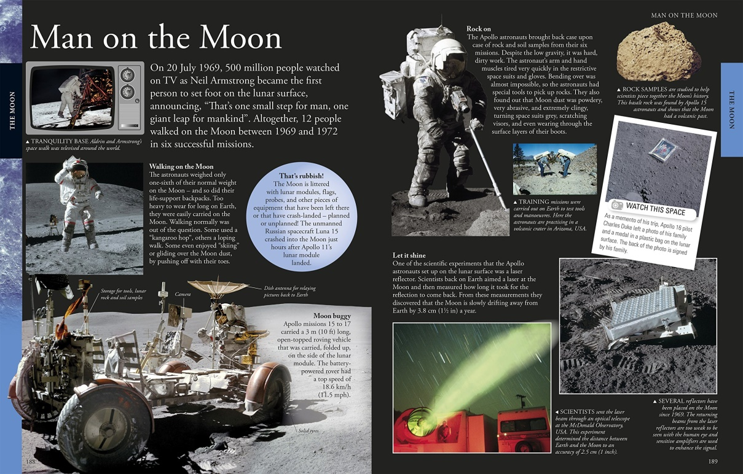

The kids will discover a wide range of space subjects in this cosmological compendium, perfect for aspiring astronomers and astronauts. Discover what space is like, take a whirl around the sun and explore the moon and stars. Featuring exclusive interviews, spectacular pictures, eyewitness accounts, mind-boggling facts and so much more, young scientists will be engrossed by this detailed look into outer space. Blast off into space and discover the planets in our Solar System and beyond in this jam-packed encyclopedia for children.

They Learn what living in space is like for an astronaut, then take a whirl around planet Earth and the moon. Then go beyond where any human has gone before, and marvel at the red, rocky landscape of Mars and the truly magnificent icy rings of Saturn. Venture onwards to the farthest depths of the Milky Way Galaxy, and beyond to the biggest and brightest stars light years away . With exclusive interviews, incredible facts, coupled with awesome photographic spreads, Space A Children's Encyclopedia will teach children everything they need to know about space. This incredible space book is perfect for space enthusiasts and budding astronomers. It contains everything you ever wanted to know about space.

**A Brief History of time**

**by Stephen Hawking**

(Age Group: Everyone)

**A Brief History of Time is Stephen Hawking’s way of explaining the most complex concepts and ideas of physics, such as space, time, black holes, planets, stars and gravity to the average Joe, so that even you and I can better understand how our planets are created, where it came from, and where it’s going.**

**~ Four Minutes Book**

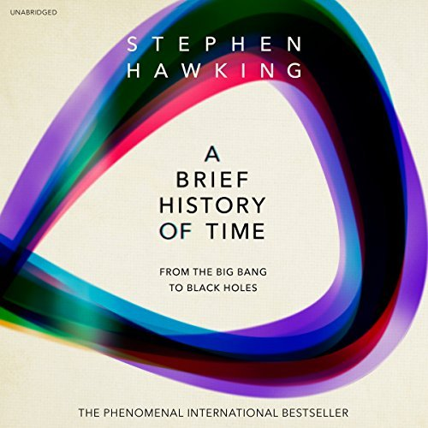“Intelligence is the ability to adapt to change” quoted by Stephen Hawking in the book.

The book was first published in 1988 which brought his wish to express the most important theories, discoveries and phenomena from the world of physics.

It is one of the most popular-science books on cosmology (study of the universe) the book was focused for those having no/ least prior knowledge of scientific theories.

It won’t be surprising to find non-technical terms about the structure, origin, development and eventual fate of universe, which is the object of study of astronomy and modern physics. He has described space and time as the building blocks of the universe and the forces that governs it. The book became the best seller and sold more than 10 million copies in the last 20 years.

You will find about cosmological phenomena such as the Big Bang Theory and black holes. The theory of general relativity and quantum mechanics is delineated in the book beautifully. In the end he talks about the search for the unifying theory that describes everything in the universe in a coherent manner. Consisting of 11 chapters this book is a good read for all age groups.

**BLACK HOLE: The Reith Lectures**

**by Stephen Hawking**

(Prerequisites: It’s better to have a basic knowledge of Physics)

**"Quasars are the brightest objects in the universe, and possibly the most distant detected so far."**

**~ Stephen Hawking**

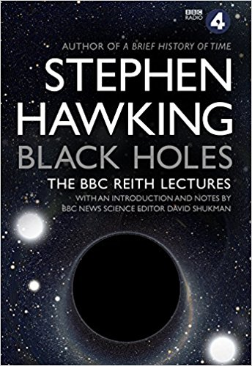In 2016 Professor Stephen Hawking delivered the BBC Reith Lectures on a subject that fascinated him for decades – black holes.  
  
In these flagship lectures the legendary physicist argued that if we could only understand black holes and how they challenge the very nature of space and time, we could unlock the secrets of the universe.

This is wonderful as an introduction to Hawking's work, or as a reminder for people who read a brief history of time a while ago and would like to be reminded of the basic concepts.

The book is super short (small size - only 64 reading pages), but full of information about Black Holes - Theories & Hypothesis about formation, characteristics & behavior etc. The illustration and comments are very helpful and they give the reader a wider understanding about this topic.  
Mr. Hawking has an uncanny ability to put things in a manner that even a layman can also understand.

The illustration and comments are very helpful and they give the reader a wider understanding about this topic.  
The book is short, but intense. It is full of information about Black Holes, their history and various theories and hypothesis about their formation, characteristics, and purpose. It will give you a very brief history of black holes precisely. Stephen Hawking will make you linger around those possibilities that you might never consider in the first place.