**VOSTOK 1 : FIRST MANNED SPACEFLIGHT IN HISTORY**

**BACKGROUND: The Race to the Stars[1]**

It was in 1957 when the Soviet Union launched the first artificial satellite, Sputnik1, both the superpowers Soviet Union and the United States wanted to develop a spaceflight technology, particularly by launching the first successful human space-flight.

The Soviet Union secretly pursued the Vostok programme in competition with the United States Project Mercury. Vostok launched several precursor unmanned missions between May 1960 and March 1961, to test and develop the Vostok rocket family and space capsule. These missions had varied degrees of success, but the final two—Korabl-Sputnik 4 and Korabl-Sputnik 5—were complete successes, allowing the first manned flight. The Russians scored a victory when they launched a small craft carrying cosmonaut Yuri Gagarin to new heights. His 108-minute flight gave him a permanent place in the history books as the first man in space.

At 05:30 Moscow time, on the morning of April 12, 1961, both Gagarin and his backup Titov were woken. They were given breakfast, assisted into their spacesuits, and then were transported to the launch pad. Gagarin entered the Vostok 1 spacecraft, and at 07:10 local time (04:10 UTC), the radio communication system was turned on. Once Gagarin was in the spacecraft, his picture appeared on television screens in the launch control room from an onboard camera. Launch would not occur for another two hours, and during the time Gagarin chatted with the mission's main CapCom, as well as Chief Designer [Sergei Korolev](https://en.wikipedia.org/wiki/Sergei_Korolev), [Nikolai Kamanin](https://en.wikipedia.org/wiki/Nikolai_Kamanin), and a few others. Following a series of tests and checks, about forty minutes after Gagarin entered the spacecraft, its hatch was closed. Gagarin, however, reported that the hatch was not sealed properly, and technicians spent nearly an hour removing all the screws and sealing the hatch again. According to a 2014 obituary, Vostok's chief designer, [Oleg Ivanovsky](https://en.wikipedia.org/wiki/Oleg_Ivanovsky), personally helped rebolt the hatch. There is some disagreement over whether the hatch was in fact not sealed correctly, as a more recent account stated the indication was false.

During this time Gagarin requested some music to be played over the radio. Korolev was suffering from chest pains and close to a nervous breakdown, as this was the 24th Soviet space launch and the 16th involving a Luna/Vostok booster, and to that point 12 launches had failed, for a success rate of exactly 50%. Two Vostoks had failed to reach orbit due to launch vehicle malfunctions and another two malfunctioned in orbit. Korolev was given a pill to calm him down. Gagarin, on the other hand, was described as calm; about half an hour before launch his [pulse](https://en.wikipedia.org/wiki/Pulse) was recorded at 64 beats per minute.

**THE SPACECRAFT**

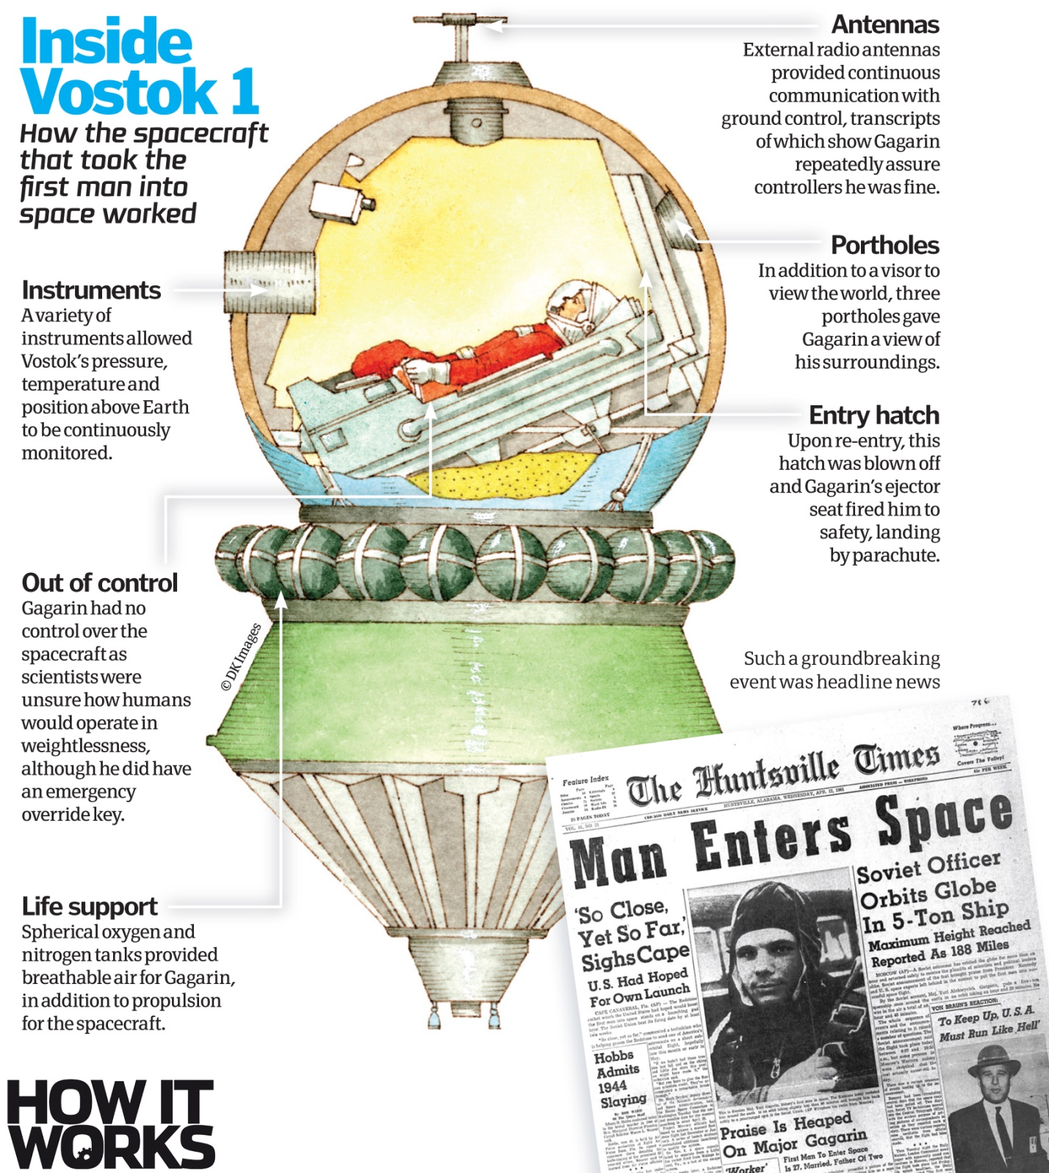

*Image Source : How It Works : How Vostok1 worked – 51 years of spaceflight*

**VOSTOK -3KA**

The Vostok 3KA was the spacecraft used for the first human spaceflights. They were launched from Baikonur Cosmodrome using Vostok 8K72K launch vehicles. The first flight of a Vostok 3KA occurred on March 9, 1961. The first flight with a crew—Vostok 1 carrying Yuri Gagarin—took place on April 12, 1961. The last flight—Vostok 6 carrying the first woman in space, Valentina Tereshkova—took place on June 16, 1963.

Specifications for this version are[2]:

Reentry Module: Vostok SA. SA stands for Spuskaemiy apparat - descent system. It was nicknamed "Sharik" (little sphere).

* Crew Size: 1
* Diameter: 2.3 m sphere
* Mass: 2,460 kg
* Heat Shield Mass: 837 kg
* Recovery equipment: 151 kg
* Parachute deploys at 2.5 km altitude
* Crew seat and provisions: 336 kg
* Crew ejects at 7 km altitude
* Ballistic reentry acceleration: 8 g (78 m/s²)

Equipment Module: Vostok PA. PA stands for Priborniy otsek - instrument section.

* Length: 2.25 m
* Diameter: 2.43 m
* Mass: 2,270 kg
* Equipment in pressurized compartment
* RCS Propellants: Cold gas (nitrogen)
* RCS Propellants: 20 kg
* Main Engine(the S5.4) (TDU): 397 kg
* Main Engine Thrust: 15.83 kN
* Main Engine Propellants: RFNA/amine
* Main Engine Propellants: 275 kg
* Main Engine Isp: 266 s (2.61 kN·s/kg)
* Main Engine Burn Time: 1 minute (typical retro burn = 42 seconds)
* Spacecraft delta v: 155 m/s
* Electrical System: Batteries
* Electric System: 0.20 average kW
* Electric System: 24.0 kW·h
* Total Mass:4,730 kg
* Endurance: Supplies for 10 days in orbit
* Launch Vehicle: Vostok 8K72K
* Typical orbit: 177 km x 471 km, 64.9 inclinaton

**The Historical Launch**

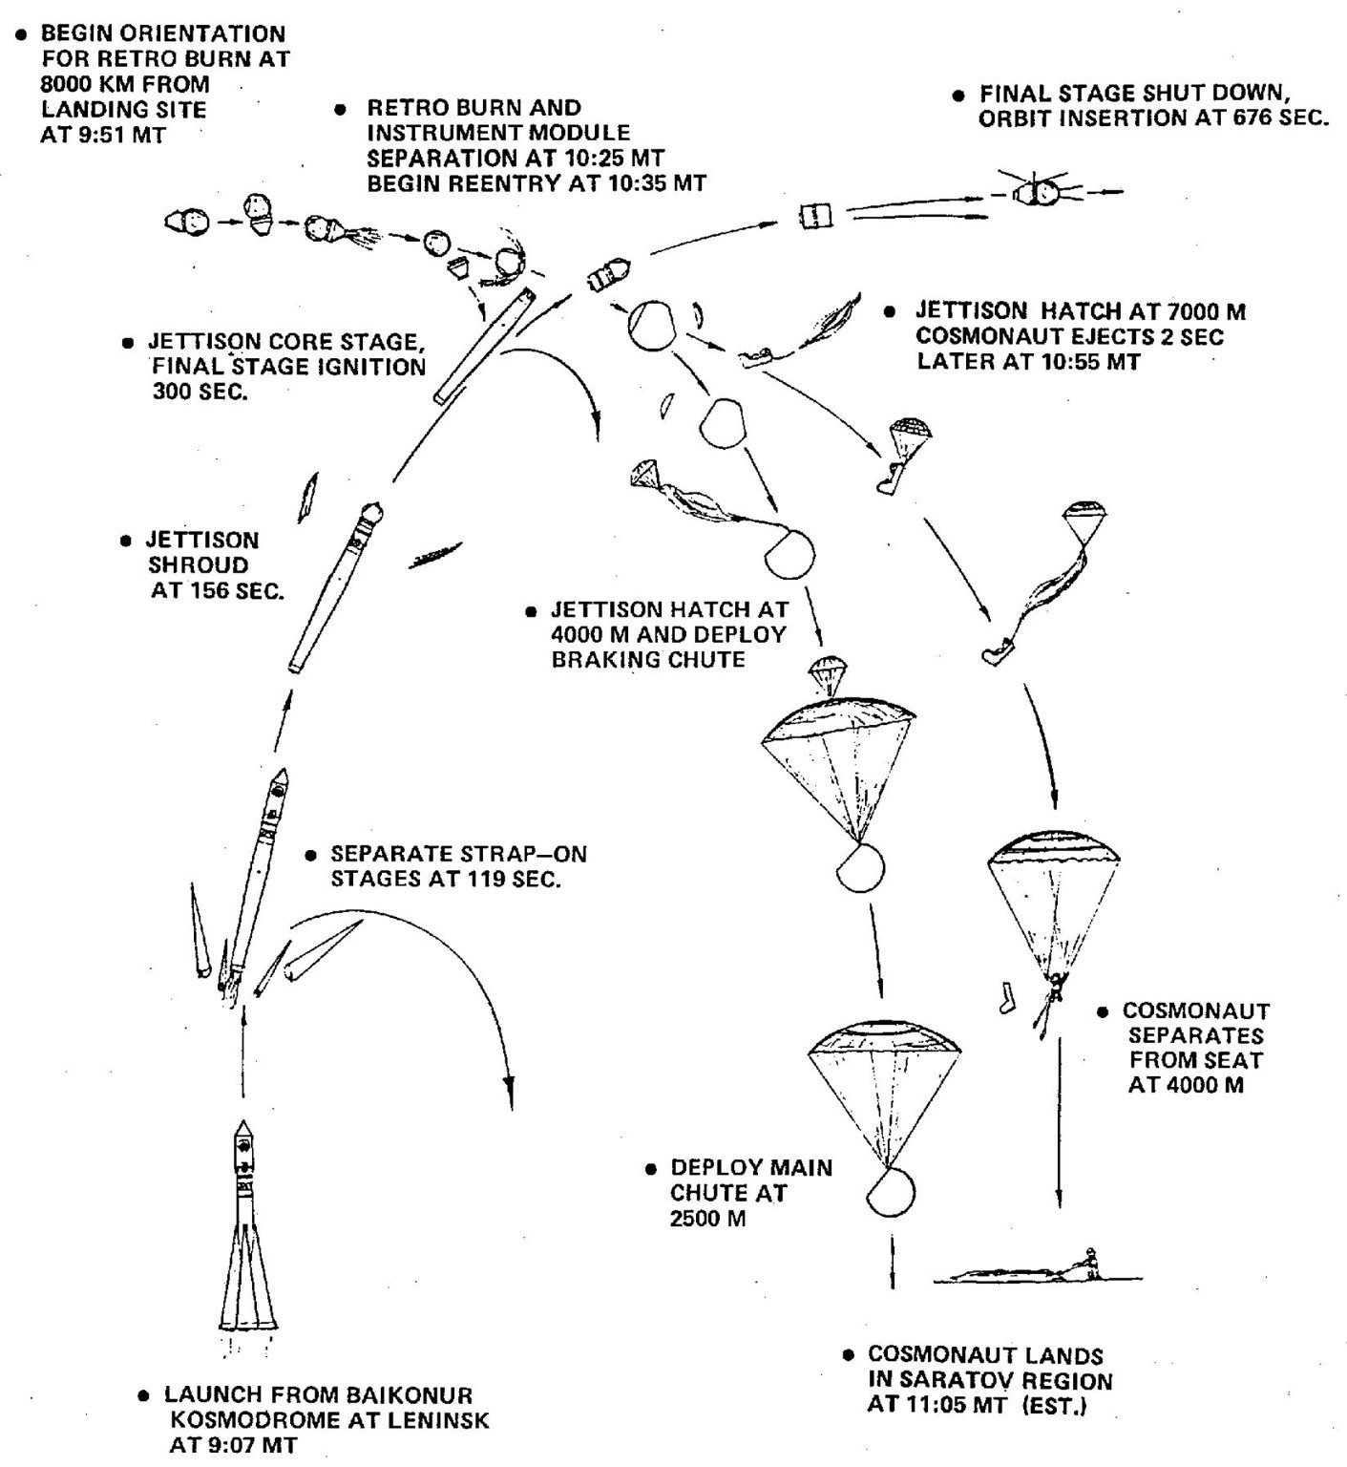

*Launch of Vostok 1*

*Image Source : NASA*

**EVENTS**

**1961 January 6 – Feb 14**

* **Cosmonaut crew selections** - Six of the 20 cosmonauts were selected by the VVS for final examinations and assignment to Vostok flight crews - Bykovsky, Nikolayev, Popovich, Gagarin, Nelyubov, Titov.
* **Cosmonaut examinations** -The Examination Commission consisted of members from the VVS Air Force , AN Academy of Science, industry, and LII Flight Test Institute. Each cosmonaut sat in a Vostok mock-up for 40 to 50 minutes and described the equipment and the operations to be conducted in each phase of flight. For this phase, Gagarin, Titov, Nikolayev, and Popovich were rated 'outstanding' and Nelyubov and Bykovsky 'good'. The essay portion of the written examination consisted of three questions. After handing in the essay, each cosmonaut was given three to five multiple choice questions. All six passed and were rated as ready to fly the Vostok 3KA.
* **Vostok suit review** - A review was held at Factory 98, where Alekseyev was developing the Vostok spacesuit.

**1961 March 2**

* **Vostok launch preparations** - Korolev, Yazdovskiy, Gallay, Feoktistov, Makarov, and Alekseyev spent over three hours editing the 'Instructions to Cosmonauts'. This was the first flight manual in the world for a piloted spacecraft, including instructions for all phases of flight and emergency situations. They argued that the cosmonauts know the equipment and must be capable of manually flying the spacecraft after releasing the electronic logical lock.

**1961 March 9**

* **Korabl-Sputnik 4** -Carried dog Chernushka, mannequin Ivan Ivanovich, and other biological specimens. Ivanovich was ejected from the capsule and recovered by parachute, and Chernsuhka was successfully recovered with the capsule on March 9, 1961 8:10 GMT.

**1961 March 13 –April 3**

* **Vostok cleared for manned flight** and Cosmonaut training- The capsule was recovered 45 km southeast of Votinsk. The mannequin was ejected successfully from the aircraft, the dog Zvezdochka was fine. Therefore all was ready for a manned flight. The environmental control system has still not completed endurance tests, and won't be able to keep the cosmonaut alive for the ten to twelve days it would take the spacecraft to decay from orbit if the retrorocket fails. Trials with the hot mock-up of the ECS in the capsule have still not been successful. Furthermore, a recovery at sea was not practical.
* **Vostok first manned spaceflight authorized.** – The three successful ejections from the Il-28 aircraft & ejections from the re-entry capsule on the ground and from an altitude of 5 km were successful. The cosmonauts are aware of the remaining problems with the capsule but were confident it is safe for a one-orbit flight. The Central Committee approved the flight. The cosmonauts' confirmation of readiness for flight was recorded and played back to the committee. The resulting decree 'On approval for launch of Vostok' provided the final authority to proceed with the first manned spaceflight.

**1961 April 11**

* **Vostok 1 countdown** -The booster rolled out to the pad at 05:00. At 10:00 the cosmonauts meet with Feoktistov for a last review of the flight plan. Launch is set at 09:07 the next day, followed by shutdown and jettison of the lateral boosters of the first stage at 09:09, and orbital insertion at 09:18. The spacecraft oriented itself toward the sun for retrofire at 09:50. At 10:15 the first command sequence was uploaded to the spacecraft, followed by the second at 10:18 and the third at 10:25. Retrofire of the TDU engine commenced at 10:25:47. The service module separated from the capsule at 10:36 as the capsule begins re-entry. The capsule's parachute was deployed at 10:43:43 and at 10:44:12 the cosmonaut's ejection seat fired. While the cosmonauts went through this, the booster has been brought upright on the pad, the service towers raised, and all umbilical connections made. Korolev, Yazdovskiy, and the others made a final inspection at the pad prior to the commencement of the countdown. They ate 'space food' out of 160 g toothpaste-type tubes for lunch - two servings of meat puree and one of chocolate sauce. Gagarin's blood pressure was measured as 115/60, pulse 64, body temperature 36.8 deg C. He was very calm through all this.

**1961 April 12**

* **Vostok 1** -First manned spaceflight, one orbit of the earth. Three press releases were prepared, one for success, two for failures. It was only known ten minutes after burnout, 25 minutes after launch, if a stable orbit had been achieved.

The payload included life-support equipment, radio and television to relay information on the condition of the pilot. The flight was automated; Gagarin's controls were locked to prevent him from taking control of the ship. The combination to unlock the controls was available in a sealed envelope in case it became necessary to take control in an emergency. After retrofire, the service module remained attached to the Sharik reentry sphere by a wire bundle. The joined craft went through wild gyrations at the beginning of re-entry, before the wires burned through. The Sharik, as it was designed to do, then naturally reached aerodynamic equilibrium with the heat shield positioned correctly.

Gagarin ejected after re-entry and descended under his own parachute, as was planned. However for many years the Soviet Union denied this, because the flight would not have been recognized for various FAI world records unless the pilot had accompanied his craft to a landing.

**1961 April 13**

* **Vostok 1 State Commission** -The commission meets from 09:30 to 12:00, making the official interview of Gagarin on his flight. There are unending questions. Afterwards Gagarin fields more questions by phone from the press.

**1961 April 14 -**  **Gagarin returns to Moscow**

**YURI GAGRIN**

*Four days after Yuri Gagarin returned from his flight, the Soviet government held a press conference during which he addressed his country and the world. The speech was recorded by a NASA translator.* *We present an excerpt of the intro and all of Gagarin's speech below.[3]*

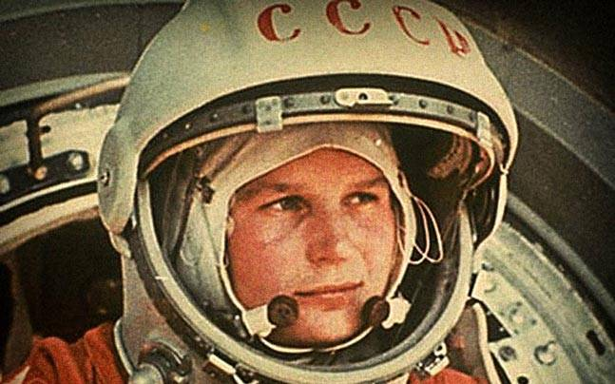“I am a simple Soviet man. I was born March 9, 1934, to the family of a peasant. The place of my birth was in the Smolensk region. There were no princes or nobility in my family tree. Before the revolution my parents were poor peasants. The older generation of my family, my grandfather and grandmother, were also poor peasants, and there were no princes or counts in our family. I attended grade school, then a manual school in Lyubertsy near Moscow. At the time of my graduation I simultaneously completed studies at the Saratov Aeroclub. I was next accepted to the Orenburg Aviation School, from which I graduated in 1957 and was granted the title of Air Force Fighter Pilot. I served with one of the branches of the Soviet Armed Forces. At my own request, I was accepted as a candidate to become a cosmonaut of the Soviet Union. As you can see, after the selection I became a cosmonaut.

I passed through a proper preparation period which was designed by our scientists. This was described in detail by the president of our Academy of Sciences. I successfully passed all preparations, learned the necessary technique and was ready for a cosmic flight.

Before the flight I was in good health and felt very well. I had complete assurance in the success of this flight. Our technique is very reliable and I, as well as my comrades, scientists, engineers and technicians did not doubt for a minute its successful completion

My state-of-being during the flight was superb. During the active portion, when the spaceship was injected into orbit, the effects of gravitation, vibration and noise, as well as other factors of the cosmic flight, did not have any bearing on my condition. I was able to work productively in accordance with the program which was assigned for this flight. After injection into orbit, when the carrier rocket was separated, a state of weightlessness began. In the beginning this feeling was somewhat unpleasant, in spite of the fact that, before the flight, I was subjected to short periods of weightlessness. However, it didn't take long at all, and as I became used to this condition, I continued to carry out the program.

In my own opinion, the effect of weightlessness has no influence on the normal state of the organism and on the physiological functions of a human organism.

During the flight, I ate and drank water, maintaining a continuous radio contact with the Earth over several channels, as well as over the telephone and telegraph. I observed the surrounding area, I followed the operation of the installations aboard the spaceship, I reported to Earth and recorded observations and other data in my log book as well as on a tape recorder. My state of being during the entire period of weightlessness was superb.

Then, in accordance with the flight program the command was given for descent. The spaceship was automatically adjusted, the braking installation was activated and the speed of flight began to decrease. The ship landed safely, and it gave me a great pleasure to meet immediately my own Soviet people. The landing took place at a preselected area in our country.

I would like to tell you a little bit about what I observed.

The view of the Earth from an altitude of 175-300 km is very sharp. The Earth's surface looks approximately the same as seen from a high-flying jet plane. Clearly distinctive are large mountain ranges, large rivers, large forest areas, shorelines and islands.

The clouds which cover the Earths' surface are very visible, and their shadow on the Earth can be seen distinctly. The color of the sky is completely black. The stars on this black background seem to be somewhat brighter and clearer. The Earth is surrounded by a characteristic blue halo. This halo is particularly visible at the horizon. From a light-blue coloring, the sky blends into a beautiful deep blue, then dark blue, violet, and finally complete black. When I left the Earth's shadow, the Sun's rays penetrated the Earth's atmosphere. At this point, the Earth's horizon was dark blue, violet and finally black. The transition into the Earth's shadow took place very rapidly. Darkness comes instantly and nothing can be seen. Obviously, the spaceship passed over the ocean during this period of time. If the spaceship would have passed over large cities, then I would have probably been able to see the lights of those cities. The stars were well visible. The exit from the Earth's shadow is also rapid and sharp. Because I was prepared for it, the influence of the cosmic flight factors were endured very well. Now I feel excellent.

I would like to praise here our Soviet designers, engineers and technicians, as well as the entire Soviet nation, for creating the remarkable spaceship "Vostok," its remarkable equipment and powerful carrier rocket which has placed such a huge spaceship in orbit.

I am immensely glad that my beloved fatherland was the first in history to penetrate cosmos. The first airplane, the first satellite, the first cosmic spaceship and the first manned flight into space, these are the stages on the great road of my fatherland toward the conquest of the mysteries of nature. We plan to fly some more and intend to conquer cosmic space as it should be done. Personally, I would like to fly some more into space. I like flying. My biggest wish is to fly toward Venus, toward Mars, which is really flying.”

**POST MISSION**

Upon his return to Earth, Gagarin was an international hero. He was cheered in Red Square by a crowd of hundreds of thousands. A national treasure, he [traveled](https://www.space.com/15461-gemini-4-astronauts-meet-yuri-gagarin.html) around the world to celebrate the historical Soviet achievement.

On returning home, he became a deputy of the Supreme Soviet and was appointed Commander of the Cosmonauts' Detachment. Because Russia did not want to risk such a public figure, they were hesitant to allow him back into space. He continued to make test flights for the Air Force, however.

On March 27, 1968, Gagarin was killed in while test-piloting a MiG-15. He was survived by his wife, Valentina Ivanovna Goryacheva, and two daughters.

When Apollo 11 touched down on the moon in July 1969, the crew left behind a commemorative medallion bearing Gagarin’s name, as well as medallions for another cosmonaut and three Apollo astronauts who lost their lives in accidents.

-*Maitree Rawat*

*-*[*maitreerawatts@gmail.com*](mailto:maitreerawatts@gmail.com)

**REFERENCES**

Vostok 1 : Part of Vostok Family : <http://www.astronautix.com/v/vostok1.html>

Vostok: Dawn of Human Spaceflight : <http://www.russianspaceweb.com/vostok1.html>

Vostok launch Vehicle : <http://www.russianspaceweb.com/vostok_lv.html>

HOW IT WORKS: How Vostok1 worked- 51 years of SpaceFlight : <https://www.howitworksdaily.com/50-years-of-spaceflight/>

Vostok 1 : <https://en.wikipedia.org/wiki/Vostok_1>

Colin Burgess, Rex Hall (June 2, 2010). The first Soviet cosmonaut team: their lives, legacy, and historical impact. Praxis. p. 356. [*ISBN*](https://en.wikipedia.org/wiki/International_Standard_Book_Number) [*0-387-84823-1*](https://en.wikipedia.org/wiki/Special:BookSources/0-387-84823-1).

Rex Hall, David Shayler (May 18, 2001). The rocket men: Vostok & Voskhod, the first Soviet manned spaceflights. Springer. p. 350. [*ISBN*](https://en.wikipedia.org/wiki/International_Standard_Book_Number) [*1-85233-391-X*](https://en.wikipedia.org/wiki/Special:BookSources/1-85233-391-X).

Vostok (spacecraft) :<https://en.wikipedia.org/wiki/Vostok_(spacecraft)>

Image Source : NASA

1. *Yuri Gagarin : First Man in Space | The Greatest Moments in Flight By Nola Taylor Redd, Space.com* 
2. *Vostok Aircraft on Encyclopedia Astronautica*
3. *Yuri Gagarin’s First Speech About His flight Into Space : The Atlantic*