Scope of Work
Project Title: NFL Multi-Platform Trading Dashboard
Date: 08-10-2025

1. Client’s Requirement
The client requires a unified trading dashboard for professional traders who wish to trade NFL sports markets across multiple platforms. The system should:
- Fetch and display live NFL market data from Pinnacle (reference feed).
- Allow traders to analyse odds and post corresponding quotes on multiple platforms (e.g., Kalshi, ProphetX) via API integrations.
- Support manual as well as automated trading, where automation adjusts quotes and trade behaviour based on Pinnacle’s live odds.
- Implement risk management controls (stop-loss, quote limits, exposure tracking).
- Record all trades and generate real-time profit and loss (P&L) summaries per user, market, and platform.
- Maintain counterparty tracking to monitor performance of traders (sharp vs weak bettors) for future quote adjustments.
- Provide notifications and logs for user alerts, trade confirmations, and system events.
Essentially, the platform acts as a smart bridge between Pinnacle (reference market) and other trading platforms, automating quote posting and ensuring safe, risk-controlled operations.

2. Developer’s Solution and Deliverables
As the developer, I will build an end-to-end system that fulfils the above goals with the following deliverables:
A. Core Features
- User Authentication & Access
  - Secure login via username/password.
  - API key registration for automated Quoting and Quote Posting.
- Live Market Feed Integration (Pinnacle)
  - Establish WebSocket & REST connection to Pinnacle’s live NFL data feed.
  - Cache live odds and market information for rapid internal access.

- Target Platform Connectivity
  - Integrate APIs for Kalshi and ProphetX and other mentioned Platforms.
  - Enable quote posting, modification, and cancellation directly from the dashboard.
- Trading & Automation Engine
  - Allow manual quote posting or enable auto-trading based on Pinnacle’s odds.
  - Apply user-defined automation rules (spread difference, liquidity conditions, etc.).
  - Log every trade for audit and future reference.
- Risk Management Layer
  - Enforce user-level and market-level limits (e.g., quote size, position exposure, stop-loss).
  - Dynamic restriction based on trader or counterparty behaviour.
- Profit & Loss Tracking
  - Real-time P&L per market, per user, per platform.
  - Historical performance analytics.
- Counterparty Tracking
  - Maintain historical behaviour of bettors interacting with trader quotes.
  - Identify “sharp” or “weak” bettors to optimize quote size and spread width in future trades.
- Monitoring, Notifications & System Logs
  - Real-time alerts for trade executions, errors, and system anomalies.
  - Central log system for debugging and audit trail.
- Web Dashboard Interface
  - Intuitive frontend showing markets, odds, automation controls, trades, and alerts.
  - Separate views for traders and admins.

3. Data Flow Charts

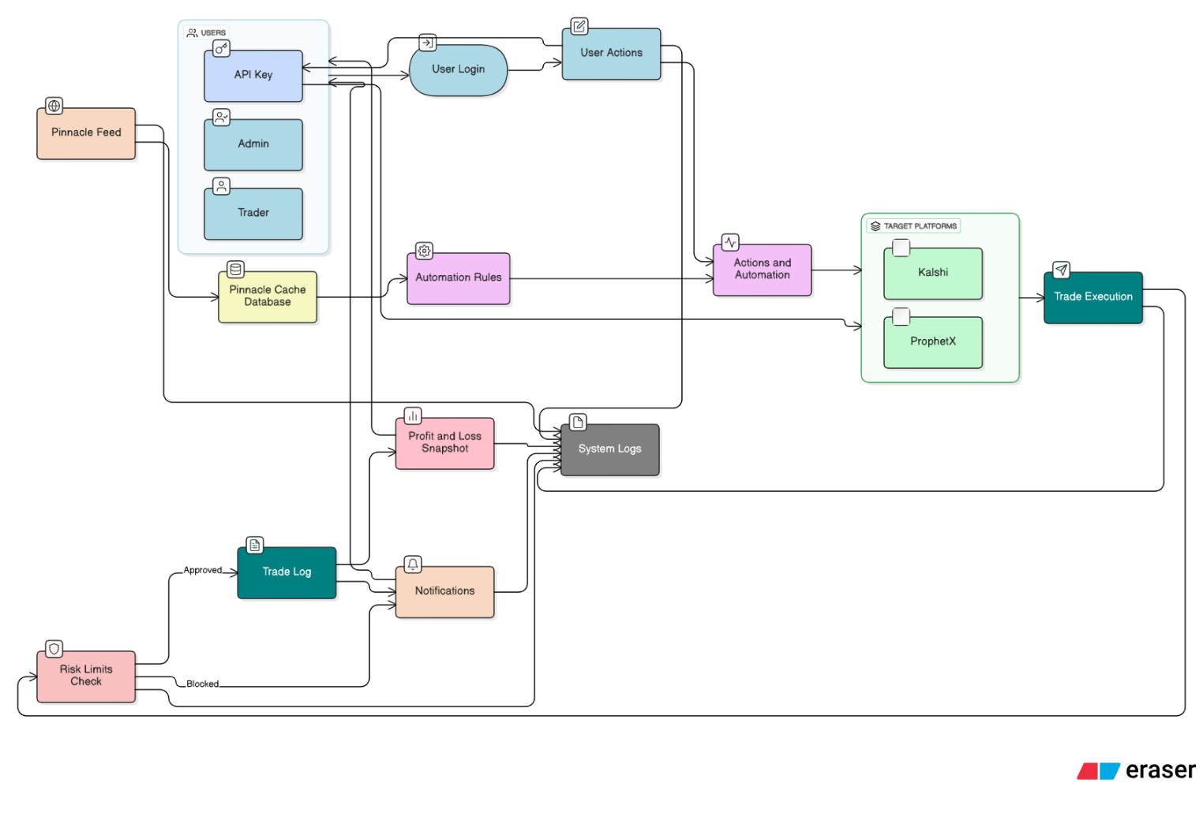

4. Proposed Tech Stack
Layer | Technology / Tools | Purpose
Frontend | React.js | User dashboard and trading UI
Backend | Python (FastAPI) | Core API server handling trading logic
Database | PostgreSQL | Structured storage for users, trades, limits, logs
Caching / Queue | Redis | Pinnacle feed caching and background job handling
Automation / Workers | Celery / Async task | Handle scheduled quote posting and updates
APIs Integration | REST & WebSocket | Connect with Pinnacle, Kalshi, ProphetX
Authentication | JWT / OAuth | Secure login and API token management
Deployment | Docker + Nginx | Containerized, scalable deployment
Monitoring / Logging | Prometheus, Grafana, or ELK | System health and trade activity visualization

5. Expected Outcome
The final system will allow traders to:
- Seamlessly compare live Pinnacle NFL odds and post optimized quotes to Kalshi and ProphetX.
- Enable automation rules that trade hands-free while respecting defined risk limits.
- Gain analytical insight through P&L, counterparty stats, and historical logs.
- Operate in a secure, scalable, and fully auditable environment.

