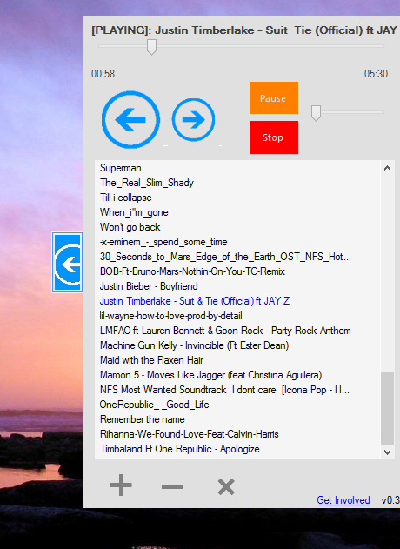 music app **discontinued**

Thanks for downloading music app. This doc is about how can you get involved with this open-source project and get latest builds.

Requirements  
Windows 8/7/Vista SP2   
.NET Framework 3.5 SP1

Download Repository   
As for the current this app doesn’t support auto updates so Download Repository is the main place to get latest builds on this project.   
  
  
Updates on the Development   
If you want to get latest updates on the development of music app just go to its blog and more like its fan page on Facebook also.

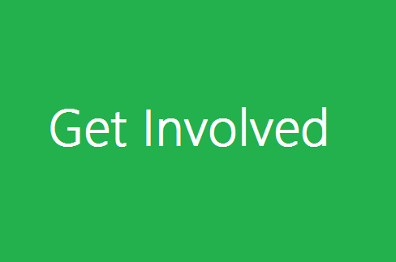

Well there are many ways you can help this project to make best in future. One of the easiest ways is just click on Get Involved link on Music App and submit the suggestion form if I like the suggestion I will implement it in next version. The best way is to join the Music App Dev Group on Facebook and discuss bugs and suggestions there. If you like any options from above please do it.