DO ART NCD Tables & Figures

23 September, 2022

## Main paper tables (South Africa only)

* Table 1: Descriptive statistics of cardiovascular risk in the South Africa site of the DO ART study, by trial arm and gender
* Table 2: Poisson + linear regressions for community follow-up compared with clinic follow-up, and including VS
* Table 3: Poisson + linear regressions with VS as predictor
* Table 4: Stratify Table 3 by treatment arm - i.e. is treatment arm an effect modifier? (YES)
* Table 5: Adjust Table 3 for treatment arm - i.e. is treatment arm a confounder? (NO)
* Table 6: Add interaction term (VS * tx arm) in Table 3 - i.e. does tx arm interact with VS? (NO)

## Distribution figures (South Africa only)

* Figure 1: CVD variables, comparing community follow-up with clinic follow-up
* Figure 2: CVD variables, comparing VS versus not
* Figure 3: CVD variables, comparing VS versus not - COMMUNITY FOLLOW-UP GROUP
* Figure 4: CVD variables, comparing VS versus not - CLINIC FOLLOW-UP GROUP
* Figure 5/6: CVD variables, by age

## Regression plots (South Africa only)

* Figure S1/S2: **Relative risk & mean difference** in cardiovascular risk for community vs. clinic follow-up
* Figure S3/S4: **Relative risk & mean difference** in cardiovascular risk for viral suppression vs. not

### Page Break

## Table 1: Descriptive statistics of cardiovascular risk in the South Africa site of the DO ART study, by trial arm and gender (N = 1010)

|  | **Category** | **Clinic follow-up   n (%)** | **Community follow-up   n (%)** | **Women   n (%)** | **Men   n (%)** | **Total   n (%)** |
| --- | --- | --- | --- | --- | --- | --- |
| Age | 18-29 | 116 (33%) | 255 (39%) | 239 (47%) | 132 (26%) | 371 (37%) |
| 30-44 | 187 (53%) | 308 (47%) | 204 (40%) | 291 (58%) | 495 (49%) |
| 45-59 | 40 (11%) | 91 (14%) | 56 (11%) | 75 (15%) | 131 (13%) |
| 60+ | 7 (2%) | 6 (1%) | 6 (1%) | 7 (1%) | 13 (1%) |
| Gender | Women | 169 (48%) | 336 (51%) | -- | -- | 505 (50%) |
| Men | 181 (52%) | 324 (49%) | -- | -- | 505 (50%) |

| **ii) Lifestyle and other risk** | **Category** | **Clinic follow-up   n (%)** | **Community follow-up   n (%)** | **Women   n (%)** | **Men   n (%)** | **Total   n (%)** |
| --- | --- | --- | --- | --- | --- | --- |
| Smoking Status   [Baseline] | Not at all | 261 (75%) | 497 (75%) | 475 (94%) | 283 (56%) | 758 (75%) |
| Former | 4 (1%) | 3 (0%) | 2 (0%) | 5 (1%) | 7 (1%) |
| Current - occasional | 17 (5%) | 42 (6%) | 13 (3%) | 46 (9%) | 59 (6%) |
| Current - frequent | 68 (19%) | 118 (18%) | 15 (3%) | 171 (34%) | 186 (18%) |
| Days of exercise (per week)   [Endline] | 5-7 | 14 (4%) | 38 (6%) | 13 (3%) | 39 (8%) | 52 (5%) |
| 3-4 | 136 (39%) | 262 (40%) | 185 (37%) | 213 (42%) | 398 (39%) |
| 1-2 | 113 (32%) | 187 (28%) | 163 (32%) | 137 (27%) | 300 (30%) |
| 0 | 54 (15%) | 114 (17%) | 101 (20%) | 67 (13%) | 168 (17%) |
| Unknown | 33 (9%) | 59 (9%) | 43 (9%) | 49 (10%) | 92 (9%) |
| Vegetable intake   [Endline] | Always or usually | 53 (15%) | 122 (18%) | 103 (20%) | 72 (14%) | 175 (17%) |
| Sometimes | 166 (47%) | 326 (49%) | 266 (53%) | 226 (45%) | 492 (49%) |
| Never or rarely | 114 (33%) | 166 (25%) | 107 (21%) | 173 (34%) | 280 (28%) |
| Unknown | 17 (5%) | 46 (7%) | 29 (6%) | 34 (7%) | 63 (6%) |
| Prior stroke or heart attack   [Endline] | No | 328 (94%) | 606 (92%) | 469 (93%) | 465 (92%) | 934 (92%) |
| Yes | 5 (1%) | 9 (1%) | 8 (2%) | 6 (1%) | 14 (1%) |
| Unknown | 17 (5%) | 45 (7%) | 28 (6%) | 34 (7%) | 62 (6%) |

| **iii) Cardiovascular Risk** | **Category** | **Clinic follow-up   n (%)** | **Community follow-up   n (%)** | **Women   n (%)** | **Men   n (%)** | **Total   n (%)** |
| --- | --- | --- | --- | --- | --- | --- |
| Blood pressure   [Endline] | Normal | 171 (49%) | 334 (51%) | 263 (52%) | 242 (48%) | 505 (50%) |
| Elevated | 88 (25%) | 133 (20%) | 99 (20%) | 122 (24%) | 221 (22%) |
| Hypertension Stage 1 | 61 (17%) | 136 (21%) | 104 (21%) | 93 (18%) | 197 (20%) |
| Hypertension Stage 2 | 12 (3%) | 20 (3%) | 16 (3%) | 16 (3%) | 32 (3%) |
| Missing | 18 (5%) | 37 (6%) | 23 (5%) | 32 (6%) | 55 (5%) |
| BMI (kg/m^2)   [Endline] | <18.5 | 10 (3%) | 20 (3%) | 4 (1%) | 26 (5%) | 30 (3%) |
| 18.5-24.9 | 152 (43%) | 268 (41%) | 149 (30%) | 271 (54%) | 420 (42%) |
| 25-29.9 | 100 (29%) | 219 (33%) | 187 (37%) | 132 (26%) | 319 (32%) |
| 30+ | 70 (20%) | 113 (17%) | 142 (28%) | 41 (8%) | 183 (18%) |
| Missing | 18 (5%) | 40 (6%) | 23 (5%) | 35 (7%) | 58 (6%) |
| Hemoglobin A1C (%)   [Endline] | Normal | 235 (67%) | 403 (61%) | 341 (68%) | 297 (59%) | 638 (63%) |
| Prediabetes | 19 (5%) | 35 (5%) | 20 (4%) | 34 (7%) | 54 (5%) |
| Diabetes | 2 (1%) | 6 (1%) | 2 (0%) | 6 (1%) | 8 (1%) |
| Missing | 94 (27%) | 216 (33%) | 142 (28%) | 168 (33%) | 310 (31%) |
| Total cholesterol (mg/dL)   [Endline] | Normal | 324 (93%) | 584 (88%) | 449 (89%) | 459 (91%) | 908 (90%) |
| Borderline High | 1 (0%) | 9 (1%) | 7 (1%) | 3 (1%) | 10 (1%) |
| High | 0 (0%) | 2 (0%) | 1 (0%) | 1 (0%) | 2 (0%) |
| Missing | 25 (7%) | 65 (10%) | 48 (10%) | 42 (8%) | 90 (9%) |
| 10-year CVD risk score   [Endline] | <10% | 255 (73%) | 444 (67%) | 362 (72%) | 337 (67%) | 699 (69%) |
|  | 95 (27%) | 216 (33%) | 143 (28%) | 168 (33%) | 311 (31%) |

### Page Break

## Table 2. Cardiovascular risk for community HIV follow-up care compared with clinic-based follow-up (N = 1010).

|  | **Baseline Analysis** | | | **Adjusted Analysis** | | | **Extended Analysis (VS)** | | |
| --- | --- | --- | --- | --- | --- | --- | --- | --- | --- |
| **Variable** | **Relative Risk** | **95% CI** | **p-value** | **Adj. Relative Risk** | **Adj. 95% CI** | **Adj. p-value** | **Ext. Relative Risk** | **Ext. 95% CI** | **Ext. p-value** |
| Elevated BP | 0.93 | (0.79,1.09) | 0.368 | 0.95 | (0.81,1.11) | 0.508 | 0.94 | (0.81,1.1) | 0.472 |
| Overweight (BMI >= 25) | 1.03 | (0.91,1.17) | 0.633 | 1.03 | (0.91,1.16) | 0.679 | 1.02 | (0.9,1.15) | 0.785 |
| Elevated blood sugar (a1c >= 5.7) | 1.22 | (0.74,2) | 0.44 | 1.22 | (0.74,1.99) | 0.432 | 1.22 | (0.74,2.02) | 0.425 |
| Elevated lipids (total cholesterol >= 200) | 6.8 | (0.89,51.64) | 0.064 | 6.63 | (0.91,48.47) | 0.062 | 6.27 | (0.8,49.17) | 0.08 |
| Smoker [baseline] | 0.99 | (0.79,1.24) | 0.919 | 1 | (1,1) | 0.997 | 1 | (1,1) | 0 |

|  | **Baseline Analysis** | | | **Adjusted Analysis** | | | **Extended Analysis (VS)** | | |
| --- | --- | --- | --- | --- | --- | --- | --- | --- | --- |
| **Variable** | **Mean Difference** | **95% CI** | **p-value** | **Adj. Mean Difference** | **Adj. 95% CI** | **Adj. p-value** | **Ext. Mean Difference** | **Ext. 95% CI** | **Ext. p-value** |
| Systolic BP (mmHg) | -0.8 | (-2.16,0.56) | 0.247 | -0.6 | (-1.96,0.77) | 0.392 | -0.57 | (-1.95,0.8) | 0.415 |
| Diastolic BP (mmHg) | -0.03 | (-1.11,1.05) | 0.956 | 0.07 | (-0.99,1.13) | 0.897 | 0.1 | (-0.96,1.16) | 0.852 |
| BMI (kg/m^2) | -0.02 | (-0.68,0.64) | 0.964 | -0.1 | (-0.72,0.51) | 0.738 | -0.2 | (-0.8,0.41) | 0.526 |
| Hemoglobin A1c (%) | 0.04 | (-0.04,0.12) | 0.287 | 0.05 | (-0.03,0.13) | 0.237 | 0.05 | (-0.03,0.13) | 0.219 |
| Total cholesterol (mg/dL) | 3.13 | (-0.18,6.43) | 0.064 | 2.88 | (-0.44,6.21) | 0.09 | 2.36 | (-0.97,5.69) | 0.165 |

* Relative risk is estimated using a GEE poisson model (and log link).
* Mean Difference is estimated using a GEE linear model.
* Baseline model adjusts for site only
* Adjusted models includes site, age, smoking and gender.
* Extended model includes model endline viral suppression [binary] plus all adjustment variables

### Page Break

## Table 3. Cardiovascular risk among people virally suppressed versus those not virally suppressed at endline (N = 983).

** Note, we drop 27 participants without endline viral load available.

|  | **Baseline Analysis** | | | **Adjusted Analysis** | | |
| --- | --- | --- | --- | --- | --- | --- |
| **Variable** | **Relative Risk** | **95% CI** | **p-value** | **Adj. Relative Risk** | **Adj. 95% CI** | **Adj. p-value** |
| Elevated BP | 1.03 | (0.87,1.21) | 0.762 | 1.04 | (0.88,1.22) | 0.674 |
| Overweight (BMI >= 25) | 1.24 | (1.08,1.42) | 0.002 | 1.16 | (1.02,1.32) | 0.028 |
| Elevated blood sugar (a1c >= 5.7) | 0.89 | (0.54,1.46) | 0.644 | 0.99 | (0.61,1.6) | 0.952 |
| Elevated lipids (total cholesterol >= 200) | 2.26 | (0.51,10.14) | 0.285 | 1.83 | (0.42,7.9) | 0.418 |
| Current smoker [baseline] | 0.81 | (0.65,1.02) | 0.071 | 0.94 | (0.76,1.16) | 0.573 |

|  | **Baseline Analysis** | | | **Adjusted Analysis** | | |
| --- | --- | --- | --- | --- | --- | --- |
| **Variable** | **Mean Difference** | **95% CI** | **p-value** | **Adj. Mean Difference** | **Adj. 95% CI** | **Adj. p-value** |
| Systolic blood pressure (mmHg) | -0.33 | (-1.67,1.02) | 0.635 | -0.3 | (-1.64,1.03) | 0.656 |
| Diastolic blood pressure (mmHg) | -0.27 | (-1.35,0.82) | 0.63 | -0.31 | (-1.38,0.76) | 0.568 |
| BMI (kg/m^2) | 1.32 | (0.67,1.98) | 0 | 0.94 | (0.31,1.57) | 0.003 |
| Hemoglobin A1c (%) | -0.02 | (-0.1,0.06) | 0.639 | -0.02 | (-0.1,0.07) | 0.696 |
| Total cholesterol (mg/dL) | 6 | (2.56,9.44) | 0.001 | 5.53 | (2.12,8.95) | 0.001 |

* Relative risk is estimated using a GEE poisson model (and log link).
* Mean difference is estimated using a GEE linear model.
* This analysis does NOT include trial arm.
* Baseline model adjusts for site only; adjusted models include site, age, smoking, and gender
* The adjusted model for smoking includes only site, age and gender

### Page Break

# Table 4: Cardiovascular risk for virally suppressed versus not, by treatment arm (N = 983)

** Note, we drop 27 participants without endline viral load available.

| **Community follow-up (n = 642)** | **Baseline Analysis** | | | **Adjusted Analysis** | | |
| --- | --- | --- | --- | --- | --- | --- |
| **Variable** | **Relative Risk** | **95% CI** | **p-value** | **Adj. Relative Risk** | **Adj. 95% CI** | **Adj. p-value** |
| Elevated BP | 1.12 | (0.9,1.4) | 0.296 | 1.13 | (0.91,1.41) | 0.278 |
| Overweight (BMI >= 25) | 1.2 | (1.01,1.42) | 0.04 | 1.19 | (1.01,1.41) | 0.035 |
| Elevated blood sugar (a1c >= 5.7) | 1.12 | (0.58,2.17) | 0.735 | 1.04 | (0.55,1.96) | 0.899 |
| Elevated lipids (total cholesterol >= 200) | 2.01 | (0.44,9.23) | 0.37 | 1.23 | (0.27,5.49) | 0.791 |
| Current smoker [baseline] | 0.86 | (0.64,1.15) | 0.302 | 0.92 | (0.7,1.2) | 0.526 |

| **Community follow-up (n = 642)** | **Baseline Analysis** | | | **Adjusted Analysis** | | |
| --- | --- | --- | --- | --- | --- | --- |
| **Variable** | **Mean Difference** | **95% CI** | **p-value** | **Adj. Mean Difference** | **Adj. 95% CI** | **Adj. p-value** |
| Systolic BP (mmHg) | 0.71 | (-0.99,2.42) | 0.412 | 0.63 | (-1.07,2.32) | 0.47 |
| Diastolic BP (mmHg) | 0.38 | (-1,1.76) | 0.589 | 0.01 | (-1.35,1.37) | 0.988 |
| BMI (kg/m^2) | 1.18 | (0.36,2) | 0.005 | 1.09 | (0.31,1.87) | 0.006 |
| Hemoglobin A1c (%) | -0.05 | (-0.15,0.06) | 0.413 | -0.08 | (-0.18,0.02) | 0.112 |
| Total cholesterol (mg/dL) | 8.37 | (3.89,12.84) | 0 | 7.06 | (2.56,11.57) | 0.002 |

| **Clinic follow-up (n = 341)** | **Baseline Analysis** | | | **Adjusted Analysis** | | |
| --- | --- | --- | --- | --- | --- | --- |
| **Variable** | **Relative Risk** | **95% CI** | **p-value** | **Adj. Relative Risk** | **Adj. 95% CI** | **Adj. p-value** |
| Elevated BP | 0.89 | (0.7,1.14) | 0.364 | 0.92 | (0.72,1.18) | 0.522 |
| Overweight (BMI >= 25) | 1.22 | (0.97,1.53) | 0.09 | 1.08 | (0.88,1.34) | 0.466 |
| Elevated blood sugar (a1c >= 5.7) | 0.73 | (0.32,1.66) | 0.456 | 0.79 | (0.35,1.79) | 0.568 |
| Elevated lipids (total cholesterol >= 200) | 1162021741157269504 | (164946929730377728,8186236198087249920) | 0 | 3828025796992098 | (2205412930903970,6644461586806146) | 0 |
| Current smoker [baseline] | 0.71 | (0.48,1.03) | 0.068 | 0.95 | (0.68,1.33) | 0.779 |

| **Clinic follow-up (n = 341)** | **Baseline Analysis** | | | **Adjusted Analysis** | | |
| --- | --- | --- | --- | --- | --- | --- |
| **Variable** | **Mean Difference** | **95% CI** | **p-value** | **Adj. Mean Difference** | **Adj. 95% CI** | **Adj. p-value** |
| Systolic BP (mmHg) | -2.01 | (-4.22,0.2) | 0.074 | -1.61 | (-3.87,0.65) | 0.164 |
| Diastolic BP (mmHg) | -1.04 | (-2.76,0.68) | 0.238 | -0.92 | (-2.58,0.75) | 0.281 |
| BMI (kg/m^2) | 1.2 | (0.1,2.3) | 0.032 | 0.61 | (-0.41,1.63) | 0.24 |
| Hemoglobin A1c (%) | 0.06 | (-0.07,0.19) | 0.378 | 0.06 | (-0.08,0.19) | 0.387 |
| Total cholesterol (mg/dL) | 2.88 | (-2.36,8.12) | 0.281 | 2.15 | (-3.2,7.51) | 0.431 |

* NEED TO DROP CHOLESTEROL FROM THIS TABLE?
* FIX GLITCH WITH HEADINGS on pg 2
* This analysis includes smoking as a binary variable because otherwise getting error

### Page Break

Table 5: Cardiovascular risk among VS versus not VS at endline, adjusting for treatment arm (N = 983)

|  | **Baseline Analysis** | | | **Adjusted Analysis** | | |
| --- | --- | --- | --- | --- | --- | --- |
| **Variable** | **Relative Risk** | **95% CI** | **p-value** | **Adj. Relative Risk** | **Adj. 95% CI** | **Adj. p-value** |
| Elevated BP | 1.03 | (0.88,1.22) | 0.687 | 1.04 | (0.88,1.23) | 0.617 |
| Overweight (BMI >= 25) | 1.24 | (1.08,1.42) | 0.002 | 1.16 | (1.02,1.32) | 0.029 |
| Elevated blood sugar (a1c >= 5.7) | 0.86 | (0.53,1.42) | 0.562 | 0.95 | (0.58,1.55) | 0.84 |
| Current smoker [baseline] | 0.81 | (0.65,1.02) | 0.072 | 0.94 | (0.76,1.16) | 0.547 |

|  | **Baseline Analysis** | | | **Adjusted Analysis** | | |
| --- | --- | --- | --- | --- | --- | --- |
| **Variable** | **Mean Difference** | **95% CI** | **p-value** | **Adj. Mean Difference** | **Adj. 95% CI** | **Adj. p-value** |
| Systolic blood pressure (mmHg) | -0.24 | (-1.6,1.11) | 0.724 | -0.25 | (-1.59,1.1) | 0.721 |
| Diastolic blood pressure (mmHg) | -0.26 | (-1.34,0.81) | 0.631 | -0.32 | (-1.38,0.74) | 0.555 |
| BMI (kg/m^2) | 1.34 | (0.68,1.99) | 0 | 0.96 | (0.34,1.59) | 0.003 |
| Hemoglobin A1c (%) | -0.03 | (-0.11,0.06) | 0.544 | -0.02 | (-0.1,0.06) | 0.588 |
| Total cholesterol (mg/dL) | 5.73 | (2.29,9.18) | 0.001 | 5.29 | (1.86,8.72) | 0.002 |

### Page Break

## Table 6: Coefficients for interaction term for poisson + linear regressions with VS as predictor, with interaction VS * arm

** Note, we drop 27 participants without endline viral load available.

|  | **Baseline Analysis** | | | **Adjusted Analysis** | | |
| --- | --- | --- | --- | --- | --- | --- |
| **Variable** | **Relative Risk** | **95% CI** | **p-value** | **Adj. Relative Risk** | **Adj. 95% CI** | **Adj. p-value** |
| Elevated BP | 1.27 | (0.92,1.77) | 0.151 | 1.23 | (0.88,1.71) | 0.22 |
| Overweight (BMI >= 25) | 1.01 | (0.76,1.34) | 0.933 | 1.12 | (0.86,1.46) | 0.416 |
| Elevated blood sugar (a1c >= 5.7) | 1.36 | (0.49,3.8) | 0.558 | 1.2 | (0.43,3.33) | 0.728 |
| Elevated lipids (total cholesterol >= 200) | 0 | (NaN,NaN) | NaN | 0 | (0,Inf) | 1 |
| Current smoker [baseline] | 1.24 | (0.77,1.99) | 0.377 | 0.99 | (0.65,1.52) | 0.97 |

|  | **Baseline Analysis** | | | **Adjusted Analysis** | | |
| --- | --- | --- | --- | --- | --- | --- |
| **Variable** | **Mean Difference** | **95% CI** | **p-value** | **Adj. Mean Difference** | **Adj. 95% CI** | **Adj. p-value** |
| Systolic blood pressure (mmHg) | 2.8 | (0.01,5.6) | 0.049 | 2.47 | (-0.34,5.29) | 0.085 |
| Diastolic blood pressure (mmHg) | 1.31 | (-0.89,3.51) | 0.243 | 1.2 | (-0.97,3.37) | 0.279 |
| BMI (kg/m^2) | 0.13 | (-1.23,1.48) | 0.856 | 0.59 | (-0.68,1.86) | 0.363 |
| Hemoglobin A1c (%) | -0.13 | (-0.3,0.03) | 0.116 | -0.15 | (-0.32,0.01) | 0.074 |
| Total cholesterol (mg/dL) | 4.92 | (-1.99,11.82) | 0.163 | 5.06 | (-1.89,12.01) | 0.154 |

### Page Break

## Figure 1: Distribution of clinical CVD measures, by arm [dashed lines are group medians]

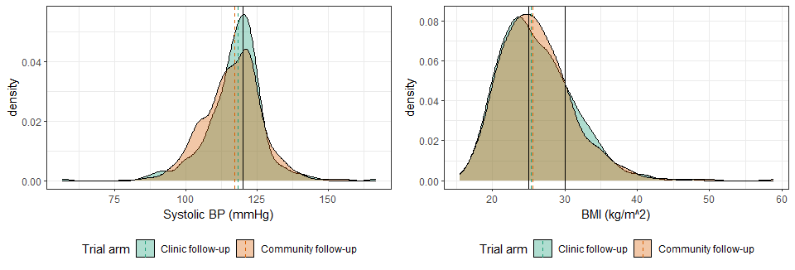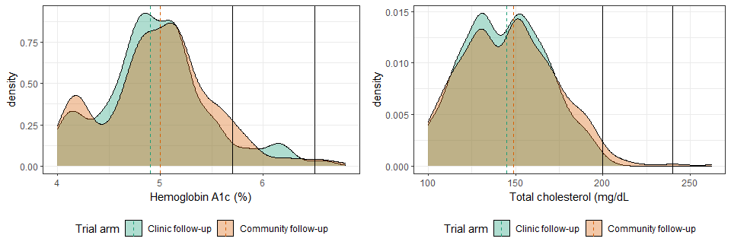

### Page Break

## Figure 2: Distribution, by viral suppression status at endline [dashed lines are group medians]

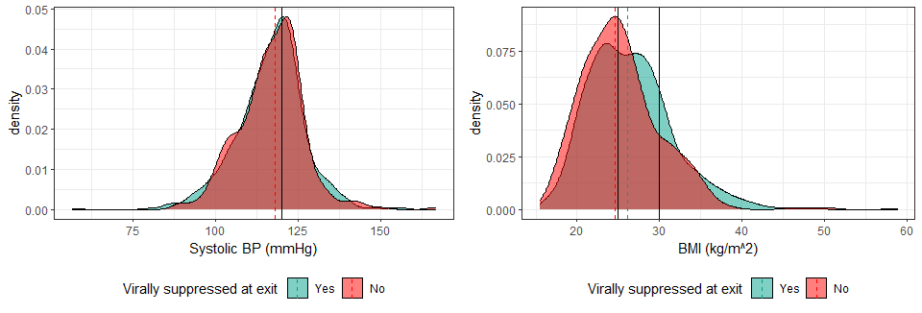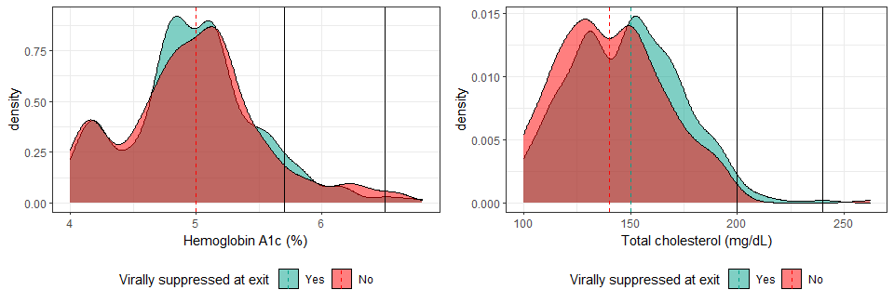

### Page Break

## Figure 3: Distribution, by VS status at endline [dashed lines are group medians] - COMMUNITY ONLY

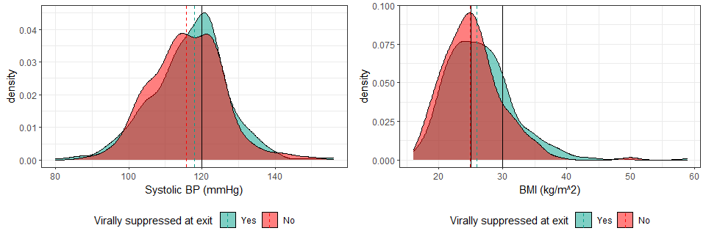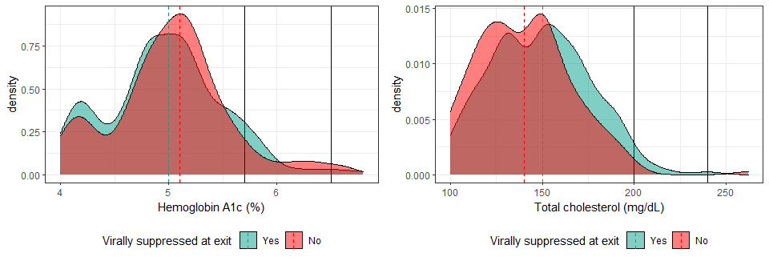

### Page Break

## Figure 4: Distribution, by VS status at endline [dashed lines are group medians] - CLINIC ONLY

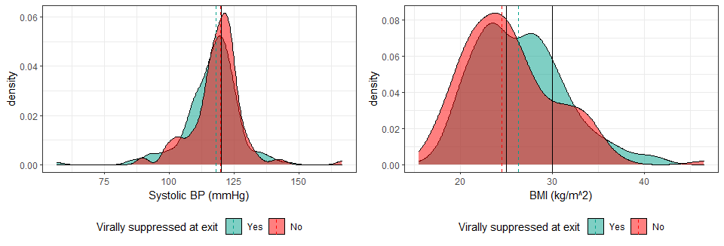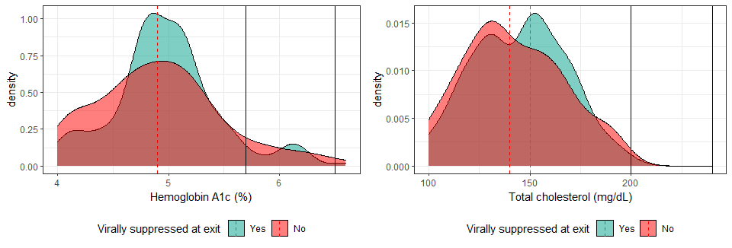

### Page Break

## Figure 5: Distribution of CVD variables by age

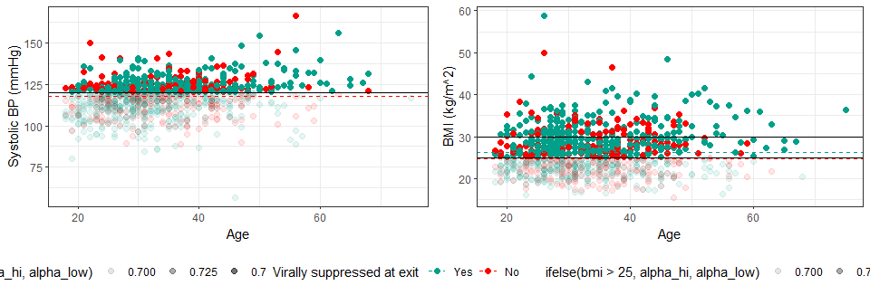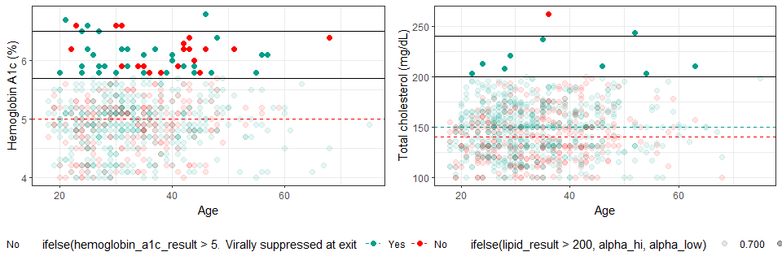

### Page Break

## Figure 6: Distribution of CVD variables by age category

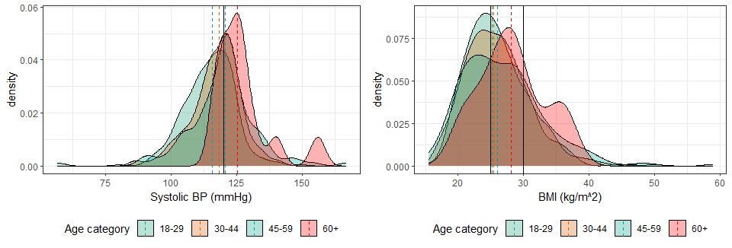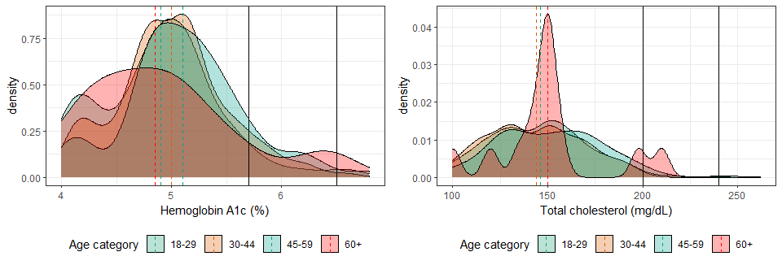

### Page Break

## Figure S1: Relative risk of cardiovascular risk for community follow-up compared with clinic follow-up

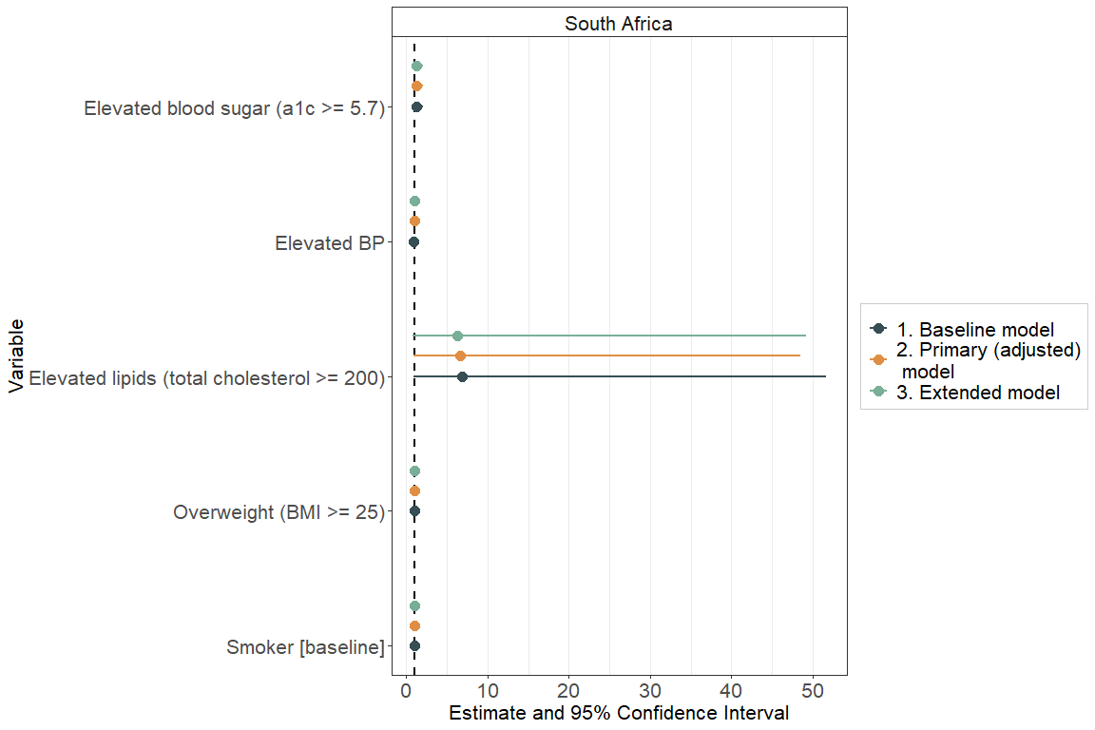

## Figure S2: Mean difference of cardiovascular risk variables for community follow-up compared with clinic follow-up

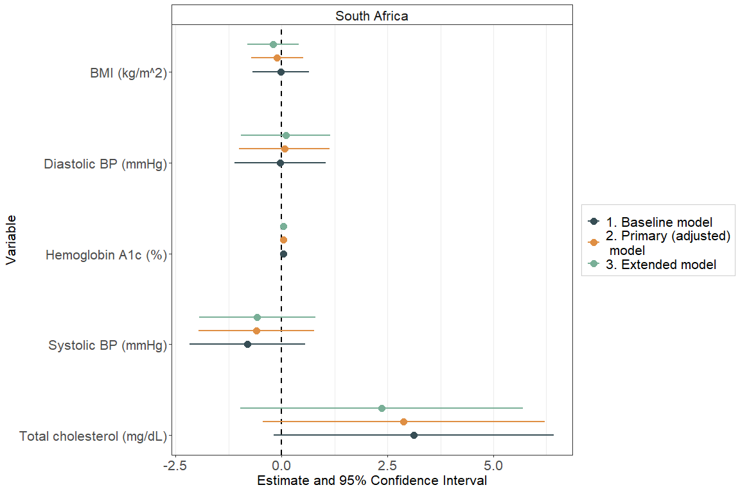

## Figure S3: Relative risk of cardiovascular risk for people who are virally suppressed versus not

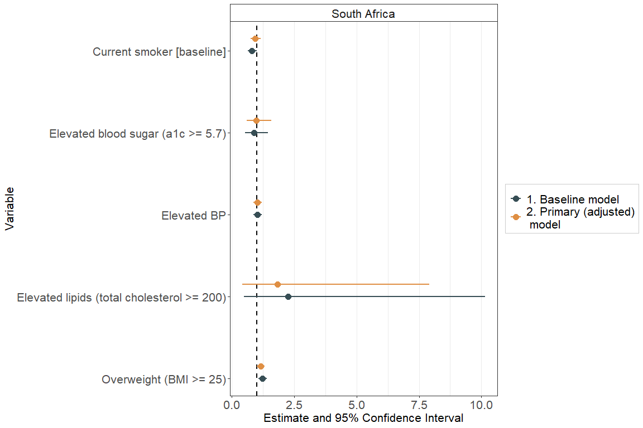

## Figure S4: Mean difference in cardiovascular risk variables for people who are virally suppressed versus not

