DO ART NCD Supplement

14 February, 2024

# Appendix tables

## S1: Variables Description

* S1 Codebook (included with main paper)

## S2: Additional Descriptive Statistics

* S2, Table 1: Change in cardiovascular risk from baseline to endline, by trial arm and gender (AHRI site only, N = 350)
* S2, Table 2: Descriptive statistics of cardiovascular risk in the DO ART study for South Africa, by viral suppression (N = 1010)
* S2, Table 3: Descriptive statistics of cardiovascular risk in the DO ART study, by site and including Uganda (N = 1315)

## S3: Additional Analysis

* S3, Table 1: Table 3 for clinic arm (unadjusted and adjusted)
* S3, Table 2: Table 3 for community arm (unadjusted and adjusted)
* S3, Table 3: Interaction term coefficients
* S3, Table 4: Table 3 by gender (adjusted only)
* S3, EXTRA table: Table 3 by site (adjusted only)

## S4: Missing Data Analysis

## S5: Figures

* S5 Figure 1: CVD variables, comparing community follow-up with clinic follow-up
* S5 Figure 2: Districbution of CVD risk by gender [SEE OTHER FILE]
* S5 Figure 3: Distribution of cardiovascular risk, by viral suppression status at exit
* S5 Figure 4: CVD variables, comparing VS versus not - CLINIC FOLLOW-UP GROUP
* S5 Figure 5: CVD variables, comparing VS versus not - COMMUNITY FOLLOW-UP GROUP
* S5 Figure 6: CVD variables, by VS and age?

### Page Break

## Appendix Table 1: Change in cardiovascular risk from baseline to endline, by trial arm and gender (AHRI site only, N = 350)

| **Change in CVD risk** | **Clinic Follow-Up Arm   Mean (SE)** | **Community Follow-Up Arm   Mean (SE)** | **Women   Mean (SE)** | **Men   Mean (SE)** | **Total   Mean (SE)** |
| --- | --- | --- | --- | --- | --- |
| Change in BMI, baseline to endline   [AHRI only] | 0.86 (0.27) | 0.67 (0.24) | 0.53 (0.24) | 0.93 (0.26) | 0.74 (0.18) |
| Change in Systolic Blood pressure, baseline to endline   [AHRI only] | 0.78 (1.5) | 2.13 (1.17) | 1.1 (1.33) | 2.08 (1.28) | 1.63 (0.92) |

### Page break

## Appendix Table 2: Descriptive statistics of cardiovascular risk in the DO ART study for South Africa, by viral suppression (N = 1010)

|  | **Category** | **Virally suppressed   n (%)** | **Not virally suppressed   n (%)** | **VS unknown   (%)** | **Total   n (%)** |
| --- | --- | --- | --- | --- | --- |
| Age | 18-39 | 482 (74%) | 239 (72%) | 21 (78%) | 742 (73%) |
| 40-59 | 159 (24%) | 90 (27%) | 6 (22%) | 255 (25%) |
| 60+ | 11 (2%) | 2 (1%) | 0 (0%) | 13 (1%) |
| Gender | Women | 348 (53%) | 146 (44%) | 11 (41%) | 505 (50%) |
| Men | 304 (47%) | 185 (56%) | 16 (59%) | 505 (50%) |
| Education | Primary | 118 (18%) | 76 (23%) | 6 (22%) | 200 (20%) |
| Secondary | 504 (77%) | 240 (73%) | 19 (70%) | 763 (76%) |
| Tertiary+ | 19 (3%) | 8 (2%) | 1 (4%) | 28 (3%) |
| Missing | 11 (2%) | 7 (2%) | 1 (4%) | 19 (2%) |

| **ii) Lifestyle and other risk** | **Category** | **Virally suppressed   n (%)** | **Not virally suppressed   n (%)** | **VS unknown   (%)** | **Total   n (%)** |
| --- | --- | --- | --- | --- | --- |
| Smoking Status   [Baseline] | Not at all | 504 (77%) | 238 (72%) | 16 (59%) | 758 (75%) |
| Former | 5 (1%) | 2 (1%) | 0 (0%) | 7 (1%) |
| Current - occasional | 31 (5%) | 25 (8%) | 3 (11%) | 59 (6%) |
| Current - frequent | 112 (17%) | 66 (20%) | 8 (30%) | 186 (18%) |
| Days of exercise (per week)   [Endline] | 5-7 | 36 (6%) | 16 (5%) | 0 (0%) | 52 (5%) |
| 3-4 | 272 (42%) | 124 (37%) | 2 (7%) | 398 (39%) |
| 1-2 | 185 (28%) | 114 (34%) | 1 (4%) | 300 (30%) |
| 0 | 118 (18%) | 50 (15%) | 0 (0%) | 168 (17%) |
| Missing | 41 (6%) | 27 (8%) | 24 (89%) | 92 (9%) |
| Vegetable intake   [Endline] | Always or usually | 114 (17%) | 61 (18%) | 0 (0%) | 175 (17%) |
| Sometimes | 326 (50%) | 164 (50%) | 2 (7%) | 492 (49%) |
| Never or rarely | 186 (29%) | 93 (28%) | 1 (4%) | 280 (28%) |
| Missing | 26 (4%) | 13 (4%) | 24 (89%) | 63 (6%) |
| Prior stroke or heart attack   [Endline] | No | 616 (94%) | 315 (95%) | 3 (11%) | 934 (92%) |
| Yes | 11 (2%) | 3 (1%) | 0 (0%) | 14 (1%) |
| Missing | 25 (4%) | 13 (4%) | 24 (89%) | 62 (6%) |

| **iii) Cardiovascular Risk** | **Category** | **Virally suppressed   n (%)** | **Not virally suppressed   n (%)** | **VS unknown   (%)** | **Total   n (%)** |
| --- | --- | --- | --- | --- | --- |
| Blood pressure   [Endline] | Normal | 333 (51%) | 171 (52%) | 1 (4%) | 505 (50%) |
| Elevated | 140 (21%) | 80 (24%) | 1 (4%) | 221 (22%) |
| Hypertension Stage 1 | 139 (21%) | 57 (17%) | 1 (4%) | 197 (20%) |
| Hypertension Stage 2 | 21 (3%) | 11 (3%) | 0 (0%) | 32 (3%) |
| Missing | 19 (3%) | 12 (4%) | 24 (89%) | 55 (5%) |
| BMI (kg/m^2)   [Endline] | <18.5 | 15 (2%) | 15 (5%) | 0 (0%) | 30 (3%) |
| 18.5-24.9 | 262 (40%) | 156 (47%) | 2 (7%) | 420 (42%) |
| 25-29.9 | 223 (34%) | 95 (29%) | 1 (4%) | 319 (32%) |
| 30+ | 130 (20%) | 53 (16%) | 0 (0%) | 183 (18%) |
| Missing | 22 (3%) | 12 (4%) | 24 (89%) | 58 (6%) |
| Hemoglobin A1C (%)   [Endline] | Normal | 426 (65%) | 210 (63%) | 2 (7%) | 638 (63%) |
| Prediabetes | 36 (6%) | 18 (5%) | 0 (0%) | 54 (5%) |
| Diabetes | 5 (1%) | 3 (1%) | 0 (0%) | 8 (1%) |
| Missing | 185 (28%) | 100 (30%) | 25 (93%) | 310 (31%) |
| Total cholesterol (mg/dL)   [Endline] | Normal | 593 (91%) | 312 (94%) | 3 (11%) | 908 (90%) |
| Borderline High | 9 (1%) | 1 (0%) | 0 (0%) | 10 (1%) |
| High | 1 (0%) | 1 (0%) | 0 (0%) | 2 (0%) |
| Missing | 49 (8%) | 17 (5%) | 24 (89%) | 90 (9%) |
| 10-year CVD risk score   [Endline] | <10% | 467 (72%) | 230 (69%) | 2 (7%) | 699 (69%) |
| Missing | 185 (28%) | 101 (31%) | 25 (93%) | 311 (31%) |

### Page break

## Appendix Table 3: Descriptive statistics of cardiovascular risk in the DO ART study, by site (N = 1315)

|  | **Category** | **SW Uganda   n (%)** | **Midlands KZN SA   n (%)** | **Northern KZN SA   n (%)** | **Total   n (%)** |
| --- | --- | --- | --- | --- | --- |
| Age | 18-39 | 214 (70%) | 488 (74%) | 254 (73%) | 956 (73%) |
| 40-59 | 83 (27%) | 165 (25%) | 90 (26%) | 338 (26%) |
| 60+ | 8 (3%) | 7 (1%) | 6 (2%) | 21 (2%) |
| Gender | Women | 144 (47%) | 345 (52%) | 160 (46%) | 649 (49%) |
| Men | 161 (53%) | 315 (48%) | 190 (54%) | 666 (51%) |
| Education | Primary | 203 (67%) | 106 (16%) | 94 (27%) | 403 (31%) |
| Secondary | 73 (24%) | 520 (79%) | 243 (69%) | 836 (64%) |
| Tertiary+ | 15 (5%) | 24 (4%) | 4 (1%) | 43 (3%) |
| Missing | 14 (5%) | 10 (2%) | 9 (3%) | 33 (3%) |

| **ii) Lifestyle and other risk** | **Category** | **SW Uganda   n (%)** | **Midlands KZN SA   n (%)** | **Northern KZN SA   n (%)** | **Total   n (%)** |
| --- | --- | --- | --- | --- | --- |
| Smoking Status   [Baseline] | Not at all | 253 (83%) | 486 (74%) | 272 (78%) | 1,011 (77%) |
| Former | 5 (2%) | 3 (0%) | 4 (1%) | 12 (1%) |
| Current - occasional | 13 (4%) | 45 (7%) | 14 (4%) | 72 (5%) |
| Current - frequent | 34 (11%) | 126 (19%) | 60 (17%) | 220 (17%) |
| Days of exercise (per week)   [Endline] | 5-7 | 162 (53%) | 21 (3%) | 31 (9%) | 214 (16%) |
| 3-4 | 58 (19%) | 312 (47%) | 86 (25%) | 456 (35%) |
| 1-2 | 22 (7%) | 189 (29%) | 111 (32%) | 322 (24%) |
| 0 | 5 (2%) | 99 (15%) | 69 (20%) | 173 (13%) |
| Missing | 58 (19%) | 39 (6%) | 53 (15%) | 150 (11%) |
| Vegetable intake   [Endline] | Always or usually | 79 (26%) | 153 (23%) | 22 (6%) | 254 (19%) |
| Sometimes | 93 (30%) | 394 (60%) | 98 (28%) | 585 (44%) |
| Never or rarely | 76 (25%) | 73 (11%) | 207 (59%) | 356 (27%) |
| Missing | 57 (19%) | 40 (6%) | 23 (7%) | 120 (9%) |
| Prior stroke or heart attack   [Endline] | No | 248 (81%) | 611 (93%) | 323 (92%) | 1,182 (90%) |
| Yes | 0 (0%) | 10 (2%) | 4 (1%) | 14 (1%) |
| Missing | 57 (19%) | 39 (6%) | 23 (7%) | 119 (9%) |

| **iii) Cardiovascular Risk** | **Category** | **SW Uganda   n (%)** | **Midlands KZN SA   n (%)** | **Northern KZN SA   n (%)** | **Total   n (%)** |
| --- | --- | --- | --- | --- | --- |
| Blood pressure   [Endline] | Normal | 143 (47%) | 330 (50%) | 175 (50%) | 648 (49%) |
| Elevated | 14 (5%) | 160 (24%) | 61 (17%) | 235 (18%) |
| Hypertension Stage 1 | 92 (30%) | 123 (19%) | 74 (21%) | 289 (22%) |
| Hypertension Stage 2 | 14 (5%) | 16 (2%) | 16 (5%) | 46 (3%) |
| Missing | 42 (14%) | 31 (5%) | 24 (7%) | 97 (7%) |
| BMI (kg/m^2)   [Endline] | <18.5 | 14 (5%) | 19 (3%) | 11 (3%) | 44 (3%) |
| 18.5-24.9 | 161 (53%) | 244 (37%) | 176 (50%) | 581 (44%) |
| 25-29.9 | 47 (15%) | 231 (35%) | 88 (25%) | 366 (28%) |
| 30+ | 8 (3%) | 134 (20%) | 49 (14%) | 191 (15%) |
| Missing | 75 (25%) | 32 (5%) | 26 (7%) | 133 (10%) |
| Hemoglobin A1C (%)   [Endline] | Normal | 174 (57%) | 379 (57%) | 259 (74%) | 812 (62%) |
| Prediabetes | 14 (5%) | 18 (3%) | 36 (10%) | 68 (5%) |
| Diabetes | 3 (1%) | 0 (0%) | 8 (2%) | 11 (1%) |
| Missing | 114 (37%) | 263 (40%) | 47 (13%) | 424 (32%) |
| Total cholesterol (mg/dL)   [Endline] | Normal | 185 (61%) | 615 (93%) | 293 (84%) | 1,093 (83%) |
| Borderline High | 5 (2%) | 3 (0%) | 7 (2%) | 15 (1%) |
| High | 1 (0%) | 0 (0%) | 2 (1%) | 3 (0%) |
| Missing | 114 (37%) | 42 (6%) | 48 (14%) | 204 (16%) |
| 10-year CVD risk score   [Endline] | <10% | 190 (62%) | 397 (60%) | 302 (86%) | 889 (68%) |
| Missing | 115 (38%) | 263 (40%) | 48 (14%) | 426 (32%) |

### Page break

## Appendix S3, Table 1: Cardiovascular risk among people virally suppressed versus those not virally suppressed at endline, in the clinic-based follow-up arm (N = 341).

|  | **Unadjusted Analysis** | | | **Adjusted Analysis** | | |
| --- | --- | --- | --- | --- | --- | --- |
| **Variable** | **Relative Risk** | **95% CI** | **p-value** | **Adj. Relative Risk** | **Adj. 95% CI** | **Adj. p-value** |
| Elevated BP | 0.89 | (0.7,1.15) | 0.375 | 0.93 | (0.72,1.19) | 0.542 |
| Overweight (BMI >= 25) | 1.23 | (0.98,1.54) | 0.068 | 1.08 | (0.87,1.34) | 0.489 |
| Elevated blood sugar (a1c >= 5.7) | 0.72 | (0.32,1.61) | 0.419 | 0.76 | (0.32,1.78) | 0.53 |
| Current smoker [baseline] | 0.71 | (0.49,1.03) | 0.073 | 0.95 | (0.67,1.33) | 0.748 |

|  | **Unadjusted Analysis** | | | **Adjusted Analysis** | | |
| --- | --- | --- | --- | --- | --- | --- |
| **Variable** | **Mean Difference** | **95% CI** | **p-value** | **Adj. Mean Difference** | **Adj. 95% CI** | **Adj. p-value** |
| Systolic blood pressure (mmHg) | -1.98 | (-4.19,0.22) | 0.078 | -1.58 | (-3.84,0.67) | 0.169 |
| Diastolic blood pressure (mmHg) | -1.07 | (-2.78,0.65) | 0.223 | -0.95 | (-2.62,0.73) | 0.268 |
| BMI (kg/m^2) | 1.27 | (0.18,2.35) | 0.022 | 0.56 | (-0.49,1.61) | 0.299 |
| Hemoglobin A1c (%) | 0.06 | (-0.07,0.19) | 0.403 | 0.06 | (-0.07,0.2) | 0.36 |
| Total cholesterol (mg/dL) | 2.7 | (-2.52,7.91) | 0.311 | 2.06 | (-3.26,7.39) | 0.448 |

## Appendix S3, Table 2: Cardiovascular risk among people virally suppressed versus those not virally suppressed at endline, in the community-based follow-up arm (N = 642).

|  | **Unadjusted Analysis** | | | **Adjusted Analysis** | | |
| --- | --- | --- | --- | --- | --- | --- |
| **Variable** | **Relative Risk** | **95% CI** | **p-value** | **Adj. Relative Risk** | **Adj. 95% CI** | **Adj. p-value** |
| Elevated BP | 1.14 | (0.92,1.43) | 0.23 | 1.17 | (0.94,1.46) | 0.158 |
| Overweight (BMI >= 25) | 1.24 | (1.04,1.47) | 0.014 | 1.21 | (1.03,1.42) | 0.024 |
| Elevated blood sugar (a1c >= 5.7) | 0.96 | (0.5,1.86) | 0.914 | 1.05 | (0.57,1.95) | 0.874 |
| Current smoker [baseline] | 0.88 | (0.65,1.18) | 0.383 | 0.95 | (0.72,1.24) | 0.69 |

|  | **Unadjusted Analysis** | | | **Adjusted Analysis** | | |
| --- | --- | --- | --- | --- | --- | --- |
| **Variable** | **Mean Difference** | **95% CI** | **p-value** | **Adj. Mean Difference** | **Adj. 95% CI** | **Adj. p-value** |
| Systolic blood pressure (mmHg) | 0.82 | (-0.89,2.53) | 0.348 | 0.94 | (-0.7,2.59) | 0.261 |
| Diastolic blood pressure (mmHg) | 0.21 | (-1.18,1.6) | 0.765 | 0.2 | (-1.13,1.53) | 0.767 |
| BMI (kg/m^2) | 1.36 | (0.55,2.18) | 0.001 | 1.18 | (0.41,1.95) | 0.003 |
| Hemoglobin A1c (%) | -0.08 | (-0.19,0.02) | 0.115 | -0.08 | (-0.18,0.02) | 0.118 |
| Total cholesterol (mg/dL) | 7.63 | (3.06,12.19) | 0.001 | 7.52 | (2.93,12.1) | 0.001 |

### Page break

## Appendix S3, Table 3: Coefficients for interaction term for cardiovascular risk for persons virally suppressed versus not suppressed at endline in South Africa (N = 983).

|  | **Unadjusted Analysis** | | | **Adjusted Analysis** | | |
| --- | --- | --- | --- | --- | --- | --- |
| **Variable** | **Relative Risk** | **95% CI** | **p-value** | **Adj. Relative Risk** | **Adj. 95% CI** | **Adj. p-value** |
| Elevated BP | 1.27 | (0.92,1.77) | 0.151 | 1.27 | (0.92,1.77) | 0.148 |
| Overweight (BMI >= 25) | 1.01 | (0.76,1.34) | 0.933 | 1.12 | (0.86,1.47) | 0.397 |
| Elevated blood sugar (a1c >= 5.7) | 1.36 | (0.49,3.8) | 0.558 | 1.3 | (0.47,3.57) | 0.615 |
| Current smoker [baseline] | 1.24 | (0.77,1.99) | 0.377 | 0.99 | (0.65,1.53) | 0.977 |

|  | **Unadjusted Analysis** | | | **Adjusted Analysis** | | |
| --- | --- | --- | --- | --- | --- | --- |
| **Variable** | **Mean Difference** | **95% CI** | **p-value** | **Adj. Mean Difference** | **Adj. 95% CI** | **Adj. p-value** |
| Systolic blood pressure (mmHg) | 2.8 | (0.01,5.6) | 0.049 | 2.76 | (-0.01,5.54) | 0.051 |
| Diastolic blood pressure (mmHg) | 1.31 | (-0.89,3.51) | 0.243 | 1.47 | (-0.69,3.62) | 0.182 |
| BMI (kg/m^2) | 0.13 | (-1.23,1.48) | 0.856 | 0.64 | (-0.63,1.9) | 0.324 |
| Hemoglobin A1c (%) | -0.13 | (-0.3,0.03) | 0.116 | -0.14 | (-0.31,0.02) | 0.091 |
| Total cholesterol (mg/dL) | 4.92 | (-1.99,11.82) | 0.163 | 5.59 | (-1.36,12.54) | 0.115 |

** Note, we drop 27 participants without endline viral load available.

** This is the coefficient for VS * arm

## Appendix S3, Table 4: Cardiovascular risk among people virally suppressed versus those not virally suppressed at endline, by gender

|  | **Women (n = 505)** | | | **Men (n = 505)** | | |
| --- | --- | --- | --- | --- | --- | --- |
| **Variable** | **Relative Risk** | **95% CI** | **p-value** | **Relative Risk** | **95% CI** | **p-value** |
| Elevated BP | 1.26 | (0.96,1.65) | 0.093 | 0.94 | (0.76,1.16) | 0.556 |
| Overweight (BMI >= 25) | 1.1 | (0.96,1.27) | 0.172 | 1.24 | (0.96,1.6) | 0.093 |
| Elevated blood sugar (a1c >= 5.7) | 1.55 | (0.54,4.44) | 0.418 | 0.82 | (0.47,1.44) | 0.491 |
| Current smoker [baseline] | 0.6 | (0.28,1.26) | 0.177 | 1.01 | (0.82,1.25) | 0.917 |

|  | **Women (n = 505)** | | | **Men (n = 505)** | | |
| --- | --- | --- | --- | --- | --- | --- |
| **Variable** | **Mean Difference** | **95% CI** | **p-value** | **Mean Difference** | **95% CI** | **p-value** |
| Systolic blood pressure (mmHg) | 1.22 | (-0.68,3.13) | 0.208 | -1.06 | (-2.87,0.75) | 0.252 |
| Diastolic blood pressure (mmHg) | 0 | (-1.48,1.47) | 0.996 | -0.46 | (-1.97,1.04) | 0.548 |
| BMI (kg/m^2) | 1.05 | (0.02,2.09) | 0.046 | 0.75 | (0,1.5) | 0.049 |
| Hemoglobin A1c (%) | 0.04 | (-0.07,0.14) | 0.526 | -0.05 | (-0.16,0.07) | 0.45 |
| Total cholesterol (mg/dL) | 4.37 | (-0.57,9.31) | 0.083 | 6.5 | (1.78,11.22) | 0.007 |

### Page Break

## Appendix S3, Table 5: Cardiovascular risk among people virally suppressed versus those not virally suppressed at endline CONTROLLING FOR CD4+ COUNT, in South Africa (N = 983).

|  | **Unadjusted Analysis** | | | **Adjusted Analysis** | | |
| --- | --- | --- | --- | --- | --- | --- |
| **Variable** | **Relative Risk** | **95% CI** | **p-value** | **Adj. Relative Risk** | **Adj. 95% CI** | **Adj. p-value** |
| Elevated BP | 1.03 | (0.87,1.21) | 0.762 | 1.05 | (0.90,1.24) | 0.521 |
| Overweight (BMI >= 25) | 1.24 | (1.08,1.42) | 0.002 | 1.16 | (1.02,1.33) | 0.023 |
| Elevated blood sugar (a1c >= 5.7) | 0.89 | (0.54,1.46) | 0.644 | 0.95 | (0.59,1.54) | 0.835 |
| Current smoker [baseline] | 0.81 | (0.65,1.02) | 0.071 | 0.95 | (0.78,1.17) | 0.650 |

|  | **Unadjusted Analysis** | | | **Adjusted Analysis** | | |
| --- | --- | --- | --- | --- | --- | --- |
| **Variable** | **Mean Difference** | **95% CI** | **p-value** | **Adj. Mean Difference** | **Adj. 95% CI** | **Adj. p-value** |
| Systolic blood pressure (mmHg) | -0.33 | (-1.67, 1.02) | 0.635 | -0.16 | (-1.49, 1.16) | 0.811 |
| Diastolic blood pressure (mmHg) | -0.27 | (-1.35, 0.82) | 0.630 | -0.28 | (-1.34, 0.78) | 0.608 |
| BMI (kg/m^2) | 1.32 | (0.67,1.98) | 0.000 | 0.96 | (0.33,1.59) | 0.003 |
| Hemoglobin A1c (%) | -0.02 | (-0.10, 0.06) | 0.639 | -0.02 | (-0.10, 0.06) | 0.674 |
| Total cholesterol (mg/dL) | 6.00 | (2.56,9.44) | 0.001 | 5.73 | (2.29,9.17) | 0.001 |

## Appendix S3, EXTRA table: Cardiovascular risk among people virally suppressed versus those not virally suppressed at endline, by site

|  | **Midlands KZN** | | | **Northern KZN** | | |
| --- | --- | --- | --- | --- | --- | --- |
| **Variable** | **Relative Risk** | **95% CI** | **p-value** | **.Relative Risk** | **.95% CI** | **.p-value** |
| Elevated BP | 1.09 | (0.9,1.33) | 0.362 | 1.02 | (0.76,1.37) | 0.905 |
| Overweight (BMI >= 25) | 1.21 | (1.05,1.39) | 0.01 | 1.05 | (0.78,1.41) | 0.757 |
| Elevated blood sugar (a1c >= 5.7) | 2 | (0.69,5.83) | 0.203 | 0.72 | (0.42,1.23) | 0.231 |
| Current smoker [baseline] | 0.88 | (0.69,1.11) | 0.278 | 1.14 | (0.75,1.72) | 0.542 |

|  | **Midlands KZN** | | | **Northern KZN** | | |
| --- | --- | --- | --- | --- | --- | --- |
| **Variable** | **Mean Difference** | **95% CI** | **p-value** | **.Mean Difference** | **.95% CI** | **.p-value** |
| Systolic blood pressure (mmHg) | 0.78 | (-0.69,2.24) | 0.3 | -1.57 | (-4.27,1.12) | 0.253 |
| Diastolic blood pressure (mmHg) | 0.12 | (-1.08,1.33) | 0.839 | -1.07 | (-3.2,1.07) | 0.329 |
| BMI (kg/m^2) | 1.28 | (0.52,2.04) | 0.001 | 0.2 | (-0.9,1.31) | 0.718 |
| Hemoglobin A1c (%) | 0.05 | (-0.05,0.15) | 0.361 | -0.11 | (-0.24,0.03) | 0.13 |
| Total cholesterol (mg/dL) | 2.81 | (-1.02,6.64) | 0.151 | 12.54 | (5.6,19.49) | 0 |

## S4: Additional Figures

## S4 Figure 1: Distribution of clinical CVD measures, by arm [dashed lines are group medians]

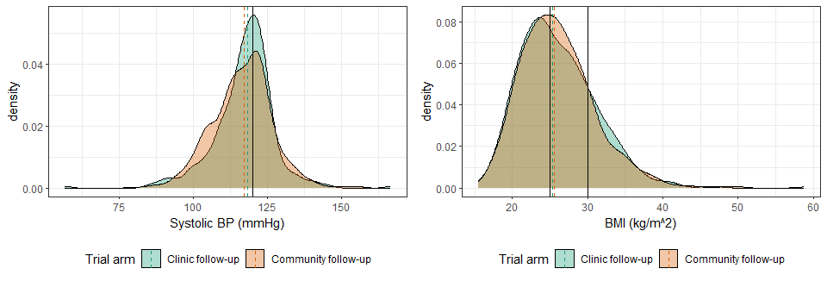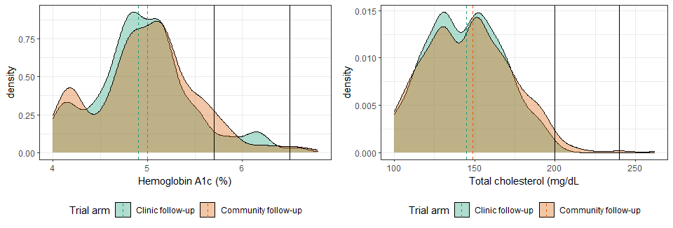

### Page Break

## S4 Figure 2: Distribution of cardiovascular risk, by viral suppression status at exit [dashed lines are group medians]

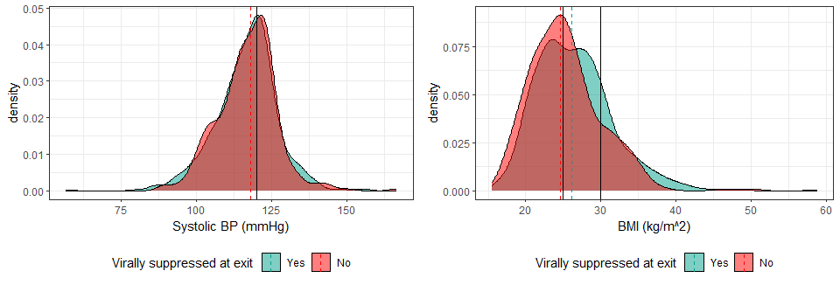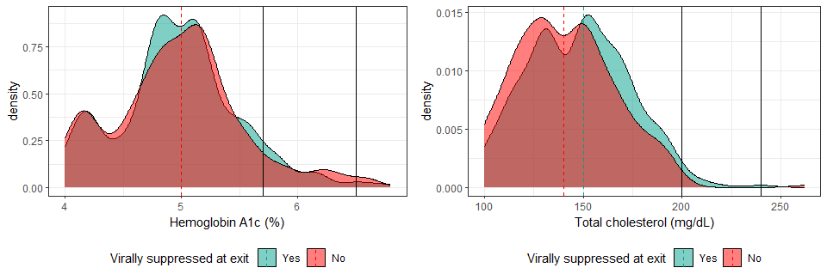

### Page Break

## S4 Figure 3: Distribution, by VS status at endline [dashed lines are group medians]



### Page Break

## S4 Figure 4: Distribution, by VS status at endline [dashed lines are group medians] - CLINIC ONLY

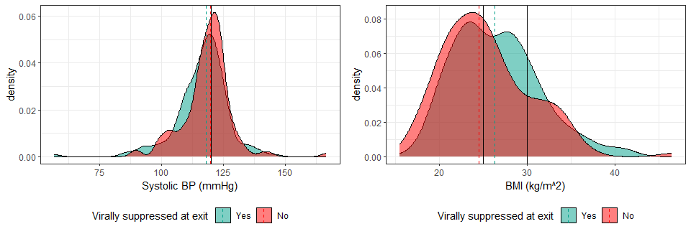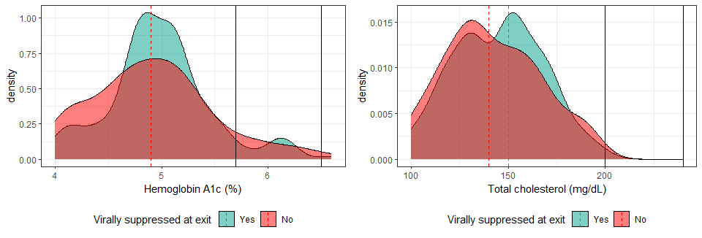

### Page break

## S4 Figure 5: Distribution, by VS status at endline [dashed lines are group medians] - COMMUNITY ONLY

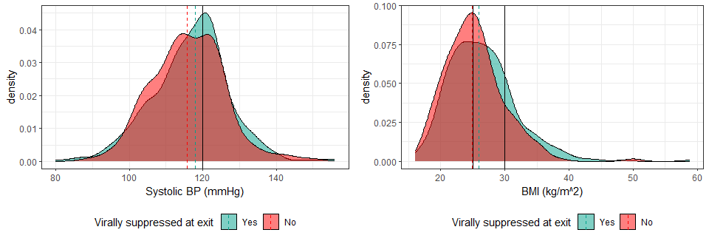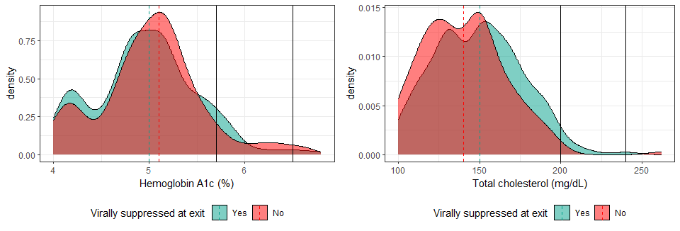

### Page Break

## S4 Figure 6: Distribution of CVD variables by age

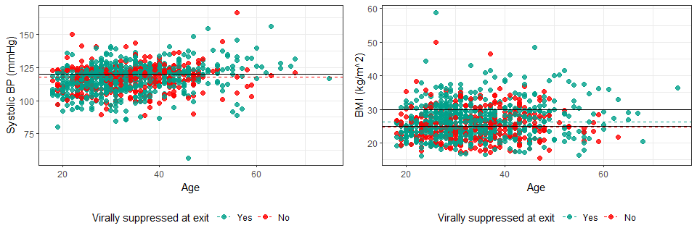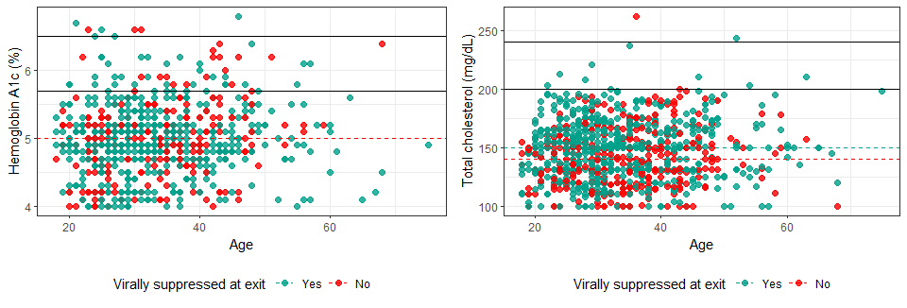 ### Page Break

## S4 Figure 7: Distribution of CVD variables by education

