DO ART NCD Supplement

26 September, 2022

# Appendix tables

## S1: Variables Description

* S1 Codebook (included with main paper)

## S2: Additional Descriptive Statistics

* S2, Table 1: Change in cardiovascular risk from baseline to endline, by trial arm and gender (AHRI site only, N = 350)
* S2, Table 2: Descriptive statistics of cardiovascular risk in the DO ART study, by site and including Uganda (N = 1315)

## S3: Additional Analysis

* S3, Table 1: Table 3 for all sites (unadjusted and adjusted)
* S3, Table 2: Table 3 for clinic arm (unadjusted and adjusted)
* S3, Table 3: Table 3 for community arm (unadjusted and adjusted)
* S3, Table 4: Interaction term coefficients

## S4: Additional Figures

* S4 Figure 1: CVD variables, comparing community follow-up with clinic follow-up
* S4 Figure 2: CVD variables, comparing VS versus not - CLINIC FOLLOW-UP GROUP
* S4 Figure 3: CVD variables, comparing VS versus not - COMMUNITY FOLLOW-UP GROUP
* S4 Figure 4: CVD variables, by age

## Number plugging (rough)

### Page Break

## Appendix Table 1: Change in cardiovascular risk from baseline to endline, by trial arm and gender (AHRI site only, N = 350)

| **Change in CVD risk** | **Clinic Follow-Up Arm   Mean (SE)** | **Community Follow-Up Arm   Mean (SE)** | **Women   Mean (SE)** | **Men   Mean (SE)** | **Total   Mean (SE)** |
| --- | --- | --- | --- | --- | --- |
| Change in BMI, baseline to endline   [AHRI only] | 0.86 (0.27) | 0.67 (0.24) | 0.53 (0.24) | 0.93 (0.26) | 0.74 (0.18) |
| Change in Systolic Blood pressure, baseline to endline   [AHRI only] | 0.78 (1.5) | 2.13 (1.17) | 1.1 (1.33) | 2.08 (1.28) | 1.63 (0.92) |

### Page break

## Appendix Table 2: Descriptive statistics of cardiovascular risk in the DO ART study, by site (N = 1315)

|  | **Category** | **SW Uganda   n (%)** | **Midlands KZN SA   n (%)** | **Northern KZN SA   n (%)** | **Total   n (%)** |
| --- | --- | --- | --- | --- | --- |
| Age | 18-39 | 214 (70%) | 488 (74%) | 254 (73%) | 956 (73%) |
| 40-59 | 83 (27%) | 165 (25%) | 90 (26%) | 338 (26%) |
| 60+ | 8 (3%) | 7 (1%) | 6 (2%) | 21 (2%) |
| Gender | Women | 144 (47%) | 345 (52%) | 160 (46%) | 649 (49%) |
| Men | 161 (53%) | 315 (48%) | 190 (54%) | 666 (51%) |

| **ii) Lifestyle and other risk** | **Category** | **SW Uganda   n (%)** | **Midlands KZN SA   n (%)** | **Northern KZN SA   n (%)** | **Total   n (%)** |
| --- | --- | --- | --- | --- | --- |
| Smoking Status   [Baseline] | Not at all | 253 (83%) | 486 (74%) | 272 (78%) | 1011 (77%) |
| Former | 5 (2%) | 3 (0%) | 4 (1%) | 12 (1%) |
| Current - occasional | 13 (4%) | 45 (7%) | 14 (4%) | 72 (5%) |
| Current - frequent | 34 (11%) | 126 (19%) | 60 (17%) | 220 (17%) |
| Days of exercise (per week)   [Endline] | 5-7 | 162 (53%) | 21 (3%) | 31 (9%) | 214 (16%) |
| 3-4 | 58 (19%) | 312 (47%) | 86 (25%) | 456 (35%) |
| 1-2 | 22 (7%) | 189 (29%) | 111 (32%) | 322 (24%) |
| 0 | 5 (2%) | 99 (15%) | 69 (20%) | 173 (13%) |
| Unknown | 58 (19%) | 39 (6%) | 53 (15%) | 150 (11%) |
| Vegetable intake   [Endline] | Always or usually | 79 (26%) | 153 (23%) | 22 (6%) | 254 (19%) |
| Sometimes | 93 (30%) | 394 (60%) | 98 (28%) | 585 (44%) |
| Never or rarely | 76 (25%) | 73 (11%) | 207 (59%) | 356 (27%) |
| Unknown | 57 (19%) | 40 (6%) | 23 (7%) | 120 (9%) |
| Prior stroke or heart attack   [Endline] | No | 248 (81%) | 611 (93%) | 323 (92%) | 1182 (90%) |
| Yes | 0 (0%) | 10 (2%) | 4 (1%) | 14 (1%) |
| Unknown | 57 (19%) | 39 (6%) | 23 (7%) | 119 (9%) |

| **iii) Cardiovascular Risk** | **Category** | **SW Uganda   n (%)** | **Midlands KZN SA   n (%)** | **Northern KZN SA   n (%)** | **Total   n (%)** |
| --- | --- | --- | --- | --- | --- |
| Blood pressure   [Endline] | Normal | 143 (47%) | 330 (50%) | 175 (50%) | 648 (49%) |
| Elevated | 14 (5%) | 160 (24%) | 61 (17%) | 235 (18%) |
| Hypertension Stage 1 | 92 (30%) | 123 (19%) | 74 (21%) | 289 (22%) |
| Hypertension Stage 2 | 14 (5%) | 16 (2%) | 16 (5%) | 46 (3%) |
| Missing | 42 (14%) | 31 (5%) | 24 (7%) | 97 (7%) |
| BMI (kg/m^2)   [Endline] | <18.5 | 14 (5%) | 19 (3%) | 11 (3%) | 44 (3%) |
| 18.5-24.9 | 161 (53%) | 244 (37%) | 176 (50%) | 581 (44%) |
| 25-29.9 | 47 (15%) | 231 (35%) | 88 (25%) | 366 (28%) |
| 30+ | 8 (3%) | 134 (20%) | 49 (14%) | 191 (15%) |
| Missing | 75 (25%) | 32 (5%) | 26 (7%) | 133 (10%) |
| Hemoglobin A1C (%)   [Endline] | Normal | 174 (57%) | 379 (57%) | 259 (74%) | 812 (62%) |
| Prediabetes | 14 (5%) | 18 (3%) | 36 (10%) | 68 (5%) |
| Diabetes | 3 (1%) | 0 (0%) | 8 (2%) | 11 (1%) |
| Missing | 114 (37%) | 263 (40%) | 47 (13%) | 424 (32%) |
| Total cholesterol (mg/dL)   [Endline] | Normal | 185 (61%) | 615 (93%) | 293 (84%) | 1093 (83%) |
| Borderline High | 5 (2%) | 3 (0%) | 7 (2%) | 15 (1%) |
| High | 1 (0%) | 0 (0%) | 2 (1%) | 3 (0%) |
| Missing | 114 (37%) | 42 (6%) | 48 (14%) | 204 (16%) |
| 10-year CVD risk score   [Endline] | <10% | 190 (62%) | 397 (60%) | 302 (86%) | 889 (68%) |
|  | 115 (38%) | 263 (40%) | 48 (14%) | 426 (32%) |

### Page Break

## Appendix S3, Table 1: Cardiovascular risk among people virally suppressed versus those not virally suppressed at endline, in South Africa (N = 983).

|  | **Baseline Analysis** | | | **Adjusted Analysis** | | |
| --- | --- | --- | --- | --- | --- | --- |
| **Variable** | **Relative Risk** | **95% CI** | **p-value** | **Adj. Relative Risk** | **Adj. 95% CI** | **Adj. p-value** |
| Elevated BP | 1.03 | (0.87,1.21) | 0.762 | 1.04 | (0.89,1.23) | 0.619 |
| Overweight (BMI >= 25) | 1.24 | (1.08,1.42) | 0.002 | 1.16 | (1.02,1.32) | 0.029 |
| Elevated blood sugar (a1c >= 5.7) | 0.89 | (0.54,1.46) | 0.644 | 0.98 | (0.6,1.59) | 0.93 |
| Current smoker [baseline] | 0.81 | (0.65,1.02) | 0.071 | 0.93 | (0.76,1.15) | 0.521 |

|  | **Baseline Analysis** | | | **Adjusted Analysis** | | |
| --- | --- | --- | --- | --- | --- | --- |
| **Variable** | **Mean Difference** | **95% CI** | **p-value** | **Adj. Mean Difference** | **Adj. 95% CI** | **Adj. p-value** |
| Systolic blood pressure (mmHg) | -0.33 | (-1.67,1.02) | 0.635 | -0.26 | (-1.6,1.07) | 0.7 |
| Diastolic blood pressure (mmHg) | -0.27 | (-1.35,0.82) | 0.63 | -0.26 | (-1.33,0.8) | 0.627 |
| BMI (kg/m^2) | 1.32 | (0.67,1.98) | 0 | 0.95 | (0.31,1.58) | 0.003 |
| Hemoglobin A1c (%) | -0.02 | (-0.1,0.06) | 0.639 | -0.02 | (-0.1,0.07) | 0.715 |
| Total cholesterol (mg/dL) | 6 | (2.56,9.44) | 0.001 | 5.75 | (2.31,9.18) | 0.001 |

* Relative risk is estimated using a GEE poisson model (and log link).
* Mean difference is estimated using a GEE linear model.
* This analysis does NOT include trial arm.
* Baseline model adjusts for site only; adjusted models include site, age, smoking, and gender
* The adjusted model for smoking includes only site, age and gender

### Page break

## Appendix S3, Table 2: Cardiovascular risk among people virally suppressed versus those not virally suppressed at endline, in the clinic-based follow-up arm (N = 341).

|  | **Baseline Analysis** | | | **Adjusted Analysis** | | |
| --- | --- | --- | --- | --- | --- | --- |
| **Variable** | **Relative Risk** | **95% CI** | **p-value** | **Adj. Relative Risk** | **Adj. 95% CI** | **Adj. p-value** |
| Elevated BP | 0.89 | (0.7,1.15) | 0.375 | 0.91 | (0.71,1.17) | 0.48 |
| Overweight (BMI >= 25) | 1.23 | (0.98,1.54) | 0.068 | 1.07 | (0.87,1.33) | 0.521 |
| Elevated blood sugar (a1c >= 5.7) | 0.72 | (0.32,1.61) | 0.419 | 0.78 | (0.34,1.79) | 0.564 |
| Current smoker [baseline] | 0.71 | (0.49,1.03) | 0.073 | 0.95 | (0.68,1.34) | 0.782 |

|  | **Baseline Analysis** | | | **Adjusted Analysis** | | |
| --- | --- | --- | --- | --- | --- | --- |
| **Variable** | **Mean Difference** | **95% CI** | **p-value** | **Adj. Mean Difference** | **Adj. 95% CI** | **Adj. p-value** |
| Systolic blood pressure (mmHg) | -1.98 | (-4.19,0.22) | 0.078 | -1.64 | (-3.89,0.61) | 0.154 |
| Diastolic blood pressure (mmHg) | -1.07 | (-2.78,0.65) | 0.223 | -0.98 | (-2.64,0.69) | 0.249 |
| BMI (kg/m^2) | 1.27 | (0.18,2.35) | 0.022 | 0.57 | (-0.49,1.62) | 0.292 |
| Hemoglobin A1c (%) | 0.06 | (-0.07,0.19) | 0.403 | 0.06 | (-0.08,0.19) | 0.4 |
| Total cholesterol (mg/dL) | 2.7 | (-2.52,7.91) | 0.311 | 2.07 | (-3.27,7.41) | 0.448 |

## Appendix S3, Table 3: Cardiovascular risk among people virally suppressed versus those not virally suppressed at endline, in the community-based follow-up arm (N = 642).

|  | **Baseline Analysis** | | | **Adjusted Analysis** | | |
| --- | --- | --- | --- | --- | --- | --- |
| **Variable** | **Relative Risk** | **95% CI** | **p-value** | **Adj. Relative Risk** | **Adj. 95% CI** | **Adj. p-value** |
| Elevated BP | 1.14 | (0.92,1.43) | 0.23 | 1.16 | (0.93,1.44) | 0.193 |
| Overweight (BMI >= 25) | 1.24 | (1.04,1.47) | 0.014 | 1.2 | (1.02,1.41) | 0.031 |
| Elevated blood sugar (a1c >= 5.7) | 0.96 | (0.5,1.86) | 0.914 | 1.04 | (0.55,1.95) | 0.902 |
| Current smoker [baseline] | 0.88 | (0.65,1.18) | 0.383 | 0.92 | (0.7,1.2) | 0.517 |

|  | **Baseline Analysis** | | | **Adjusted Analysis** | | |
| --- | --- | --- | --- | --- | --- | --- |
| **Variable** | **Mean Difference** | **95% CI** | **p-value** | **Adj. Mean Difference** | **Adj. 95% CI** | **Adj. p-value** |
| Systolic blood pressure (mmHg) | 0.82 | (-0.89,2.53) | 0.348 | 0.79 | (-0.9,2.48) | 0.359 |
| Diastolic blood pressure (mmHg) | 0.21 | (-1.18,1.6) | 0.765 | 0.16 | (-1.19,1.51) | 0.816 |
| BMI (kg/m^2) | 1.36 | (0.55,2.18) | 0.001 | 1.18 | (0.4,1.97) | 0.003 |
| Hemoglobin A1c (%) | -0.08 | (-0.19,0.02) | 0.115 | -0.08 | (-0.18,0.03) | 0.146 |
| Total cholesterol (mg/dL) | 7.63 | (3.06,12.19) | 0.001 | 7.48 | (2.91,12.04) | 0.001 |

### Page Break

## Appendix S3, Table 4: Coefficients for interaction term for cardiovascular risk for persons virally suppressed versus not suppressed at endline in South Africa (N = 983).

|  | **Baseline Analysis** | | | **Adjusted Analysis** | | |
| --- | --- | --- | --- | --- | --- | --- |
| **Variable** | **Relative Risk** | **95% CI** | **p-value** | **Adj. Relative Risk** | **Adj. 95% CI** | **Adj. p-value** |
| Elevated BP | 1.27 | (0.92,1.77) | 0.151 | 1.27 | (0.91,1.76) | 0.16 |
| Overweight (BMI >= 25) | 1.01 | (0.76,1.34) | 0.933 | 1.12 | (0.86,1.46) | 0.4 |
| Elevated blood sugar (a1c >= 5.7) | 1.36 | (0.49,3.8) | 0.558 | 1.23 | (0.44,3.4) | 0.692 |
| Current smoker [baseline] | 1.24 | (0.77,1.99) | 0.377 | 0.98 | (0.64,1.51) | 0.933 |

|  | **Baseline Analysis** | | | **Adjusted Analysis** | | |
| --- | --- | --- | --- | --- | --- | --- |
| **Variable** | **Mean Difference** | **95% CI** | **p-value** | **Adj. Mean Difference** | **Adj. 95% CI** | **Adj. p-value** |
| Systolic blood pressure (mmHg) | 2.8 | (0.01,5.6) | 0.049 | 2.69 | (-0.11,5.5) | 0.06 |
| Diastolic blood pressure (mmHg) | 1.31 | (-0.89,3.51) | 0.243 | 1.41 | (-0.76,3.58) | 0.203 |
| BMI (kg/m^2) | 0.13 | (-1.23,1.48) | 0.856 | 0.65 | (-0.62,1.92) | 0.316 |
| Hemoglobin A1c (%) | -0.13 | (-0.3,0.03) | 0.116 | -0.14 | (-0.31,0.03) | 0.102 |
| Total cholesterol (mg/dL) | 4.92 | (-1.99,11.82) | 0.163 | 5.51 | (-1.43,12.45) | 0.12 |

** Note, we drop 27 participants without endline viral load available.

** This is the coefficient for VS * arm

## S4: Additional Figures

## S4 Figure 1: Distribution of clinical CVD measures, by arm [dashed lines are group medians]

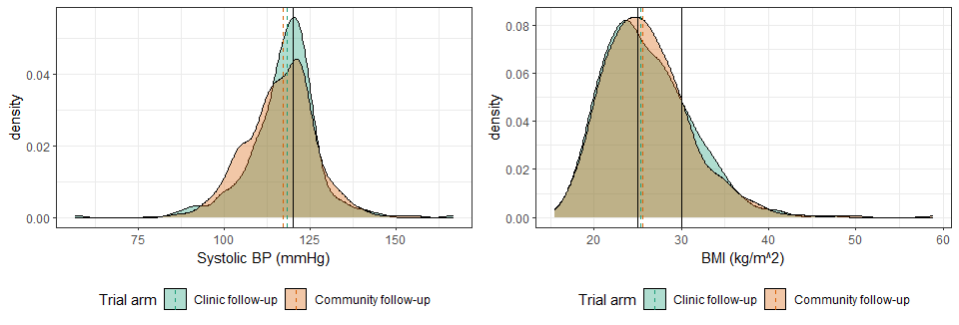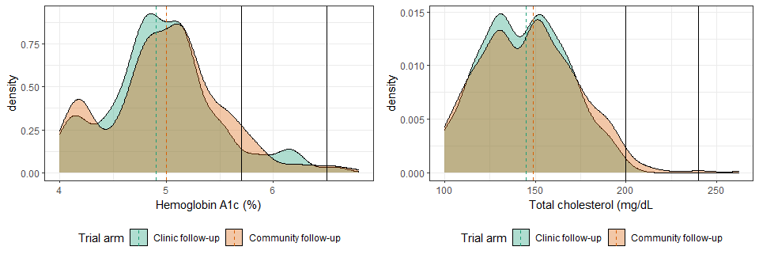

### Page Break

## S4 Figure 2: Distribution, by VS status at endline [dashed lines are group medians] - CLINIC ONLY

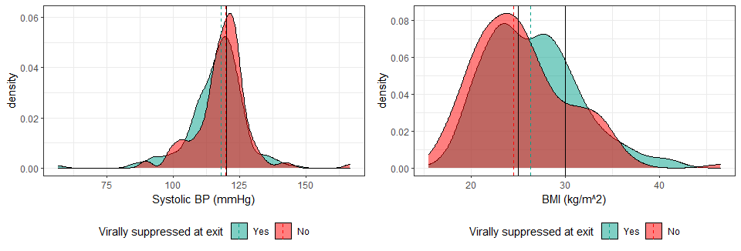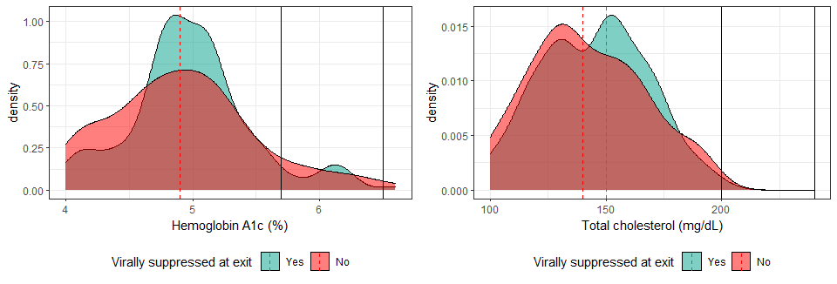

### Page break

## S4 Figure 3: Distribution, by VS status at endline [dashed lines are group medians] - COMMUNITY ONLY

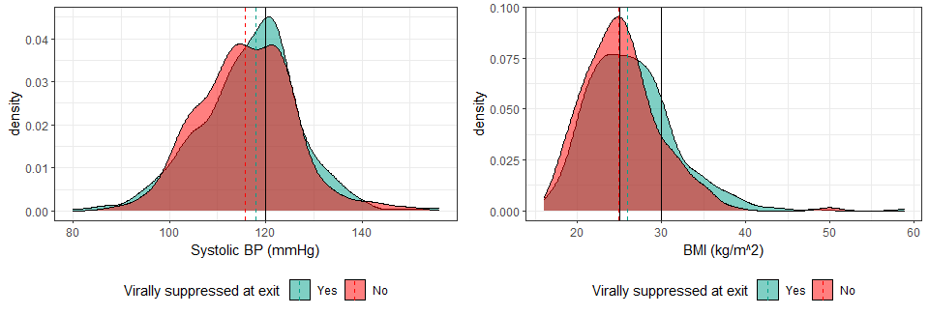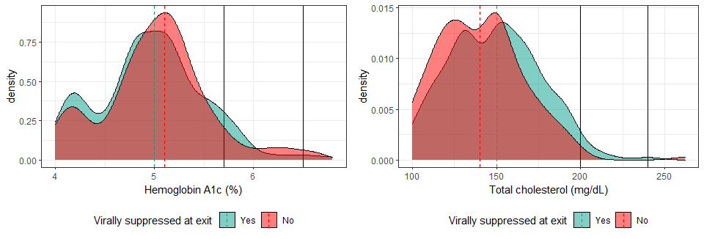

### Page Break

## S4 Figure 4: Distribution of CVD variables by age

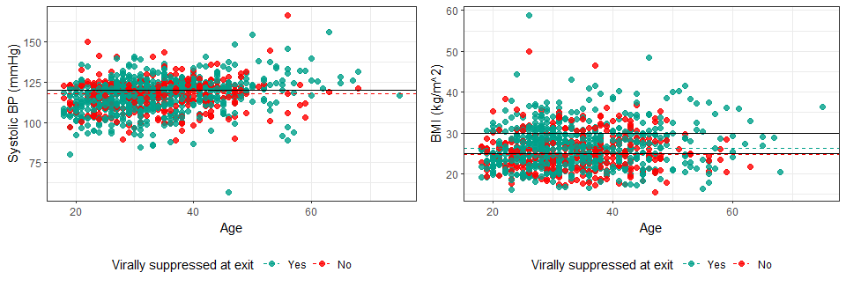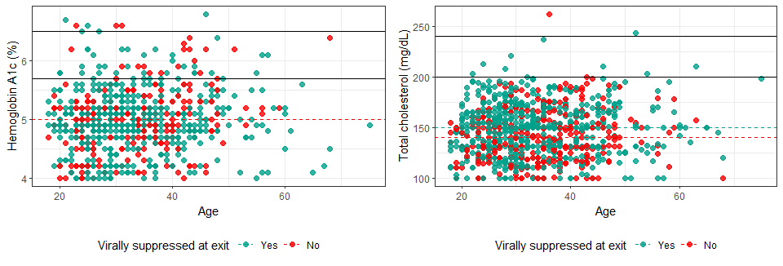 ### Page Break

# NUMBER PLUGGING (rough)  
  
ncd_merged_subset %>% filter(armR == "Community follow-up") %>%filter(is.na(exit_viral_load_result)) %>% nrow()

## [1] 18

ncd_merged_subset %>% filter(armR == "Clinic follow-up") %>% filter(is.na(exit_viral_load_result)) %>% nrow()

## [1] 9