4_cholesterol_figures

09 May, 2022

## Distribution of CVD variable [overall]

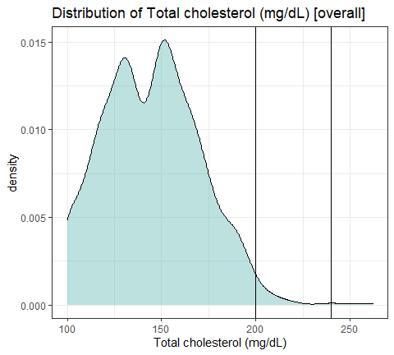

## Distribution, by arm [dashed lines are group medians]

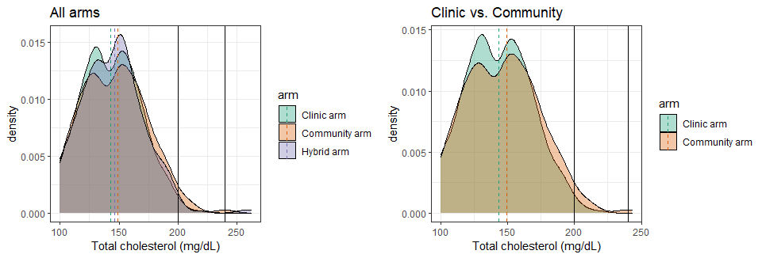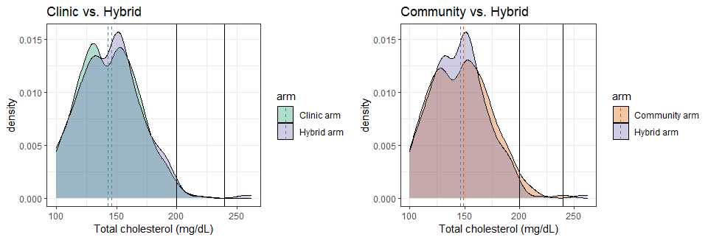

## Distribution, by gender [dashed lines are group medians]

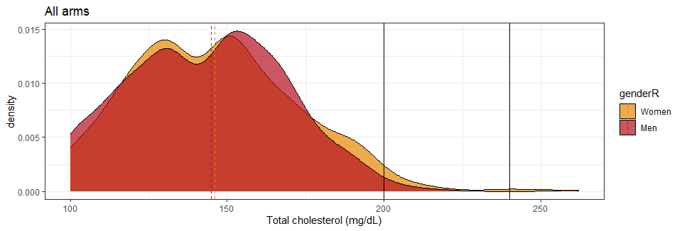

### Page Break

## Distribution, by arm [dashed lines are group medians] – MEN ONLY

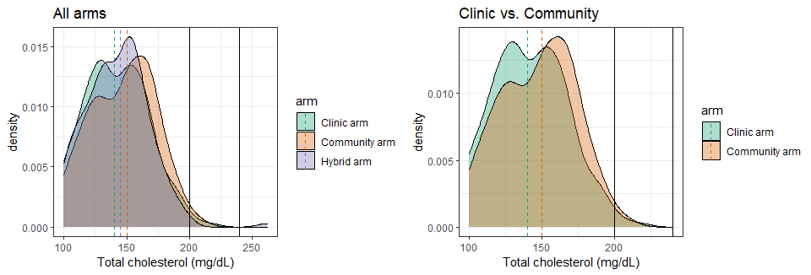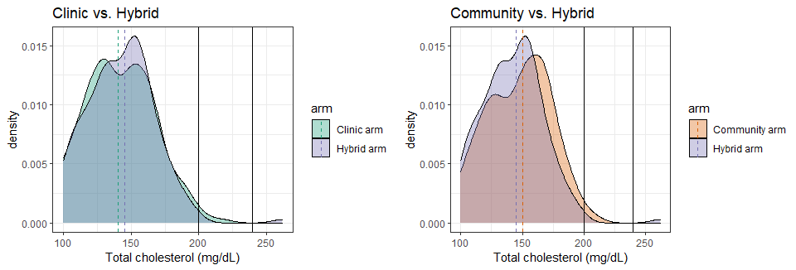

### Page Break

## Distribution, by arm [dashed lines are group medians] – WOMEN ONLY

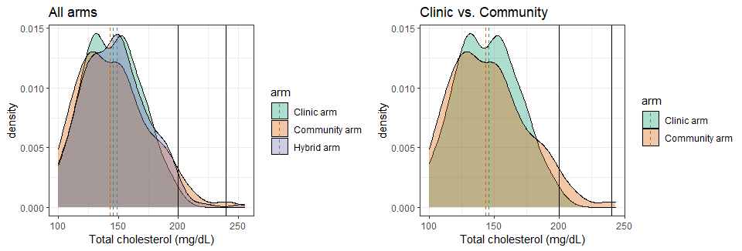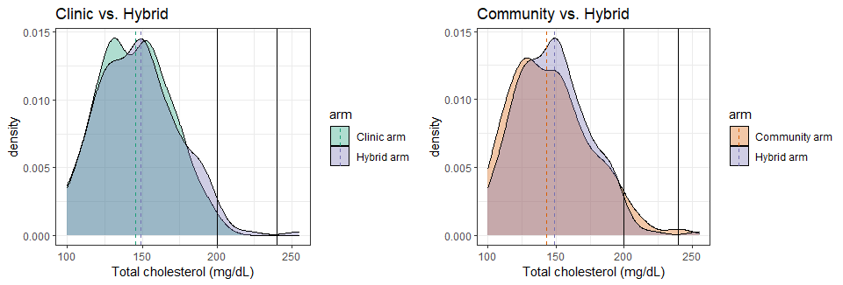

### Page Break

## Distribution, by viral suppression status at endline [dashed lines are group medians]

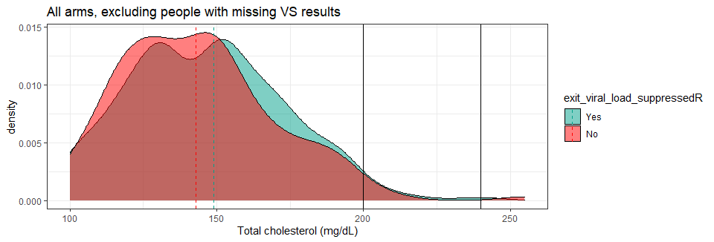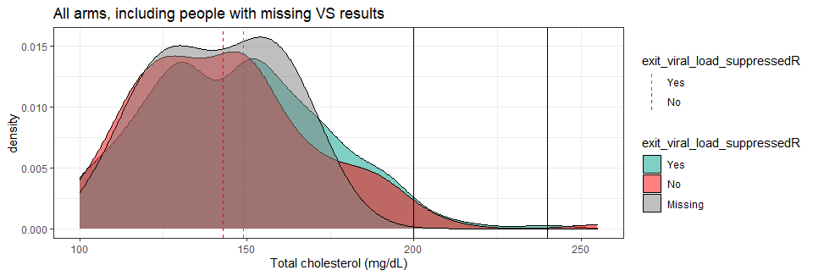

### Page Break

## Distribution, by arm [dashed lines are group medians] – VIRALLY SUPPRESSED ONLY

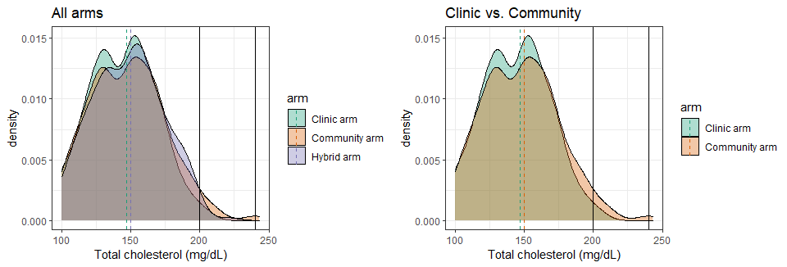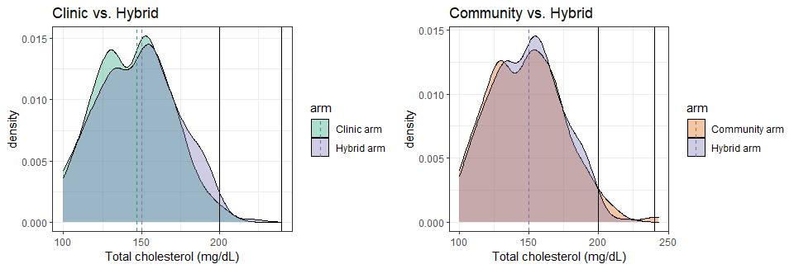

### Page Break

## Distribution, by arm [dashed lines are group medians] – NOT SUPPRESSED ONLY

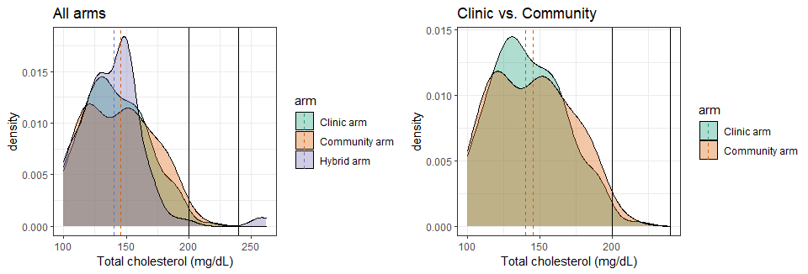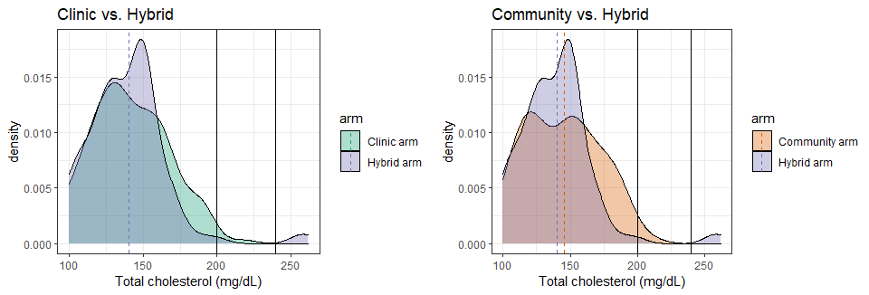

### Page Break

## Distribution, by country [dashed lines are group medians]

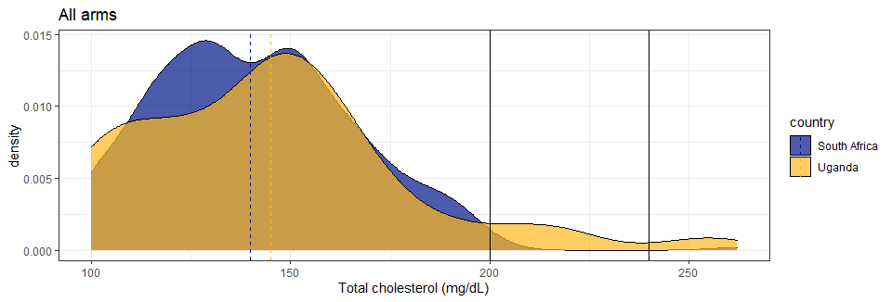

### Page Break

## Distribution, by arm [dashed lines are group medians] – SOUTH AFRICA ONLY

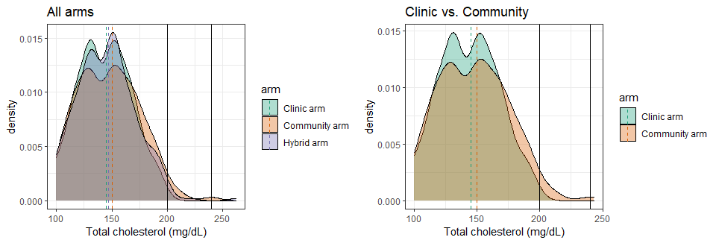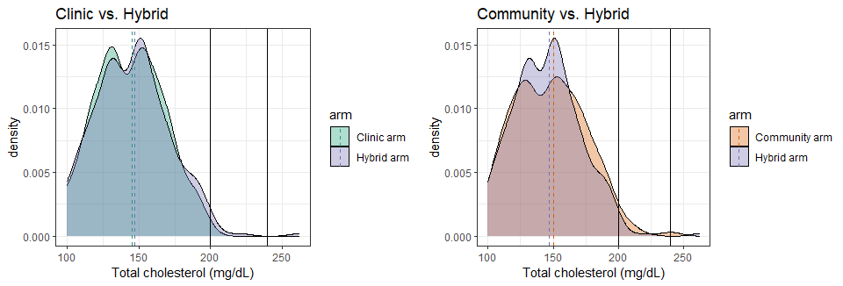

### Page Break

## Distribution, by arm [dashed lines are group medians] – UGANDA ONLY

