NCPDP Descriptives

Maitreyi Sahu

04 October, 2023

## Tabulated frequencies

| **Characteristic** | **N = 83,262**1 |
| --- | --- |
| Pharmacy Closures | 371 (0.4%) |
| Year of Closure |  |
| 2021 | 2 (0.5%) |
| 2022 | 10 (2.7%) |
| 2023 | 358 (96%) |
| 2031 | 1 (0.3%) |
| Unknown | 82,891 |
| Pharmacy Type |  |
| Independent | 29,964 (36%) |
| Chain | 39,548 (47%) |
| Franchise | 671 (0.8%) |
| Government | 1,889 (2.3%) |
| Other | 11,190 (13%) |
| Open 24 Hours? | 3,954 (4.7%) |
| 1n (%) | |

## Number of closures by pharmacy type and year

|  | Year of Closure | | | |  |
| --- | --- | --- | --- | --- | --- |
|  | 2021 | 2022 | 2023 | 2031 | Total |
| Pharmacy Type |  |  |  |  |  |
| Independent | 1 (50%) | 6 (60%) | 239 (67%) | 0 (0%) | 246 (66%) |
| Chain | 1 (50%) | 2 (20%) | 85 (24%) | 0 (0%) | 88 (24%) |
| Franchise | 0 (0%) | 0 (0%) | 7 (2.0%) | 0 (0%) | 7 (1.9%) |
| Government | 0 (0%) | 0 (0%) | 5 (1.4%) | 0 (0%) | 5 (1.3%) |
| Other | 0 (0%) | 2 (20%) | 22 (6.1%) | 1 (100%) | 25 (6.7%) |
| Total | 2 (100%) | 10 (100%) | 358 (100%) | 1 (100%) | 371 (100%) |

### Figure: Pharmacy closures by pharmacy type and year

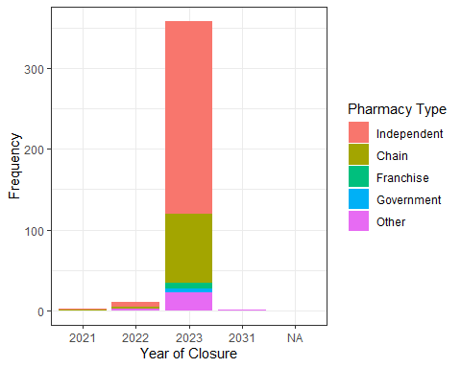

### Figure: Pharmacy closures by whether open 24 hours and year

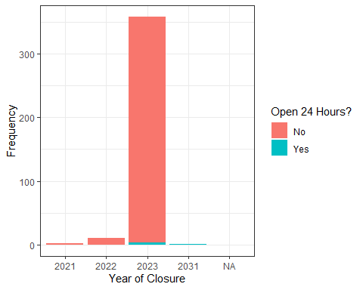

### Figure: Pharmacy closures by “Type1”

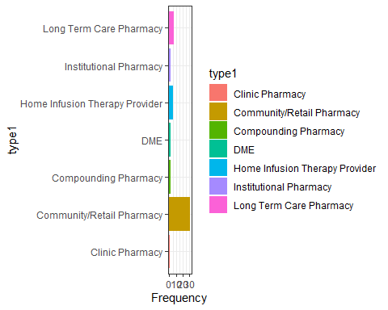

### Figure: Pharmacy closures by “Type2” (colors not consistent, sorry)

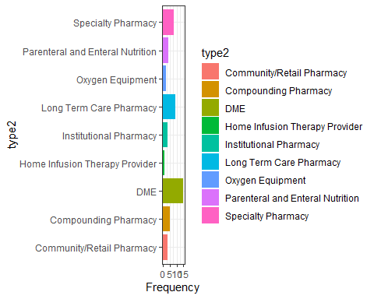

### Figure: Pharmacy closures by “Type3” (colors not consistent, sorry)

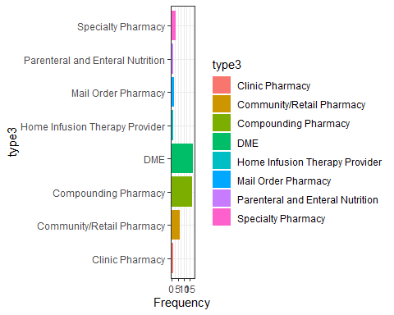

## Figure: Pharmacy closures by state

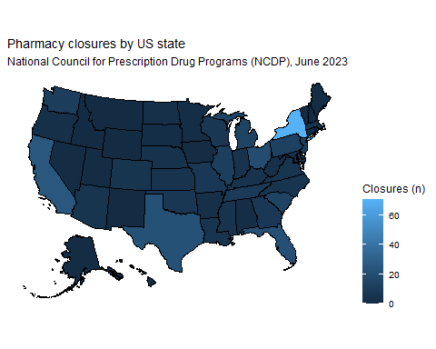

# Figure: Pharmacy closures by county

