Replication
In admin cmd ->
Microsoft Windows [Version 10.0.26200.8457]
(c) Microsoft Corporation. All rights reserved.

C:\Windows\System32>net stop MongoDB
The MongoDB Server (MongoDB) service is not started.

More help is available by typing NET HELPMSG 3521.

C:\Windows\System32>sc query MongoDB

SERVICE_NAME: MongoDB
TYPE : 10 WIN32_OWN_PROCESS
STATE : 1 STOPPED
WIN32_EXIT_CODE : 0 (0x0)
SERVICE_EXIT_CODE : 0 (0x0)
CHECKPOINT : 0x0
WAIT_HINT : 0x0

C:\Windows\System32>1. Create Data Folders
'1.' is not recognized as an internal or external command,
operable program or batch file.

C:\Windows\System32>If you want a completely fresh replica set, delete old folders:
want was unexpected at this time.

C:\Windows\System32>C:\data\db0
'C:\data\db0' is not recognized as an internal or external command,
operable program or batch file.

C:\Windows\System32>C:\data\db1
'C:\data\db1' is not recognized as an internal or external command,
operable program or batch file.

C:\Windows\System32>C:\data\db2
'C:\data\db2' is not recognized as an internal or external command,
operable program or batch file.

C:\Windows\System32>

C:\Windows\System32>mkdir C:\data
A subdirectory or file C:\data already exists.

C:\Windows\System32>mkdir C:\data\db0
A subdirectory or file C:\data\db0 already exists.

C:\Windows\System32>mkdir C:\data\db1
A subdirectory or file C:\data\db1 already exists.

C:\Windows\System32>mkdir C:\data\db2
A subdirectory or file C:\data\db2 already exists.

C:\Windows\System32>rmdir /s /q C:\data\db0

C:\Windows\System32>rmdir /s /q C:\data\db1

C:\Windows\System32>rmdir /s /q C:\data\db2

C:\Windows\System32>mkdir C:\data\db0

C:\Windows\System32>mkdir C:\data\db1

C:\Windows\System32>mkdir C:\data\db2

C:\Windows\System32>dir C:\data
Volume in drive C is Windows
Volume Serial Number is C8AA-8222

Directory of C:\data

10-06-2026 18:51 <DIR> .
10-06-2026 18:51 <DIR> db0
10-06-2026 18:51 <DIR> db1
10-06-2026 18:51 <DIR> db2
0 File(s) 0 bytes
4 Dir(s) 180,923,985,920 bytes free

C:\Windows\System32>rmdir /s /q C:\data\db0
C:\data\db0\DIAGNO~1.DAT\metrics.2026-06-10T13-23-04Z-00000 - The process cannot access the file because it is being used by another process.
C:\data\db0\journal - The directory is not empty.
C:\data\db0\mongod.lock - The process cannot access the file because it is being used by another process.
C:\data\db0\_tmp\spilldb - The directory is not empty.

C:\Windows\System32>rmdir /s /q C:\data\db1
C:\data\db1\DIAGNO~1.DAT\metrics.2026-06-10T13-23-26Z-00000 - The process cannot access the file because it is being used by another process.
C:\data\db1\journal - The directory is not empty.
C:\data\db1\mongod.lock - The process cannot access the file because it is being used by another process.
C:\data\db1\_tmp\spilldb - The directory is not empty.

C:\Windows\System32>rmdir /s /q C:\data\db2
C:\data\db2\DIAGNO~1.DAT\metrics.2026-06-10T13-23-39Z-00000 - The process cannot access the file because it is being used by another process.
C:\data\db2\journal - The directory is not empty.
C:\data\db2\mongod.lock - The process cannot access the file because it is being used by another process.
C:\data\db2\_tmp\spilldb - The directory is not empty.

C:\Windows\System32>tasklist | findstr mongod
mongod.exe 23256 Console 1 1,64,544 K

C:\Windows\System32>taskkill /F /IM mongod.exe
ERROR: The process "mongod.exe" not found.

C:\Windows\System32>tasklist | findstr mongod

C:\Windows\System32>rmdir /s /q C:\data\db0

C:\Windows\System32>rmdir /s /q C:\data\db1

C:\Windows\System32>rmdir /s /q C:\data\db2

C:\Windows\System32>dir C:\data
Volume in drive C is Windows
Volume Serial Number is C8AA-8222

Directory of C:\data

10-06-2026 18:59 <DIR> .
0 File(s) 0 bytes
1 Dir(s) 180,929,318,912 bytes free

C:\Windows\System32>mkdir C:\data\db0

C:\Windows\System32>mkdir C:\data\db1

C:\Windows\System32>mkdir C:\data\db2

C:\Windows\System32>dir C:\data\db0
Volume in drive C is Windows
Volume Serial Number is C8AA-8222

Directory of C:\data\db0

10-06-2026 18:59 <DIR> .
10-06-2026 19:00 <DIR> ..
0 File(s) 0 bytes
2 Dir(s) 180,928,356,352 bytes free

C:\Windows\System32>

27018
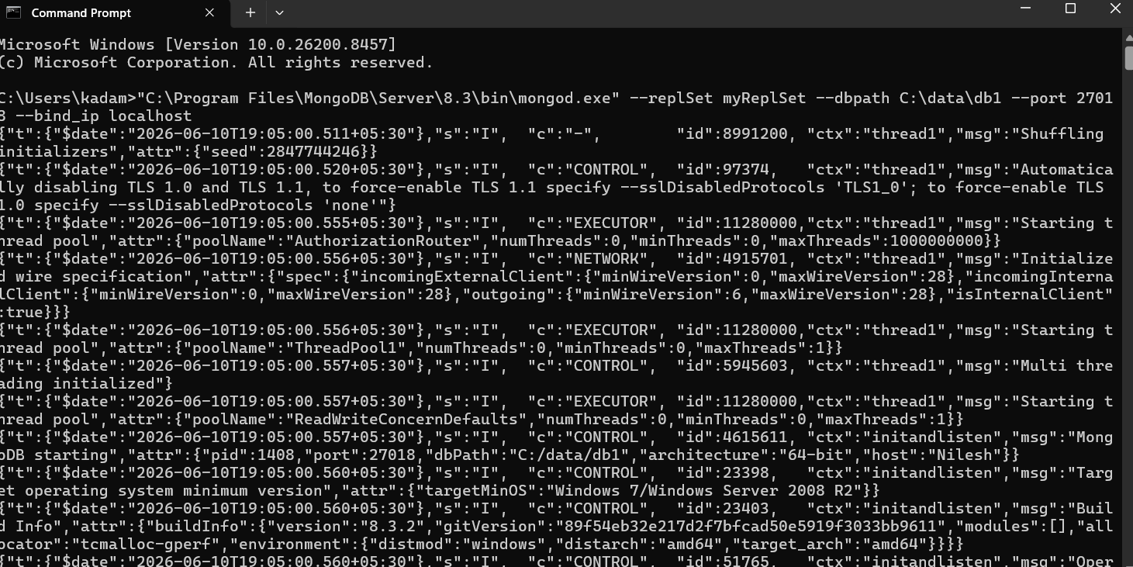
27019
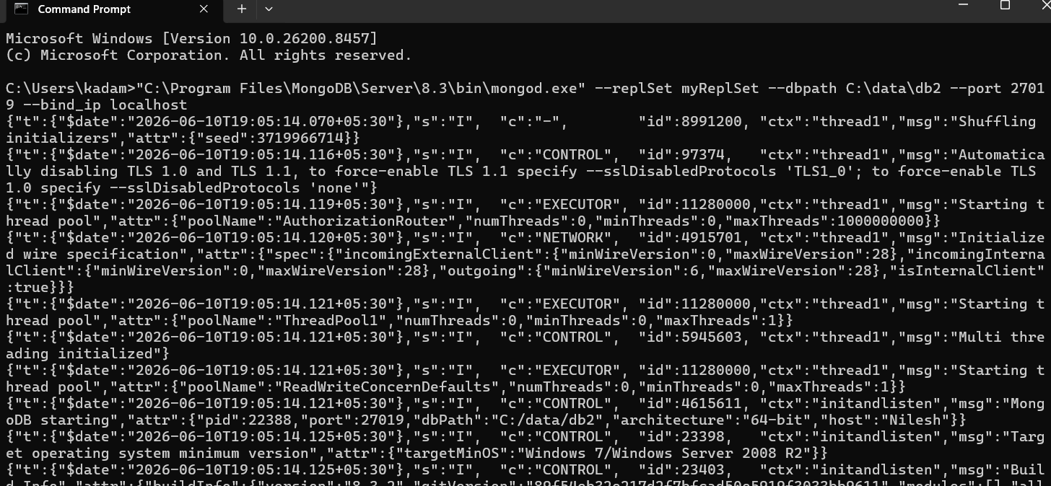
27017
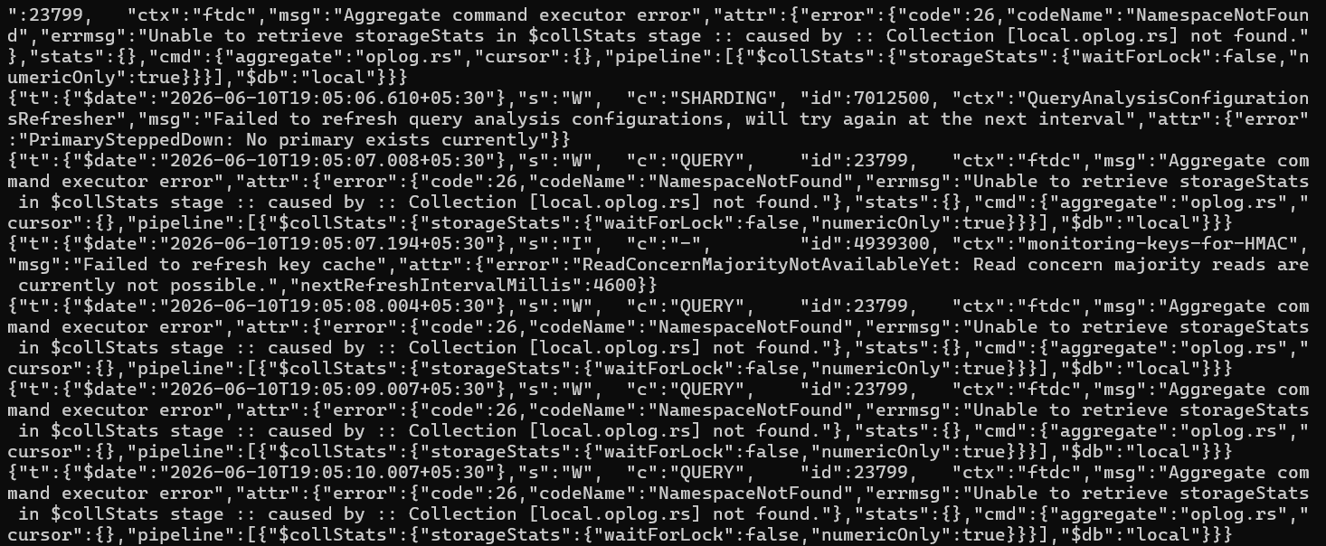
MongoDb 27017
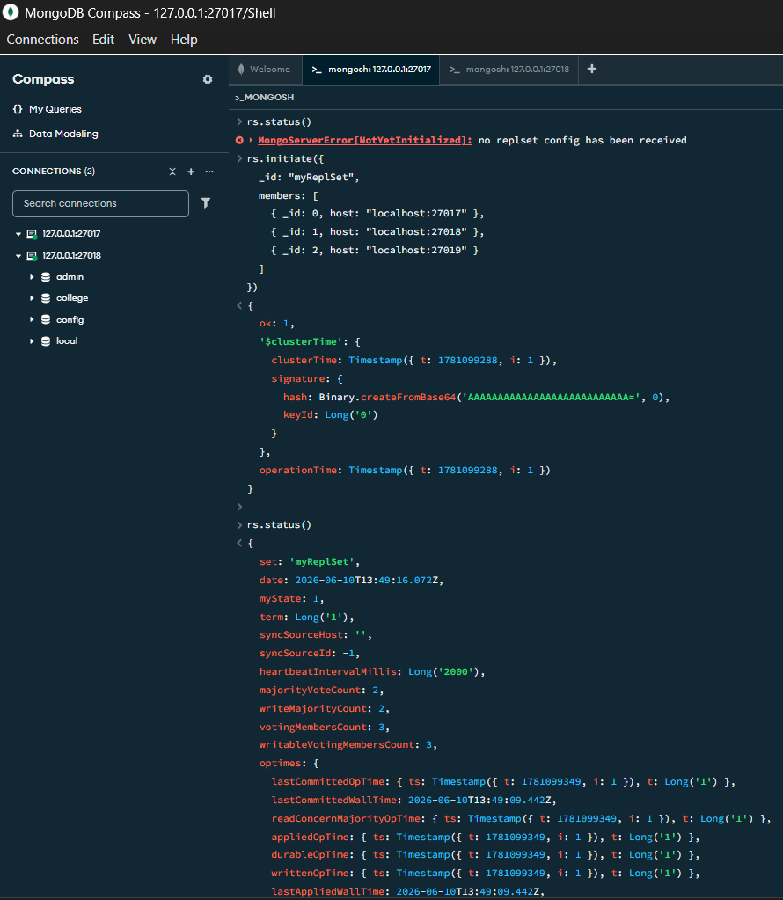
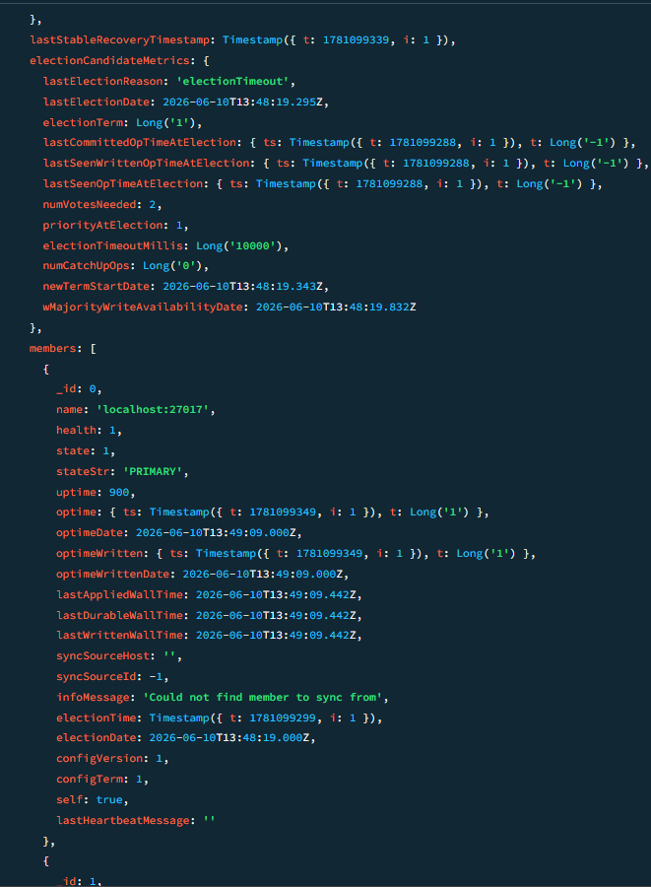
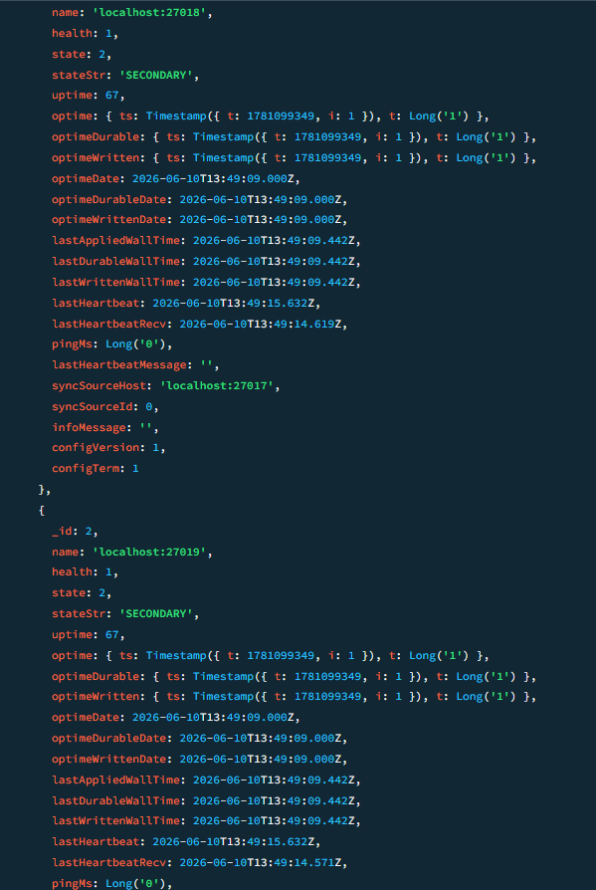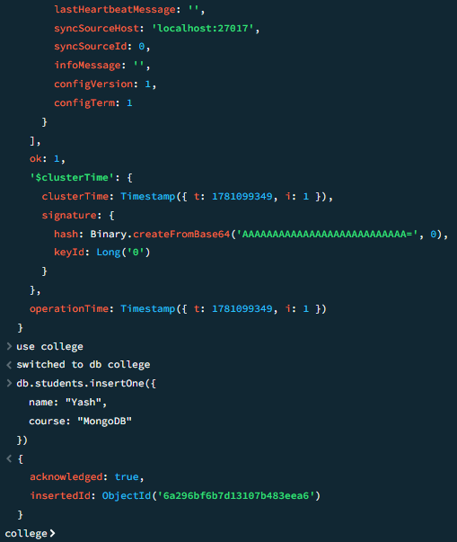
Mongo Db -27018
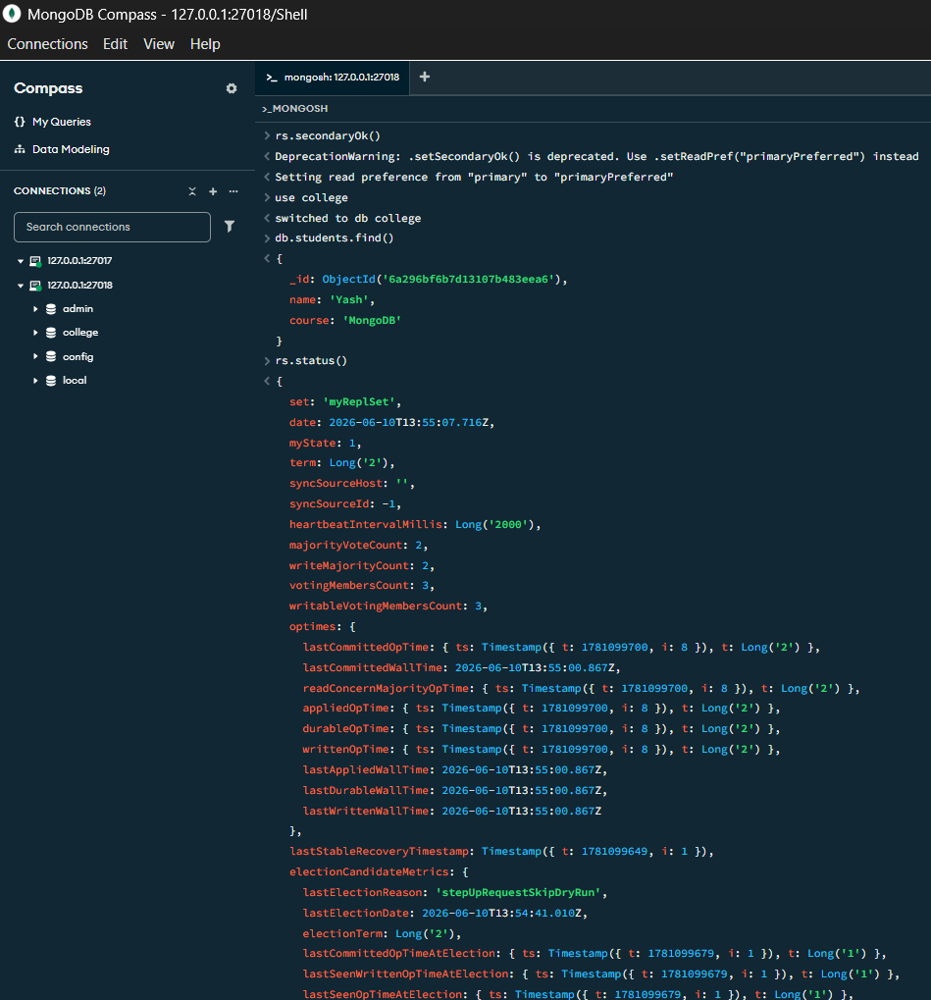
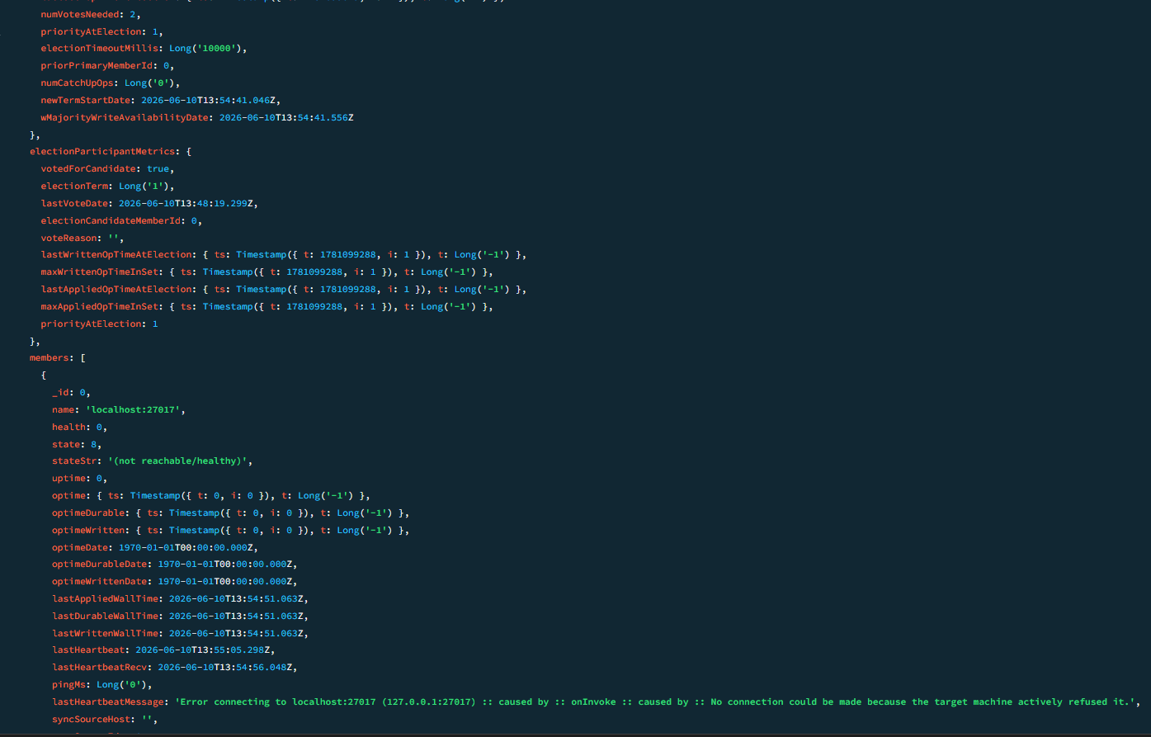
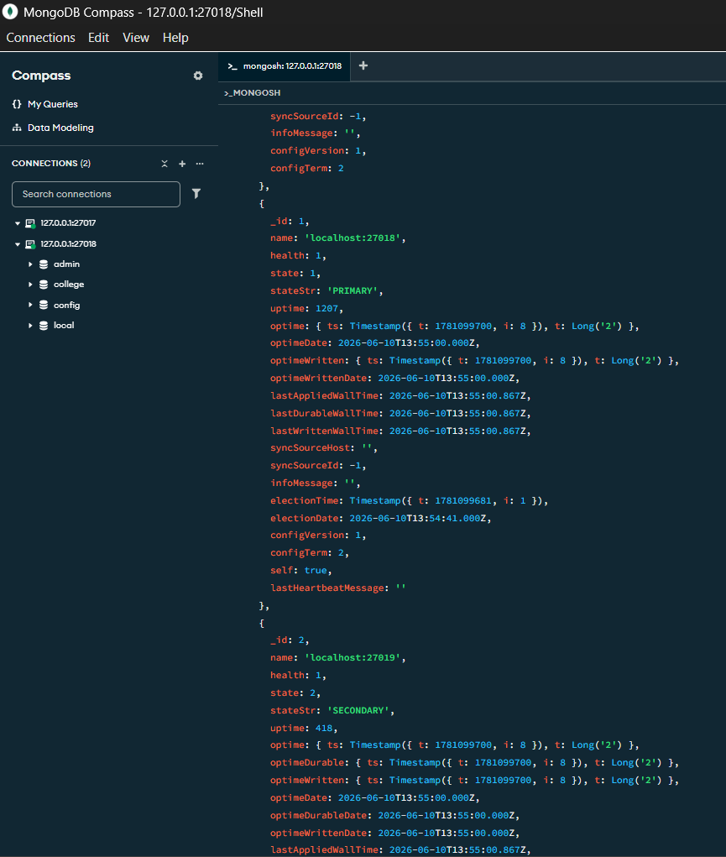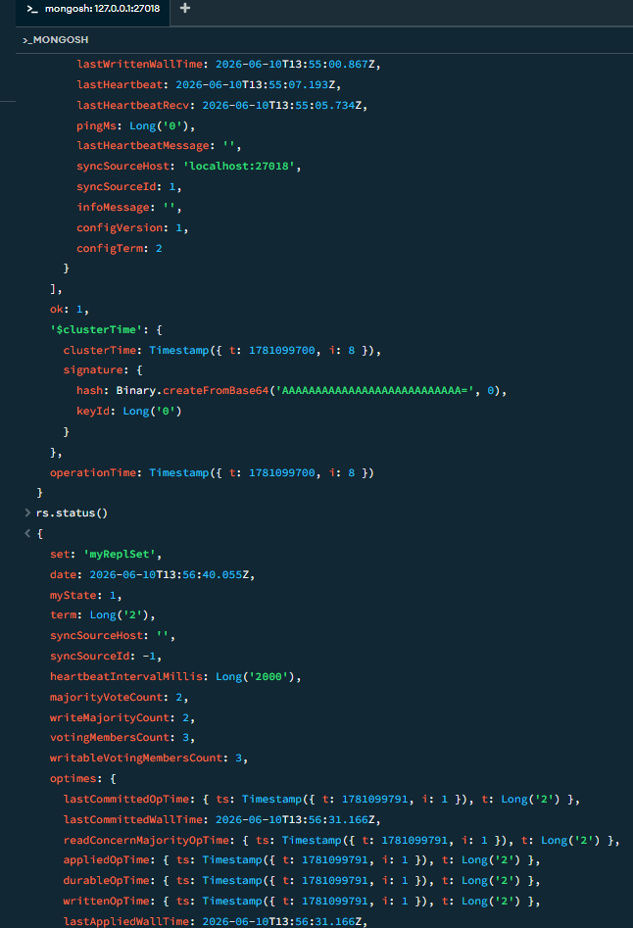
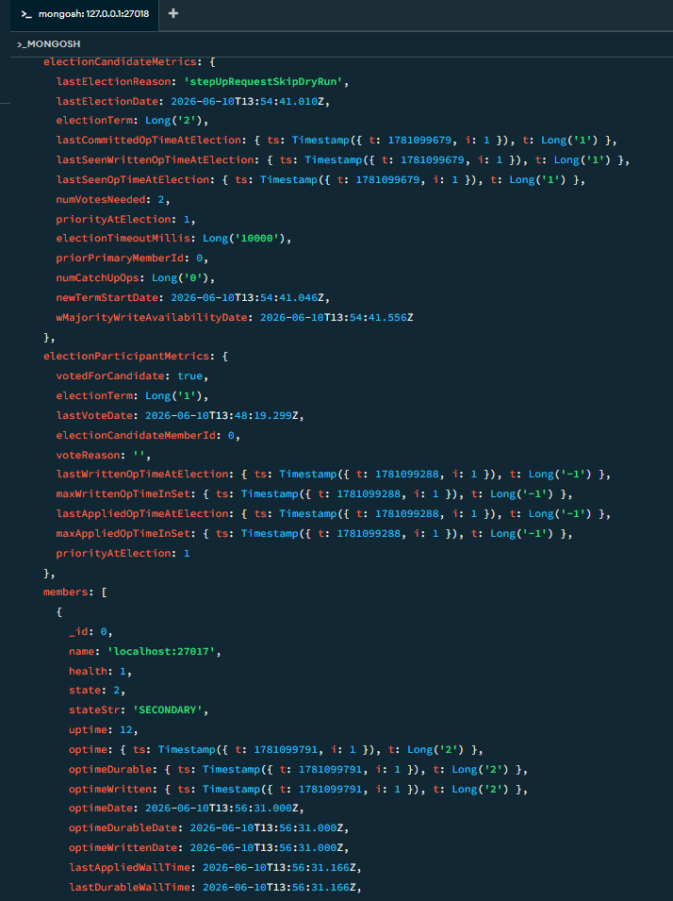
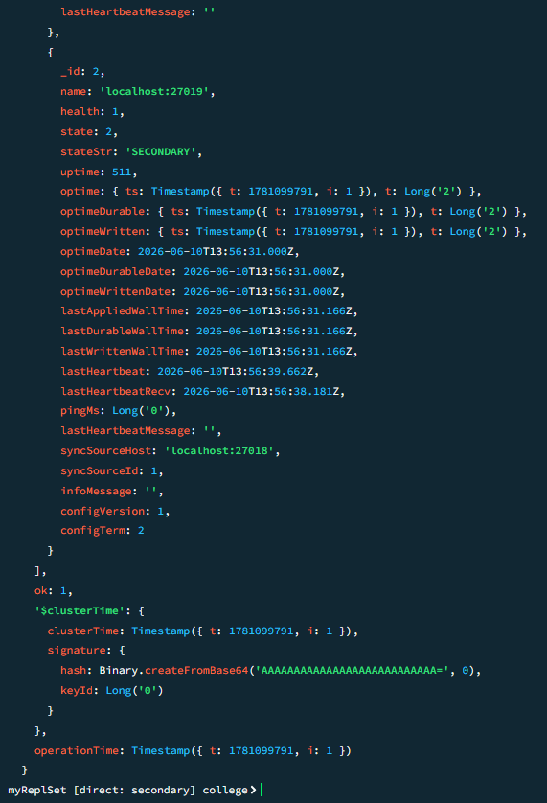
Sharding
Microsoft Windows [Version 10.0.26200.8457]
(c) Microsoft Corporation. All rights reserved.

C:\Windows\System32>mkdir C:\data\config

C:\Windows\System32>mkdir C:\data\shard1

C:\Windows\System32>mkdir C:\data\shard2

C:\Windows\System32>dir C:\data
Volume in drive C is Windows
Volume Serial Number is C8AA-8222

Directory of C:\data

10-06-2026 19:42 <DIR> .
10-06-2026 19:42 <DIR> config
10-06-2026 19:28 <DIR> db0
10-06-2026 19:29 <DIR> db1
10-06-2026 19:29 <DIR> db2
10-06-2026 19:42 <DIR> shard1
10-06-2026 19:42 <DIR> shard2
0 File(s) 0 bytes
7 Dir(s) 180,106,682,368 bytes free

C:\Windows\System32>
Microsoft Windows [Version 10.0.26200.8457]
(c) Microsoft Corporation. All rights reserved.

C:\Windows\System32>net start MongoDB
The MongoDB Server (MongoDB) service is starting.
The MongoDB Server (MongoDB) service was started successfully.

C:\Windows\System32>sc query MongoDB

SERVICE_NAME: MongoDB
TYPE : 10 WIN32_OWN_PROCESS
STATE : 4 RUNNING
(STOPPABLE, NOT_PAUSABLE, ACCEPTS_PRESHUTDOWN)
WIN32_EXIT_CODE : 0 (0x0)
SERVICE_EXIT_CODE : 0 (0x0)
CHECKPOINT : 0x0
WAIT_HINT : 0x0

C:\Windows\System32>
after this , I am getting errors

