Sharding
In admin cmd
Microsoft Windows [Version 10.0.26200.8655]
(c) Microsoft Corporation. All rights reserved.

C:\Windows\System32>mkdir C:\mongo-data
A subdirectory or file C:\mongo-data already exists.

C:\Windows\System32>mkdir C:\mongo-data\config
A subdirectory or file C:\mongo-data\config already exists.

C:\Windows\System32>mkdir C:\mongo-data\shard1
A subdirectory or file C:\mongo-data\shard1 already exists.

C:\Windows\System32>mkdir C:\mongo-data\shard2
A subdirectory or file C:\mongo-data\shard2 already exists.
27011
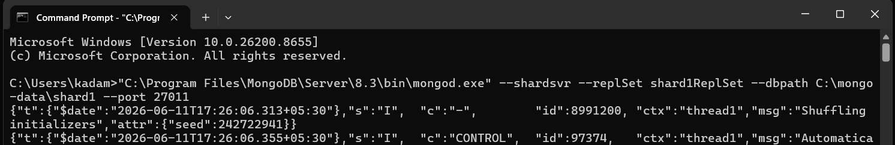

27019
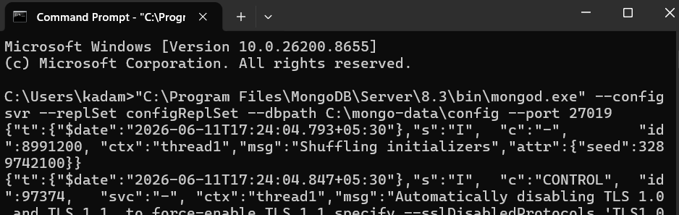
27012
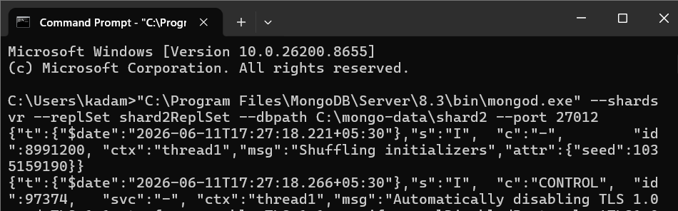
27017
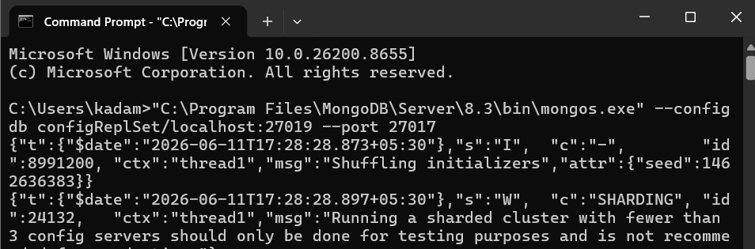
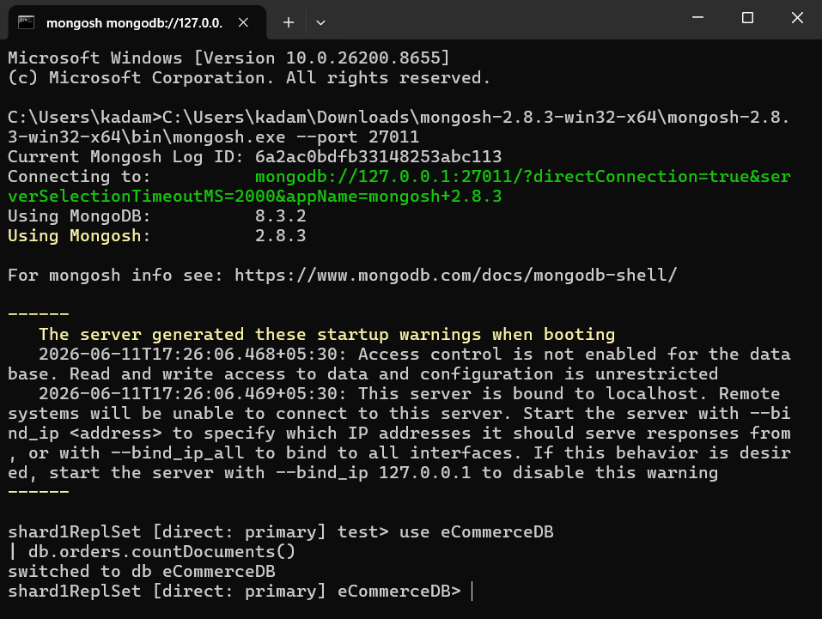
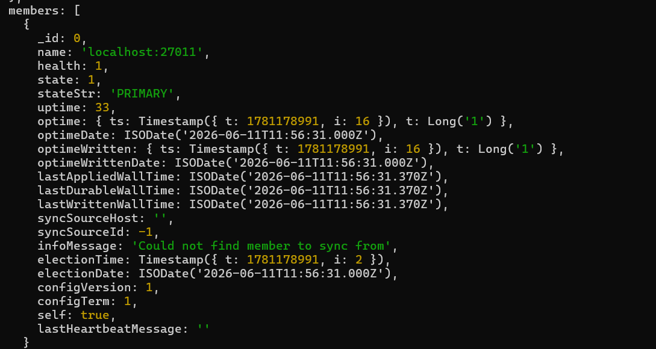
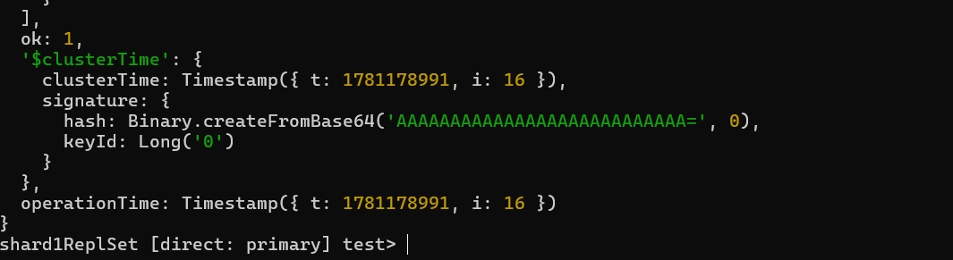
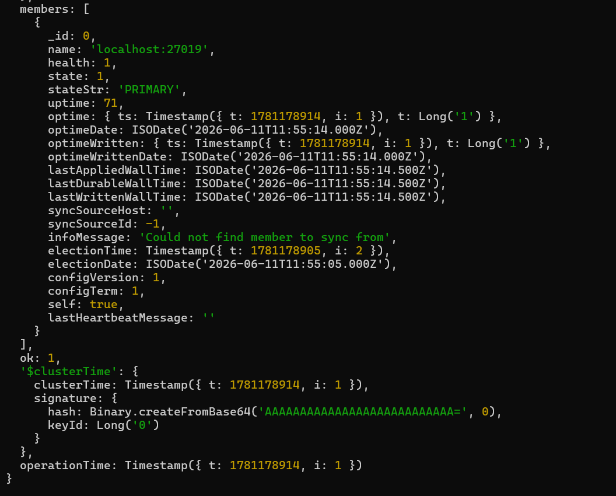
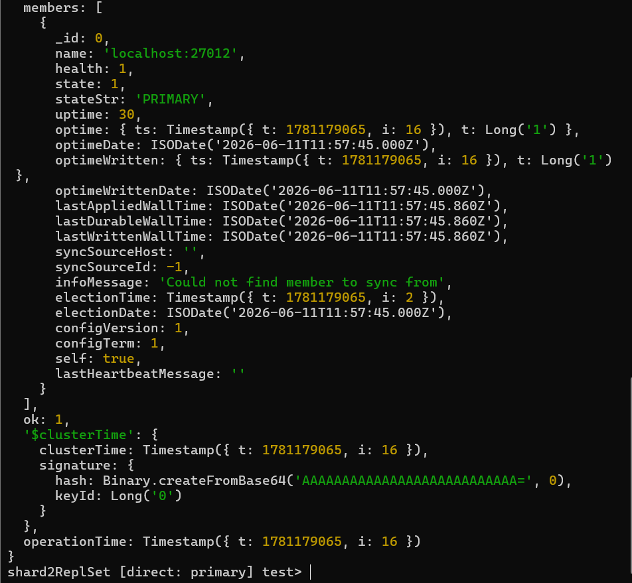

Shared percentages
