> // mul operator
>db.products. insertMany ([
{ "_id" : 1, "name" : "xPhone", "price" : 799, "releaseDate": ISODate("2011-05-14"), "spec" : { "ram" : 4, "screen" : 6.5, "cpu" : 2.66 },"color": ["white", "black"], "storage" : [64, 128, 256]},
{ "_id" : 2, "name" : "xTablet", "price" : 899, "releaseDate": ISODate("2011-09-01") , "spec" : { "ram" : 16, "screen" : 9.5, "cpu" : 3.66 },"color":["white", "black", "purple"], "storage": [128,256, 512]},
{ "_id" : 3, "name" : "SmartTablet", "price" : 899, "releaseDate": ISODate("2015-01-14"), "spec" : { "ram" : 12, "screen" : 9.7, "cpu" : 3.66 },"color": ["blue"], "storage" : [16,64, 128]},
{ "_id" : 4, "name" : "SmartPad", "price" : 699, "releaseDate": ISODate("2020-85-14"),"spec" : { "ram" : 8, "screen" : 9.7, "cpu" : 1.66 },"color": ["white", "orange","gold", "gray"], "storage" : [128,256, 1024]},
{ "_id" : 5, "name" : "SmartPhone", "price" : 599,"releaseDate": ISODate("2022-09-14"), "spec" : { "ram" : 4, "screen" : 5.7, "cpu" : 1.66 },"color": ["white","orange","gold", "gray"], "storage": [128,256]}

MongoBulkWriteError: db already exists with different case already have: [vitcampus] trying to create [Vitcampus]
>use vitcampus
< switched to db vitcampus
>show collections
products
> db.products_new. insertMany ([
{ "_id" : 1, "name" : "xPhone", "price" : 799, "releaseDate": ISODate("2011-05-14"), "spec" : { "ram" : 4, "screen" : 6.5, "cpu" : 2.66 },"color":["white", "black"], "storage" : [64,128,256]},
[ "_id" : 2, "name" : "xTablet", "price" : 899, "releaseDate": ISODate("2011-09-01") , "spec" : { "ram" : 16, "screen" : 9.5, "cpu" : 3.66 },"color": ["white", "black", "purple"], "storage": [128,256,512]},
[ "_id" : 3, "name" : "SmartTablet", "price" : 899, "releaseDate": ISODate("2015-81-14"), "spec" : { "ram" : 12, "screen" : 9.7, "cpu" : 3.66 },"color": ["blue"], "storage" : [16, 64, 128]},
{ "_id" : 4, "name" : "SmartPad", "price" : 699, "releaseDate": ISODate("2020-85-14"),"spec" : { "ram" : 8, "screen" : 9.7, "cpu" : 1.66 },"color": ["white", "orange","gold", "gray"], "storage": [128,256, 1024]},
{ "_id" : 5, "name" : "SmartPhone", "price" : 599,"releaseDate": ISODate("2022-09-14"), "spec" : { "ram" : 4, "screen" : 5.7, "cpu" : 1.66 },"color": ["white","orange","gold","gray"], "storage": [128,256]}

acknowledged: true,
insertedIds: {

'1 : 2,

'2': 3,

'3': 4,

'4': 5

db.products_new.updateOne({ _id: 5 }, { $mul: { price: 1.1 } })

acknowledged: true,

insertedId: null,

matchedCount: 1,
modifiedCount: 1,
upsertedCount: 0

// to verify
db.products.updateOne({ _id: 5 }, { $mul: { price: 1.1 } })

acknowledged: true,
insertedId: null,
matchedCount: 1,
modifiedCount: 1,

upsertedCount: 0

> // to double the values
db.products. updateOne({
_id: 1

$mul: {
"storage.0": 2,
"storage.1": 2,
"storage.2": 2

acknowledged: true,
insertedId: null,
matchedCount: 1,
modifiedCount: 1,
upsertedCount: 0

>db.products. findone({ _id: 1 }, { name: 1, storage: 1 })

_id: 1,
name: 'xPhone',
storage: [
128,

256,

51

>db.products.updateMany({}, {
$mul: {
"spec.ram": 2

acknowledged: true,
insertedId: null,
matchedCount: 5,

modifiedCount: 5,

upsertedCount: 0

> // to verify
> db.products. find({}, { name: 1, "spec.ram": 1 })

_id: 1,
name: 'xPhone',
spec: {

ram: 8

_id: 2,
name: 'xTablet',
spec: {
ram: 32

id: 3,
name: 'SmartTablet',
spec: {

ram: 24

_id: 4,
name: 'SmartPad',

spec: {

ram: 16

_id: 5,
name: 'SmartPhone',
spec: {

ram: 8

> // to remove one or more fields from document

> db.products.updateOne({
_id: 1

A

$unset: {
price: ##

acknowledged: true,
insertedId: null,
matchedCount: 1,
modifiedCount: 1,

upsertedCount: 0

>db.products.find({}, { name: 1, price: 1 })

_id: 1,
name: 'xPhone'

_id: 2,
name: 'xTablet',
price: 899

_id: 3,
name: 'SmartTablet',
price: 899

_id: 4,
name: 'SmartPad',
price: 699

_id: 5,
name: 'SmartPhone',
price: 548.9000000000001

> db.products.updateMany({}, {
$unset: {
"spec.ram": ##

acknowledged: true,
insertedId: null,
matchedCount: 5,
modifiedCount: 5,
upsertedCount: 0
>db.products.find({}, {
spec: 1

_id: 1,
spec: {
screen: 6.5,

cpu: 2.66

_id: 2,
spec: {
screen: 9.5,

cpu: 3.66

_id: 3,
spec: {
screen: 9.7,
cpu: 3.66

_id: 4,
spec: {
screen: 9.7,
cpu: 1.66

_id: 5,
spec: {
screen: 5.7,
cpu: 1.66

>db.products.updateMany({}, { $unset: { "storage.0": "" } })

acknowledged: true,
insertedId: null,

matchedCount: 5,
modifiedCount: 5,

upsertedCount: 0

> db.products.find({}, { "storage":1})

id: 1,
storage: [
null,
256

51

_id: 2,
storage: [
null,
256,

512

_id: 3,
storage: [
null,

64,

128

_id: 4,
storage: [
null,

256

1024

_id: 5,
storage: [
null,

256

> db.products.updateMany({}, {
$unset: {
releaseDate: "#,
spec: ##

acknowledged: true,
insertedId: null,
matchedCount: 5,
modifiedCount: 5,
upsertedCount: 8

> db.products.find({}, {
name: 1,

storage: 1,
releaseDate: 1,
spec: 1

_id: 1,
name: 'xPhone' ,
storage: [
null,
256,

512

_id: 2,
name: 'xTablet',
storage: [
null
256

512

_id: 3,
name: 'SmartTablet',
storage: [
null,
64

128

1

_id: 4,
name: 'SmartPad',
storage: [
null,
256

1024

_id: 5,
name: 'SmartPhone',
storage: [
null,
256

> // rename operator
> db.products.drop();
< true
> db.products. insertMany ([
{ "_id" : 1, "nmea" : "xPhone", "price" : 799, "releaseDate": ISODate("2011-05-14"), "spec" : { "ram" : 4, "screen" : 6.5, "cpu" : 2.66 },"color": ["white", "black"], "storage" : [64, 128, 256]},
{ "_id" : 2, "nmea" : "xTablet", "price" : 899, "releaseDate": ISODate("2011-09-01") , "spec" : { "ram" : 16, "screen" : 9.5, "cpu" : 3.66 },"color":["white", "black", "purple"], "storage": [128,256,512]],
{ "_id" : 3, "nmea" : "SmartTablet", "price" : 899, "releaseDate": ISODate("2015-81-14"), "spec" : { "ram" : 12, "screen" : 9.7, "cpu" : 3.66 },"color":["blue"], "storage" : [16,64,128]},
{ "_id" : 4, "nmea" : "SmartPad", "price" : 699, "releaseDate": ISODate("2020-05-14"), "spec" : { "ram" : 8, "screen" : 9.7, "cpu" : 1.66 },"color": ["white", "orange","gold", "gray"], "storage": [128, 256,1024]},
[ "_id" : 5, "nmea" : "SmartPhone", "price" : 599,"releaseDate": ISODate("2022-09-14"), "spec" : { "ram" : 4, "screen" : 5.7, "cpu" : 1.66 },"color":["white", "orange","gold", "gray"], "storage": [128, 256]}

acknowledged: true,

insertedIds: {

'1': 2,

'2': 3,

'3': 4,

'4': 5

> db.products.updateMany({}, {
$rename: {
nmea: "name"

acknowledged: true,
insertedId: null,
matchedCount: 5,
modifiedCount: 5,
upsertedCount: 0

db.products. find({}, { name: 1 })

id: 1,

name: 'xPhone'

id: 2,

name: 'xTablet'

_1d: 3

name: 'SmartTablet'

id: 4,

name: 'SmartPad'

name

id: 5,

SmartPhone'
> db.products.updateMany({}, {
$rename: {
"spec.screen": "spec. screenSize"

acknowledged: true,
insertedId: null,
matchedCount: 5,

modifiedCount: 5,

upsertedCount: 0

> db.products.find({}, {
spec: 1

v

_id: 1,
spec: {
ram: 4,
cpu: 2.66,
screenSize: 6.5

_id: 2,
spec: {
ram: 16,
cpu: 3.66,
screenSize: 9.5

_id: 3,
spec: {
ram: 12,
cpu: 3.66,
screenSize: 9.7

_id: 4,
spec: {
ram: 8,
cpu: 1.66,
screenSize: 9.7

_id: 5,
spec: {
ram: 4,
cpu: 1.66,
screenSize: 5.7

db.products.updateone({
_id: 1

$rename: {
"spec.cpu": "cpu"

acknowledged: true,
insertedId: null,
matchedCount: 1,
modifiedCount: 1,

upsertedCount: 8

> db.products. find({ _id: 1})

_id: 1,

price: 799,
releaseDate: 2011-05-14T00:00:00.000Z,
spec: {
ram: 4,
screenSize: 6.5

color: [
'white',
'black'

D,
storage: [

64

128,

256

],
name: 'xPhone',

cpu: 2.66

> db.products.updateOne({
_id: 2

1,
$rename: {
"color": "storage"

acknowledged: true,
insertedId: null,
matchedCount: 1,
modifiedCount: 1,
upsertedcount: 8

> db.products. find({ _id: 2 })

_id: 2,
price: 899,
releaseDate: 2011-09-01T00:00:00.000Z,

spec: {
ram: 16,

cpu: 3.66,
screenSize: 9.5

storage: [
'white',
'black',
'purple'

name: 'xTablet'

1,

> /*Upsert is a combination of update and insert. Upsert performs two functions:
Update data if there is a matching document.
Insert a new document in case there is no document matches the query criteria.
*/
> db.products.updateMany(
{_id: 6 },
{ $set: {price: 999} }

acknowledged: true,

insertedId: null,
matchedCount: 0,

modifiedCount: 0,

upsertedCount: 0

> // found no match
> db.products.updateMany(
{ _id: 6 },
{ $set: {price: 999} },
{ upsert: true}

acknowledged: true,
insertedId: 6,

matchedCount: 0,
modifiedCount: 0,

upsertedCount: 1

> //will insert one
>db.products. find({_id:6})

_id: 6,

price: 999

> db.products.deleteone({ _id: 1})

acknowledged: true,
deletedCount: 1

> // to delete the first document from collection
> db.products.delete0ne({})

acknowledged: true,
deletedCount: 1

> db.products.deleteMany({ price: 899 })

acknowledged: true,
deletedCount: 1

> db.products.deleteMany({})

acknowledged: true,
deletedCount: 3
> // deleteMany() method to delete all documents above
Eclipse ->
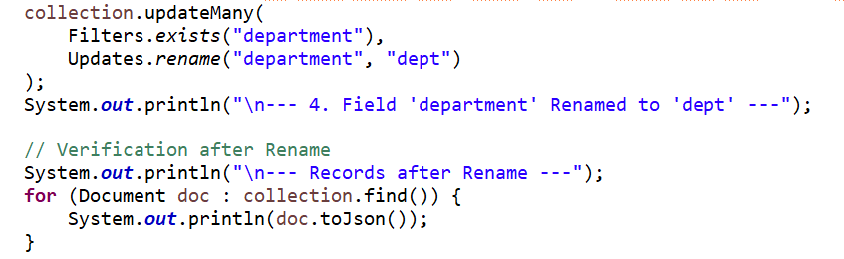
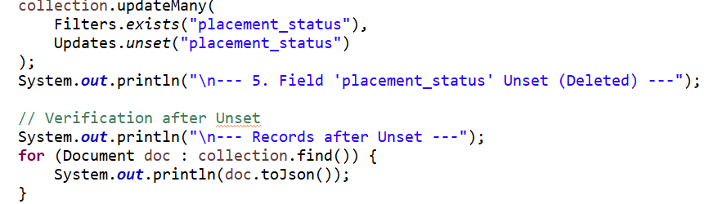
O/p
