**READ ME**

**CS 6375**

**Assignment 4**

**Team Members:**

**HARSH PANKAJKUMAR BHALANI (hpb170030)**

**MAITRI DHARMENDRAKUMAR SHAH (mxs172030)**

Number of free late days used: 0

Language Used: Python

Packages: nltk, numpy

To Run the Code:

Open Command prompt at the file location and give the command as below:

python NaiveBayes.py “train folder /path” “test folder/path”

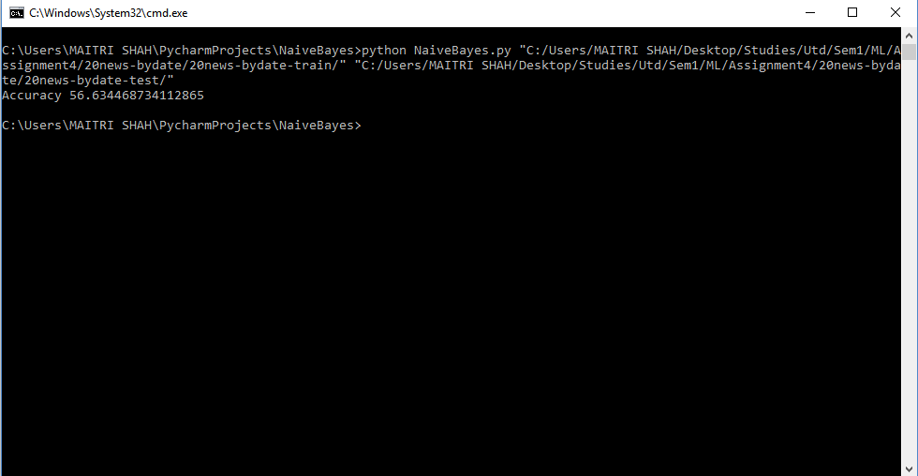

5 folders:

comp.graphics

misc.forsale

rec.autos

rec.motorcycles

sci.space

Results:

Accuracy = 56.63%