**Mini Project 1**

**Name :**

**Maitri Dharmendrakumar Shah (mxs172030)**

**Nayana Thomas(nxt170630)**

**Contribution of team members:**

Nayana :

Wrote equation and calculation in word

Drew a graph about simulation and found the way to distribute it

Learned R Coding

Tried different R codes

Wrote narration for codes

Derived conclusions from calculations

Maitri :

Did calculation on paper

Explained the simulation

Learned R coding

Did debugging for R codes

Derived conclusions from graphs

Wrote explanation for section1

**Ans 1.**

**(a)**

Section1:

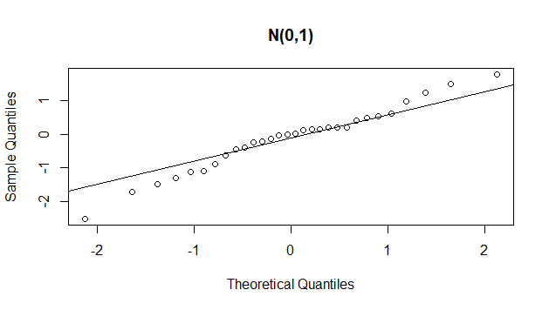

Section2:

x <- rnorm(30);

qqnorm(x,main="N(0,1)");

qqline(x)

Narration of code:

To get Normal Distribution, rnorm function is used to take 30 draws. To draw a normal Q-Q plot, qqnorm function is used and to assign name to that plot main attribute is used.

**(b)**

Section1:

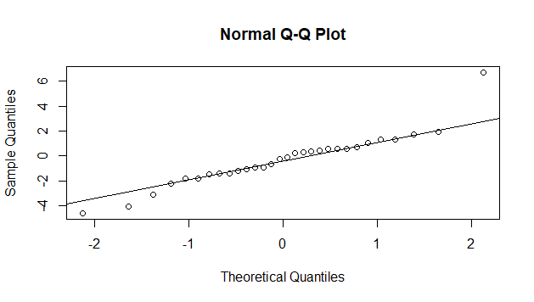

Fig. 2 (a)

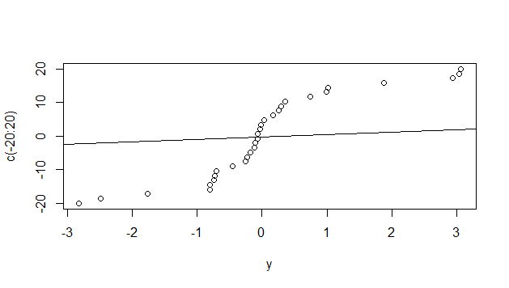

Fig. 2 (b)

Section2:

y <- rt(30, df = 2)

qqnorm(y)

qqline(y)

qqplot(y, c(-20:20))

qqline(y)

Narration of Code:

To get a t distribution with 2 degrees of freedom, rt function is used where 30 is the number of observations and 2 is degree.

To draw a normal Q-Q plot, qqnorm function is used. Fig.2(a) shows output of the code for normal q-q plot.

To draw appropriate t Q-Q plot, vector from -20 to 20 is taken which gives us proper output of t distribution. Fig.2(b) shows output of the code for t q-q plot.

**(c)**

Section1:

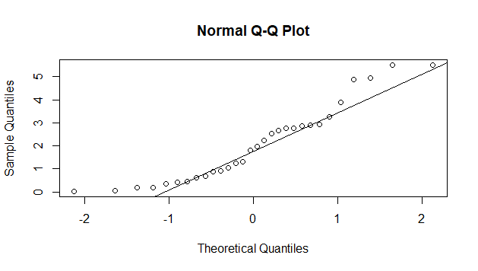

Fig. 3(a)

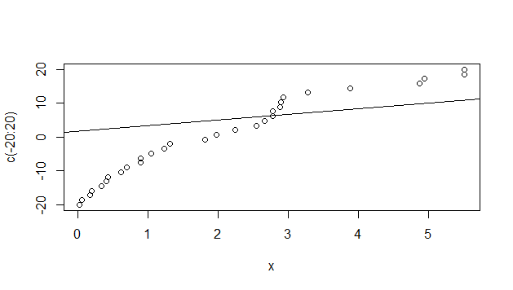

Fig. 3 (b)

Mean = Shape * Scale;

Var = Shape * Scale2

So,

Scale = Var / Mean;

Shape = Mean / Scale

Hence,

Scale = 3/2 and Shape = 4/3

Section2:

x = rgamma(30,shape = 4/3, scale = 3/2)

qqnorm(x)

qqline(x)

qqplot(x,c(-20:20))

qqline(x)

Narration of Code:

To get a gamma distribution with mean=3 and var=2, rgamma function is used where 30 is the number of observations.

To draw a normal Q-Q plot, qqnorm function is used. Fig.3(a) shows output of the code for normal q-q plot.

To draw appropriate Q-Q plot, vector from -20 to 20 is taken which gives us proper output of t distribution. Fig.3(b) shows output of the code for q-q plot.

**(d)**

A1:

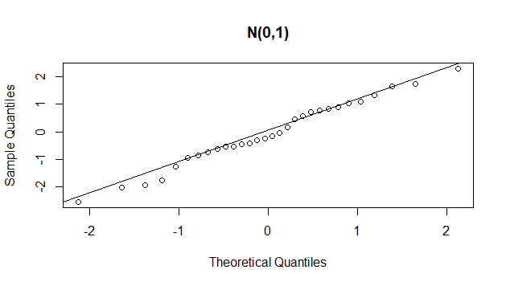

A2:

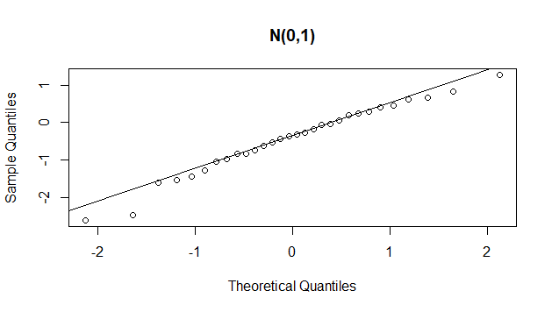

A3:

BB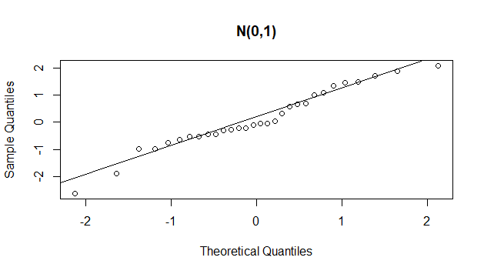

Explanation:

B1:

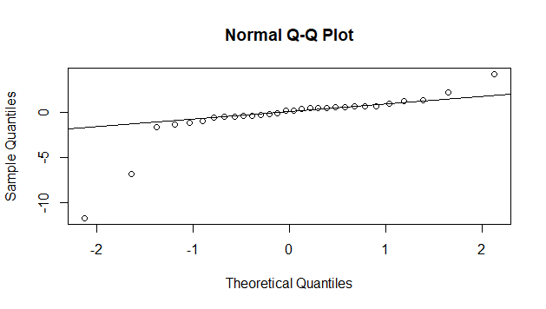

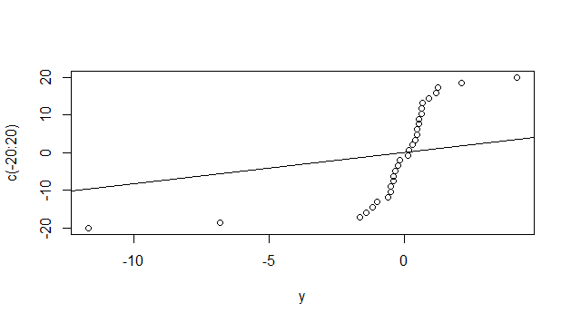

B2:

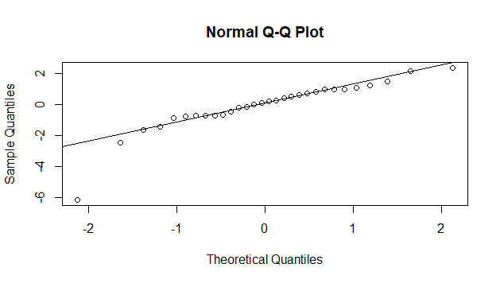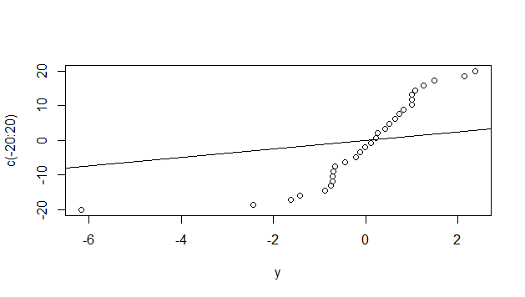

B3:

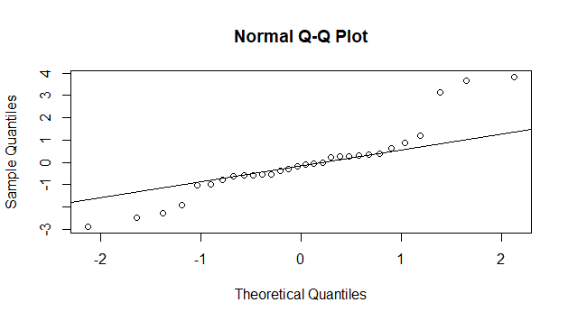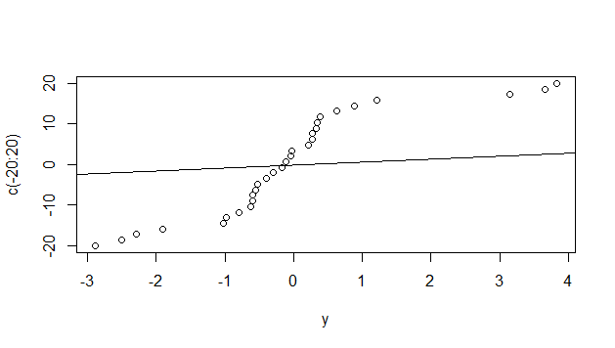

Explanation:

C1:

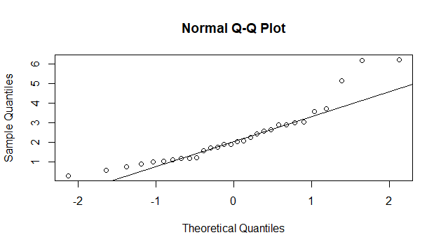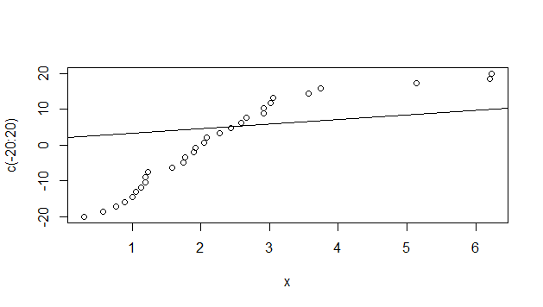

C2:

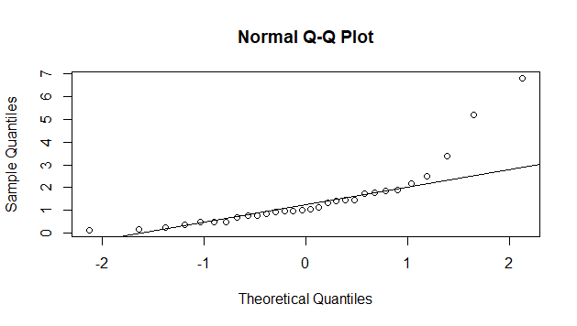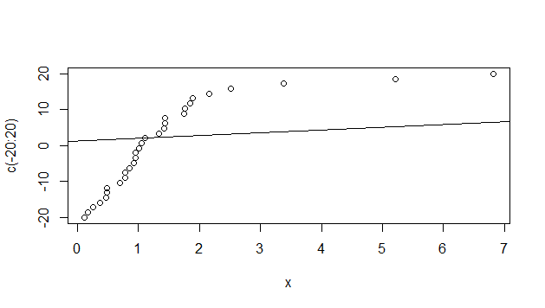

C3:

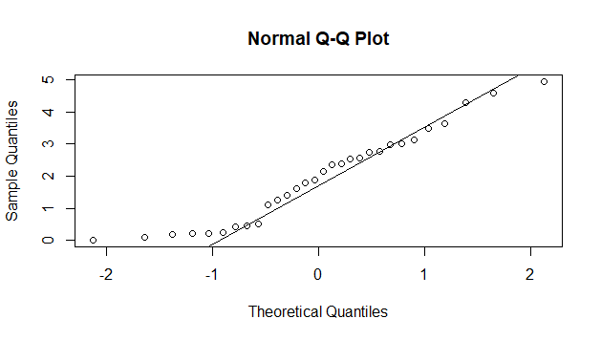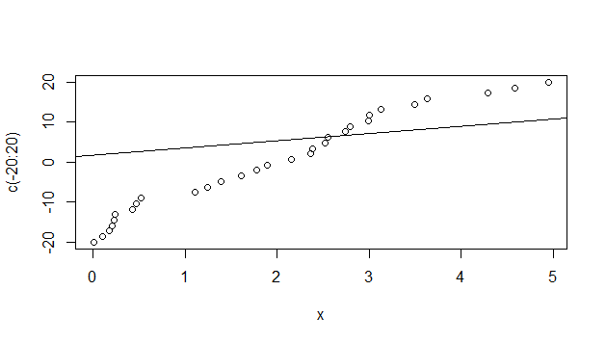

Explanation:

**Que2.**

Section1:

Section2:

singers<-read.table("Singer.txt",header = TRUE, sep="," )

summary(singers)

Soprano<-subset(singers,voice.part=="Soprano",select=height)

summary(Soprano)

Alto<-subset(singers,voice.part=="Alto",select=height)

summary(Alto)

Tenor<-subset(singers,voice.part=="Tenor",select=height)

summary(Tenor)

Bass<-subset(singers,voice.part=="Bass",select=height)

summary(Bass)