|  |  |
| --- | --- |
|  | **K. K. Wagh Polytechnic, Nashik.**  Hirabai Haridas Vidyanagari, Amrutdham, Panchavati, Nashik-422003  **Department of Computer Technology** |

**Micro-Project Report**

**Institute Code:** 0078  **Academic Year:** 2021-22 **Program:** Computer Technology **Course:** Client-Side Scripting **Course Code:** 22519 **Scheme**: I **Semester**: V **Class:** TYCM – I **Date of Report**: / /2021

**Title of Micro-Project:** E-Commerce Website using HTML, CSS and JavaScript.

1. **Problem Definition:**

An E-Commerce Website is a portal which allows merchants in developing counters to advertise and sell their goods. This would permit rural communities to make their wares available to the rest of the world. The objective of this project is to create a portal which would allow product information to be updated securely and will allow users to buy goods form the merchant. The main concern is given to the village women to explore their talents and to enhance our traditional Indian culture. In future the internet become whole and soul to the business fields, each and all trades are going to be done through it so this portal may helpful to the women as a business person in this running world.

**2.0 Rationale:**

With the help of ecommerce web design, you get an opportunity to have your products and services available to customers 24 hours. It gives a good exposure to your business and help you to reach out to potential customers. Since most of the people prefer to shop online due to paucity of time, you can easily make more revenue. With the help of an e-commerce website people can select and buy desired products anytime. They can pay easily through credit cards or other payment options available in website.

**3.0 Aim /Benefits of Micro-Project:**

To Provide visitors a personalized experience We are going to create an E-Commerce Website to increase sales and for being continuous and constant. The Primary goal to create this website is to reach maximum customers at the right time to increase sales and profitability of business.

**4.0 Course Outcomes Achieved (COs):**

**CO505.1:** Create interactive web pages using program flow control structure.

**CO505.2:** Implement arrays and functions in JavaScript.

**CO505.3:** Create event-based web forms using JavaScript.

**CO505.4:** Use JavaScript for handling cookies.

**CO505.5:** Create interactive web pages using regular expressions for validations.

**CO505.6:** Create menus and navigations in web pages.

**5.0 Literature Review:**

Cultural aspect and e-commerce website design will play a significant role for successful global e-commerce sites in the future. Future success of businesses will rely on e-commerce. To compete in the global e-commerce marketplace, local businesses need to focus on designing culturally friendly e-commerce websites.

Reference:

[www.amazon.in](http://www.amazon.in)

[www.flipcart.in](http://www.flipcart.in)

**6.0 Actual Methodology followed:**

1. Finalized team members.
2. Discussed about the topic with mentor/guide/subject teacher.
3. Selected the project topic based on research.
4. Distributed different tasks like collecting information, creating proposal etc. between team members.
5. Collected the information about the topic.
6. Merged all the information and research collected by team members.
7. Created final document.
8. Created Program Code for E-Commerce Website using HTML & CSS Concepts.
9. Checked Requirements of guide regarding Program code and made Changes Accordingly.
10. Created all the required documentation according to guidelines and merging created project document in report.
11. Submitted the project along with viva.

**7.0 Actual Resources used:**

|  |  |  |  |  |
| --- | --- | --- | --- | --- |
| **Sr. No.** | **Name of Resource/material** | **Specifications** | **Quantity** | **Remarks** |
|  | Computer system | Manufacturer: Dell  Processor: Intel (R) Core i5  @ 2.3 GHz  RAM: 8.00 GB | 01 | Available |
|  | Notepad editor | Version 1703(OS Build 15063.966) | 01 | Available |
|  | Other resources | Chrome, MS-Office | 01 | Available |

**8.0 Output:**

**Home**

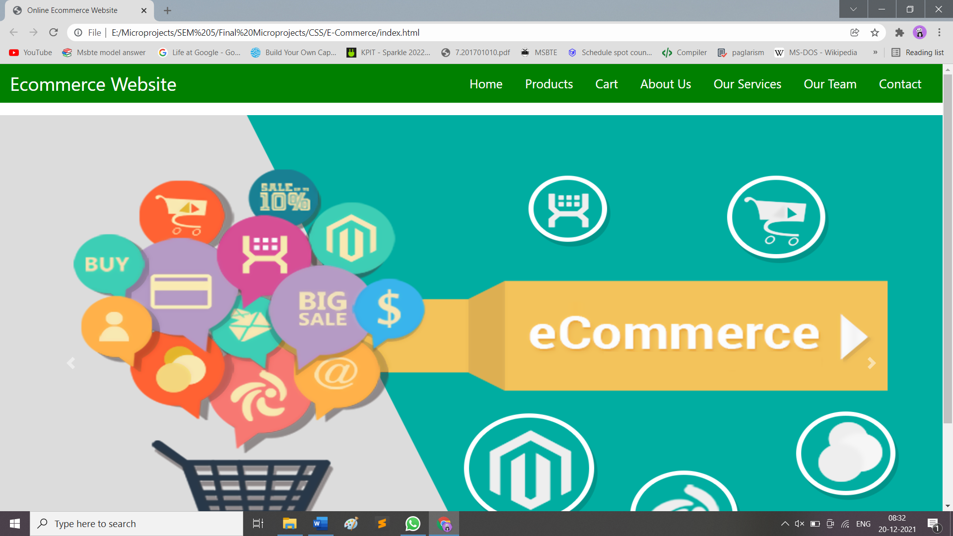

**Products**

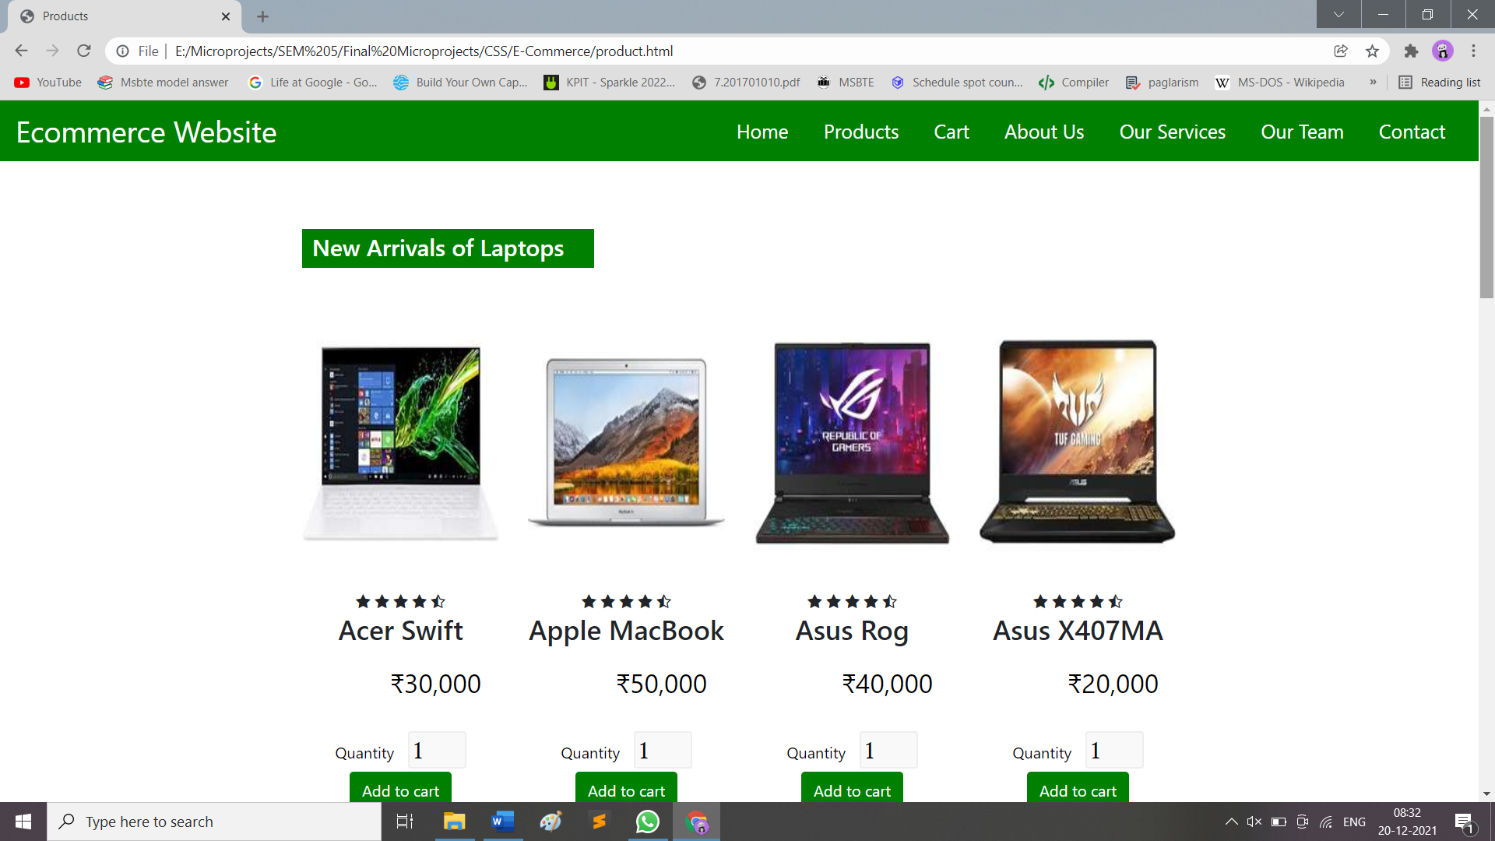

**Cart**

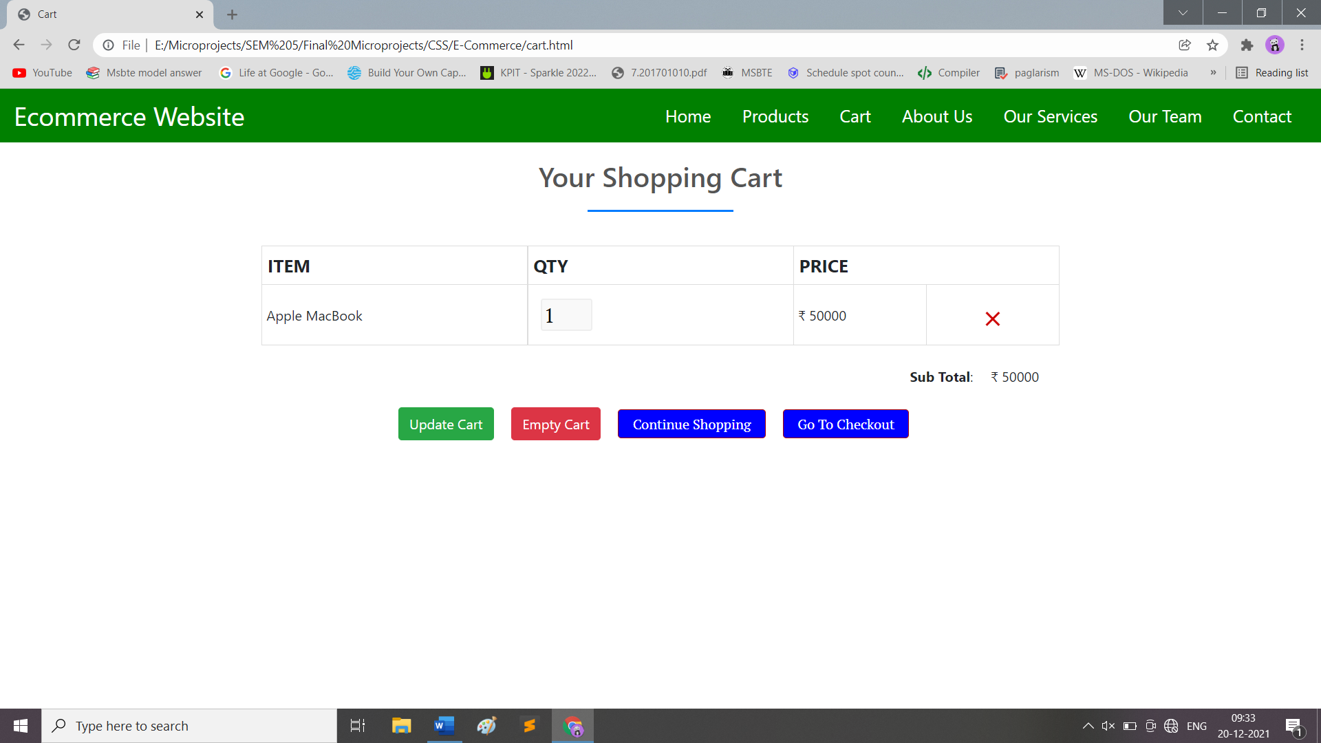

**About Us**

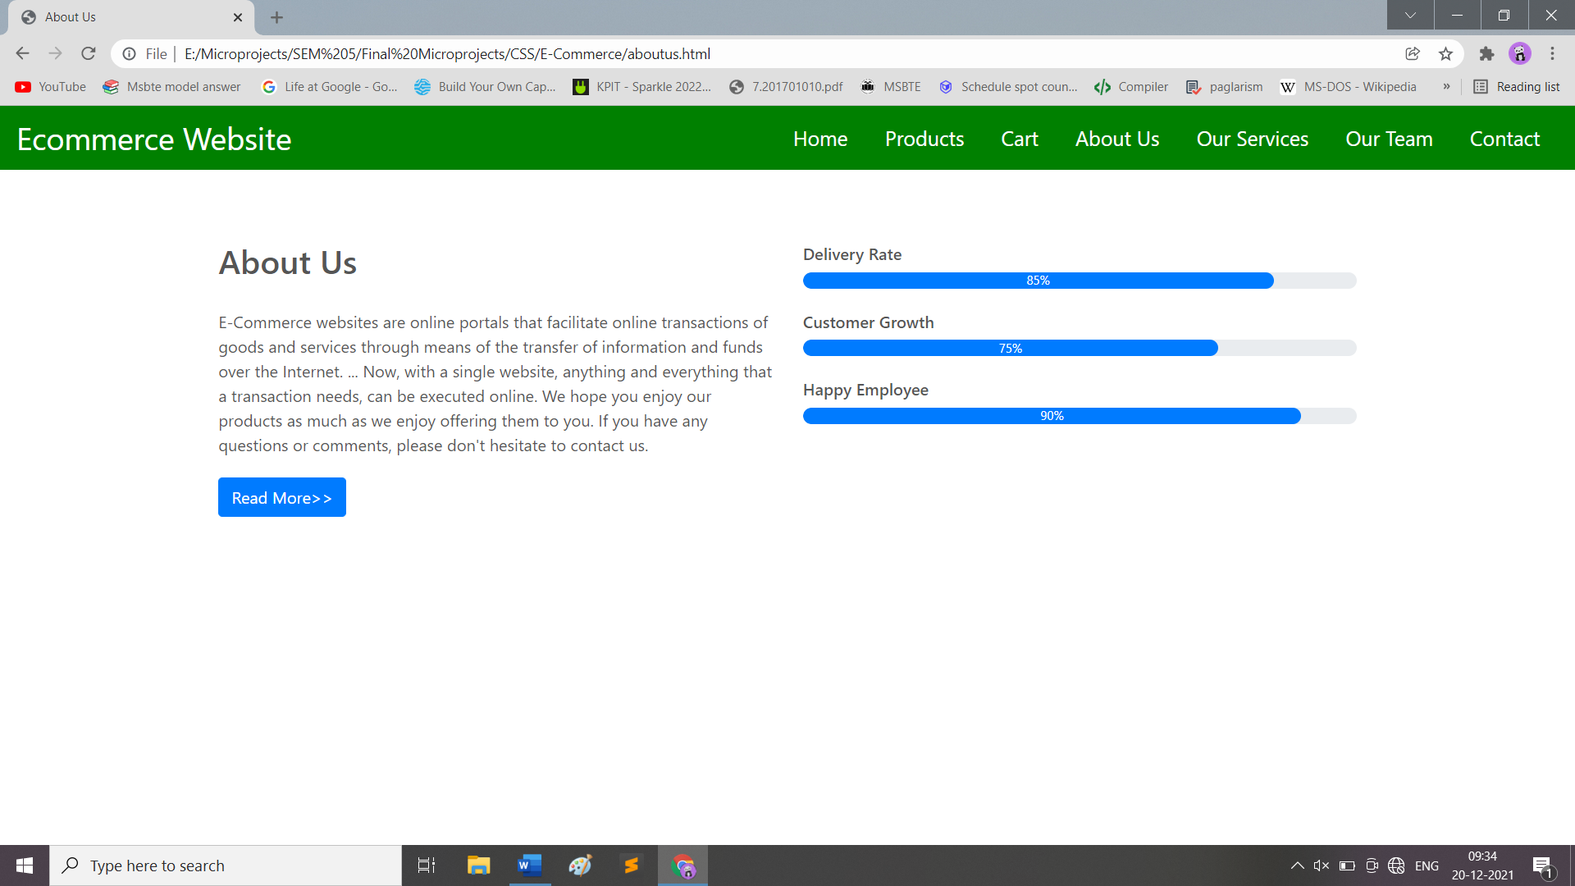

**Our Services**

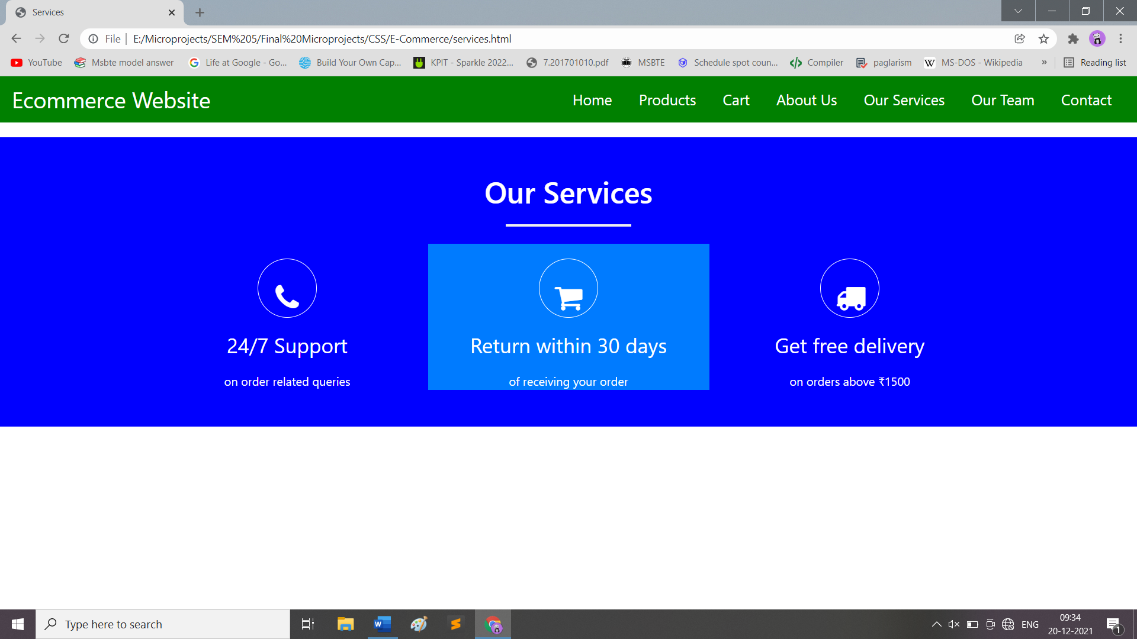

**Our Team**

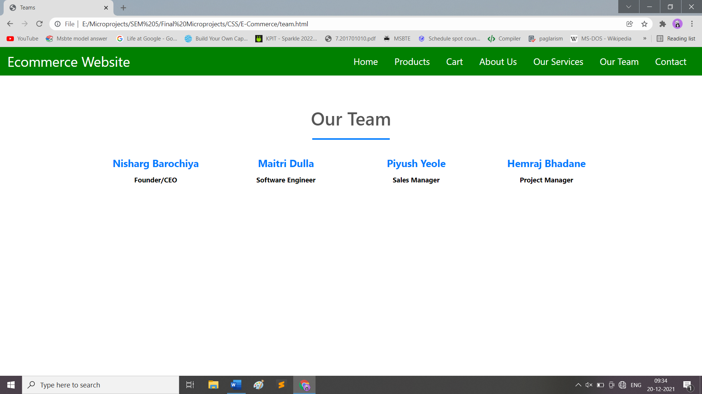

**Contact**

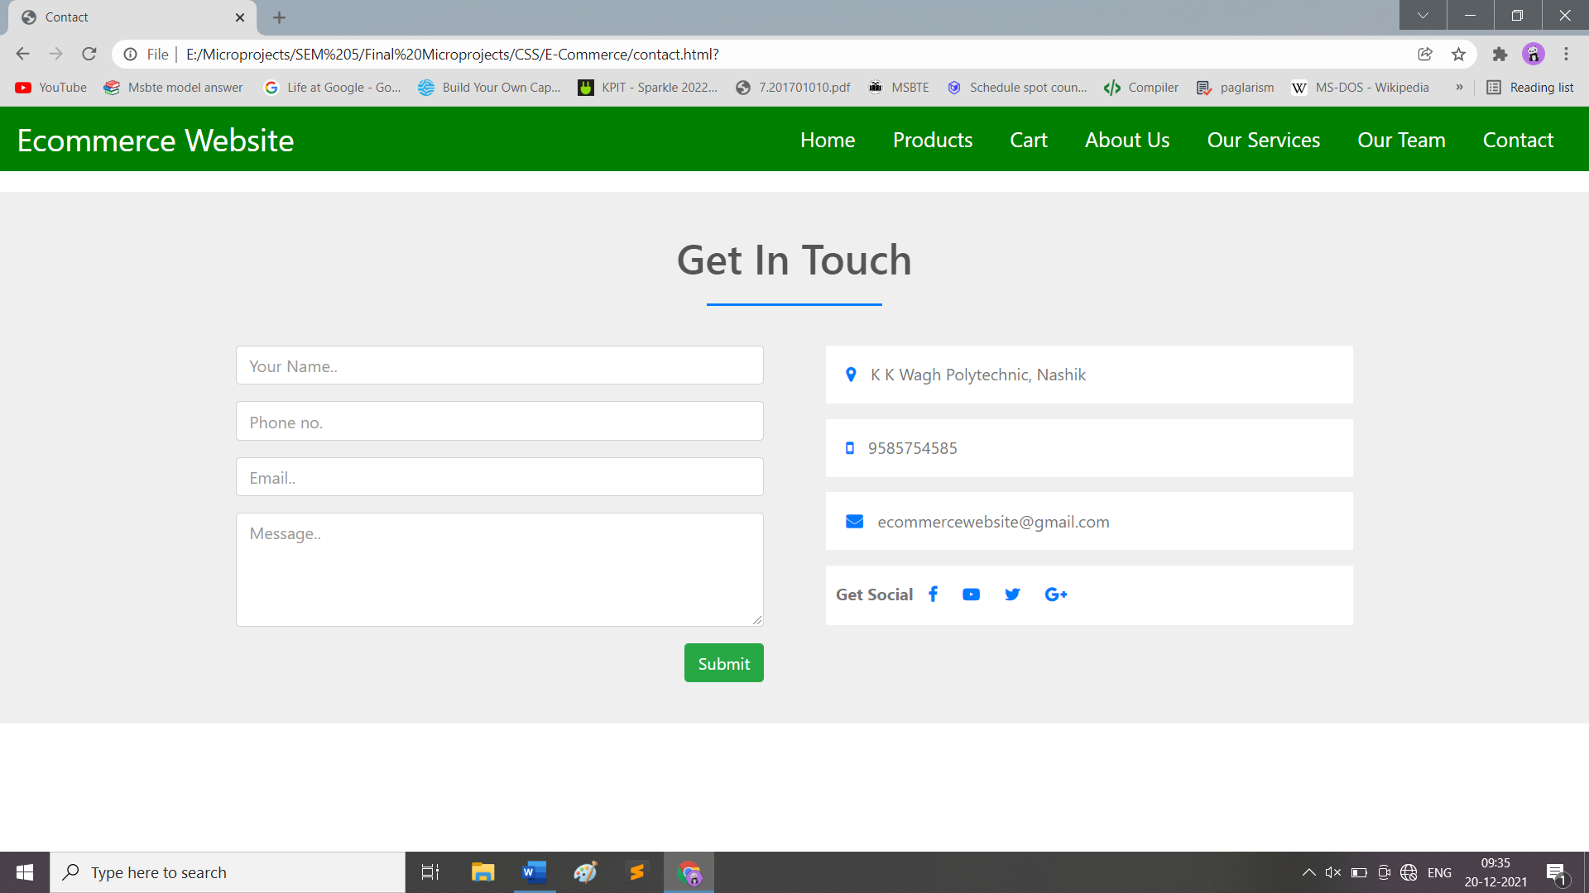

**Checkout**

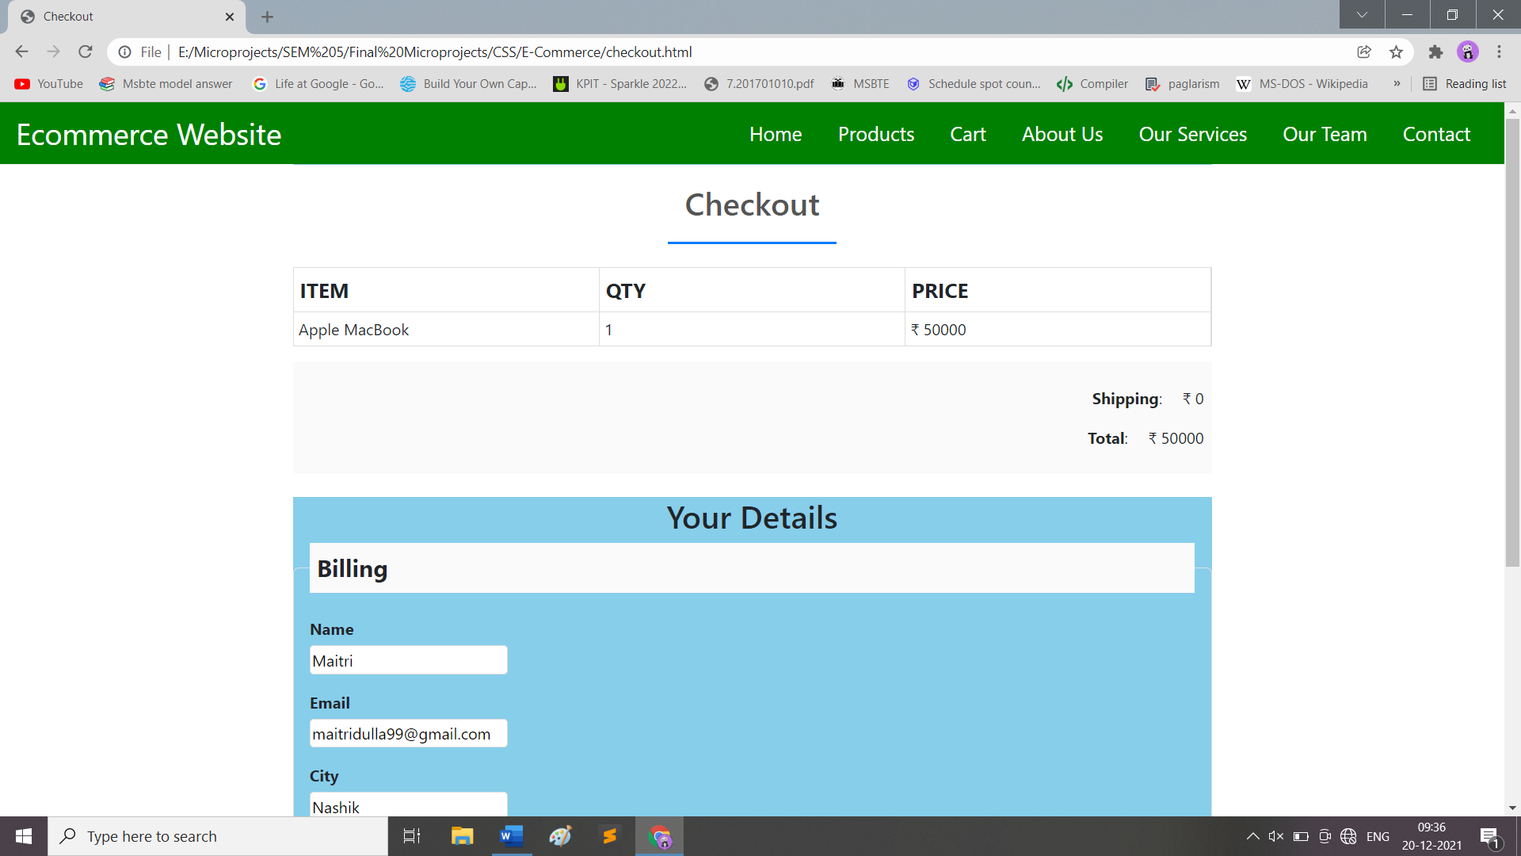

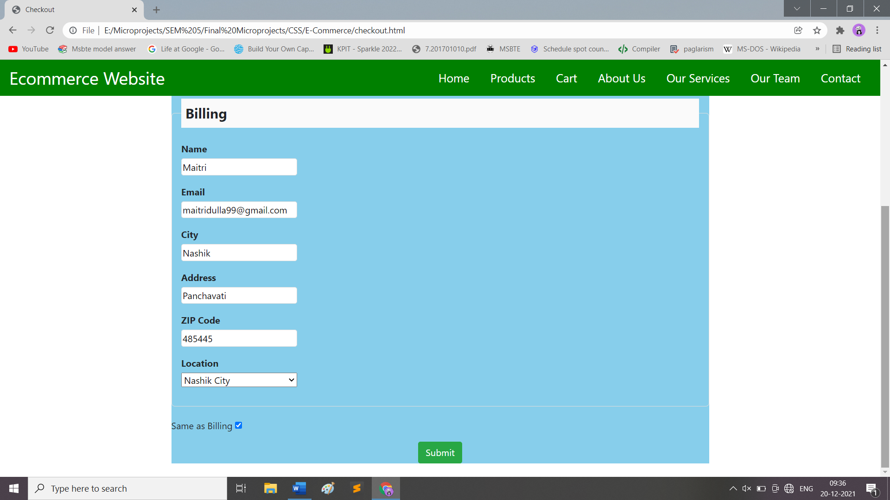

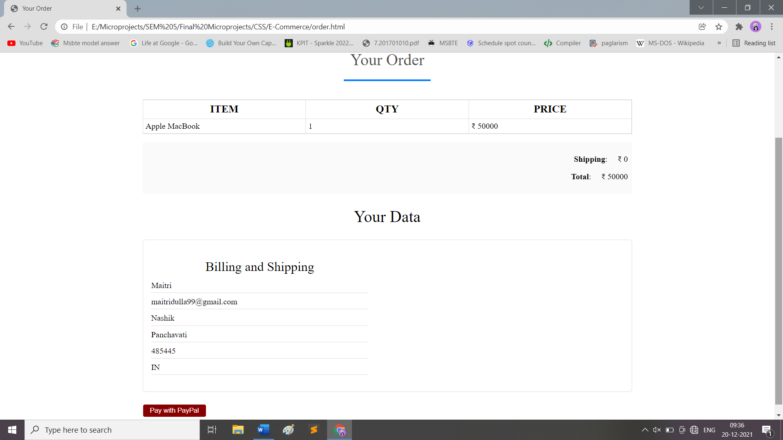

**9.0 Skill Developed / Learning outcome of this Micro-Project:**

1. Work in Team.
2. Leadership.
3. Scheduling Capability.
4. Team Management.

**10.0 Applications of Micro Project:**

1. Retail and Wholesale
2. Online Marketing
3. Finance
4. Manufacturing
5. Online Booking
6. Online Publishing
7. Digital Advertising

**11.0 Name of Group Members:**

|  |  |  |  |  |
| --- | --- | --- | --- | --- |
| Enrolment | Roll No. | Seat No. | Name of Students | Student Signature |
| 1900780314 | 07 |  | Bhadane Hemraj Kamlesh |  |
| 1900780316 | 09 |  | Barochiya Nisharg Kalpesh |  |
| 1900780366 | 59 |  | Yeole Piyush Avinash |  |
| 1900780537 | 65 |  | Dulla Rajesh Maitri |  |

**Date: / / Evaluated by: Dated Signature of Guide: __________________ Name of Guide:** Prof. P. S. Chavan