Session-1
- Write a short paragraph in your own words defining what a 'program' is and give one real-life example from any app you use daily (like Instagram, Zomato, or Paytm).
Ans. A program is a set of instructions written by a programmer that tells a computer or mobile device what to do. It helps users perform different tasks quickly and efficiently. For example, the Instagram app is a program that allows users to share photos and videos, send messages, and watch reels. The program processes user actions and displays the required information on the screen.
- List three popular programming languages you have heard of, and for each, mention whether it is usually compiled, interpreted, or can be both.<br><br><em><strong>Hint:</strong> Think of languages like Java, Python, and JavaScript.</em>
Ans. 1. Java – Both (compiled and interpreted)
2. Python – Interpreted
3. JavaScript – Interpreted (traditionally), but modern implementations can be both interpreted and compiled (JIT)

- Draw a flowchart (on paper or using any online tool) for the process of booking a movie ticket on BookMyShow, starting from opening the app to receiving the booking confirmation.
Ans.
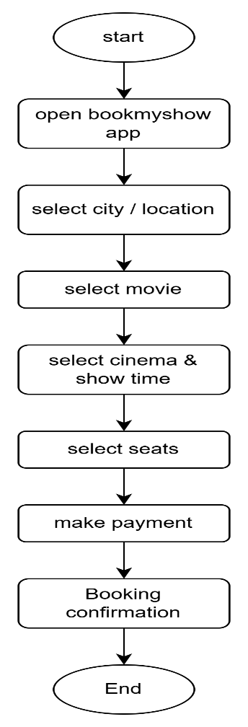
- Write down the steps (as an algorithm, using simple numbered instructions) for ordering food on Swiggy — from opening the app to completing payment.
Ans. Algorithm: Ordering Food on Swiggy
- Open the Swiggy app on your mobile phone.
- Log in to your account (if not already logged in).
- Allow location access or enter your delivery address.
- Browse or search for a restaurant.
- Select the restaurant you want to order from.
- Browse the menu and choose food items.
- Tap Add to add the selected items to your cart.
- Review the items in your cart.
- Modify quantities or remove items if needed.
10. Tap Proceed to Checkout.
11.Confirm the delivery address.
12.Apply a coupon code (if available).
13.Choose a payment method (UPI, card, wallet, net banking, or cash on delivery).
14.Review the total amount to be paid.
15.Tap Place Order.
16.Complete the payment process if required.
17.Receive the order confirmation and tracking details.
End of Algorithm

