12/15/2020

Maitri Hemangkumar Patel

Hi-Tech distribution

Is supplying computer science books to nearby colleges and universities in Quebec. We designed and implemented a windows application using Microsoft Visual Studio 2019, c#, and SQL server 2019

FINAL PROJECT

Hi-Tech Distribution Inc.

Contents

GUI 2

Log IN Form/Choose Option Form 2

User/Employee Management Form 2

Order Management Form 3

Customer Management Form 3

Book Management Form 4

Database 4

Author 4

Books 4

AuthorBooks 4

Publishers 5

Categories 5

Users 5

Employees 5

Customers 5

Jobs 6

Orders 6

OrderDetails 6

Database Diagram 6

Insights 7

Users/Operations/Test Result/Notes 7

# GUI

## Log IN Form/Choose Option Form

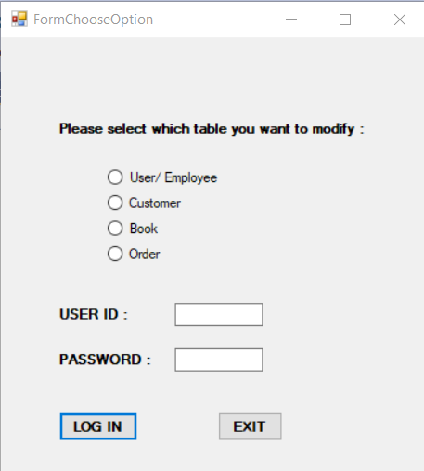

## User/Employee Management Form

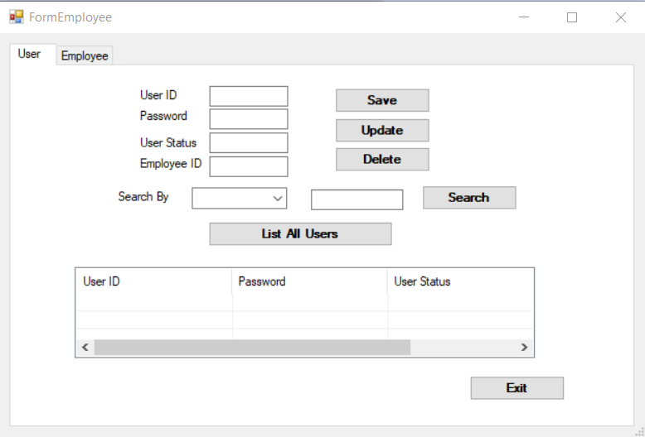

## Order Management Form

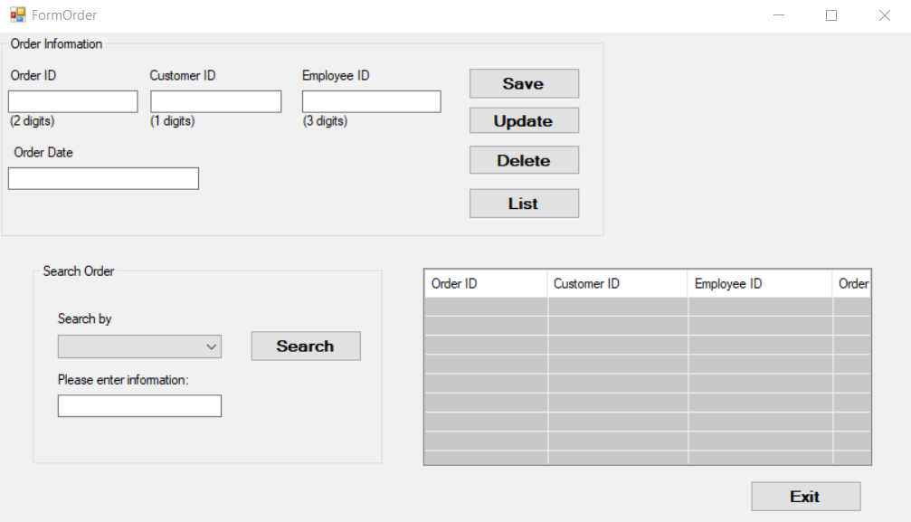

## Customer Management Form

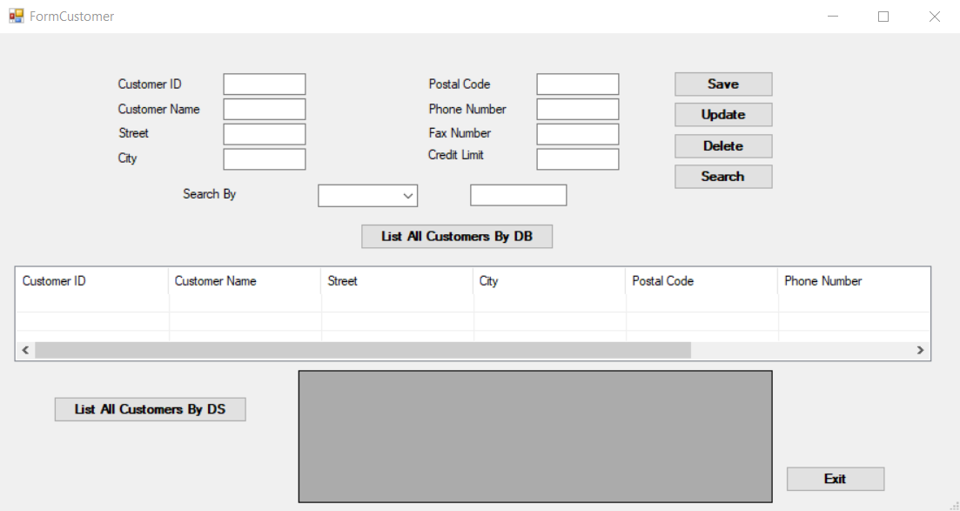

## Book Management Form

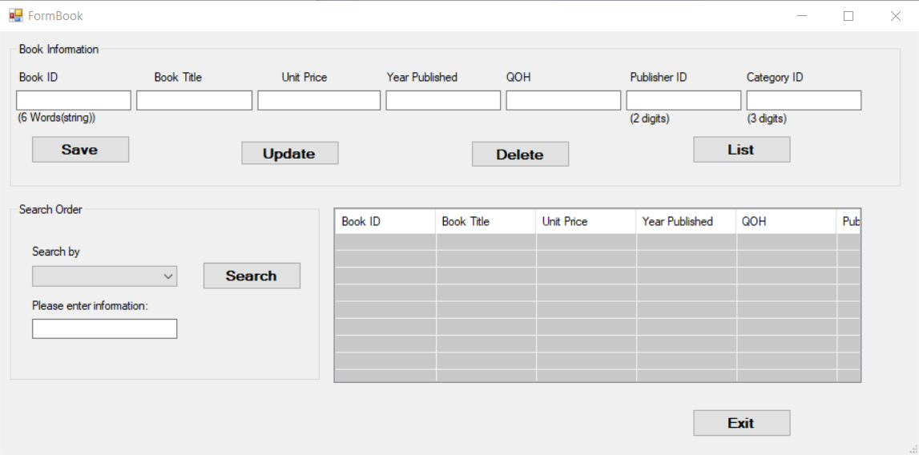

# Database

## Author

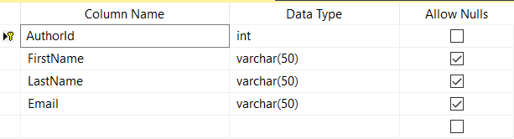

## Books

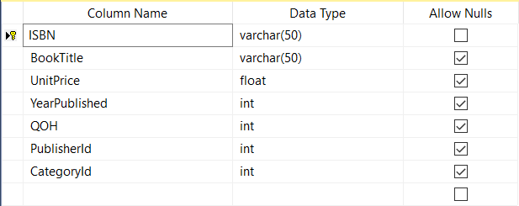

## AuthorBooks

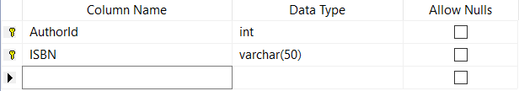

## Publishers

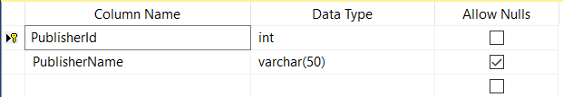

## Categories

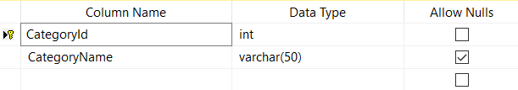

## Users

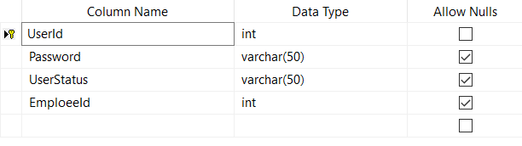

## Employees

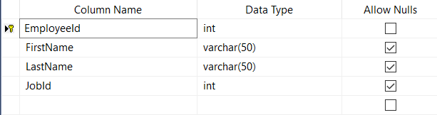

## Customers

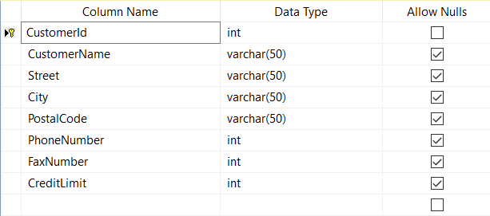

## Jobs

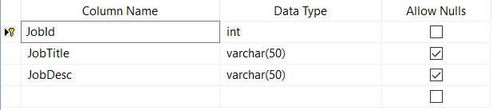

## Orders

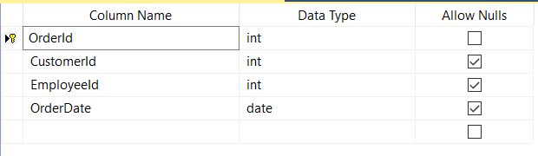

## OrderDetails

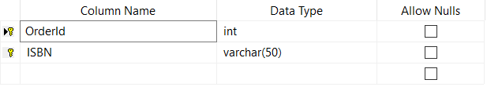

# Database Diagram

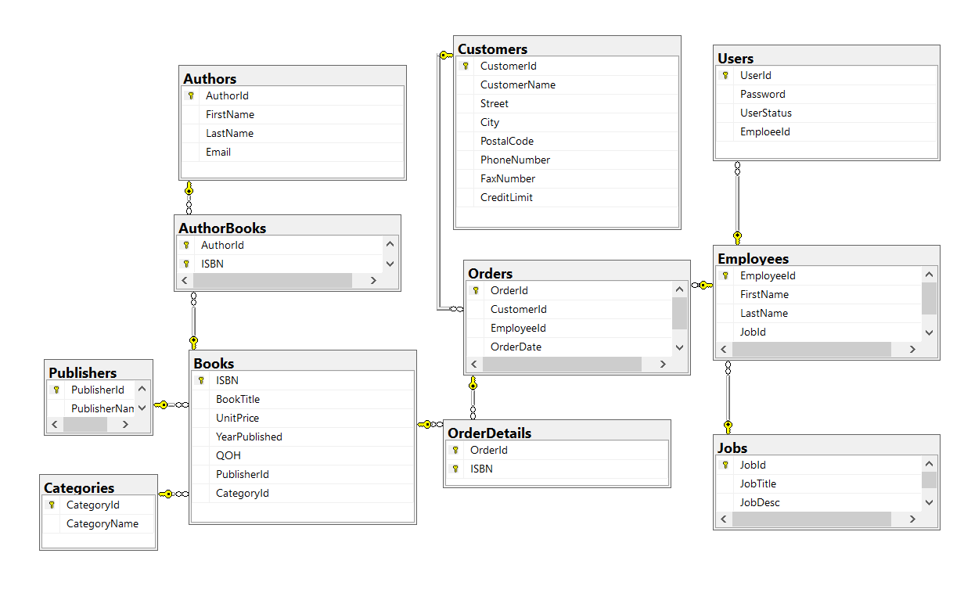

Authors (AuthorId, FirstName, LastName, Email)

Books (ISBN, BookTitle, UnitPrice, YearPublished, QOH, PublisherId, CategoryId)

AuthorBooks (AuthorId, ISBN)

Publishers (PublisherId, PublisherName)

Categories (CategoryId, CategoryName)

Orders (OrderId, OrderDate, CustomerId, EmployeeId)

OrderDetails (OrderId, ISBN)

Jobs (JobId, JobTitle, JobDesc)

Users (UserId, Password, UserStatus, EmployeeId)

Employees (EmployeeId, FirstName, LastName, JobId)

Customers (CustomerId, CustomerName, Street, City, PostalCode, Phonenumber, FaxNumber, CreditLimit)

# Insights

Working on this project gives me lots of knowledge that will be helpful for me in the future. It was very great project and I would like to spent more time and learn more things from it.

# Users/Operations/Test Result/Notes

|  |  |  |  |
| --- | --- | --- | --- |
| Users | Operations | Test Result | Notes |
| * MIS Manager | * Add/Update/Delete User Information * Search/List Information * Add/Update/Delete Employee Information * Search/List Employee Information | * Working | * I used Connected Mode, and this was the part where I spent more time as it was the beginning of the project but at the end everything went well. |
| * Sales Manager | * Add/Update/Delete Customer Information * Search/List Customer Information | * Working | * I used Disconnected Mode, and it went well working on this as I already knew where to focus and spend more time. |
| * Inventory Controller | * Add/Update/Delete/Search/List Book Information and Related Information | * Working | * I used connected mode because I spent most of the time on it and I am more familiar with it. |
| * Order Clerk | * Add/Update/Cancel Customer Orders * Search/List Customer Orders | * Working | * I used Entity Framework and we have learned a lot from this project. I need more time in this time because I did not have enough time for this part. |

THANK YOU

# 