CIS430– Lab Assignment 1

Name: Maitri Radhesh

ID: 2831749

Object: Creating a Relational Database Schema Using SQL and SQL Server

This is the 1st SQL project which is extremely basic. Here, I must create a database, **COMPANY_Radhe** with tables for **TWO Entities** in the database schema using SQL (Data Definition Language) statements in a MS SQL Server.

Initially, I used the **master** to create the database.

After the creation of the database, I had to create the 1st table, **EMPLOYEE** with the following record values namely;

* **FNAME**
* **MINIT**
* **LNAME**
* **SSN**
* **BDATE**
* **ADDRESS**
* **SEX**
* **SALARY**
* **SUPERSSN**
* **DNO**

All the above record values have a datatype to be assigned to them in accordance to the kind of values that shall be inserted in that particular column. The datatypes assigned are:

* **FNAME- VARCHAR(25)**
* **MINIT- CHAR**
* **LNAME- VARCHAR(25)**
* **SSN- CHAR(9)**
* **BDATE- DATE**
* **ADDRESS- VARCHAR(50)**
* **SEX- CHAR**
* **SALARY- DECIMAL(18,2)**
* **SUPERSSN- CHAR(9)**
* **DNO- INT**

The values assigned to some of the datatypes are the capacity of the memory that they can hold.

I made use of the Database that I created to create the table.

The next step is to view the creation of this table. In order to do so, I made use of the **SELECT * FROM** command.

Once the table has been created, I inserted the values into the table. To do so, I used the **INSERT INTO** command.

On the completion of the insertion, if I must view the records in the form of a table, then I need to make use of the **SELECT * FROM** command.

In the similar way, I also created the 2nd table, **DEPARTMENT** with the following record values namely;

* **DNAME**
* **DNUMBER**
* **MGRSSN**
* **MGRSTARTDATE**

All the above record values have a datatype to be assigned to them in accordance to the kind of values that shall be inserted in that particular column. The datatypes assigned are:

* **DNAME- VARCHAR(25)**
* **DNUMBER- INT**
* **MGRSSN- CHAR(9)**
* **MGRSTARTDATE- DATE**

The values assigned to some of the datatypes are the capacity of the memory that they can hold.

The next step is to view the creation of this table. In order to do so, I made use of the **SELECT * FROM** command.

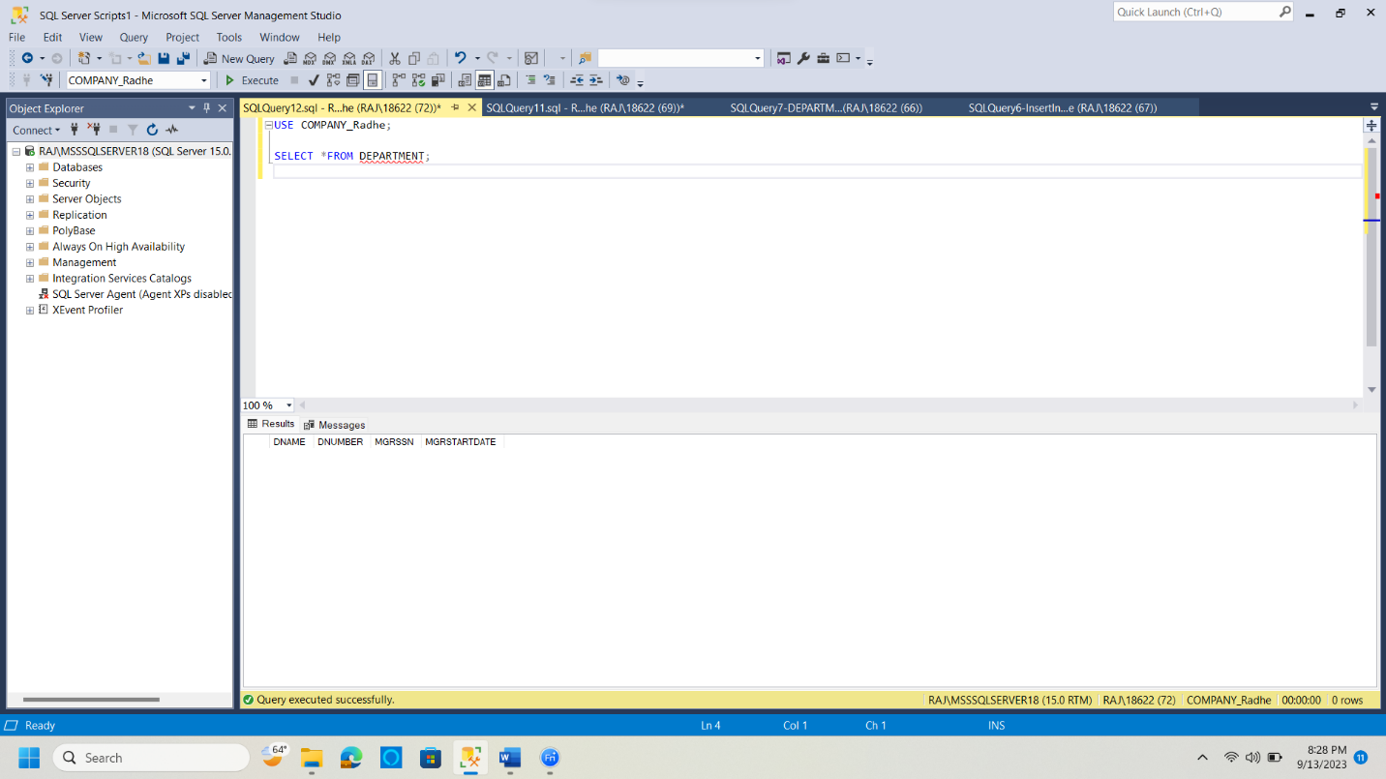

Once the table has been created, I inserted the values into the table. To do so, I used the **INSERT INTO** command.

On the completion of the insertion, if I must view the records in the form of a table, then I need to make use of the **SELECT * FROM** command.

