
Ramsey Healthcare
Financing and Payout Recommendations
Maitrya Anupam | 11/14/23 | Corporate Finance

Executive Summary:
Ramsay Health Care Limited (RHC) has exhibited aggressive financing over the past five years, with significant reliance on debt. A comparative analysis with peers, SHL and CHE, reveals that RHC's financial metrics, including debt-to-equity and interest coverage ratios, signify potential financial vulnerabilities.
For the upcoming year, RHC has expansive investment plans in both hospital and out-of-hospital services. The projected financial requirement for 2024 is between $1.734 to $1.964 billion. Even though RHC has secured a revolving bank loan facility of A$1.5 billion, it's crucial to strategize the financing mix. After considering the present value of interest tax shield and financial distress costs, raising more than approximately $800 million through debt could be counterproductive. Consequently, it is advised that RHC should not pay out dividends for the year 2024 and instead channelize it back into the firm. Raising the remaining amount can be achieved through issuing new equity or by a rights issue. Not paying out dividends can affect the stock price for the firm negatively as it’s not being conservative in its payout policy.
While RHC has witnessed negative dividend growth, peers like Sonic and Chemed Corporation show varied strategies. Sonic has a history of mergers and acquisitions, while Chemed has engaged in share repurchases. To strengthen its financial stance, RHC should abstain from dividends and focus on capital reinvestment.
Industry Overview:
Ramsay Health Care Ltd. (ASX: RHC) operates in the healthcare industry, specifically in the private hospital sector. The healthcare industry is a significant sector with a vast financial landscape. The healthcare industry in Australia is poised for growth with a projected revenue of US$1,032.00 million in 2023, and an expected annual growth rate of 7.10% from 2023 to 2027​​. Here's a brief financial overview of the healthcare industry in Australia:
Market Size: The market size of the Health Services industry in Australia as of 2023 is estimated to be $202.4 billion, marking a 0.82% increase from the previous year​​.
Mergers and Acquisitions (M&A): In recent years, the M&A activity in the healthcare sector witnessed a slight decrease in deal volumes (116 deals in 2022 compared to 129 in 2021), while the values dropped more substantially (US$1,855 million in 2022, versus US$5,213 million in 2021). The values and volumes are now more aligned to pre-COVID levels​​.
Challenges: Major challenges include staffing, inflation, affordability issues for patients, shrinking margins, and supply chain disruptions. Around 85% of health system leaders cited staffing challenges and 76% mentioned inflation as significant factors affecting their strategies for 2023​​.
Profitability Expectations: Despite the challenges, industry leaders overwhelmingly expect a profitable 2023 for their companies, even as most anticipate a recession​.
Global Healthcare Market: The global healthcare market is projected to reach $665.37 billion by 2028. In the US alone, the national healthcare expenditure was $4.3 trillion in 2021 and is estimated to reach $6.2 trillion by 2028​​.
Industry characteristics:
The healthcare industry is complex and presents unique challenges and considerations when it comes to financing and payout decisions. Here are some of the key industry characteristics that are relevant for these decisions:
- Regulatory Environment: The healthcare industry is heavily regulated which impacts financing decisions. Compliance with various laws and regulations requires significant investment.
- Capital Intensity: Healthcare is a capital-intensive industry requiring substantial investment in facilities, equipment, and technology. Access to capital is crucial for maintaining and upgrading infrastructure.
- Labor Costs: The healthcare industry is labour-intensive with a significant portion of expenses allocated to clinical and administrative personnel.
- Patient Volume and Demographics: Patient volumes and the demographic profile of the patient population can impact revenue and thereby influence financing and payout decisions.
- Patient Satisfaction and Quality of Care: Investments to improve patient satisfaction and quality of care can impact financial decisions, and positive outcomes can lead to higher reimbursements in certain reimbursement models.
Company Overview:
Ramsay Health Care Ltd. is a prominent healthcare service provider headquartered in Sydney, Australia. The company was established in 1964 by Paul Ramsay and has since grown into a multinational healthcare provider with a network of hospitals and day surgery facilities spanning across Australia, the United Kingdom, France, and Indonesia. Ramsay Health Care Ltd. operates under the ticker symbol RHC on the Australian Securities Exchange (ASX). Ramsey has a 3% market share in the Australian health services industry as of 2023.
The company's healthcare facilities cater to a wide range of medical needs from day surgery procedures to complex surgeries. They provide a broad spectrum of services including psychiatric care, rehabilitation, and a variety of medical specialties such as cardiology, neurology, orthopaedics, and many more.
Financially, Ramsay Health Care Ltd. has shown resilience despite challenges. For instance, in 2023, it reported a revenue of A$14.86 billion, according to Morningstar. However, it faced a downgrade in its Long-Term Issuer Default Rating (IDR) to 'BBB-', from 'BBB', as per Fitch Ratings, due to expectations of elevated leverage till at least FY26​​.
The two peer companies we have chosen for the analysis are Sonic Healthcare Ltd - SHL (ASX) and Chemed Corporation - CHE (NYSE). Selection of Sonic Healthcare Ltd and Chemed Corporation as peer firms for Ramsay Health Care Ltd can be justified based on several grounds:
- Sector Similarity: All three companies operate within the healthcare sector, albeit with different specializations, providing a basis for comparative analysis.
- Market Capitalization: The companies have comparable market capitalization which can be used for analysis as size of the firm can impact operations with economies of scale in picture.
- Market Presence: Being significant players in their domains, the financial decisions of these companies can reflect larger industry trends. Analysing how each navigates financing and payout decisions can provide insights into different strategies and their outcomes in comparable market conditions.
- Comparable Market Share: Sonic has a 2% market share in the Australian market compared to the 3% Ramsey does. Chemed has a similar market share in the American market.
Comparing Ramsay with Sonic and Chemed can provide a nuanced understanding of financing and payout strategies within the diverse healthcare sector, helping to benchmark and analyse Ramsay's financial decisions in a broader context.
Financing decisions:
We have used the 5 Year average trends and year on year data of various financial ratios to analyse the financing decisions of RHC and have compared them to the peer companies, SHL and CHE.
The ratios are as follows,
Using the 5-year average ratios we obtained, we analysed the financing decisions made by RHC (Ramsay Health Care Limited) and compared them with industry peers SHL and CHE. The inferences are as follows,
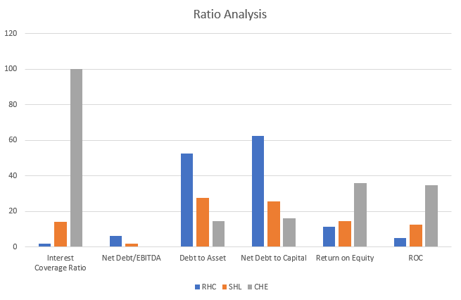
1. Interest Coverage Ratio: Indicates that RHC has just under twice the operating profit needed to cover its interest expenses. This is a relatively lower cushion, indicating higher financial risk. SHL & CHE, both these companies have significantly higher interest coverage ratios.
2. Net Debt/EBITDA: RHC has a net debt that is a bit over 6 times its EBITDA. This implies a high leverage situation, where the company may find it challenging to pay off its debts’. For SHL & CHE, these ratios show that SHL and CHE have much lower net debt relative to their EBITDA, indicating stronger financial health and lower leverage.
3. Debt to Asset: Over half of RHC's assets are financed by debt. SHL and CHE have significantly lower debt-to-asset ratios, suggesting they rely less on external financing.
4. Net Debt to Capital: More than 60% of RHC’s capital structure is in the form of net debt. Both peers have a lower dependence on debt in their capital structure, indicating a more conservative financing approach.
5. Debt/Equity: RHC has a very high debt relative to its equity. This suggests that the company is highly leveraged and might be riskier from a financing standpoint. Both the peer companies have much lower debt-to-equity ratios, suggesting a more balanced approach between debt and equity financing.
6. Return on Equity (ROE): RHC’s ROE suggests that for every dollar of equity, RHC generated an 11.32% return. Both peers have higher ROEs, indicating they are more efficient in generating profit from their equity.
7. Return on Capital (ROC): RHC's return on capital is relatively low, indicating that the company may not be efficiently using its capital to generate returns. Both SHL and CHE demonstrate significantly higher ROCs, suggesting better utilization of capital.
Over the past 5 years, RHC has had a financing strategy that is reliant on debt compared to its peers. This contrasts with the pecking order theory where managers prefer to finance using net income and equity prior to date. It has a higher dependence on debt as evidenced by most of its ratios, especially the debt/equity ratio. This can be a sign of either growth ambitions, low interest rates on some of its loans or potential financial challenges in raising equity.
On the other hand, both SHL and CHE appear more conservative in their financing decisions with a stronger emphasis on equity financing and lower leverage. Additionally, they seem to have been more efficient in utilizing their capital to generate returns.
By the look of it RHC seems to be in a worse financial position when compared to its peers. Also, the financing decisions made by the management have not been effective.
Financing Requirement:
To assess whether RHC requires additional financing to improve its financial condition we must look at what the company has planned for its future.
Ramsay Health Care plans strategic investments. Notably, an increase in digital and data operating expenses in Australia, totalling $34-44 million, underscores the company’s commitment to technological advancement and operational efficiency.
As part of its financial planning, Ramsay Health Care allocates a significant budget for group capital expenditure, ranging from $0.89 billion to $1.02 billion. This strategic investment aims to reinforce the company’s infrastructure and support its growth initiatives. The total financial requirement for RHC in 2024 is 1734-1964 million.
Ramsay Health Care’s investment strategy remains robust in 2024, with a focus on expanding its footprint in both hospital treatment capacity and out-of-hospital services. Investments in brownfield and greenfield projects in Australia are expected to reach $250-$300 million, indicative of the company’s dedication to enhancing healthcare services.
Ramsay Health Care has secured A$1.5 billion in new committed revolving bank loan facilities with two of its key relationship banks. The facilities, which will mature in 1HFY26, are part of Ramsay’s ongoing bank loan refinancing activities and will be used to repay facilities maturing in 1HFY25. Ramsay will continue to seek to diversify the source and tenor of its borrowings over time.
Long Term Debt
The Long-Term Debt for RHC and SHL are given as follows. CHE has no long-term debt commitments. Sonic has all its 1673.6M long term debt in unsecured bonds.

LT Debt by Seniority Summary for RHC
Seniority | Amt | Pct
Senior Secured | 3,099.1 | 52.2%
Senior Unsecured | 2,832.3 | 47.8%
Total Classified | 5,931.4 | 100.0%
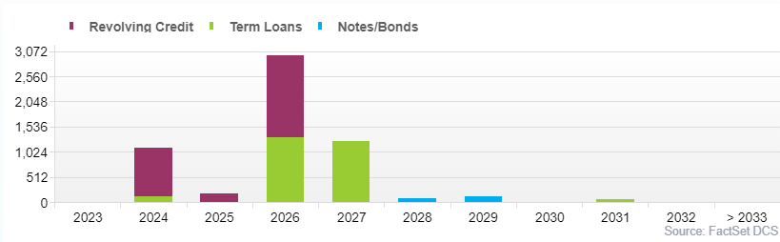
RHC
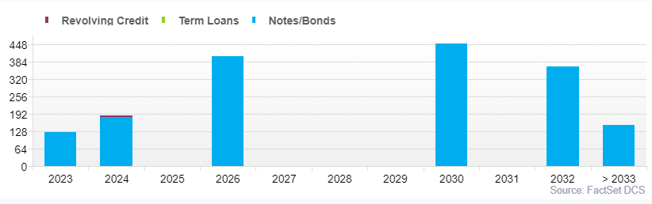
SHL
Raise equity or debt?
To raise funds for this expense an assessment is made whether to raise the funds through equity or debt.
Current financial health of RHC:
To analyse the current financial health of RHC we must calculate the present value of interest tax shield and financial distress cost.
Let’s start by calculating WACC, which we use for discounting the future cash flows.
Calculating Cost of Debt (Rd):
Currently RHC has a total market equity value of 13,753.9 million (E) and Debt value of 11,887 million (D). By calculating 5-year average interest coverage ratio for RHC we find it to be 2.72
Cost of Debt (Rd) = Risk Free Rate + Default Spread
Risk Free Rate is the 10 Year Australian Government Bond yield – 4.438%
Default Spread for RHC (BBB Rating) – 2.25% (From NYU stern default spread table)
Therefore, based on this data we calculated Rd as 6.688%
Calculating Cost of Equity (Re):
We used CAPM model to calculate the cost of equity,
Re = Rf + Beta*(Rm – Rf)
Rf = 4.438%, Rm = 7.69% (Last 5-year average ASX 200 return), Beta = 0.8747 (Using regression for RHC and ASX last 5 years returns)
Substituting, we get, Re = 4.438 + 0.8747 * (7.69 – 4.438) = 7.289%
WACC:
To calculate the Weighted Average Cost of Capital (WACC), you need to consider both the cost of equity (Re) and the cost of debt (Rd) and then weigh them by their respective proportions in the capital structure.
Based on Re, Rd and effective tax rate of 31.5% we get Rwacc as 0.0603
PV of Interest Tax Shield:
It is the product of Total Debt and effective tax rate, assuming debt to be constant throughout the life we get,
PV of Interest Tax Shield = 11,887 * 31.5% = 3,750.26
PV of Financial Distress Cost:
We can calculate financial distress cost by (Rd of AAA company - Rd of RHC) * Debt = (0.75%- 2.25%) * 11,887 which is -178.30.
PV of Financial Distress Cost = Financial Distress Cost / WACC
= -178.30 / 6.688% = -2,955.86
Adding PV of interest tax shield and PV of financial cost of distress we get 794.40.
Which currently means the company’s level debt has its advantages.
By using solver, it is calculated that if interest coverage ratio of RHC goes to 2.5 then PV of financial cost of distress > PV of interest tax shield indicating that raising more than around 800 million through debt is a bad idea.
So, for the further financing in 2024 we suggest not to payout any dividends instead reinvest back into the company. Expected 2024 dividend is 237 and raise 800 million through debt and rest through issuing new equity. Alternatively, the company can do a rights issue to raise capital.
Payout Decision:
Dividend and corporate action.
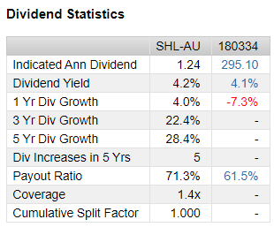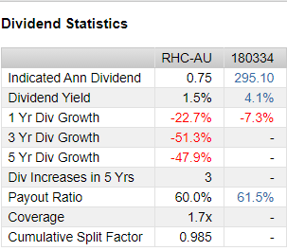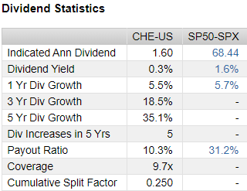
Negative dividend growth for RHC in comparison to Sonic and Chemed Corporation can be observed from the tables above. Ramsey’s DPS summary is given below.
The general trend has been a decrease in dividends over the last few terms which is consistent with our findings that Ramsey should recapitalise. They haven’t engaged in any buybacks over the last 5 years however some funds were raised through private placements.
Chemed has paid of 0.4 million dividends for the last quarter and 0.38 M before that. It had been 0.36 M for the majority of 2022 They’ve also done considerable share repurchases last year around 1M dollars. All of these had a positive impact on its share price.
Sonic’s dividend payout decision varies according to their performance in the respective years. Sonic also engages in M&A transactions quite often and raises capital through private placements in comparison.
So, as suggested in the financing decision, RHC must decide not to payout any dividend for 2024 and instead reinvest it back into the company for its financing requirements.
Conclusion:
RHC's aggressive financing, leaning heavily on debt, has made it financially riskier compared to peers SHL and CHE, as seen in its high debt/equity ratio. This has coincided with a decline in dividends over five years, hinting at a possible need for recapitalization. RHC's ambitious 2024 investment plans necessitate significant funding, estimated at $1734-1964 million. While some bank loan facilities are secured, there's a notable funding gap. Recommendations include cautiously limiting debt financing to around $800 million, reinvesting the anticipated 2024 dividends of $237 million, and considering issuing new equity via a rights issue to cover remaining financial needs. Although we recommend raising fund through equity instead of debt, it’s not practically possible to raise 1387 million through equity. So RHC should generate a growth in EBIT through the funds they have raised so they can raise equity in future and reduce debt to decrease the financial distress cost of the company. Withholding dividends, given RHC's financial scenario and capital demands, is deemed prudent, contrasting with firms like Chemed that maintain dividend payouts and share repurchases due to a steadier financial stance. Various factors like interest rate fluctuations, global economic conditions, regulatory changes, market perceptions, and dividend expectations could impact RHC's financial strategies and market position, underscoring a need to rebalance its financing towards equity and possibly recapitalize for long-term financial stability.

Reference:
- Ramsay Health Care. (2023). Annual report 2023. https://www.ramsayhealth.com/globalassets/global/investor-centre/investor-centre-pdfs/rhc-annual-report-2023_final.pdf
- Sonic Healthcare. (2023). Annual report 2022. https://investors.sonichealthcare.com/FormBuilder/_Resource/_module/T8Ln_c4ibUqyFnnNe9zNRA/docs/Reports/AR/SHL_AnnualReport_2022.pdf
- ChemEd. (2023). Annual Report 2022. https://www.chemed.com/static-files/0ab96c41-10fa-4246-80d1-a01c34f24a42
- Damodaran, A. (n.d.). Data and information on corporate finance. Stern School of Business. https://pages.stern.nyu.edu/~adamodar/New_Home_Page/datafile/ratings.html
- McKinsey & Company. (n.d.). What to expect in US healthcare in 2023 and beyond. https://www.mckinsey.com/industries/healthcare/our-insights/what-to-expect-in-us-healthcare-in-2023-and-beyond
- Deloitte. (2022). 2023 outlook for health care. https://www2.deloitte.com/us/en/blog/health-care-blog/2022/2023-outlook-for-health-care-could-margins-staffing-stall-progress-to-future-of-health.html
- J.P. Morgan. (2023, January 19). Healthcare business leaders outlook. https://www.jpmorgan.com/insights/outlook/business-leaders-outlook/healthcare-business-leaders-outlook
- IBISWorld. (n.d.). Health services market size. https://www.ibisworld.com/au/market-size/health-services/
- Parliamentary Library. (n.d.). Health overview: Budget review 2022-23. https://www.aph.gov.au/About_Parliament/Parliamentary_Departments/Parliamentary_Library/pubs/rp/BudgetReview202223/HealthOverview
- PwC Australia. (n.d.). Australian mergers and acquisitions outlook: Health. https://www.pwc.com.au/deals/australian-mergers-and-acquisitions-outlook-industry-insights/health.html

