**Introduction:**

A Code-Player is a software that is developed to run the codes of various web development languages, like HTML, CSS, JavaScript and much more in one place, you need to write your code in one place and get the instant output of your code. Normally we write our codes in our HTML editor like Notepad++ or IDE like Brackets, but here we need to switch between our Browser and editor to write the code and then find the output in the browser which is time consuming, we try to a solution for this problem through this project.

**Purpose:**

When we want to write our code for the purpose of development a website we have two options:

**>**Either to write the code in our html editor and then find the output in the browser, which is not so much user friendly.

**>** We can use other online compiler, but we have to write all the codes (HTML, CSS, Javascript) in one place.

Through this project we are find a path that is the mid-way for both the option which gives the automation user friendly behaviour of the compiler as well as flexibility of the html editor to write codes separately and more professionally.

**CHAREACTERSTIC OF THE PROPOSED SYSTEM :**

* **Remote access -**Code for your project and then access the data Remotely
* **User friendly-** save your time as well as provide the feature of automation line to line code automatically
* **Security –** your code on the site is safe, no unauthorized access.
* **Multi language supported-** code player currently support 3 web development language (HTML, CSS, Javascript), for creating dynamic web pages

**How Does the System Work :**

User go to the website, where the user need’s to login directly if he had a account or sign up for the website then he have to login after successful sign up he will be directed to the dashboard where he can either look at his previous work or select new-project to fresh start a project.





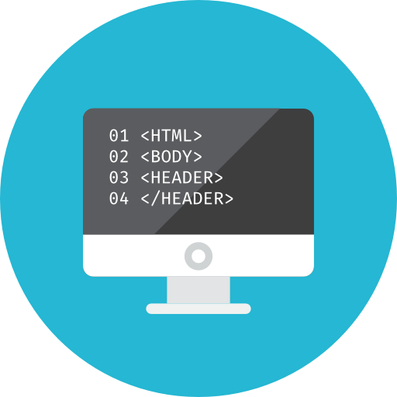

User login/signup

User Write code

**Progress Report:**

Till now, the UI of the website is completely designed, Pages like Sign-up Login Forget password is created, the main component of the project which is the compiler(‘code player’) is it’s final stage and working correctly with the user output.

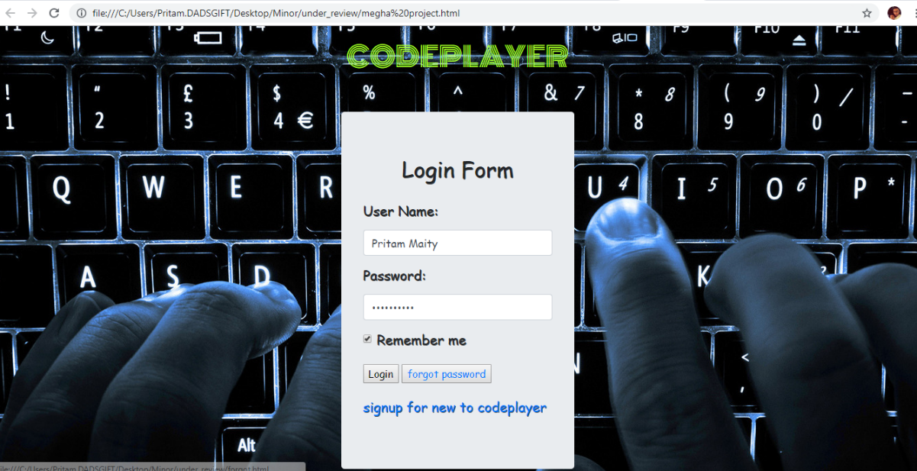1.This is the login page for the user, with a link of signup

2. Signup Page for new User to the website.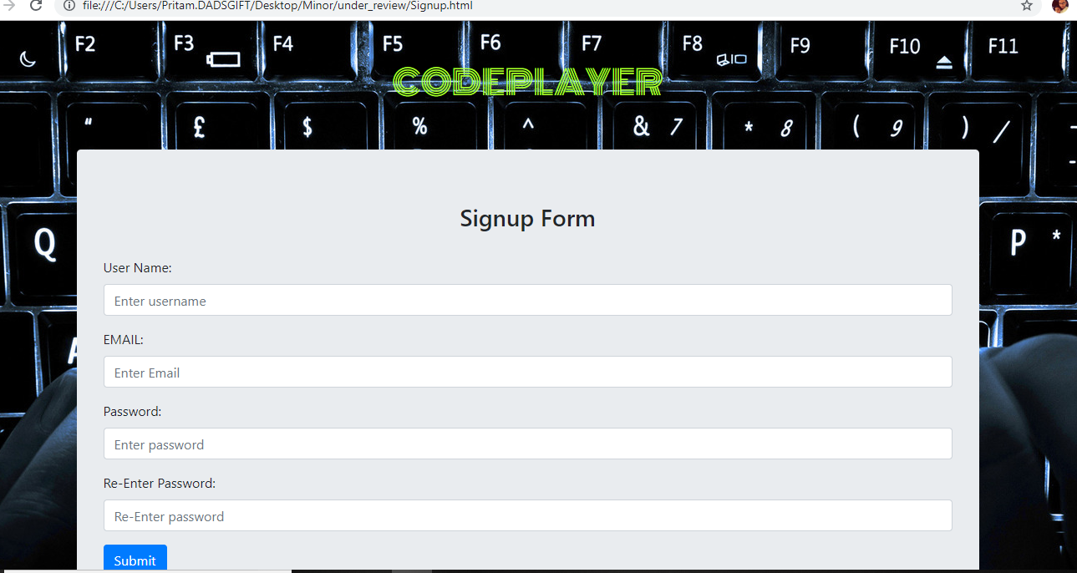

3. Forget password page for the user.

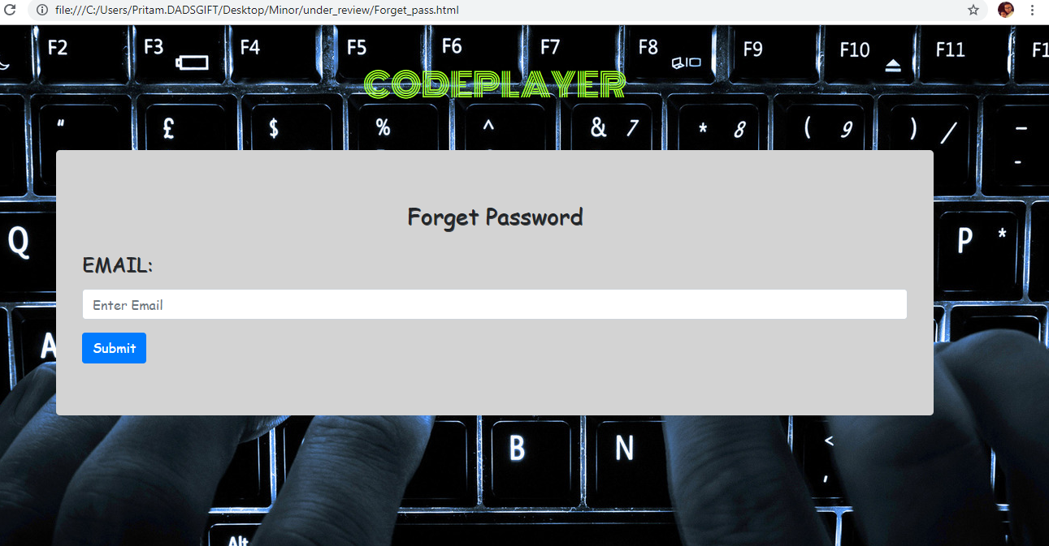

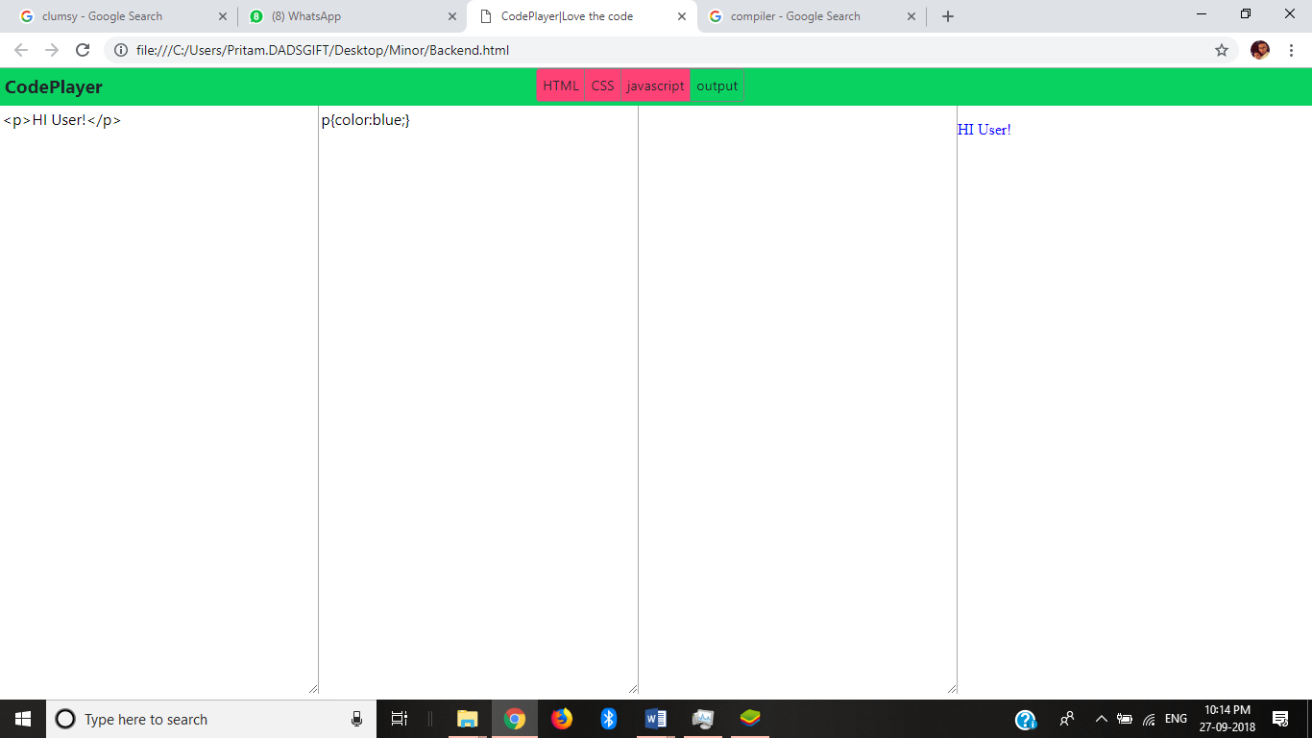4.Code-Player in its working condition.