# Javascript history and instruction:

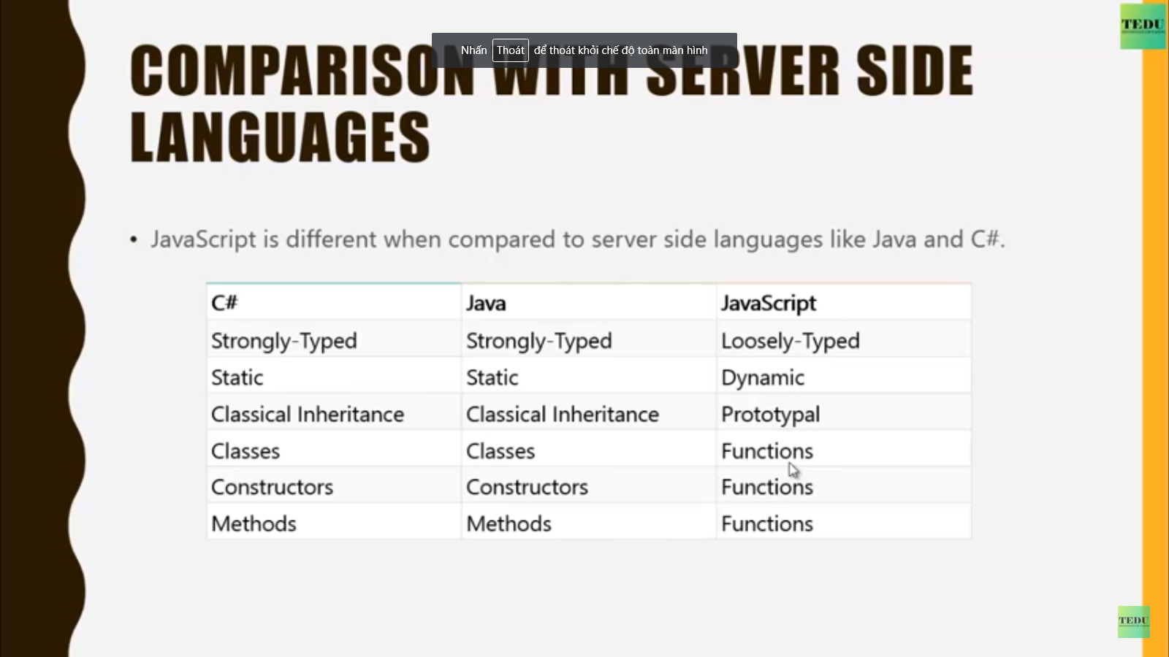

# Framework support:

+ AngularJS, ExtJS,...

# Sciprt tag

+ From html 5.

+ Internal script file: <script> //code js here </script>

+ External script file: <script src = “/name.js”</script>

+ Script tag into <head> tag

+ Script at the end of <bode> tag

# Javacript overview

# Display popup message:

+ Aler message box

+ Confirm message box

+ Prompt message box

# Variable