Q1. Explain the flow of MVC2 Architecture
Ans: MVC Flow (Exactly as per Diagram Order)
1. User → Controller (Servlet)
User sends request (URL / form submit) to the Controller, implemented using a Servlet.
2. Controller → Model (Operation Implementor)
The Controller (Servlet) identifies the required operation and forwards the request to the Model (operation implementor / service / DAO class).
3. Model → Database (DB)
The Model executes business logic and sends SQL/JDBC request to the Database.
4. Database → Model
The Database returns data / status back to the Model.
5. Model → Controller
The Model (operation implementor) returns the processed result to the Controller (Servlet).
6. Controller → View (JSP)
The Controller selects the appropriate View, implemented using JSP.
7. View → Model
The View (JSP) may call Model methods (using EL / JSTL / Beans) to access required data.
8. Model → View
The Model provides data objects back to the View (JSP) for presentation.
9. View → User
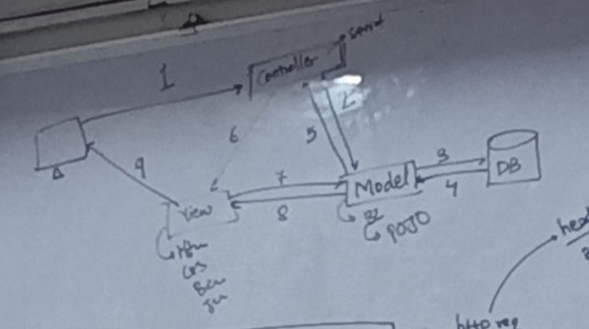
The View (JSP) generates the final HTML response and sends it back to the User.

Q2. How many design pattern u have used across the project ?
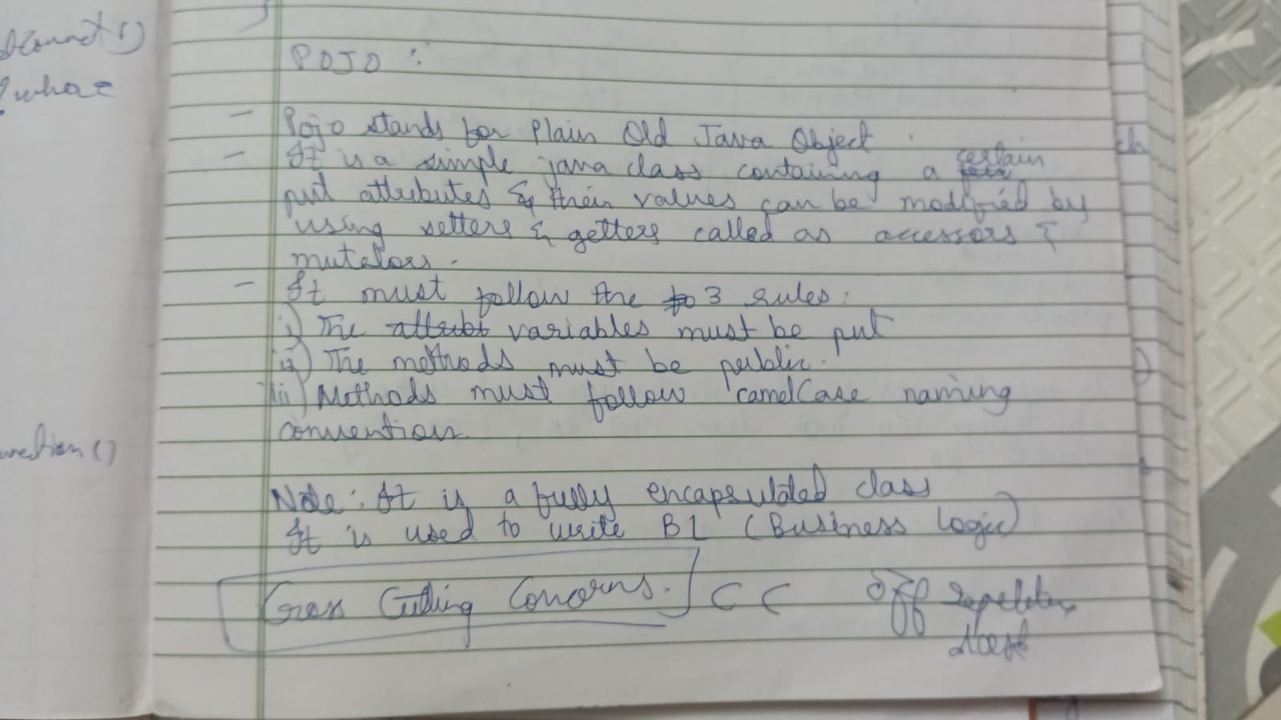
Ans: In our project, we have primarily used ONE main design pattern, which is the MVC 2 (Model–View–Controller) architecture. Additionally, we followed POJO-based design for data modeling and Programming by Contract (PByC) principles for validation and correctness.
Q3. Where do we write the business logic?
Ans: We write business logic in POJO that resides in Model.
Q4. What is Pojo?
Ans:

Q5. Why POJO is used to write Business Logic?
Ans: POJO (Plain Old Java Object) is used because it is simple and easy.
It stores data in variables with getters and setters, passes data between layers, and keeps the code clean by helping with cross-cutting tasks, meaning the same data handling code can be reused everywhere without repeating it.

Q6. What is PByC?
Ans: Programming by Contract (PByC) is a concept where rules, policies, and responsibilities are defined in advance using interfaces.
These rules act as a contract between the service provider and the service consumer.
- Interface is the topmost layer and contains only method declarations.
- The Founder / Architect defines the policy using an interface.
- This policy acts like a contract.
- Whoever wants to use the system must follow this contract.

Q7. Steps to JDBC?
Ans:
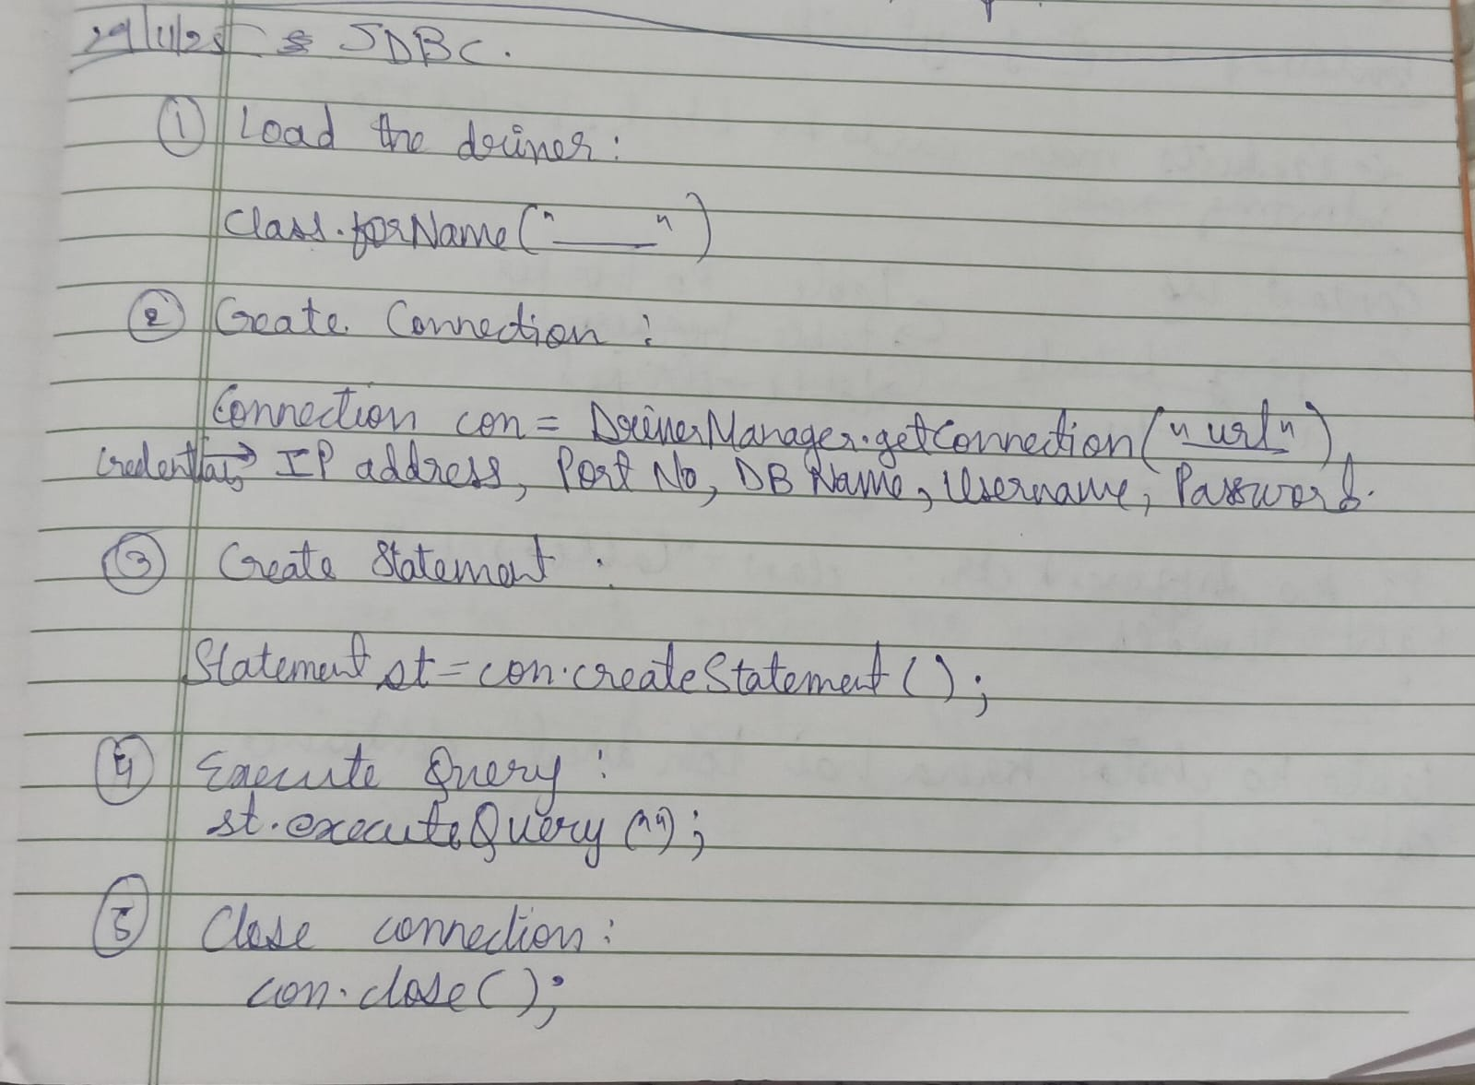
Q8. Difference between Procedures, Functions and Triggers ?
🔹 Stored Procedure
• A stored procedure is a block of SQL code that is called manually.
• It is used to perform operations like insert, update, delete.
• It may or may not return a value.
👉 Example: Place order, cancel order.
🔹 Function
• A function is a database object that always returns a value.
• It is mainly used for calculations or counts.
• It is called inside a SELECT statement.
👉 Example: Total orders count.
🔹 Trigger
• A trigger is a database program that executes automatically.
• It runs when an insert, update, or delete happens on a table.
• It is used to maintain data consistency.
👉 Example: Auto-update status after insert.

Q9. How you have done the config of ur project ?
Ans:
We created the project as a Dynamic Java Web Project in Eclipse and organized it according to MVC principles.
- Controller → Java Servlets
- Model → DAO classes and POJO classes
- View → JSP pages with Bootstrap

Server Configuration
We configured Apache Tomcat as the application server and set it as the project’s runtime environment.

Request Handling Configuration
Request handling is configured directly inside servlets.
- Servlets handle incoming requests
- Based on logic, requests are forwarded to appropriate JSP pages
- Each module has its own servlet for better control

Database Configuration
Database configuration is done using JDBC with MySQL.

Session & Security Configuration
Session management and security are handled programmatically.
- Session created after successful login
- Session validation for protected resources
- Session invalidation during logout
- Input validation handled as per Programming by Contract principles

