**Curriculum Vitae**

**Curriculum Vitae**

**Riad Kharma**

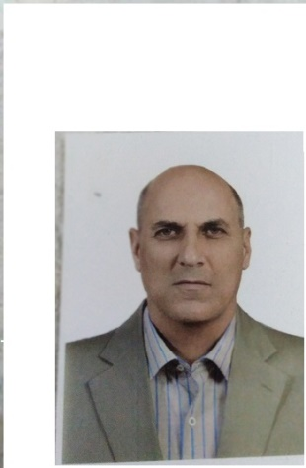

**Curriculum Vitae**

**Riad Kharma**

**PERSONAL DATA**

* **Address**  : Dawra – Beirut
* **Date of birth** : 14 February 1965
* **Phone** : 71 – 631 233
* **E-mail** : [riad_kharma@hotmail.com](mailto:riad_kharma@hotmail.com)
* **Citizenship**  : Lebanese

**EDUCATION**

* 1989

First year of Bachelor degree - Lebanese University

*Majoring in Law*

* 1988

Lebanese baccalaureate in Literature and Philosophy – Ouyoun High School

**Languages**

* Arabic : Speak, read & write.
* French: Speak, read & write.

**Curriculum Vitae**

**Riad Kharma**

**Abilities**

* Team and individual work
* Problem solving and decision making skills
* Good analytical and teamwork skills
* Good persuasive skills
* Fluent in spoken and written Arabic and French

**EXPERIENCE**

* 2018

An employee at ProSec Security company.

* 2015-2016

ISF Chief Officer of Halba police station.

* 2012-2015

ISF Chief Officer of the registration office in the ISF traffic office in Halba.

* 2007-2012

ISF Chief officer of Arida marine police station.

* 1994-2007

ISF Police Officer.

**Hobbies**

Reading and walking.

**References**

Available upon request.