D.K.T.E. Society’s Textile and Engineering Institute, Ichalkaranji
(An Autonomous Institute, Affiliated to Shivaji University, Kolhapur)
Accredited with ‘A+’ Grade by NAAC



Department of Computer Science and Engineering
(Artificial Intelligence and Machine Learning) 2026–2027

THE COMMUNITY ENGAGEMENT PROJECT REPORT ON
“NUTRITION AND HYGIENE MAINTENANCE IN HOTELS”

Under the guidance of: Miss. S.S.Demanna

Developed By:

- Sanika Tavate PRN: 25UAM128
- Prachi Majalekar PRN: 25UAM118
- Rutuja Dhole PRN: 25UAM079
- Gayatri Sankpal PRN: 25UAM142
- Shreya Bhosale PRN: 25UAM140
- Rukaiya Shaikh PRN: 25UAM127

CERTIFICATE

This is to certify that,
- Sanika Tavate PRN: 25UAM128
- Prachi Majalekar PRN: 25UAM118
- Rutuja Dhole PRN: 25UAM079
- Gayatri Sanpkal PRN: 25UAM142
- Shreya Bhosale PRN: 25UAM140
- Rukaiya Shaikh PRN: 25UAM127

have successfully completed the project work entitled

“NUTRITION AND HYGIENE MAINTENANCE IN HOTELS”
in partial fulfilment for the award of degree of Bachelor of Technology in Computer Science and Engineering (Artificial Intelligence and Machine Learning). This is a record of the work carried out during the academic year 2026–2027.

Miss. S.S.Demanna Prof. Dr. S. K. Shirgave
[ Project Guide] [Head of Department]

Date: 23-10-2026
Place: Ichalkaranji

DECLARATION

We, the undersigned students of S.Y. C.S.E. (AIML), declare that the Community Engagement Project report entitled “Nutrition and Hygiene Maintenance in Hotels”, written and submitted under the guidance of Prof. S.S.Demanna is our original work. The information and observations included in this report are based on our study and our visit to Sanskruti Hotel, Ichalkaranji, where applicable. The report has been prepared for academic purposes and has not been copied from any ready-made report.

Date: 23-10-2026
Place: Ichalkaranji

INDEX

CONTENTS | PAGE
1. Introduction | 1
2. Problem Statement | 2
3. Problem Description | 3
4. Facility Requirements Related to the Problem | 4
5. Field Visit Report – Sanskruti Hotel, Ichalkaranji | 5
6. Technical Solutions on the Problem | 6–9
7. Authority Letter | 10
8. Conclusion | 11
9. References | 12

1

INTRODUCTION

Hotels and restaurants serve food to many people every day. Therefore, nutrition, hygiene, and food-waste management are important parts of safe and responsible food service. Nutritious meals support health, hygienic handling reduces the risk of contamination, and proper food-waste management helps maintain a clean environment and avoid unnecessary waste.
Nutrition in hotels includes providing varied meals containing carbohydrates, proteins, healthy fats, vitamins, minerals, fibre, and water. Hotels can support balanced food choices by including vegetables, fruits, pulses, whole grains, and suitable protein sources. Clear menu descriptions and appropriate cooking methods can help customers make informed choices.
Hygiene maintenance includes personal cleanliness of food handlers, handwashing, clean uniforms, safe water, sanitised utensils, clean kitchen surfaces, proper food storage, waste disposal, and pest control. Raw and cooked foods should be kept separate to prevent cross-contamination. Food should be protected from dust, insects, chemicals, and other sources of contamination.
Food-waste management involves preventing avoidable food waste, storing ingredients correctly, planning menus and quantities, monitoring leftovers, and disposing of unavoidable waste responsibly. Food waste should be kept away from food-preparation areas, bins should be covered and emptied regularly, and waste should be segregated according to local requirements.
As part of this community engagement project, our group visited Sanskruti Hotel in Ichalkaranji to learn about general hotel practices related to nutrition, hygiene, and food-waste management. The visit also provided an opportunity to interact with staff and ask questions about their daily work. The report discusses the importance of these practices and suggests practical improvements.

2

PROBLEM STATEMENT

Hotels prepare and serve food in large quantities, often under time pressure. Maintaining consistent hygiene can be difficult if staff do not follow handwashing practices, food is stored incorrectly, kitchen surfaces and utensils are not cleaned properly, or raw and cooked foods are handled together. Such conditions may increase the risk of food contamination.
Another concern is food waste. Over-preparation, oversized portions, inaccurate demand estimates, spoilage, and improper storage can cause food and money to be wasted. If food waste is not collected and disposed of correctly, it can cause unpleasant odours, attract pests, and affect the cleanliness of the hotel.
Nutritional quality may also be affected when menus provide limited balanced options or rely heavily on fried foods. Customers may not always receive clear information about ingredients and allergens.
The project aims to understand these challenges and promote practical steps such as staff training, clean food-handling procedures, safe storage, balanced menu planning, portion planning, waste segregation, and regular monitoring. The objective is to encourage safer, cleaner, more nutritious, and more sustainable hotel food service.

3

PROBLEM DESCRIPTION

A hotel’s food-service process includes purchasing ingredients, receiving deliveries, storing food, preparing and cooking meals, serving customers, cleaning equipment, and disposing of waste. Each stage requires appropriate hygiene and management. Unsafe water, dirty utensils, unclean hands, incorrect storage, or insufficient separation between raw and cooked foods can create contamination risks.
Personal hygiene is essential. Food handlers should wash their hands at appropriate times, wear clean clothing, keep hair restrained, protect cuts with suitable dressings, and follow workplace rules when unwell. Worktops, chopping boards, knives, serving tools, dining tables, and equipment must be cleaned and sanitised as appropriate.
Nutrition is another important consideration. A menu with a variety of vegetables, fruits, pulses, grains, and protein sources gives customers more balanced choices. Sensible portion sizes and appropriate cooking methods may also help reduce plate waste while supporting customer satisfaction.
Food waste can arise from spoiled ingredients, over-purchasing, overproduction, incorrect storage, preparation trimmings, and uneaten food left on plates. Hotels can monitor which items are wasted, plan quantities according to demand, rotate stock, store ingredients properly, and offer suitable portion options. Food that is unsafe must not be reused or served; any donation or reuse must follow applicable food-safety rules.
This project focuses on the combined importance of nutrition, hygiene, and food-waste management. Staff awareness, simple written procedures, appropriate facilities, accurate records, and regular checks can help hotels improve their practices.

4

FACILITY REQUIREMENTS RELATED TO THE PROBLEM

1. Clean Kitchen Infrastructure: Maintain cleanable floors, walls, worktops, lighting, and ventilation.
2. Safe Water Supply: Use safe water for drinking, cooking, washing ingredients, and cleaning.
3. Handwashing Facilities: Provide water, soap, and hygienic hand-drying facilities in suitable locations.
4. Food Storage Equipment: Use suitable refrigeration, freezers, dry-storage shelves, and covered containers.
5. Separation of Food: Separate raw ingredients from cooked and ready-to-eat foods and prevent cross-contamination.
6. Cleaning and Sanitising Supplies: Provide suitable products and a written schedule for cleaning utensils, surfaces, and equipment.
7. Waste Collection and Segregation: Use labelled or clearly identified bins, keep them covered, and remove waste regularly.
8. Food-Waste Prevention: Use stock rotation, demand-based preparation, portion planning, and waste tracking.
9. Nutrition-Friendly Menu: Offer varied and balanced food choices and provide accurate ingredient/allergen information.
10. Staff Training and Records: Train staff and maintain cleaning, storage-temperature, stock, and waste-monitoring records.

5

FIELD VISIT REPORT

Visit to Sanskruti Hotel, Ichalkaranji

As part of our Community Engagement Project on “Nutrition and Hygiene Maintenance in Hotels,” our group visited Sanskruti Hotel in Ichalkaranji. The purpose of the visit was to learn about the role of nutrition, hygiene, and food-waste management in daily hotel operations. We aimed to understand how staff handle food, maintain cleanliness, store ingredients, manage leftover food, and keep the working and dining areas clean.
During the visit, we had an opportunity to interact with hotel staff and ask questions related to their daily responsibilities. The questions listed below are suitable for recording the information gathered during the visit. Please edit the answers according to what the staff actually told us; the report does not assume specific answers or observations that have not been confirmed.
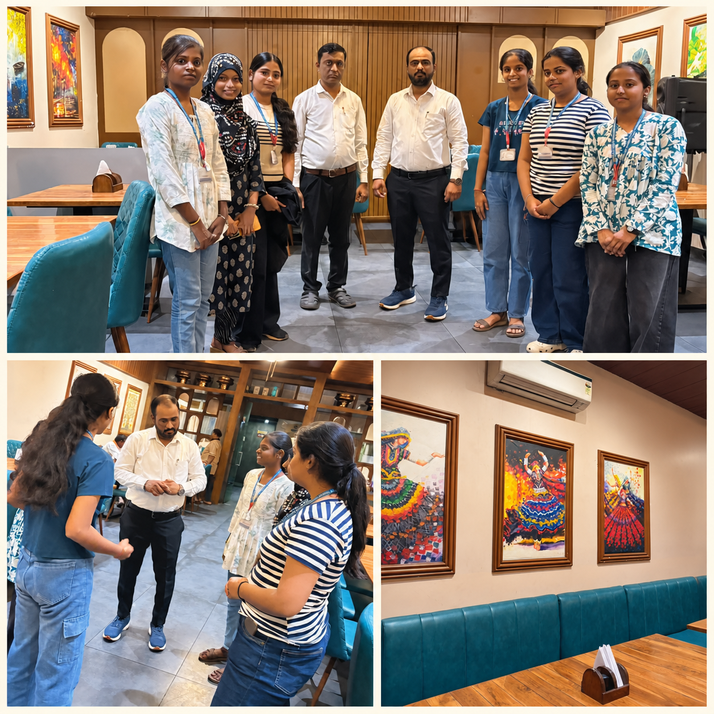

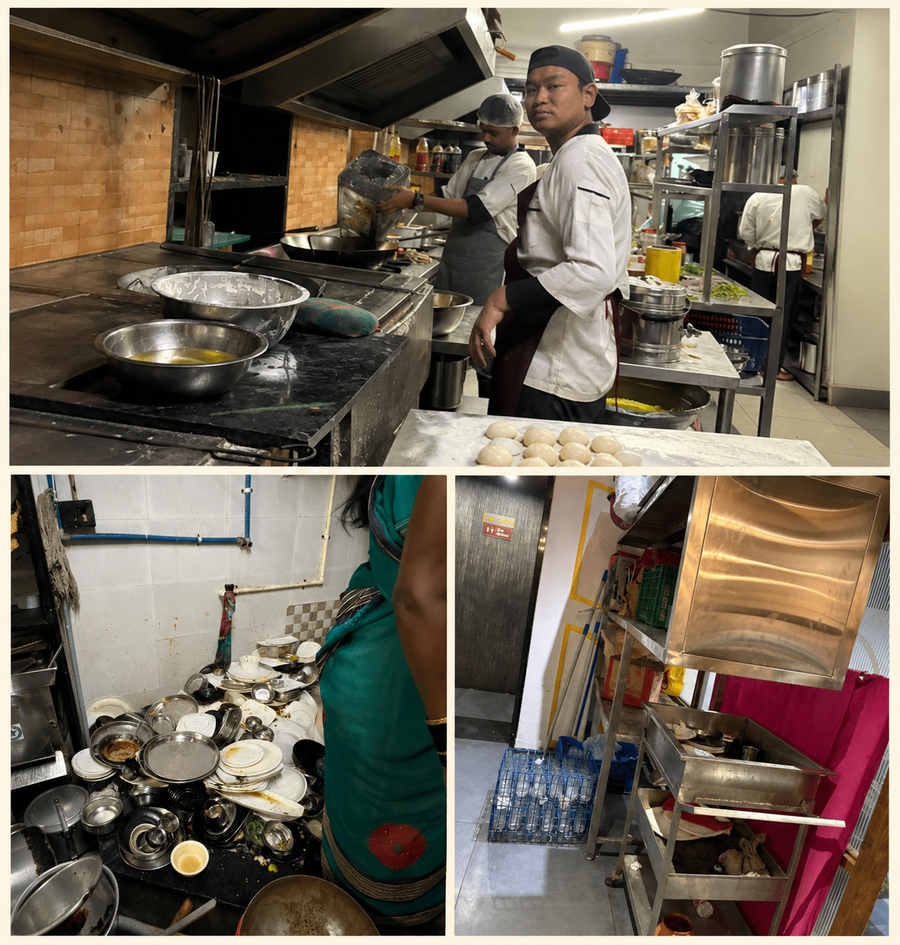

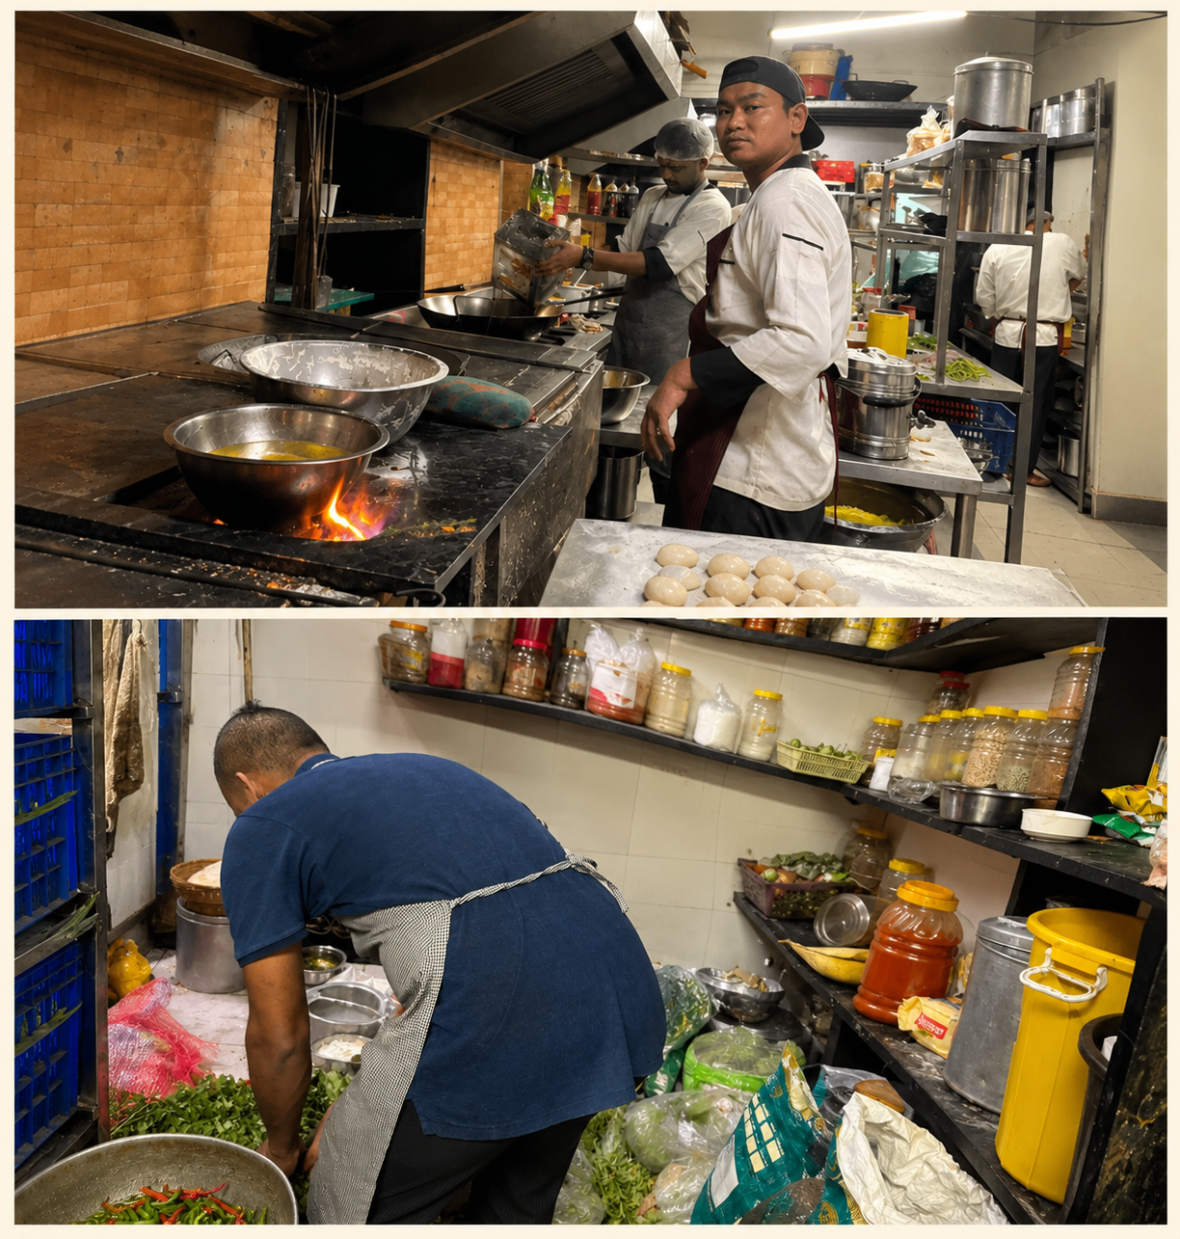

Objectives of the Visit
- To understand daily food preparation and serving practices.
- To learn how staff maintain personal hygiene and kitchen cleanliness.
- To ask how ingredients and cooked food are stored safely.
- To understand how leftover food and kitchen waste are handled.
- To learn how the hotel plans food quantities and reduces unnecessary waste.
- To identify good practices and possible areas for improvement.

Questions Asked to the Hotel Staff

- What steps do you follow to maintain cleanliness in the kitchen and dining area?
- How often are kitchen surfaces, utensils, and equipment cleaned and sanitised?
- What personal hygiene rules must food handlers follow?
- How do you store raw ingredients and cooked food safely?
- How do you check whether ingredients are fresh and safe to use?
- How do you decide how much food to prepare each day?
- What do you do with food that remains unsold at the end of the day?
- How do you manage food scraps, vegetable peels, and other kitchen waste?
- Are wet waste and dry waste collected separately?
- What steps do you take to prevent insects and pests around food and waste areas?
- Does the menu include balanced options such as vegetables, pulses, and other protein sources?
- Do staff receive training or instructions about food safety and hygiene?
Staff

6

TECHNICAL SOLUTIONS ON THE PROBLEM

The following practical measures can help hotels improve nutrition, hygiene, and food-waste management.

1. Standard Operating Procedures (SOPs)
Description: Written procedures explain how food should be received, stored, prepared, cooked, served, and discarded.
Implementation Strategies:
- Prepare simple procedures for food handling, cleaning, and waste disposal.
- Display handwashing and cleaning instructions in suitable work areas.
- Assign responsibilities and review procedures regularly.
Benefits: Improves consistency, clarifies responsibilities, and supports staff training.

2. Personal Hygiene and Staff Training
Description: Staff training explains how personal cleanliness and safe handling prevent contamination.
Implementation Strategies:
- Train staff on proper handwashing and when it is required.
- Require clean uniforms and appropriate hair restraints.
- Explain safe handling practices and procedures for reporting illness.
Benefits: Reduces contamination risks and improves awareness.

3. Safe Food Storage and Temperature Monitoring
Description: Correct storage helps maintain food quality and reduces the growth of harmful microorganisms.
Implementation Strategies:
- Store chilled, frozen, and dry foods under suitable conditions.
- Use thermometers and temperature logs where appropriate.
- Label food and rotate stock using first-in, first-out principles.
Benefits: Helps prevent spoilage, improves stock control, and reduces waste.

7

TECHNICAL SOLUTIONS ON THE PROBLEM (CONTINUED)

4. Prevention of Cross-Contamination
Description: Cross-contamination occurs when harmful microorganisms or allergens transfer between food, surfaces, or utensils.
Implementation Strategies:
- Separate raw food from cooked and ready-to-eat food.
- Clean and sanitise food-contact surfaces between tasks.
- Store chemicals away from ingredients and prepared food.
Benefits: Improves food safety and lowers contamination risks.

5. Nutrition-Focused Menu Planning
Description: Menu planning can provide varied, balanced choices for different customer preferences.
Implementation Strategies:
- Include vegetables, fruits, pulses, grains, and suitable protein sources.
- Offer different cooking methods and avoid relying only on fried options.
- Provide accurate ingredient and allergen information.
Benefits: Helps customers make informed choices and may improve satisfaction.

6. Cleaning, Sanitising, and Pest Control
Description: Routine cleaning and appropriate sanitising maintain hygienic kitchen and dining areas.
Implementation Strategies:
- Prepare a schedule that lists tasks, frequency, and responsible staff.
- Use cleaning products according to label instructions.
- Keep bins covered and remove waste regularly; prevent pest entry.
Benefits: Maintains cleanliness and helps prevent pest problems.

7. Food-Waste Segregation and Disposal
Description: Food waste should be collected and managed in a way that maintains cleanliness and follows local waste-management rules.
Implementation Strategies:
- Provide covered, easy-to-clean bins and empty them regularly.
- Separate wet/biodegradable waste from dry waste according to local requirements.
- Keep waste bins away from food preparation and storage areas.
- Clean waste containers and the surrounding area routinely.
- Send waste for appropriate collection, composting, or other authorised processing where available.
Benefits: Reduces odours and pest attraction, improves cleanliness, and supports responsible waste handling.

8. Food-Waste Prevention and Portion Planning
Description: Preventing food waste helps hotels use ingredients efficiently and reduce avoidable costs.
Implementation Strategies:
- Estimate demand using sales and customer patterns.
- Prepare food in suitable batches instead of making excessive quantities too early.
- Use correct storage and stock rotation to reduce spoilage.
- Offer suitable portion choices where practical and monitor plate waste.
- Record the type and quantity of waste to identify recurring causes.
Benefits: Reduces avoidable waste, supports cost control, and improves planning.

9. Leftover Food Handling
Description: Leftover food must be handled safely. Food that has been held unsafely or may be contaminated must not be reused or served.
Implementation Strategies:
- Follow applicable food-safety rules for cooling, storing, reheating, and holding food.
- Label and track food according to the hotel’s safe procedures.
- Do not mix old leftovers with freshly prepared food.
- Consider donation only when permitted and when safe handling and applicable requirements can be met.
Benefits: Protects customers while helping reduce unnecessary disposal when safe and lawful options exist.
TECHNICAL SOLUTIONS ON THE PROBLEM (CONTINUED)

10. Digital Checklists and Regular Inspection
Description: Paper or digital records help management track hygiene, nutrition-related procedures, and food-waste reduction.
Implementation Strategies:
- Use daily checklists for cleaning, storage temperatures, deliveries, and stock rotation.
- Record approximate food waste by type and the likely reason for it.
- Review customer feedback and staff suggestions.
- Correct problems promptly and follow current local food-safety requirements.
Benefits: Improves accountability, helps identify repeated problems, and supports continuous improvement.

10

AUTHORITY LETTER
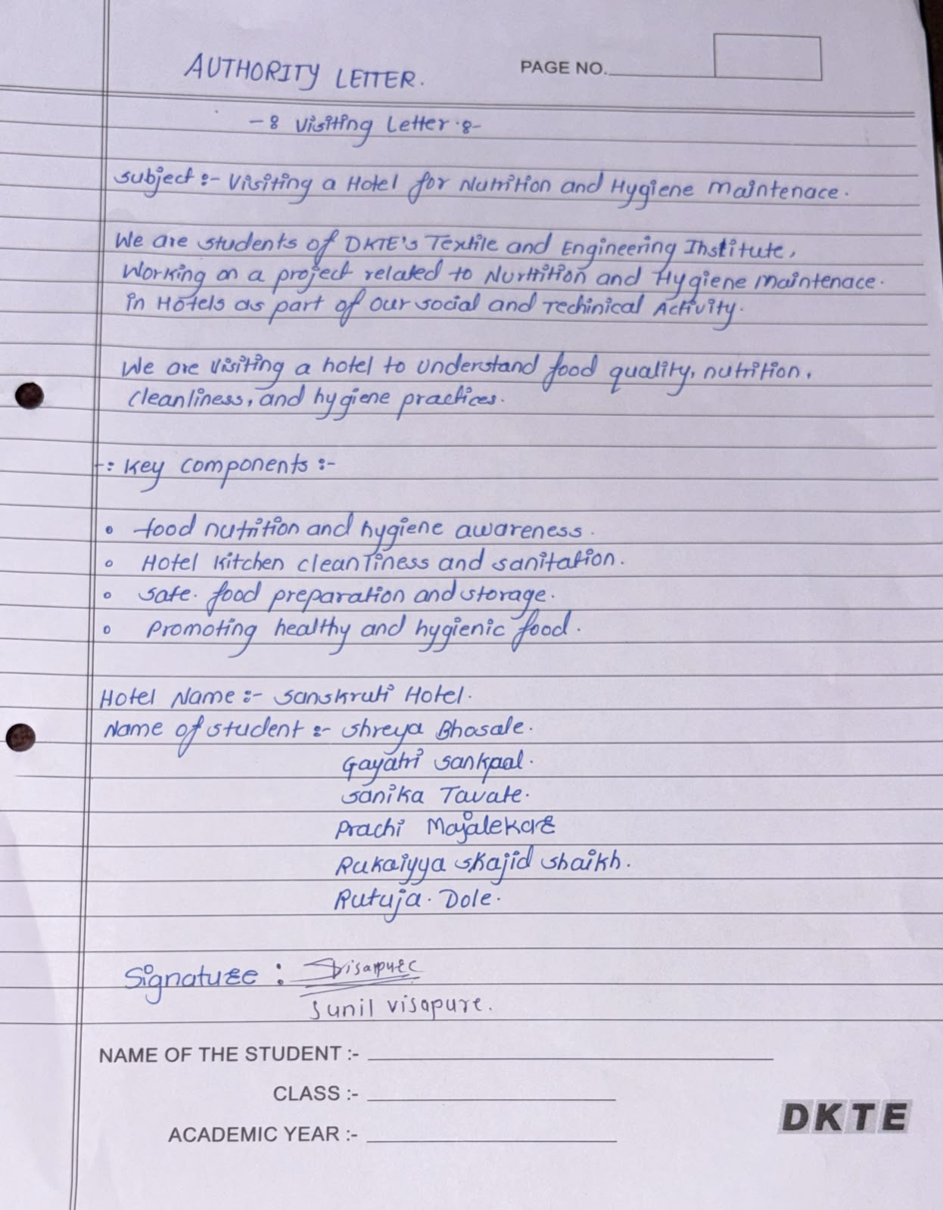

11

CONCLUSION
Nutrition, hygiene, and food-waste management are important for safe and responsible hotel operations. Balanced menu choices support customer well-being, while personal hygiene, safe storage, clean equipment, safe water, and prevention of cross-contamination help protect food safety.
The visit to Sanskruti Hotel in Ichalkaranji was included as the field-visit component of this project. Interaction with staff can help students understand day-to-day procedures and the practical challenges faced in food preparation, cleaning, and waste handling. The specific observations and answers should be recorded from the group’s actual visit.
Hotels can improve their practices through staff training, clear cleaning schedules, stock rotation, safe storage, demand-based food preparation, appropriate portion planning, and correct waste segregation. Food that may be unsafe should never be reused or served, and any reuse or donation must follow relevant food-safety requirements.
Overall, maintaining nutrition and hygiene while reducing avoidable food waste can protect customers, improve cleanliness, reduce unnecessary costs, and strengthen customer confidence. Cooperation among management, kitchen staff, serving staff, suppliers, and waste-collection services is essential for continuous improvement.

12

REFERENCES

Official Guidance / Websites
- Food Safety and Standards Authority of India (FSSAI). Food safety, hygiene, and food business operator guidance. https://www.fssai.gov.in/
- FSSAI. Food Safety Training and Certification (FoSTaC) programme information. https://fostac.fssai.gov.in/
- World Health Organization (WHO). Five Keys to Safer Food Manual. https://www.who.int/
- World Health Organization (WHO). Healthy diet fact sheet. https://www.who.int/news-room/fact-sheets/detail/healthy-diet
- Food and Agriculture Organization of the United Nations (FAO). Food loss and food waste resources. https://www.fao.org/food-loss-and-food-waste/

Additional Reference Material
- Food Safety and Standards Act, 2006, and applicable rules and regulations in India.
- Relevant food-safety and waste-management guidance provided by local authorities and the hotel or restaurant visited.
- Notes and observations recorded during the group’s field visit to Sanskruti Hotel, Ichalkaranji.
- Note: Verify current requirements and complete the report with the actual date of visit and the staff responses recorded by your group.

