**AMAZON POLLY**

Convert text file to speech and store it as MP3 in S3.

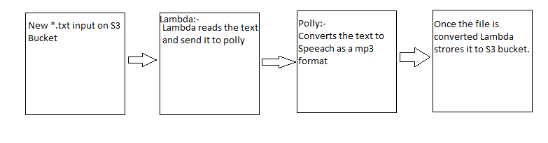

Create a S3 Bucket.

Create Lambda function to Monitor and trigger polly functions.

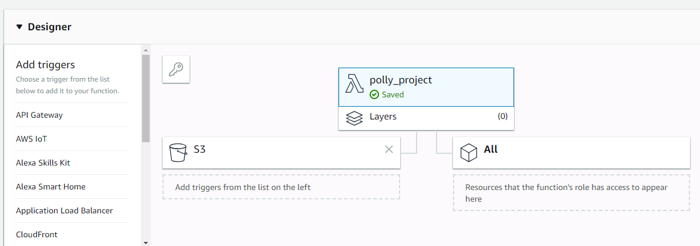

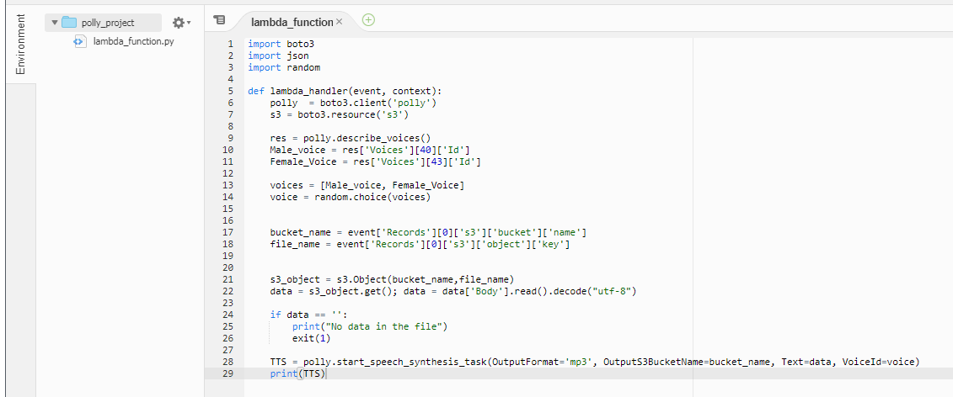

Upload a file text file to S3.

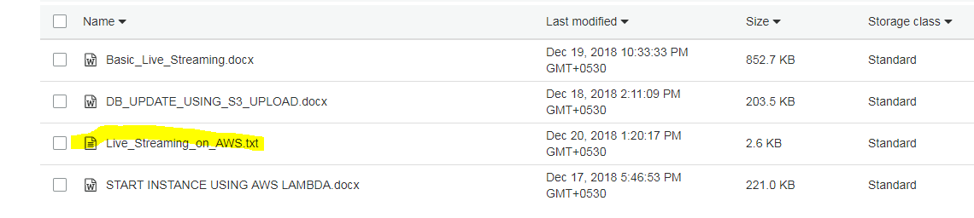

Now in the backend Lambda would fetch the content and create a mp3 in our S3 bucket.

