Myanmar Secondary Data Analysis - Outline

mz

*Table of Contents*

1 Demographic - social, economic; Households - structure, income, vulnerability 1

1.1 2014 Census 1

1.1.1 Population Based Dataset - Township level data 1

1.1.2 Household Based Dataset - Township level data 3

1.1.3 Occupation-Industry 4

1.2 World Population Prospects 5

2 Agricultural - food security, crops, land 5

2.1 International Rice Research Institute 5

3 Appendix 1: Variables 6

*This is a draft outline of the secondary data analysis chapter for the Myanmar ageing farmers report.*

*This is tentative, with placeholders for possible charts/maps, and indication of available variables and datasets.*

# Demographic - social, economic; Households - structure, income, vulnerability

## 2014 Census

The Myanmar Information Managment Unit is a well harmonized online resource for both cleaned up census data and GIS resources to match the administrative levels used in the 2014 census. (MIMU 2014)

### Population Based Dataset - Township level data

There are 330 townships - or rather there were that many in the 2014 census - for each of which almost 280 population aggregate variables are available. The list of variables is at the end of this document.

Figure 1 is just a quick map of all the 330 townships, highlighting the two of special interest, and scatterplot of township level data, with the relevant areas highlighted.

Any of these variables can be mapped, or plotted against eachother, like e.g. the ones in Figure 2.

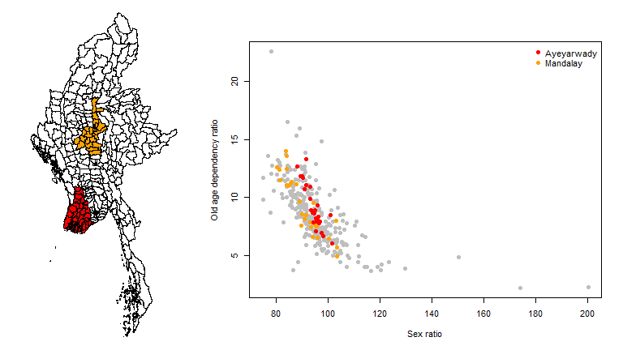

Figure 1 left: Map of 330 Myanmar townships with Mandalay and Ayeyarwady towhnsips highlighted; right: township level ecological correlation between sex ratios and old age (65+) dependency ratios.

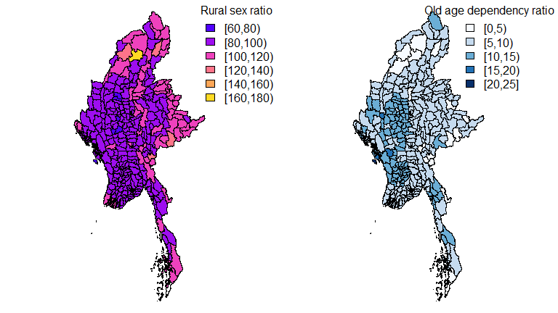

Figure 2: Cloropleth maps of Myanmar at township level (330) - left Sex ratio of rural population, right old age dependency ratio (over 65)

Of course all of these also be zoomed in to just the region of interest, and e.g. Figure 3 shows the cloropleth maps for literacy rates for all the townships in both the states of interest.

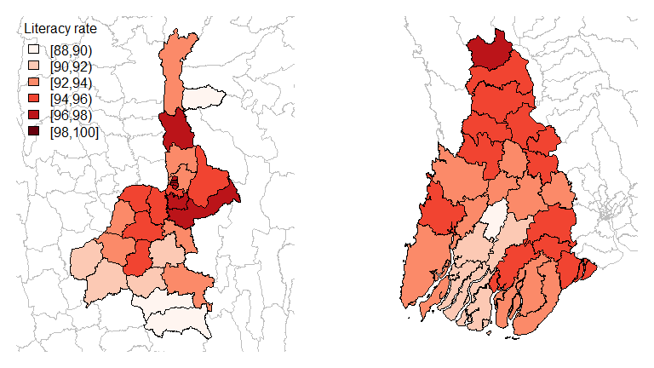

Figure 3: Zoom into Mandalay townships on left (28) and Ayeyarwady townships on the right (26) on single variable - Literacy rate for both sexes

All of these can of course be aggregated up to district and/or state and region levels and mapped or plotted accordingly.

### Household Based Dataset - Township level data

All of this applies to the household level data as well. A list of the variables available is at the end of this document for reference.

Of course a combination is also possible, as for example in Figure 4, which looks at the proportion of female headed households across the 330 townships, and also adds a zoomed map of both the Yangon region and Naypyitaw, and a histograms that let us compare the distribution within each of the regions with the distribution nationally.

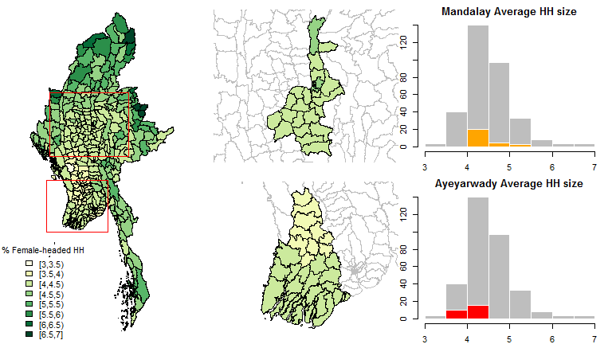

Figure 4: Average size of in 330 townships (left), in Nat Pyi Taw middle top and Yangon middle bottom, along with histograpms showing the relative distirbutions of each region compared to the national one.

### Occupation-Industry

Still using 2014 census data (BaselineData_Census_Occupation_Industry_MIMU_Jan2016) (MIMU 2014) the occupation/industry tables are summarised bellow. Populaiton pyramids, etc. Geography only goes to regional level though, so mapping is limited.

Economic Activity (status):

* 15 Regions
  + age groups - over 10 (14)
    - male/female

Economic Activity (status):

* urban/rural (15)
  + age groups - over 10 (14)

Occupation (9 categories, incl. "skilled agricultural, forestry and fishery workers"):

* urban/rural (15)
  + age groups - over 10 (13)

Occupation (9 categories, incl. "skilled agricultural, forestry and fishery workers"):

* 15 Regions
  + male/female

Industry (16 categories, incl. " Agriculture, forestry and fishing"):

* urban/rural (15)
  + age groups - over 10 (13)

Industry (16 categories, incl. " Agriculture, forestry and fishing"):

* 15 Regions
  + male/female

*e.g. we can do populaiton pyramids with eomployment struture etc with this stuff.*

## World Population Prospects

*For population growth, age composition, dependency ratios etc. estimated 1950-2015, and projected until 2050 as well as urbanisation etc. there is the UN data (UNPD 2015)...*

# Agricultural - food security, crops, land

## International Rice Research Institute

International Rice Research Institute data on trends etc. (IRRI 2016) has statistics on production, yield etc. which can be plotted as trend line charts. List of variables in Appendix

So for example here is rice yeild, export ( acdcording to the USDA and dotted also according to the FAO) and per capita consumption of rice over the whole period:

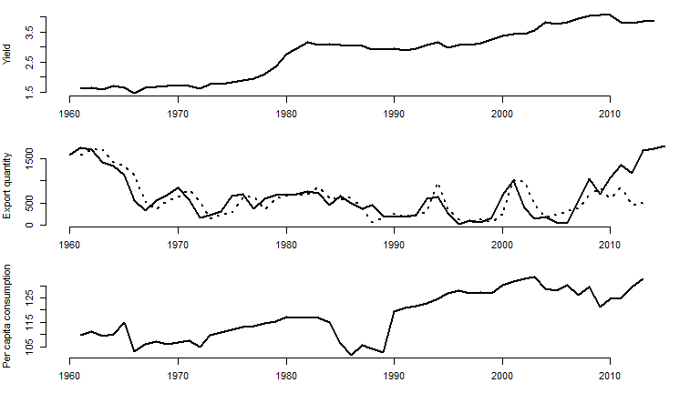

Figure 5: Some IRRI trends: Rice paddy yield (top), export quantitiy (middle) and per capita rice consumption (bottom).

# Appendix 1: Variables

Census population level variable list:

## [1] "MIMU - State/Region Pcode"   
## [2] "MIMU - State/Region Name"   
## [3] "MIMU - District Pcode"   
## [4] "MIMU - District Name"   
## [5] "MIMU - Township Pcode"   
## [6] "MIMU - Township Name"   
## [7] "Total population - Both sexes"   
## [8] "Total population - Male"   
## [9] "Total population - Female"   
## [10] "Total population - Sex ratio"   
## [11] " Population in conventional households - Both sexes"   
## [12] " Population in conventional households - Male"   
## [13] " Population in conventional households - Female"   
## [14] "Population in institutions - Both sexes"   
## [15] "Population in institutions - Male"   
## [16] "Population in institutions - Female"   
## [17] "Urban population - Both sexes"   
## [18] "Urban population - Male"   
## [19] "Urban population - Female"   
## [20] "Urban population - Sex ratio"   
## [21] "Rural population - Both sexes"   
## [22] "Rural population - Male"   
## [23] "Rural population - Female"   
## [24] "Rural population - Sex ratio"   
## [25] "Rural population - Urban population (%)"   
## [26] "Selected age groups and dependency ratios - 0 - 14"   
## [27] "Selected age groups and dependency ratios - 15 - 64"   
## [28] "Selected age groups and dependency ratios - 65+"   
## [29] "Selected age groups and dependency ratios - Total dependency ratio"   
## [30] "Selected age groups and dependency ratios - Child dependency ratio"   
## [31] "Selected age groups and dependency ratios - Old dependency ratio"   
## [32] "Selected age groups and dependency ratios - 10 - 17"   
## [33] "Selected age groups and dependency ratios - 18+"   
## [34] "Marital status for both sex (15 year and above) - Total"   
## [35] "Marital status for both sex (15 year and above) - Single"   
## [36] "Marital status for both sex (15 year and above) - Married"   
## [37] "Marital status for both sex (15 year and above) - Widowed"   
## [38] "Marital status for both sex (15 year and above) - Divorced/ Separated"   
## [39] "Marital status for both sex (15 year and above) - Renounced"   
## [40] "Marital status for male (15 year and above) - Total"   
## [41] "Marital status for male (15 year and above) - Single"   
## [42] "Marital status for male (15 year and above) - Married"   
## [43] "Marital status for male (15 year and above) - Widowed"   
## [44] "Marital status for male (15 year and above) - Divorced/ Separated"   
## [45] "Marital status for male (15 year and above) - Renounced"   
## [46] "Marital status for female (15 year and above) - Total"   
## [47] "Marital status for female (15 year and above) - Single"   
## [48] "Marital status for female (15 year and above) - Married"   
## [49] "Marital status for female (15 year and above) - Widowed"   
## [50] "Marital status for female (15 year and above) - Divorced/ Separated"   
## [51] "Marital status for female (15 year and above) - Renounced"   
## [52] "Both sexes (Total 15 year and above) - Total"   
## [53] "Both sexes (Total 15 year and above) - Literate"   
## [54] "Both sexes (Total 15 year and above) - Illiterate"   
## [55] "Both sexes (Total 15 year and above) - % literate"   
## [56] "Male (Total 15 year and above) - Total"   
## [57] "Male (Total 15 year and above) - Literate"   
## [58] "Male (Total 15 year and above) - Illiterate"   
## [59] "Male (Total 15 year and above) - % literate"   
## [60] "Female (Total 15 year and above) - Total"   
## [61] "Female (Total 15 year and above) - Literate"   
## [62] "Female (Total 15 year and above) - Illiterate"   
## [63] "Female (Total 15 year and above) - % literate"   
## [64] "Urban Both sexes (Total 15 year and above) - Total"   
## [65] "Urban Both sexes (Total 15 year and above) - Literate"   
## [66] "Urban Both sexes (Total 15 year and above) - Illiterate"   
## [67] "Urban Both sexes (Total 15 year and above) - % literate"   
## [68] "Urban Male (Total 15 year and above) - Total"   
## [69] "Urban Male (Total 15 year and above) - Literate"   
## [70] "Urban Male (Total 15 year and above) - Illiterate"   
## [71] "Urban Male (Total 15 year and above) - % literate"   
## [72] "Urban Female (Total 15 year and above) - Total"   
## [73] "Urban Female (Total 15 year and above) - Literate"   
## [74] "Urban Female (Total 15 year and above) - Illiterate"   
## [75] "Urban Female (Total 15 year and above) - % literate"   
## [76] "Rural Both sexes (Total 15 year and above) - Total"   
## [77] "Rural Both sexes (Total 15 year and above) - Literate"   
## [78] "Rural Both sexes (Total 15 year and above) - Illiterate"   
## [79] "Rural Both sexes (Total 15 year and above) - % literate"   
## [80] "Rural Male (Total 15 year and above) - Total"   
## [81] "Rural Male (Total 15 year and above) - Literate"   
## [82] "Rural Male (Total 15 year and above) - Illiterate"   
## [83] "Rural Male (Total 15 year and above) - % literate"   
## [84] "Rural Female (Total 15 year and above) - Total"   
## [85] "Rural Female (Total 15 year and above) - Literate"   
## [86] "Rural Female (Total 15 year and above) - Illiterate"   
## [87] "Rural Female (Total 15 year and above) - % literate"   
## [88] "Both sexes, 5 - 29 years school/college attendance - Total"   
## [89] "Both sexes, 5 - 29 years school/college attendance - Currently attending"   
## [90] "Both sexes, 5 - 29 years school/college attendance - Attended previously"   
## [91] "Both sexes, 5 - 29 years school/college attendance - Never attended"   
## [92] "Male, 5 - 29 years school/college attendance - Total"   
## [93] "Male, 5 - 29 years school/college attendance - Currently attending"   
## [94] "Male, 5 - 29 years school/college attendance - Attended previously"   
## [95] "Male, 5 - 29 years school/college attendance - Never attended"   
## [96] "Female, 5 - 29 years school/college attendance - Total"   
## [97] "Female, 5 - 29 years school/college attendance - Currently attending"   
## [98] "Female, 5 - 29 years school/college attendance - Attended previously"   
## [99] "Female, 5 - 29 years school/college attendance - Never attended"   
## [100] "Both Sex, 25 years and over by highest level of education completed (both households and institutions) - Total"   
## [101] "Both Sex, 25 years and over by highest level of education completed (both households and institutions) - None"   
## [102] "Both Sex, 25 years and over by highest level of education completed (both households and institutions) - Primary school (grade 1 - 5)"  
## [103] "Both Sex, 25 years and over by highest level of education completed (both households and institutions) - Middle school (grade 6 - 9)"   
## [104] "Both Sex, 25 years and over by highest level of education completed (both households and institutions) - High school (grade 10 - 11)"   
## [105] "Both Sex, 25 years and over by highest level of education completed (both households and institutions) - Diploma"   
## [106] "Both Sex, 25 years and over by highest level of education completed (both households and institutions) - University/ College"   
## [107] "Both Sex, 25 years and over by highest level of education completed (both households and institutions) - Post-graduate and above"   
## [108] "Both Sex, 25 years and over by highest level of education completed (both households and institutions) - Vocational training"   
## [109] "Both Sex, 25 years and over by highest level of education completed (both households and institutions) - Other"   
## [110] "Male, 25 years and over by highest level of education completed (both households and institutions) - Total"   
## [111] "Male, 25 years and over by highest level of education completed (both households and institutions) - None"   
## [112] "Male, 25 years and over by highest level of education completed (both households and institutions) - Primary school (grade 1 - 5)"   
## [113] "Male, 25 years and over by highest level of education completed (both households and institutions) - Middle school (grade 6 - 9)"   
## [114] "Male, 25 years and over by highest level of education completed (both households and institutions) - High school (grade 10 - 11)"   
## [115] "Male, 25 years and over by highest level of education completed (both households and institutions) - Diploma"   
## [116] "Male, 25 years and over by highest level of education completed (both households and institutions) - University/ College"   
## [117] "Male, 25 years and over by highest level of education completed (both households and institutions) - Post-graduate and above"   
## [118] "Male, 25 years and over by highest level of education completed (both households and institutions) - Vocational training"   
## [119] "Male, 25 years and over by highest level of education completed (both households and institutions) - Other"   
## [120] "Female, 25 years and over by highest level of education completed (both households and institutions) - Total"   
## [121] "Female, 25 years and over by highest level of education completed (both households and institutions) - None"   
## [122] "Female, 25 years and over by highest level of education completed (both households and institutions) - Primary school (grade 1 - 5)"   
## [123] "Female, 25 years and over by highest level of education completed (both households and institutions) - Middle school (grade 6 - 9)"   
## [124] "Female, 25 years and over by highest level of education completed (both households and institutions) - High school (grade 10 - 11)"   
## [125] "Female, 25 years and over by highest level of education completed (both households and institutions) - Diploma"   
## [126] "Female, 25 years and over by highest level of education completed (both households and institutions) - University/ College"   
## [127] "Female, 25 years and over by highest level of education completed (both households and institutions) - Post-graduate and above"   
## [128] "Female, 25 years and over by highest level of education completed (both households and institutions) - Vocational training"   
## [129] "Female, 25 years and over by highest level of education completed (both households and institutions) - Other"   
## [130] "Both Sex, 25 years and over by highest level of education completed (in conventional households ) - Total"   
## [131] "Both Sex, 25 years and over by highest level of education completed (in conventional households ) - None"   
## [132] "Both Sex, 25 years and over by highest level of education completed (in conventional households ) - Primary school (grade 1 - 5)"   
## [133] "Both Sex, 25 years and over by highest level of education completed (in conventional households ) - Middle school (grade 6 - 9)"   
## [134] "Both Sex, 25 years and over by highest level of education completed (in conventional households ) - High school (grade 10 - 11)"   
## [135] "Both Sex, 25 years and over by highest level of education completed (in conventional households ) - Diploma"   
## [136] "Both Sex, 25 years and over by highest level of education completed (in conventional households ) - University/ College"   
## [137] "Both Sex, 25 years and over by highest level of education completed (in conventional households ) - Post-graduate and above"   
## [138] "Both Sex, 25 years and over by highest level of education completed (in conventional households ) - Vocational training"   
## [139] "Both Sex, 25 years and over by highest level of education completed (in conventional households ) - Other"   
## [140] "Male, 25 years and over by highest level of education completed (in conventional households ) - Total"   
## [141] "Male, 25 years and over by highest level of education completed (in conventional households ) - None"   
## [142] "Male, 25 years and over by highest level of education completed (in conventional households ) - Primary school (grade 1 - 5)"   
## [143] "Male, 25 years and over by highest level of education completed (in conventional households ) - Middle school (grade 6 - 9)"   
## [144] "Male, 25 years and over by highest level of education completed (in conventional households ) - High school (grade 10 - 11)"   
## [145] "Male, 25 years and over by highest level of education completed (in conventional households ) - Diploma"   
## [146] "Male, 25 years and over by highest level of education completed (in conventional households ) - University/ College"   
## [147] "Male, 25 years and over by highest level of education completed (in conventional households ) - Post-graduate and above"   
## [148] "Male, 25 years and over by highest level of education completed (in conventional households ) - Vocational training"   
## [149] "Male, 25 years and over by highest level of education completed (in conventional households ) - Other"   
## [150] "Female, 25 years and over by highest level of education completed (in conventional households ) - Total"   
## [151] "Female, 25 years and over by highest level of education completed (in conventional households ) - None"   
## [152] "Female, 25 years and over by highest level of education completed (in conventional households ) - Primary school (grade 1 - 5)"   
## [153] "Female, 25 years and over by highest level of education completed (in conventional households ) - Middle school (grade 6 - 9)"   
## [154] "Female, 25 years and over by highest level of education completed (in conventional households ) - High school (grade 10 - 11)"   
## [155] "Female, 25 years and over by highest level of education completed (in conventional households ) - Diploma"   
## [156] "Female, 25 years and over by highest level of education completed (in conventional households ) - University/ College"   
## [157] "Female, 25 years and over by highest level of education completed (in conventional households ) - Post-graduate and above"   
## [158] "Female, 25 years and over by highest level of education completed (in conventional households ) - Vocational training"   
## [159] "Female, 25 years and over by highest level of education completed (in conventional households ) - Other"   
## [160] "Both Sex, 25 years and over by highest level of education completed (in institutions) - Total"   
## [161] "Both Sex, 25 years and over by highest level of education completed (in institutions) - None"   
## [162] "Both Sex, 25 years and over by highest level of education completed (in institutions) - Primary school (grade 1 - 5)"   
## [163] "Both Sex, 25 years and over by highest level of education completed (in institutions) - Middle school (grade 6 - 9)"   
## [164] "Both Sex, 25 years and over by highest level of education completed (in institutions) - High school (grade 10 - 11)"   
## [165] "Both Sex, 25 years and over by highest level of education completed (in institutions) - Diploma"   
## [166] "Both Sex, 25 years and over by highest level of education completed (in institutions) - University/ College"   
## [167] "Both Sex, 25 years and over by highest level of education completed (in institutions) - Post-graduate and above"   
## [168] "Both Sex, 25 years and over by highest level of education completed (in institutions) - Vocational training"   
## [169] "Both Sex, 25 years and over by highest level of education completed (in institutions) - Other"   
## [170] "Male, 25 years and over by highest level of education completed (in institutions) - Total"   
## [171] "Male, 25 years and over by highest level of education completed (in institutions) - None"   
## [172] "Male, 25 years and over by highest level of education completed (in institutions) - Primary school (grade 1 - 5)"   
## [173] "Male, 25 years and over by highest level of education completed (in institutions) - Middle school (grade 6 - 9)"   
## [174] "Male, 25 years and over by highest level of education completed (in institutions) - High school (grade 10 - 11)"   
## [175] "Male, 25 years and over by highest level of education completed (in institutions) - Diploma"   
## [176] "Male, 25 years and over by highest level of education completed (in institutions) - University/ College"   
## [177] "Male, 25 years and over by highest level of education completed (in institutions) - Post-graduate and above"   
## [178] "Male, 25 years and over by highest level of education completed (in institutions) - Vocational training"   
## [179] "Male, 25 years and over by highest level of education completed (in institutions) - Other"   
## [180] "Female, 25 years and over by highest level of education completed (in institutions) - Total"   
## [181] "Female, 25 years and over by highest level of education completed (in institutions) - None"   
## [182] "Female, 25 years and over by highest level of education completed (in institutions) - Primary school (grade 1 - 5)"   
## [183] "Female, 25 years and over by highest level of education completed (in institutions) - Middle school (grade 6 - 9)"   
## [184] "Female, 25 years and over by highest level of education completed (in institutions) - High school (grade 10 - 11)"   
## [185] "Female, 25 years and over by highest level of education completed (in institutions) - Diploma"   
## [186] "Female, 25 years and over by highest level of education completed (in institutions) - University/ College"   
## [187] "Female, 25 years and over by highest level of education completed (in institutions) - Post-graduate and above"   
## [188] "Female, 25 years and over by highest level of education completed (in institutions) - Vocational training"   
## [189] "Female, 25 years and over by highest level of education completed (in institutions) - Other"   
## [190] "Bothe Sex, 10 years abnd over by Usual activity status - Total"   
## [191] "Bothe Sex, 10 years abnd over by Usual activity status - Employee (government)"   
## [192] "Bothe Sex, 10 years abnd over by Usual activity status - Employee (private)"   
## [193] "Bothe Sex, 10 years abnd over by Usual activity status - Employer"   
## [194] "Bothe Sex, 10 years abnd over by Usual activity status - Own account worker"   
## [195] "Bothe Sex, 10 years abnd over by Usual activity status - Unpaid family worker"   
## [196] "Bothe Sex, 10 years abnd over by Usual activity status - Sought work"   
## [197] "Bothe Sex, 10 years abnd over by Usual activity status - Did not seek work"   
## [198] "Bothe Sex, 10 years abnd over by Usual activity status - Full time student"   
## [199] "Bothe Sex, 10 years abnd over by Usual activity status - Household worker"   
## [200] "Bothe Sex, 10 years abnd over by Usual activity status - Pensioner, retired, elderly"   
## [201] "Bothe Sex, 10 years abnd over by Usual activity status - Ill, disabled"   
## [202] "Bothe Sex, 10 years abnd over by Usual activity status - Other"   
## [203] "Male, 10 years abnd over by Usual activity status - Total"   
## [204] "Male, 10 years abnd over by Usual activity status - Employee (government)"   
## [205] "Male, 10 years abnd over by Usual activity status - Employee (private)"   
## [206] "Male, 10 years abnd over by Usual activity status - Employer"   
## [207] "Male, 10 years abnd over by Usual activity status - Own account worker"   
## [208] "Male, 10 years abnd over by Usual activity status - Unpaid family worker"   
## [209] "Male, 10 years abnd over by Usual activity status - Sought work"   
## [210] "Male, 10 years abnd over by Usual activity status - Did not seek work"   
## [211] "Male, 10 years abnd over by Usual activity status - Full time student"   
## [212] "Male, 10 years abnd over by Usual activity status - Household worker"   
## [213] "Male, 10 years abnd over by Usual activity status - Pensioner, retired, elderly"   
## [214] "Male, 10 years abnd over by Usual activity status - Ill, disabled"   
## [215] "Male, 10 years abnd over by Usual activity status - Other"   
## [216] "Female, 10 years abnd over by Usual activity status - Total"   
## [217] "Female, 10 years abnd over by Usual activity status - Employee (government)"   
## [218] "Female, 10 years abnd over by Usual activity status - Employee (private)"   
## [219] "Female, 10 years abnd over by Usual activity status - Employer"   
## [220] "Female, 10 years abnd over by Usual activity status - Own account worker"   
## [221] "Female, 10 years abnd over by Usual activity status - Unpaid family worker"   
## [222] "Female, 10 years abnd over by Usual activity status - Sought work"   
## [223] "Female, 10 years abnd over by Usual activity status - Did not seek work"   
## [224] "Female, 10 years abnd over by Usual activity status - Full time student"   
## [225] "Female, 10 years abnd over by Usual activity status - Household worker"   
## [226] "Female, 10 years abnd over by Usual activity status - Pensioner, retired, elderly"   
## [227] "Female, 10 years abnd over by Usual activity status - Ill, disabled"   
## [228] "Female, 10 years abnd over by Usual activity status - Other"   
## [229] "Identity card, 10 year and over in total - Total"   
## [230] "Identity card, 10 year and over in total - Citizenship Scrutiny Card"   
## [231] "Identity card, 10 year and over in total - Associate Scrutiny Card"   
## [232] "Identity card, 10 year and over in total - Naturalised Scrutiny Card"   
## [233] "Identity card, 10 year and over in total - National Registration Card"   
## [234] "Identity card, 10 year and over in total - Religious Card"   
## [235] "Identity card, 10 year and over in total - Temporary Registration Card"   
## [236] "Identity card, 10 year and over in total - Foreign Registration Card"   
## [237] "Identity card, 10 year and over in total - Foreign Passport"   
## [238] "Identity card, 10 year and over in total - None"   
## [239] "Identity card, 10 year and over in Urban - Total"   
## [240] "Identity card, 10 year and over in Urban - Citizenship Scrutiny Card"   
## [241] "Identity card, 10 year and over in Urban - Associate Scrutiny Card"   
## [242] "Identity card, 10 year and over in Urban - Naturalised Scrutiny Card"   
## [243] "Identity card, 10 year and over in Urban - National Registration Card"   
## [244] "Identity card, 10 year and over in Urban - Religious Card"   
## [245] "Identity card, 10 year and over in Urban - Temporary Registration Card"   
## [246] "Identity card, 10 year and over in Urban - Foreign Registration Card"   
## [247] "Identity card, 10 year and over in Urban - Foreign Passport"   
## [248] "Identity card, 10 year and over in Urban - None"   
## [249] "Identity card, 10 year and over in Rural - Total"   
## [250] "Identity card, 10 year and over in Rural - Citizenship Scrutiny Card"   
## [251] "Identity card, 10 year and over in Rural - Associate Scrutiny Card"   
## [252] "Identity card, 10 year and over in Rural - Naturalised Scrutiny Card"   
## [253] "Identity card, 10 year and over in Rural - National Registration Card"   
## [254] "Identity card, 10 year and over in Rural - Religious Card"   
## [255] "Identity card, 10 year and over in Rural - Temporary Registration Card"   
## [256] "Identity card, 10 year and over in Rural - Foreign Registration Card"   
## [257] "Identity card, 10 year and over in Rural - Foreign Passport"   
## [258] "Identity card, 10 year and over in Rural - None"   
## [259] "Total population (Both Sex) Total population (Both Sex) - Total"   
## [260] "Total population (Both Sex) Total population (Both Sex) - Not disabled"   
## [261] "Total population (Both Sex) Total population (Both Sex) - With any of 4 disabilities"   
## [262] "Total population (Both Sex) Total population (Both Sex) - Disability prevalence rate (%)"   
## [263] "Type of disability (Both Sex) Type of disability (Both Sex) - Seeing"   
## [264] "Type of disability (Both Sex) Type of disability (Both Sex) - Hearing"   
## [265] "Type of disability (Both Sex) Type of disability (Both Sex) - Walking"   
## [266] "Type of disability (Both Sex) Type of disability (Both Sex) - Remembering"   
## [267] "Total population (Male) Total population (Male) - Total"   
## [268] "Total population (Male) Total population (Male) - Not disabled"   
## [269] "Total population (Male) Total population (Male) - With any of 4 disabilities"   
## [270] "Total population (Male) Total population (Male) - Disability prevalence rate (%)"   
## [271] "Type of disability (Male) Type of disability (Male) - Seeing"   
## [272] "Type of disability (Male) Type of disability (Male) - Hearing"   
## [273] "Type of disability (Male) Type of disability (Male) - Walking"   
## [274] "Type of disability (Male) Type of disability (Male) - Remembering"   
## [275] "Total population (Female) Total population (Female) - Total"   
## [276] "Total population (Female) Total population (Female) - Not disabled"   
## [277] "Total population (Female) Total population (Female) - With any of 4 disabilities"   
## [278] "Total population (Female) Total population (Female) - Disability prevalence rate (%)"   
## [279] "Type of disability (Female) Type of disability (Female) - Seeing"   
## [280] "Type of disability (Female) Type of disability (Female) - Hearing"   
## [281] "Type of disability (Female) Type of disability (Female) - Walking"   
## [282] "Type of disability (Female) Type of disability (Female) - Remembering"

Census household level variable list:

## [1] "MIMU - State/Region Pcode"   
## [2] "MIMU - State/Region Name"   
## [3] "MIMU - District Pcode"   
## [4] "MIMU - District Name"   
## [5] "MIMU - Township Pcode"   
## [6] "MIMU - Township Name"   
## [7] "Conventional households - Number"   
## [8] "Conventional households - Male- headed"   
## [9] "Conventional households - Female- headed"   
## [10] "Conventional households - Female- headed households (%)"   
## [11] "Population in .... - Conventional households"   
## [12] "Population in .... - Institutions"   
## [13] "Mean household size"   
## [14] "Households consisting of: - 1 person"   
## [15] "Households consisting of: - 2 persons"   
## [16] "Households consisting of: - 3 persons"   
## [17] "Households consisting of: - 4 persons"   
## [18] "Households consisting of: - 5 persons"   
## [19] "Households consisting of: - 6 persons"   
## [20] "Households consisting of: - 7 persons"   
## [21] "Households consisting of: - 8 persons"   
## [22] "Households consisting of: - 9 and more"   
## [23] "Type of housing unit - Total"   
## [24] "Type of housing unit - Apartment/ Condominium"   
## [25] "Type of housing unit - Bungalow/ Brick house"   
## [26] "Type of housing unit - Semi-pacca house"   
## [27] "Type of housing unit - Wooden house"   
## [28] "Type of housing unit - Bamboo"   
## [29] "Type of housing unit - Hut 2 - 3 years"   
## [30] "Type of housing unit - Hut 1 year"   
## [31] "Type of housing unit - Other"   
## [32] "Type of ownership - Total"   
## [33] "Type of ownership - Owner"   
## [34] "Type of ownership - Renter"   
## [35] "Type of ownership - Provided free (individually)"   
## [36] "Type of ownership - Government Quarters"   
## [37] "Type of ownership - Private Company Quarters"   
## [38] "Type of ownership - Other"   
## [39] "Type of toilet - Total"   
## [40] "Type of toilet - Flush"   
## [41] "Type of toilet - Water seal (Improved pit latrine)"   
## [42] "Type of toilet - Safe sanitation (%)"   
## [43] "Type of toilet - Pit (Traditional pit latrine)"   
## [44] "Type of toilet - Bucket (Surface latrine)"   
## [45] "Type of toilet - Other"   
## [46] "Type of toilet - None"   
## [47] "Roof - Total"   
## [48] "Roof - Dhani/Theke/ In leaf"   
## [49] "Roof - Bamboo"   
## [50] "Roof - Wood"   
## [51] "Roof - Corrugated sheet"   
## [52] "Roof - Tile/Brick/ Concrete"   
## [53] "Roof - Other"   
## [54] "Walls - Total"   
## [55] "Walls - Dhani/Theke/ In leaf"   
## [56] "Walls - Bamboo"   
## [57] "Walls - Earth"   
## [58] "Walls - Wood"   
## [59] "Walls - Corrugated sheet"   
## [60] "Walls - Tile/Brick/ Concrete"   
## [61] "Walls - Other"   
## [62] "Floors - Total"   
## [63] "Floors - Bamboo"   
## [64] "Floors - Earth"   
## [65] "Floors - Wood"   
## [66] "Floors - Tile/Brick/ Concrete"   
## [67] "Floors - Other"   
## [68] "Source of lighting - Total"   
## [69] "Source of lighting - Electricity"   
## [70] "Source of lighting - Kerosene"   
## [71] "Source of lighting - Candle"   
## [72] "Source of lighting - Battery"   
## [73] "Source of lighting - Generator (private)"   
## [74] "Source of lighting - Water mill (private)"   
## [75] "Source of lighting - Solar system/energy"   
## [76] "Source of lighting - Other"   
## [77] "Source of drinking water - Total"   
## [78] "Source of drinking water - Tap water/ Piped"   
## [79] "Source of drinking water - Tube well, borehole"   
## [80] "Source of drinking water - Protected well/ Spring"   
## [81] "Source of drinking water - Unprotected well/Spring"   
## [82] "Source of drinking water - Pool/Pond/ Lake"   
## [83] "Source of drinking water - River/stream/ canal"   
## [84] "Source of drinking water - Waterfall/ Rain water"   
## [85] "Source of drinking water - Bottled water/ Water purifier"   
## [86] "Source of drinking water - Tanker/ Truck"   
## [87] "Source of drinking water - Other"   
## [88] "Source of non-drinking water - Total"   
## [89] "Source of non-drinking water - Tap water/ Piped"   
## [90] "Source of non-drinking water - Tube well, borehole"   
## [91] "Source of non-drinking water - Protected well/ Spring"   
## [92] "Source of non-drinking water - Unprotected well/Spring"   
## [93] "Source of non-drinking water - Pool/Pond/ Lake"   
## [94] "Source of non-drinking water - River/stream/ canal"   
## [95] "Source of non-drinking water - Waterfall/ Rain water"   
## [96] "Source of non-drinking water - Bottled water/ Water purifier"   
## [97] "Source of non-drinking water - Tanker/ Truck"   
## [98] "Source of non-drinking water - Other"   
## [99] "Type of cooking fuel - Total"   
## [100] "Type of cooking fuel - Electricity"   
## [101] "Type of cooking fuel - LPG"   
## [102] "Type of cooking fuel - Kerosene"   
## [103] "Type of cooking fuel - BioGas"   
## [104] "Type of cooking fuel - Firewood"   
## [105] "Type of cooking fuel - Charcoal"   
## [106] "Type of cooking fuel - Coal"   
## [107] "Type of cooking fuel - Straw/Grass"   
## [108] "Type of cooking fuel - Other"   
## [109] "Availability of communication and related amenities - Conventional households"  
## [110] "Availability of communication and related amenities - Radio"   
## [111] "Availability of communication and related amenities - Television"   
## [112] "Availability of communication and related amenities - Land line phone"   
## [113] "Availability of communication and related amenities - Mobile phone"   
## [114] "Availability of communication and related amenities - Computer"   
## [115] "Availability of communication and related amenities - Internet at home"   
## [116] "Availability of of transportation items - Conventional households"   
## [117] "Availability of of transportation items - Car/Truck/ Van"   
## [118] "Availability of of transportation items - Motorcycle/ Moped"   
## [119] "Availability of of transportation items - Bicycle"   
## [120] "Availability of of transportation items - 4-Wheel tractor"   
## [121] "Availability of of transportation items - Canoe/Boat"   
## [122] "Availability of of transportation items - Motor boat"   
## [123] "Availability of of transportation items - Cart (bullock)"

IRRI variable list

## [1] ARABLE LAND BEGINNING STOCK - MILLED RICE   
## [3] BROKEN RICE CONSUMER PRICE INDEX   
## [5] DRAFT ANIMALS ENDING STOCK - MILLED RICE   
## [7] EXPORT QUANTITY EXPORT VALUE   
## [9] FARM HARVEST PRICE - PADDY FEED - MILLED RICE   
## [11] FERTILIZER CONSUMPTION FOOD - MILLED RICE   
## [13] HARVESTED AREA HARVESTERS-THRESHERS   
## [15] HUSKED OR BROWN RICE IMPORT QUANTITY   
## [17] IMPORT VALUE LAND AREA   
## [19] MV AREA OFFICIAL EXCHANGE RATE   
## [21] OTHERS USES - MILLED RICE PROCESSED - MILLED RICE   
## [23] PRODUCTION - MILLED RICE PRODUCTION - PADDY   
## [25] RICE (NO TYPE) RICE CALORIE INTAKE   
## [27] RICE CALORIE INTAKE PER CAPITA RICE CONSUMPTION PER CAPITA   
## [29] RICE FAT INTAKE RICE PROTEIN INTAKE   
## [31] SEED - MILLED RICE EQUIVALENT SEMI-MILLED RICE   
## [33] STOCK CHANGE - MILLED RICE TOTAL CONSUMPTION - MILLED RICE  
## [35] TRACTORS WASTE - MILLED RICE   
## [37] YIELD - PADDY   
## 37 Levels: ARABLE LAND BEGINNING STOCK - MILLED RICE ... YIELD - PADDY

##### References

IRRI. 2016. “World Rice Statistics.” <http://ricestat.irri.org:8080/wrsv3/entrypoint.htm>.

MIMU. 2014. “The 2014 Myanmar Population and Housing Census.” <http://www.themimu.info/census-data>.

UNPD. 2015. “World Population Prospects.”