**Don’t mind the gap**

For the last year, British organisations with over 250 employees have been uploading their *gender pay gap* figures onto a [government data platform,](https://gender-pay-gap.service.gov.uk/) free for all to see. This data accumulation has sped up in the past weeks, with the deadline for public sector organisations having just passed this holiday weekend, while private companies have until April 5 to submit their data—or face *unlimited fines*.

These openly available data have been of considerable interest to journalists and the public, who have been analysing the numbers more or less thoughtfully (if they got beyond just bandying about headline figures of what they deem particularly gross offenders). I have no reason to doubt the good intentions of the legislators mandating the gender pay gap reporting, or the honesty of the dismay and outrage being stoked by the media in response to the results. But I have good reason to believe that the *gender pay gap* isvery poorly suited to tackle gender discrimination in the workplace.

The main reasons I want to try to flesh out here are:

* People confuse the gender pay gap with unequal pay;
* The gender pay gap is an artefact of other forces than gender discrimination;
* There is a danger of the gap becoming victim of Goodhart’s law: when the measure becomes the target and therefore ceases to be a good measure.
* Opportunity costs and unintended consequences.

(Of all the issues with the gender pay gap that come to mind, these are the more statistical and methodological ones, so the fact that I am not a labour economist, or that I might have different political leanings than you, should be irrelevant.)

**What is the gender pay gap being reported?**

First of all, let’s be clear on something: men and women doing the same work in a company must receive equal pay. This is a legal requirement in the UK, and has been since 1975. It is however not uncommon for people to be under the impression that that is not so, at least in part due to headlines decrying the fact that British women are being *“cheated”* or *“short-changed”* by their employers; or advocacy groups publicising the so-called *Equal Pay Day*, which is a day in November after which *“women effectively work for free”*. Even sloppy language such as *“[most] companies pay their male staff more than their female staff”*, while technically true, is terribly misleading as it will be interpreted by most as describing unequal pay for equal work.

These are therefore examples conflating wage discrimination—which is illegal—with the gender differences in the jobs that people choose—which may be caused by gender discrimination, but also by differences in education, skills, personal preferences, social and cultural norms, access and opportunities, responsibilities, levels of risk aversion and forward planning, and other demographic characteristics such as age, ethnicity etc. Like I said, I am not a labour economist, so I won’t go into too much detail here, but to mention that research that has tried to control for as many of these factors as possible, has found most of the gender pay gap disappear. And to be clear: I am also not here to claim that gender discrimination does not exist or that gender stereotyping is not harmful, simply that the gender pay gap is not a good measure or target if we want to work towards a more equitable society.

So what are British companies required to report? First of all they have to report the difference in the mean and in the median of the full-time hourly wages they pay to their male and female employees. Reporting both the mean and the median is important since wage distributions tend to be very right skewed, so either one of the statistics could be misleading. Only full-time employees are counted[1] and the calculation is done on hourly figures in order to avoid issues with (men being more likely to work) overtime.

So for example we can check my employer, Oxford University, to see that full-time female employees’ average hourly rate is 24.5 % lower than that of males, while the median rate is 13.7 % lower. And this is not because it is paying men and women different rates on the same positions, but because there are more men in the higher paid positions and more women in the lowest ones.

Additionally each employer must also report the gender ratio in each of the four pay quartiles i.e. of the lowest paid 25 % of employees, how many are men and how many women, similar for the next 25 % etc. This distributional information gives a bit more context to the headline figures mentioned above. And as you would expect, it varies dramatically between companies and especially between sectors. For example in Figure 1 below you can compare the distribution at Oxford (top), where there are more women than men in the bottom three quartiles, and the distribution in a random company from the transport sector, where there are very few women at all, but the ones that are, are mainly in the third quartile (this company has a negative gender pay gap i.e. women on average make more than men).

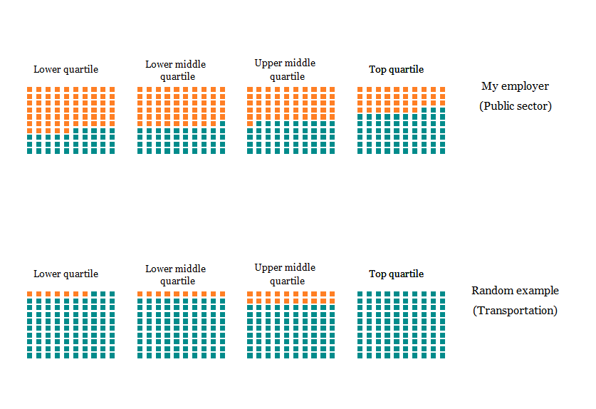

Figure 1: Example gender distributions in each quartile for two organisations Source: <https://gender-pay-gap.service.gov.uk> (accessed 3.4.18)

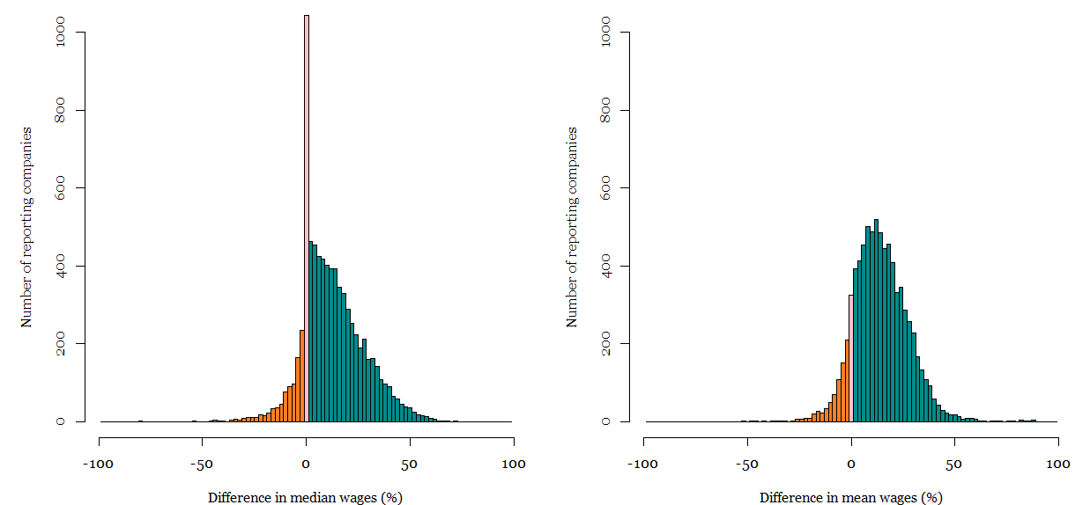

Figure 1: Reported wage gaps in for organisations with over 250 staff (N = 7867) Source: <https://gender-pay-gap.service.gov.uk> (accessed 3.4.18)

**The gender pay gap is sensitive to other things than gender discrimination**

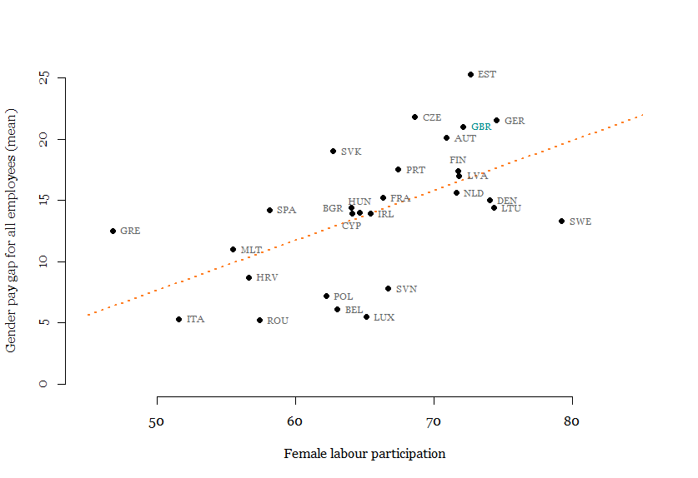

Figure 2: Gender pay gap and female labour market participation in EU countries. Source: http://ec.europa.eu/eurostat/ (accessed 30.3.18)

**Goodhart’s law much?**

I hesitate to use Goodhart’s law in this case actually, because the underlying idea of the law is that the measure must have been a good one at some point in time. But as we have seen, the correlation between the gender pay gap (the measure) and gender-based discrimination in the workplace (the target) already depends massively the degree of labour force participation, so it was never a good measure to begin with.

**Other unintended consequences**

Finally, with every policy it is worth asking what are the unintended consequences of this policy, especially along other dimensions that we might be concerned about.

*The gender pay gap is not a good measure of gender discrimination. The attention it is being given is disproportionate and misleading. If it leads to companies gaming it, it’s effects could be extremely counterproductive. It might also improve for reasons that have nothing to do with improving the lot of women, or improvements in it might come at the expense of much more deprivileged groups in our society. On balance the introduction of mandatory reporting is probably harmful.*

1. However when reporting the gender gap for bonuses, which I don’t discuss here, employers must include part-time employees. And since many more women work part-time than men, this leads the bonus figures to overestimate the gender gap. The reasoning behind choosing such guidelines for reporting is not clear to me. Nor is why they did not also require companies to report part-time gender gaps as well (which often favour women i.e. are negative).