**Impact of previous lactation curve and somatic cell count curve on new infection post calving**

**Maj Beldring, Matt Denwood, Tariq Halasa, Carsten Thure Kirkeby, Søren Saxmose Nielsen**

Animal Welfare and Disease Control, Department of Veterinary and Animal Sciences, Faculty of Health and Medical Sciences, University of Copenhagen

Keywords: Intramammary infection; Wilmink curve; Woods curve; somatic cell count;

Abstract not before the very end. Only example of intro to abstract here

Introduction

WHO -> EU health law -> antibiotic usage in production animal -> AB can be given with a POS pcr test -> false positive tests are a major issues

NOTE TO SELF: Lactation phase should also be 305 days based on Wilminks, as this function is developed based on a 305 days lactation phase (could eliminate some of the crazy outliers using this threshold)

Focus: SCC curves can be a tool for selection dairy cattle for treatment at dry-off.

The increased antibiotic resistance poses a greater health risk for humans and animals (WHO, 2018), why in food production, efforts should be made to reduce antibiotic usage without affecting animal welfare and food safety. This is also in focus of the EU Animal Health Law from 2016 (EU, 2016), thus longevity is required, but not at the cost of increased antibiotic consumption or untreated diseases in the animals.

In dairy cattle, most of the antibiotic consumption is due to intramammary infections (IMI) (references needed), which is routinely monitored via cell count measurements in milk samples. IMI is hard to control and affect milk production and animal welfare, thus not desirable in the herd (Halasa et al., 2007) (P van den Borne et al., 2010). One way to address IMI is during the dry off period in the dairy cow’s lactation circle, where antibiotic treatment is possible if justified by e.g. a positive PCR test for one or more of the four major pathogens causing IMI (SEGES et al., 2015). However, PCR tests are expensive and the chance for a false positive test, mainly due to contamination of the test, should not be neglected (references needed).

By analysing routinely recorded data, including the then calculated infection; dairy cattle can be selected for antibiotic treatments at dry-off. As the infection rate is reflected by the routinely recorded somatic cell count (SCC) (reference needed), investigations of what affect the SCC level must be carried out.

**Rewrite the following to fit with the curves: The** purpose of the study is to reduce antibiotic consumption in dairy cattle and improve animal welfare and the cost benefit of farmers how……. As an increased SCC level indicates infections in the udder (reference needed), SCC based diagnosing will benefit farmers as these data are routinely recorded (reference needed), why it can be instantly decided if a cow would benefit from an antibiotic treatment during the dry off period. The animal welfare could also benefit from SCC based diagnosing, as all cows affected by the painful IMI can be treated, and not only cows pre-selected for testing (reference needed).

The objective of the study is to estimate the impact of various variables on the SCC level, including season for sampling, cattle breed and treatments at dry-off. Check if more of the following should be included: The primary objective is to estimate the impact of the somatic cell count (SCC) level from previous lactations on current SCC level. Secondary objective is to estimate the SCC level from previous lactations on treatments, comparing the risk of treatment with the milk yield and SCC levels.

Materials and methods

Methods must be chronological order. Don’t use phrases like: “before”, “in the beginning” ,“ by the way”

Data

Data from the Danish Cattle Database (SEGES, n.d.) from year 2010 to 2020 have been retrieved and initial included in the study. Data include routinely recorded data for all Danish Dairy cattle in the industrialized production, with 11 milk controls per year, which is the standard number of control, hence the majority of the Danish Dairy Cattle herds. (reference: Tjek græsbølls reference). The target population is all Danish dairy cattle in industrialized production.

Data for the databases are collected by farmers, veterinarians, the breeding association, dairies, slaughterhouses, quality controls and ear brand manufacturers (SEGES, n.d.). Data for the study are selected from the databases retrieved from the Danish Cattle Database for the ACROBAT project (IVH, 2020), and overall project that includes this study.

Give here initial number of animals and herds… and create table 1: Summaries

|  |  |  |  |
| --- | --- | --- | --- |
| Table 1: Description of the prediction variables and actual values for the two different outcome variables. Finish it when I know if we go with dataset 1 or 2 | | | |
|  | **Median** | **Range** | **Unit** |
| Cows Parity 2 |  |  | No. |
| Cows Parity 3 |  |  | No. |
| Cows Parity 4 |  |  | No. |
| SCC Parity 2 |  |  | K |
| SCC Parity 3  SCC Parity 4  DIM  IMI |  |  | K  K |

Descriptive analysis

Identification of patterns in the data and linear dependency between variables of interests was carried out with R (R Core team, 2020).

Somatic Cell Count

The SCC both from previous and current lactation phase was log transformed to achieve a normal distribution. The DIM and the transformed SCC was fitted on herd level to the Wilmink function (Wilmink 1987):

$${logit(SCC)}_{j,k}=a_{j,k}+b_{j,k}∙DIM+ {exp⁡(-exp⁡(k}_{j,k})∙DIM)∙ d_{j,k}$$

where the subscripts *j* and *k* represents the *jth* cow and the *kth* herd, and *a, b, k* and *d* are the parameters describing the curve.

About nls (write R program, packages etc..)

Statistical modelling

To determine the nonlinear least-squares estimates of the parameters in the Wilmink function, the nls function R was used.

Parameters are retrieved and saved as a new data frame.

A Wilmink curve is constructed using the 95% CI and the median of each of the parameters (Søren says we can also use 75% ; for now only constructed with 95%.

Boot function in R (reference and correct name) are used to construct the curve.

Results

2,564,032 individual dairy cows and 3940 herds are included in the production data for year 2010-2020. After removing NA in the SCC observations as well as decreasing the milk range to > 0 L. and < 100 L, 1,521,221 unique animals and 3843 unique herds where included in the analysis

Somatic Cell Count

Figures 1-3 describing the Wilmink curves and the nls output

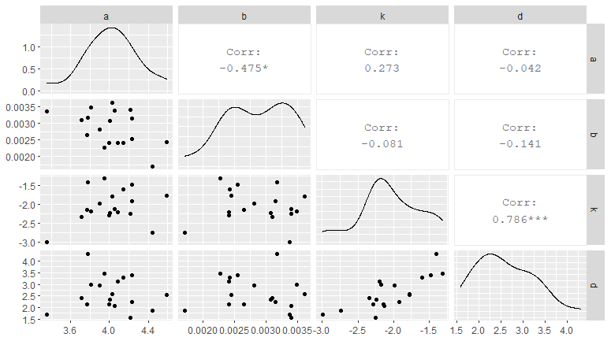

Figure 1: Intercorrelation of Wilmink curve Parameters ... MORE text

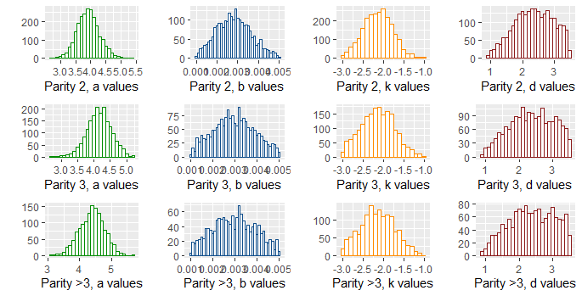

Figure 2: Histogram of parameter distribution for each parity. MORE txt

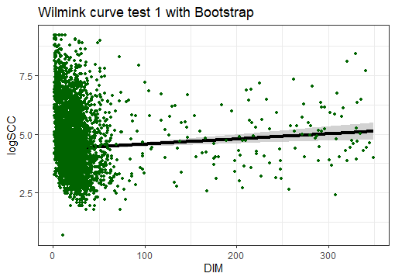

Figure 3: Wilmink curve contructed with parameters from the nls output, based on the median and the 95CI. MORE text. This is just initial figure. No points should be in the figure

Discussion

* REMEMBER references for the discussion.. Appr. 10 references
* Finish one thing at the time. 2-4 pages long.
* Limitation section: important, this is the weak site, so write good limitation, as the reviewers then cannot attack this.
* Don’t write: more research is needed. Because this will always be the fact. Instead we could write where to go from now.

Findings rely mainly on the statistical analysis, which also will be the biggest challenge, as it is expected modelling big data will demand both strong computational power and advanced statistical and programming skills from the researcher. This has been taking into consideration when choosing the project group, the computer and the programs for analysing.

Some variables may be handled carefully, such as an unconsciously and/or consciously biased sampling by farmers. However, this only applies for PCR results, as most data are automatically and routinely recorded.

Somatic Cell Count

Describe the parameters. Describe the threshold

Conclusion

To be applied

Acknowledgement

The authors would like to thank Line Svennesen for providing valuable information about PCR sampling in practical at the farms, and SEGES for have given access to the Danish Cattle Database.

References

EU. (2016). *Animal Health Law 2016*. https://eur-lex.europa.eu/legal-content/EN/TXT/?uri=OJ:L:2016:084:TOC

Halasa, T., Huijps, K., Østerås, O., & Hogeveen, H. (2007). Economic effects of bovine mastitis and mastitis management: A review. *Veterinary Quarterly*, *29*(1), 18–31. https://doi.org/10.1080/01652176.2007.9695224

IVH. (2020). *ACROBAT project*. https://ivh.ku.dk/english/research/animal-welfare-and-disease-control/projects/acrobat/

P van den Borne, B. H., Halasa, T., van Schaik, G., Hogeveen, H., & Nielen, M. (2010). Bioeconomic modeling of lactational antimicrobial treatment of new bovine subclinical intramammary infections caused by contagious pathogens. *Journal of Dairy Science*, *93*, 4034–4044. https://doi.org/10.3168/jds.2009-3030

R Core team. (2020). *R: A language and environment for statistical computing* (4.0). R Foundation for Statistical Computing, Vienna, Austria. https://www.r-project.org/

SEGES. (n.d.). *Danish Cattle Database*. Landbrug Og Fødevarer. https://www.seges.dk/fagomraader/kvaeg/raadgivning/kvaeg-it

SEGES, AU, KU-SUND, & Den Danske Dyrlægeforening. (2015). *SEGES antibiotic usage*. https://www.landbrugsinfo.dk/-/media/landbrugsinfo/public/0/c/b/kv_17_retningslinjer-for-brug-af-antibiotika.pdf

WHO. (2018). *WHO - Antimicrobial resistance*. http://www.who.int/en/news-room/fact-sheets/detail/antimicrobial-resistance